UBUNTU COMMANDS
OPERATING SYSTEMS LABS


ASSIGNMENT # 01
Submitted By
ASJID AHMED
(17P-6124)
Submitted to
MR. MUHAMMAD ABDULLAH
(COMPUTER INSTRUCTOR)

DEPARTMENT OF COMPUTER SCIENCE
FAST NATIONAL UNIVERSITY OF COMPUTER AND EMERGING SCINCES, PESHAWAR
Session 2017-2021

Set Command
It is used to set the flags on/off and can be used to set variables as well
Below are the functions of this command
- -a: It is used to mark variables that are modified or created for export.
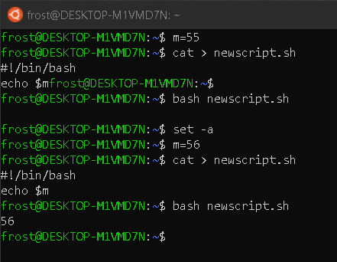
- -f: It is used to disable the file name generation (globbing).

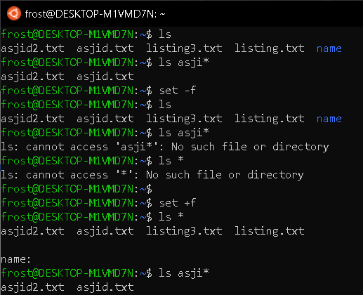
-o: Set the option corresponding to option-name:

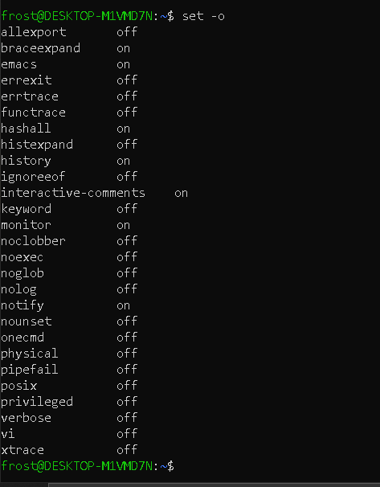
- -p: It is used to disable the processing of the '$ENV' file and import shell functions. It is turned on whenever the real and effective user ids do not match. Turning off this option may cause the working uid and gid to be set as the authorized uid and gid. (Privileged mode)
- -t: It is used to exit from the command after executing one command.
“The terminal will be terminated after executing this command”

- -u: It is used to treat unset variables as an error when substituting.
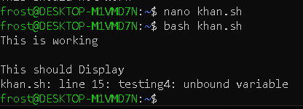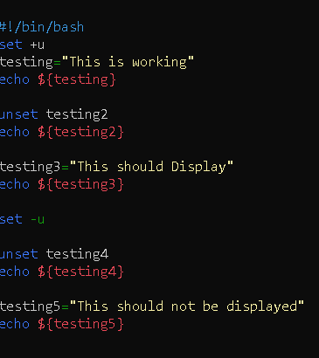
- -v: It is used to print shell input lines.
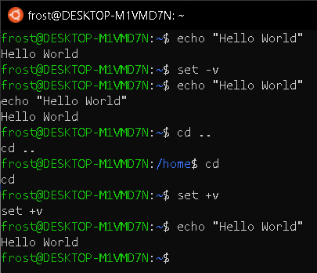

- -x: It is used to print commands and their arguments in a sequential way (as they are executed).
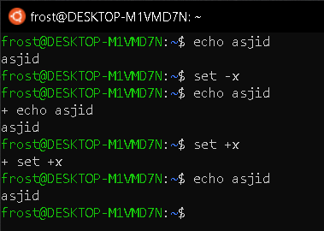
- -B: It is used to perform brace expansion by the Shell.
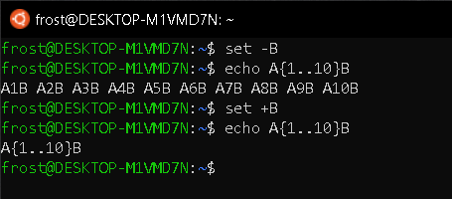
- -C: It is used to disallow existing regular files to be overwritten by redirection of output.
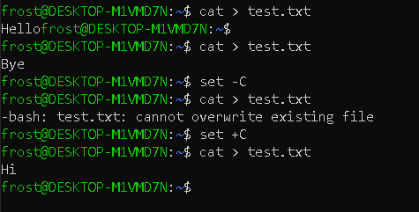
- -H: It is used to enable style history substitution. By default, it is on when the shell is interactive.
- -P: It is used if we do not want to follow symbolic links (Shortcuts) when executing commands.
Example:
If you want to set a flag you should set it like this
# set –a
And if you want to turn the flag off you have to type the command like this
# set +a

Set command can also be used to set a variable and to use it
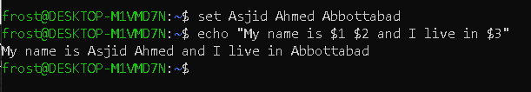
If you are interested to know more about set command you can type “help set” in bash or follow the link below:
https://www.tutorialdocs.com/article/set-command-in-bash.html#:~:text=About%20The%20set%20Command&text=This%20new%20Shell%20is%20the,the%20environment%20can%20be%20customized.

