**1.**

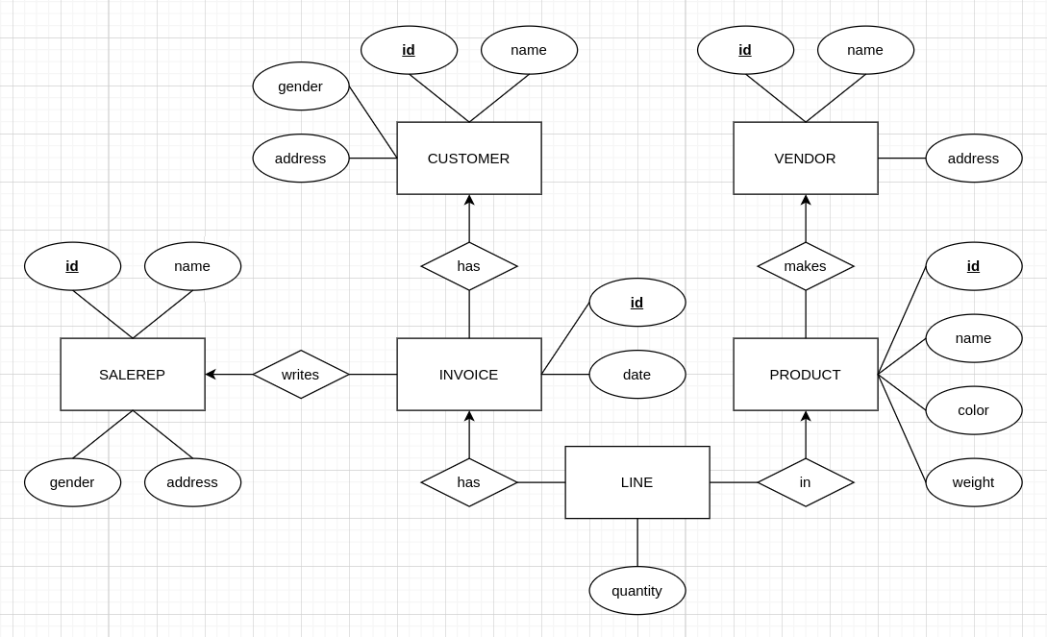

SaleRep(id, name, gender, address)

CK id

Customer(id, name, gender, address)

CK id

Product(id, name, color, weight, vId)

CK id

FK vId references Vendor(id)

Vendor(id, name, address)

CK id

Invoice(id, cId, sId, date)

CK id or cId and sId

FK cId references Customer(id)

FK sId references SaleRep(id)

Line(iId, pId, quantity)

CK iId and pId

FK iId references Invoice(id)

FK pId references Product(id)

**2.**

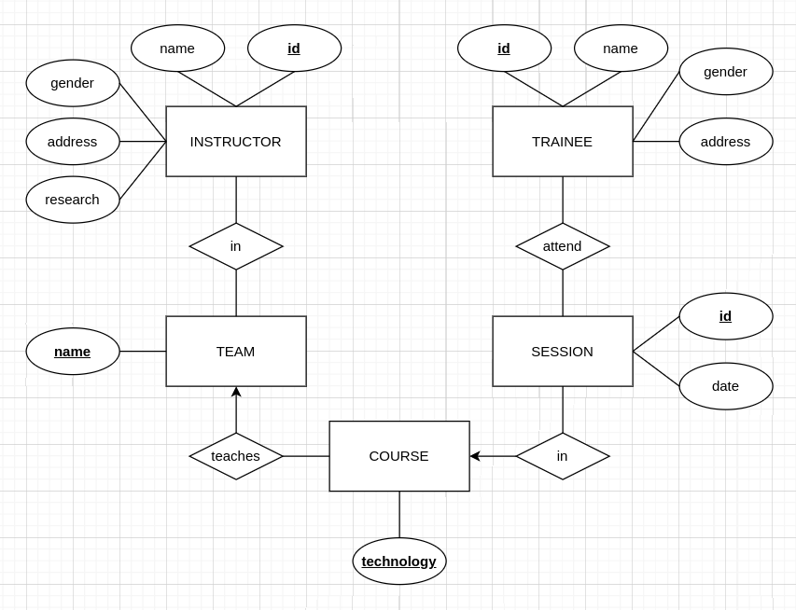

Instructor(id, name, gender, address, research)

CK id

Team(name)

CK name

Trainee(id, name, gender, address)

CK id

TeamInstructor(iId, tId)

CK iId and tId

FK iId references Instructor(id)

FK tId reference Team(id)

Course(technology, tId)

CK technology

FK tId references Team(id)

Session(id, date, cTechnology)

CK id or date and cTechnology

FK cId references Course(technology)

Attend(tId, sId, attended)

CK tId and sId

FK tId references Trainee(id)

FK sId references Session(id)

**3.**

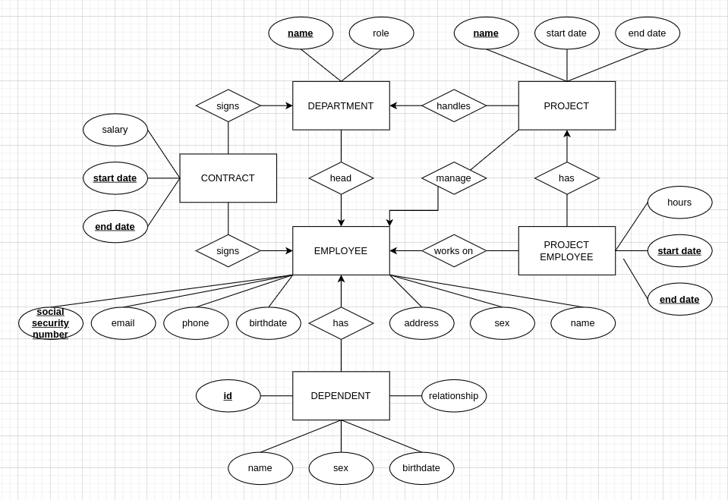

Employee(socialSecurityNumber, email, phone, name, sex, address, birthdate)

CK socialSecurityNumber

Dependent(id, name, sex, birthdate, relationship, eSSN)

CK id

FK eSSN references Employee(socialSecurityNumber)

Department(name, role, head)

CK name

FK head references Employee(socialSecurityNumber)

Project(name, startDate, endDate, manager, department)

CK name

FK manager references Employee(socialSecurityNumber)

FK department references Department(name)

Contract(eSSN, dName, startDate, endDate, salary)

CK eSSN and dName and startDate and endDate

FK eSSN references Employee(socialSecurityNumber)

FK dName references Department(name)

ProjectEmployee(eSSN, pName, startDate, endDate, hours)

CK eSSN and pName and startDate and endDate

FK eSSN references Employee(socialSecurityNumber)

FK pName references Project(name)