Workshop #3: Class and Object

**Learning Outcomes:**

Upon successful completion of this workshop, you will have demonstrated the abilities to:

* Design and implement a class.
* Create an object from a class
* Describe to your instructor what you have learned in completing this workshop.

**Requirements:**

**Part 1: [2 points]**To complete this task you should read and study the lecture [Encapsulation](../index.html)  
-Create a new project named “**CarManager**”. It contains the file **Car.java and Tester.java.**-In the file Car.java, you implement the Car class base on the class diagram as below:

|  |
| --- |
| **Car** |
| **-Colour: String -EnginePower:int -Convertible: boolean -ParkingBrake: boolean** |
| **//constructors +Car() +Car(String Colour, int EnginePower, boolean Convertible, boolean ParkingBrake ) //getters +getColour():String +getEnginePower():int +getConvertible(): boolean +getParkingBrake(): boolean //setters +setColour(String colour):void +setEnginePower(int EnginePower):void +setConvertible(boolean Convertible): void +setParkingBrake(boolean ParkingBrake): void //other logic methods +pressStartButton():void +pressAcceleratorButton():void +output(): void** |

* Default constructor: to assign all fields to empty values
* Constructor with parameters: to assign all fields to input parameters
* Getters: to return the value of a field
* Setters: to change the value of a field
* The method pressStartButton(): print out the message “You have pressed the start button”
* The method pressAcceleratorButton(): print out the message “You have pressed the Accelerator button”
* The method output(): print out values of all fields
* In the file “Test.java”. you type like as follow:

public class Tester {

public static void main(String[] args) {

Car c=new Car();

c.pressStartButton();

c.pressAcceleratorButton();

c.output();

Car c2=new Car("red", 100, true, true);

c2.pressAcceleratorButton();

c2.setColour("black");

System.out.println("Colour of c2:" + c2.getColour());  
 c2.output();

}

}

* Run the method main to see the output

**Part 2: Find classes [3 points] and use UML to draw class structure (optional)**

Problem: Mr. Hung is the owner of the shop that sells guitars. He wants you to build him a shop management app. This app is used for keeping track of guitars. Each guitar contains serialNumber, price, builder, model, back Wood, top Wood. The guitar can create a melodious sound. The shop will keep guitars in the inventory. The owner can add a new guitar to it, he search also the guitar by the serialNumber.

Requirement: Write your paper down classes in the problem and use UML draw class structure.

***Note***: show members of a class: fields and methods

Do it yourself before getting help

Guideline**:**

Apply design guideline :

* Main nouns: Guitar
* Auxiliary nouns describe details of the guitar:serialNumber, price, builder, model, back Wood, top Wood.
* Verbs describe behaviors of the guitar: create Sound

Continue finding other nouns

* Main nouns: Inventory
* Auxiliary nouns describe details of the inventory: the list(array) of guitars
* Verbs describe behaviors of the inventory: add a new guitar, search the guitar by serialNumber.

Using UML to draw a class diagram

**Part 3: only implement the Guitar class [4 points].**

Step by step workshop instructions:

* Create a new project named “**workshop3**”
* In the project, create a new file named “**Guitar.java”**
  + Declare fields with access modifier as private: String serialNumber, int price, String builder, String model, String backWood, String topWood
  + Declare and implement methods with access modifier as public:
    - public Guitar() {…} : to assign all fields to empty values
    - public Guitar( String serialNumber, int price, String builder, String model, String backWood, String topWood) {…}: to assign all fields by input parameters
    - public String getSerialNumber(){…}: return the value of the field serialNumber.
    - public void setSerialNumber(String serialNumber){…}: if the input parameter is not empty then assign it to the field serialNumber.
    - Implement getter/setter of all other fields
    - public void createSound(){…}: in the method, invoke all getters and use System.out to print out values after getting.
* In the project, create a new file named “**Tester.java.** Createthe method main in here, you type:

public class Tester {

public static void main(String[] args) {

Guitar obj1=new Guitar();

Guitar obj2=new Guitar("G123",2000,"Sony","Model123","hardWood","softWood");

System.out.println("State of obj1:");

obj1.createSound();

System.out.println("State of obj2:");

obj2.createSound();

System.out.println("set price = 3000 of obj1");

obj1.setPrice(3000);

System.out.println("get price of obj1:" + obj1.getPrice() );

}

}

The output is:

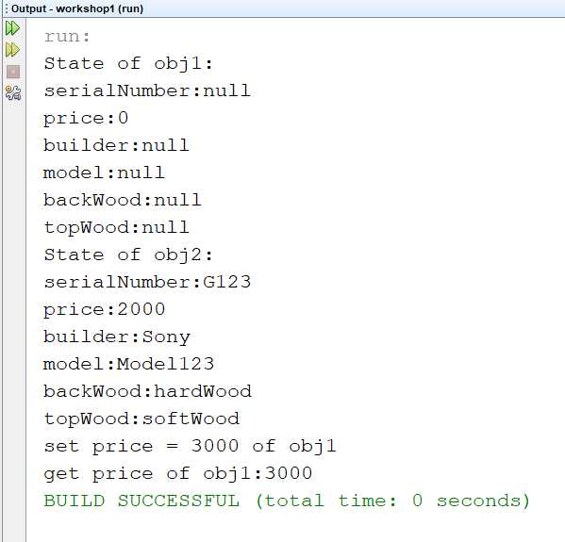

**Part 4: Draw the memory map when the program runs [1 point]**

Explain step by step what happened when the program runs and answer some questions.

* What is stored in the static heap, stack, dynamic heap?
* What are objects in the program?
* What is the state of obj1, obj2?
* Do you access all fields of obj1 in the class Tester.java? Why?
* What is the current object when the program runs to the line “obj2.createSound();”?
* In the method main, can you use the keyword “this” to access all fields of obj2? Why?