1. In this case, I chose AGILE software development methodology because:

* This is a startup, team size is small/medium and has less experience in developing a software, and they might have to learn new technology while developing
* Requirements are not very clear, only few requirements for parents are listed, missing requirements for babysitters, and they might change in the future

1. 4 functional requirements that are necessary for babysitters:

* Babysitters can view details of parents’ requests and accept or decline it
* Babysitters can view the price of services, taxes and their total income
* Babysitters can view their schedule by day, week, month, …
* Babysitters can add credit cards to their accounts

1. 2 user stories:

* As a babysitter, I want to add credit cards to my account so that I can receive my payment easily
* As a babysitter, I want to view date, price, locations, … of requests so that I can choose which request to accept

1. Story map:

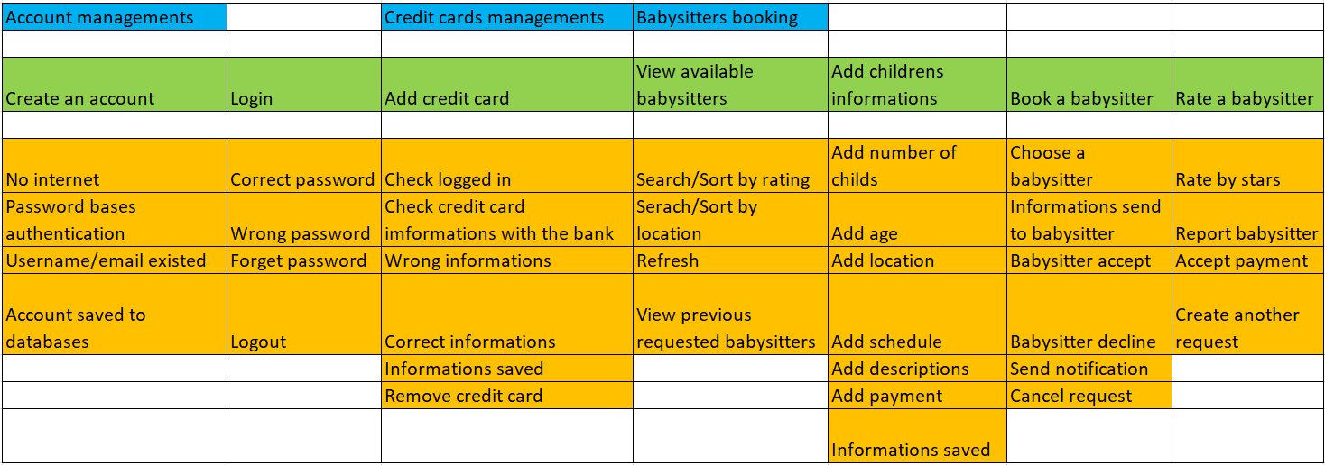

2. In this case, I think ITERATIVE methodology is NOT SUITABLE because:
   * ITERATIVE require system specifications to be clear, easy to understand, but in this case, they are not defined
   * ITERATIVE require many resources, and more complex to manage but this is a startup, they might not have enough resources to proceed
   * ITERATIVE only suitable for big, risky business
3. I suggest the team do black-box testing, think as a user, develop test cases based on typical user behavior and try it. Ex:
   * As a parent, try creating an account and book a babysitter
   * As a babysitter, try adding a credit card to the account, finish a request and check whether the money is deposited to the credit card or not

For non-functional requirements, the team can test:

* + Posting a request as a parent and see if it immediately appears on the babysitter side
  + Checking if UI is easy to use