EXERCISE 1
Windows Form Application – Basic

* Content:
- Create a basic Windows Form application that calculates the service charge for a dentist visit.
- For each customer, the services provided include: teeth removal, lime shaving, dental imaging and fillings. Each type will have its own cost. Finally, the total cost of the guest must pay. Note: only charge when the customer name information has been entered (if this information is not available, the program generates MessageBox alert).
- The application has a simple interface below.
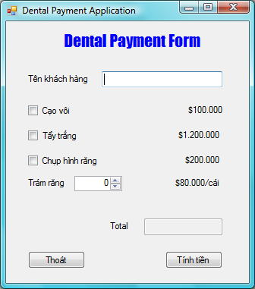

Guideline:
- Create a Windows Form application named DentalPaymentApp by following these steps
  - Create a new project (Ctrl+Shift +N),
  - In the new project window select Visual C # .Net - Windows
  - For the template section, select Windows Forms Application
  - Set name of the project in the Name section
- After completing the steps on VS.NET will generate a sample Windows Form project, allowing programmers to start building applications. The interface of VS.NET 2005 for the newly created application is as shown in Figure 3 below.
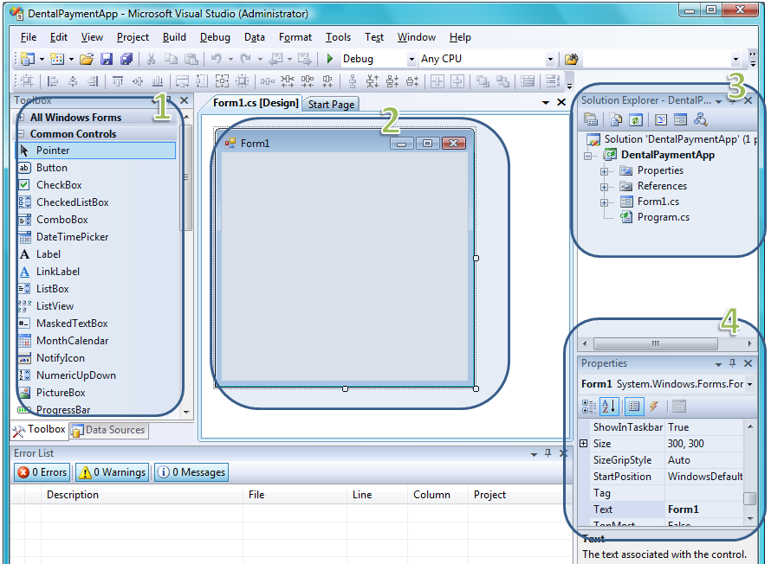
- Design the form according to the following description
Table 1: Describe the controls on the form
No | Name | Control | Set properties for the control
1 | lblTitle | Label | Text = “Dental Payment Form”, Font = “Impact, Size = 17”, ForeColor = Blue
2 | lblName | Label | Text = “Customer name”
3 | txtName | TextBox
4 | chkClean | CheckBox | Text = “Cạo vôi”
5 | lblCleanCost | Label | Text=”$100000”
6 | chkWhitening | CheckBox | Text=”Tẩy trắng”
7 | lblWhiteningCost | Label | Text=”$1200000”
8 | chkXRay | CheckBox | Text=”Chụp hình răng”
9 | lblXRayCost | Label | Text=”$200000”
10 | lblFilling | Label | Text=”Trám răng”
11 | numFilling | NumericUpDown
12 | lblFillCost | Label | Text=”$80000”
13 | lblTotal | Label | Text=”Total”
14 | txtTotal | TextBox | Enable = False
15 | btnExit | Button | Text=”Thoát”
16 | btnCalc | Button | Text=”Tính tiền”
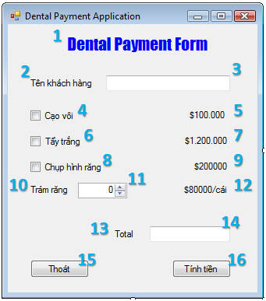

Doing:
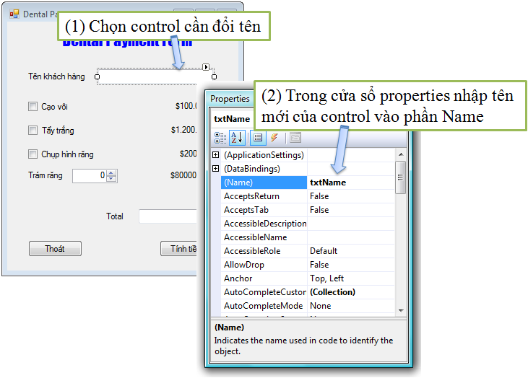
Illustrate the renaming of TextBox on the Form
- Create a click event handler for the "Exit" button: this function will execute the application when finished (closing the form)
How to create event handlers: can do one of two ways
- Way 1: Double click the button to create event handler in the screen Form design view: then VS will create event handler associated with the event Click of the button "Exit"
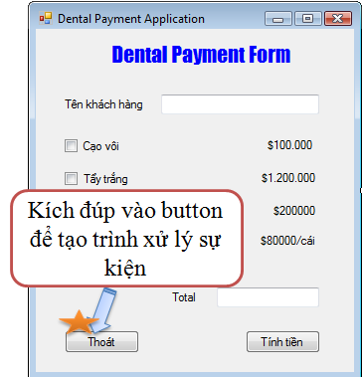
- Way 2: Select the button to create a handler, then click the event tab in the Properties window, double click the Click item in the event window.
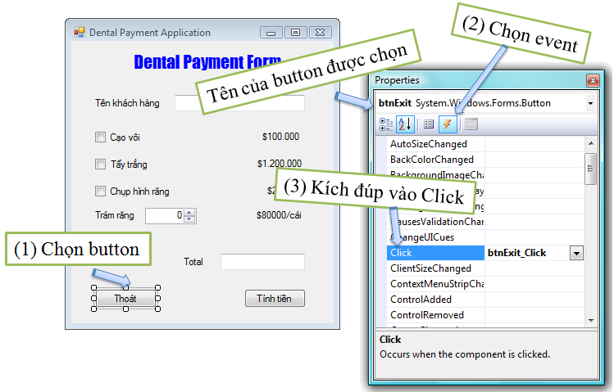
1. Create a cash register function, this function is activated when the "Cash register" button is selected. Describe the GetPay () function as follows (GetPay () is a member method of the main Form class:
+ Check if the customer name is entered or not?
+ If not: ➔ export notice, request enter guest name.
+ Imported: perform the following steps
Total = 0
If (cạo vôi) Total += 100.000
If ( tẩy trắng) Total += 1.200.000
If ( chụp hình răng) Total +=200000
Total += (số răng trám)*80000

EXERCISE 2
Windows Form Application – Basic

* Content:
Building an application to simulate the Security Panel device as follows:
A lab wants to set up a Security Panel outside the door. Only authorized individuals are allowed to enter and each login they must enter the provided security code. The following security code (aka access code) is considered valid and provided to the employee groups as follows:
Value | Group
1645 or 1689 | Technicians
8345 | Custodians
9998, 1006 – 1008 | Scientist
Once you enter the access code, there are two states: granted or denied. All access information will be displayed in an information box below the keypad. If access is granted, the date, time, group (technician, custodian, scientist) will be displayed in the info box. If access is denied, the date, time and "Access denied" information will be displayed in the box below. In addition, if a user only clicks a security code number, it will display a notice of the date, time and "Restricted Access". An illustration of the interface of the Security Panel application
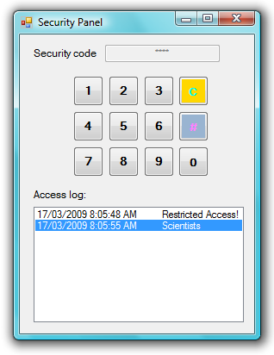

Guideline:
- Design the Form as shown in Figure 1
  - Describe the controls on the form as shown in Figure 2:
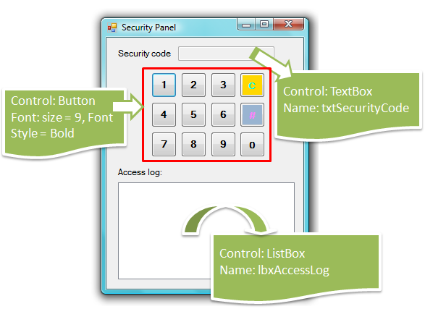
Describe the controls on the form
Instructions on how to quickly design buttons on the form:
    - First create a button template first, format the button according to the specified pattern including font, size, color ...
    - Then copy the newly created template button, then paste it into the appropriate locations
    - Align the appropriate position for the buttons.
    - Modify the Text property of each button.
    - Rename again the Name attribute for each button.
  - Set properties for TextBox txtSecurityCode:
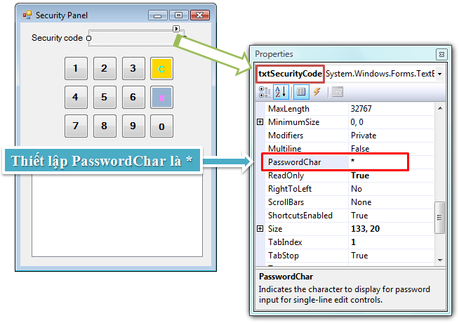

- PasswordChar of TextBox is “*”
- ReadOnly is True
- The next section writes handling for buttons on the Form (students do it themselves ...)
Guideline:
- Create an event listener Click common buttons 0 - 9. Each time buttons 0-9 are pressed, add this number to the end of txtSecurityCode.Text (Text property stores the current code that the user is entering) ).
  - How to create a generic event handler for buttons:
    - Select all buttons to create a handler (in the case above, select buttons with numbers 0-9.
    - Then double click on the Click event, in the property window. This allows the creation of a generic event handler for the selected buttons.
* Note: If students double click on each button, they will create their own handlers for each button! (Be careful in the case of this lab)
- Create a Click event handler for the button (#), which is the login or enter function.
Use the switch case statement to check if the code entered by the user is in the description list on the Access Code table, the Access codes are: {1645,1689, 8345, 9998, 1006, 1008}. Then save the login information to the listbox as prescribed:
  - Logged in successfully: Access code is valid (belonging to 1 of 6 codes above)
    - Save an item line: <Date> <Time> <Group name>
  - Fail: Access code is different from the code in the description table
    - Save an item line: <Date> <Time> Restricted Access!
- Create the click event handler for the button (C), this is the button with the Clear function: delete the entered code.

EXERCISE 3
Windows Form Application – Advanced

- Create the following form and save it as a name StartUp.cs:
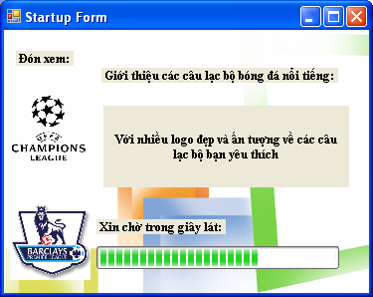
Requirement: Use the ProgressBar control to run the process, after a period of time then automatically switches to another window (As in item 2).
- Create the following form and save it as a name frmMain.vb:
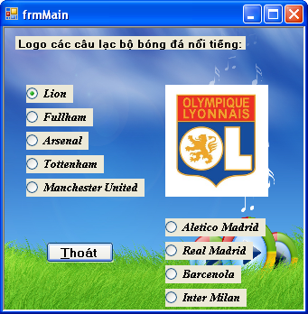

→ Add the Lunar button under the Exit button. When you press the Lunar button will switch to a new window (As in item 3).
Requirement:
- Clicking Exit will exit the program.
- Clicking on the options will display the corresponding Club Logo (Image may be changed if not available).
Guideline: To display the image, we do the following
pic1.Image = My.Resources.logo1;
Inside:
+ pic1 is the name of the PictureBox control.
+ logo1 is the name of the image added in Resource.

3. Create the following form and save it as a name Lunar.cs:
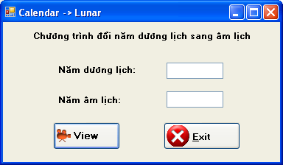
Requirement:
- When the cursor is in the textbox, the textbox background is pink. In contrast, the white background.
- Click the Exit button and exit this window. (Me.Close())
Entering the Calendar Year and clicking the View button will display the corresponding lunar year.

EXERCISE 4

Note:
- Use Entity Framework.
- Create a new project.
Database: MyDB2 (file MyDB2.sql)
Write a Windows Forms application.
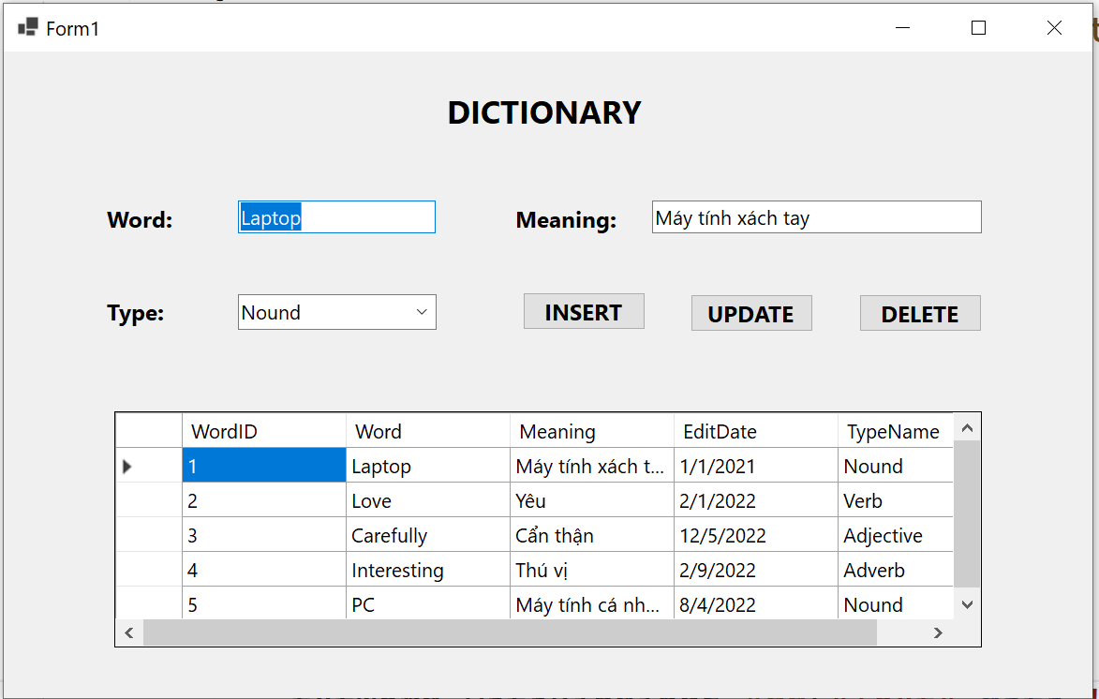
Implement the event click button INSERT,UPDATE,DELETE
EXERCISE 5

Note:
- Use ADO.NET.
- Create a new project.
Database: MyDB2 (file MyDB2.sql)
Write a Windows Forms application.
Implement the event click button INSERT,UPDATE,DELETE

