More on classes
Workshop 4
In this workshop, you’ll learn:
- What is encapsulation?
- Organize classes in packages
- Information hiding: Access modifiers and others

0. Create packages in the project for workshop 4:
Create a new project named w4. Check the box “Create Main Class”, then type “Main” in the text box next to it as below then click the button “Finish”:
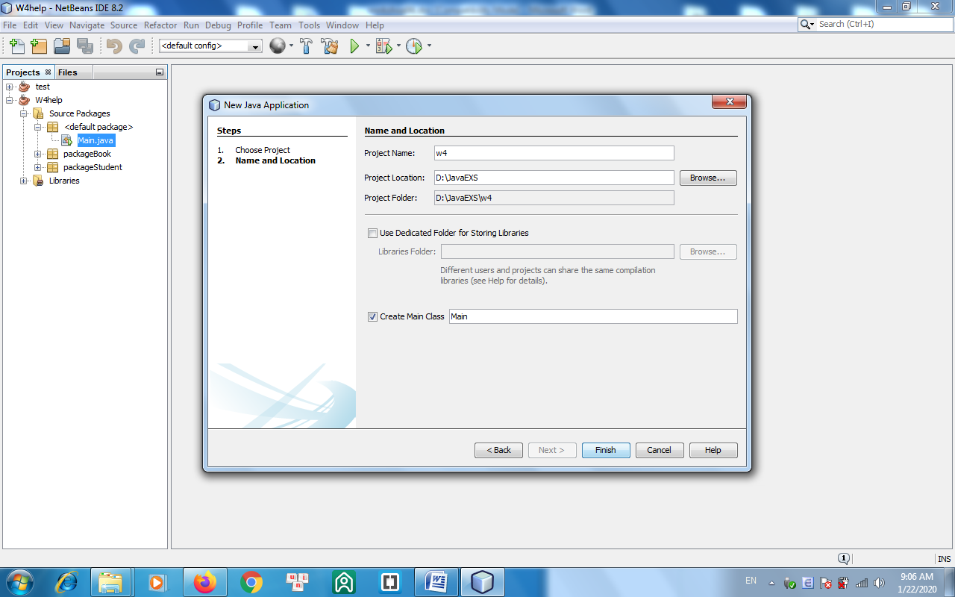
The class named Main is created in the Main.java file, which contains the main() function.
Right-click on the “Source packages” item and create 2 packages named pkgBook and pkgStudent.
1. Write a class named Book (in the package pkgBook) having the following attributes:
- title: a String object that holds the book’s title.
- pages: an int variable that holds the number of pages of the book.
- cost: a double variable that holds the book’s cost.
- fiction: a boolean variable, that holds information about whether the book is fiction or not.
Create default and parameterized constructor. Create “set/get” methods to change/return value of class variables.
Write statements in the main funtion to test all the above operations.
The program output might look something like:

Enter title : Dreamy island
Enter number of pages: 200
Enter cost: 250
Enter fiction(true/false): false
Dream island 200 150.0 false

Enter new cost: 300

Dream island 200 300.0 false

2. Write a class Student (in the package pkgStudent) having the following attributes:
- id: a String object that holds the student’s id.
- name: a String object that holds the student’s name.
- mark: a double variable that holds the student’s average mark.
Create default and parameterized constructor. Create toString() method so that the statement System.out.println(x) where x is the Student object will display on screen a student’s information in format below:
id, name, mark
Write statements in the main funtion to test all the above operations.
The program output might look something like:
Enter id: A01
Enter name: Tran Ha
Enter mark: 7.5

A01, Tran Ha, 7.5

