More on classes
Workshop 4
In this workshop, you’ll learn:
- What is encapsulation?
- Organize classes in packages
- Information hiding: Access modifiers and others

0. Create packages in the project for workshop 4:
Create a new project named w4. Check the box “Create Main Class”, then type “Main” in the text box next to it as below then click the button “Finish”:
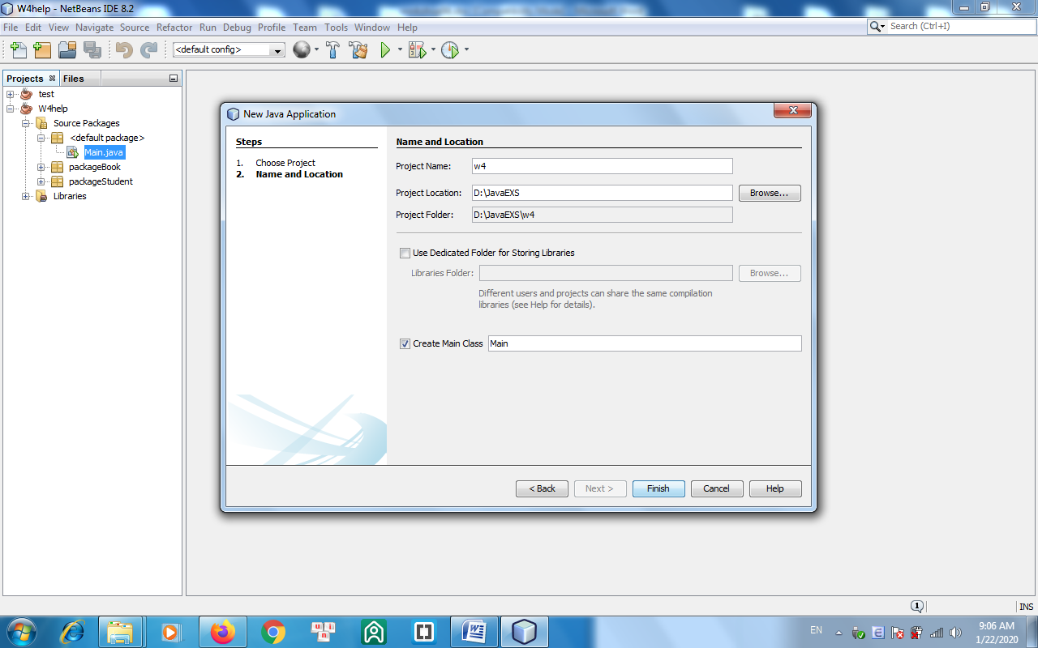
The class named Main is created in the Main.java file, which contains the main() function.
Right-click on the “Source packages” item and create 2 packages named pkgBook and pkgStudent.
1. Write a class named Book (in the package pkgBook) having the following attributes:
- title: a String object that holds the book’s title.
- pages: an int variable that holds the number of pages of the book.
- cost: a double variable that holds the book’s cost.
- fiction: a boolean variable, that holds information about whether the book is fiction or not.
Create default and parameterized constructor. Create “set/get” methods to change/return value of class variables.
Write statements in the main funtion to test all the above operations.
The program output might look something like:

Enter title : Dreamy island
Enter number of pages: 200
Enter cost: 250
Enter fiction(true/false): false
Dream island 200 150.0 false

Enter new cost: 300

Dream island 200 300.0 false
2. Write a class Student (in the package pkgStudent) having the following attributes:
- id: a String object that holds the student’s id.
- name: a String object that holds the student’s name.
- birthDate: a Date object that holds the student’s birth date.
- mark: a double variable that holds the student’s average mark.
Create default and parameterized constructor. Create toString() method so that the statement System.out.println(x) where x is the Student object will display on screen a student’s information in format below:
id, name, birthDate, mark
Write statements in the main funtion to test all the above operations.
The program output might look something like:
Enter id: A01
Enter name: Tran Ha
Enter date of birth:
Year: 1999
Month: 10
Day: 25
Enter mark: 7.5

A01, Tran Ha,25/10/1999, 7.5

Hint:
import java.text.SimpleDateFormat;
public void setDate(int xYear, int xMonth, int xDate) {
bDate = new Date(xYear-1900, xMonth-1, xDate);
}
public String getDateString(Date x) {
SimpleDateFormat sdf = new SimpleDateFormat("dd/MM/yyyy");
String y = sdf.format(x);
return(y);
}

The 2 functions below help you to convert groups of three integers: year, month, day into Date object and Date objects into dd / MM / yyyy fỏmatted string:

import java.text.SimpleDateFormat;
import java.util.Date;

public class TestDate {

public Date ymdToDate(int xYear, int xMonth, int xDate) {
Date x = new Date(xYear-1900, xMonth-1, xDate);
return(x);
}

public String dateToDmyString(Date x) {
SimpleDateFormat t = new SimpleDateFormat("dd/MM/yyyy");
String y = t.format(x);
return(y);
}

}

You can write the Main class with the main function to test them as follows:

import java.util.*;
public class Main {

public static void main(String[] args) {
int xYear, xMonth, xDay;
xYear = 2019;
xMonth = 10;
xDay = 25;
TestDate t = new TestDate();
Date x = t.ymdToDate(xYear,xMonth,xDay);
System.out.println("Date x = " + x);
System.out.println();
String s = t.dateToDmyString(x);
System.out.println("Date x = " + s);
System.out.println();
}

}

Additional proposed exercises:
3. Write a Rectangle class to represent rectangles, with two data fields (width, height) and four methods (input data, display data, calculate and return area, calculate and return perimeter). Write another class to test all methods of the Rectangle class.
4. Write java program to manage fractions with addition, subtraction, multiplication and division.

