Introducing Regular Expressions
- A regular expression is a text string that defines a character pattern
- One use of regular expressions is pattern-matching, in which a text string is tested to see whether it matches the pattern defined by a regular expression
- Creating a regular expression
  - You create a regular expression in JavaScript using the command
re = /pattern/;
  - This syntax for creating regular expressions is sometimes referred to as a regular expression literal
- Matching a substring
  - The most basic regular expression consists of a substring that you want to locate in the test string
  - The regular expression to match the first occurrence of a substring is /chars/
- Setting regular expression flags
  - To make a regular expression not sensitive to case, use the regular expression literal /pattern/i
  - To allow a global search for all matches in a test string, use the regular expression literal /pattern/g
Defining character positions
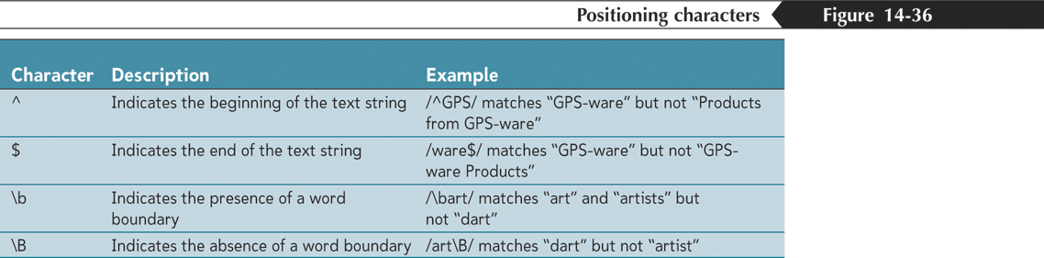
Defining character positions
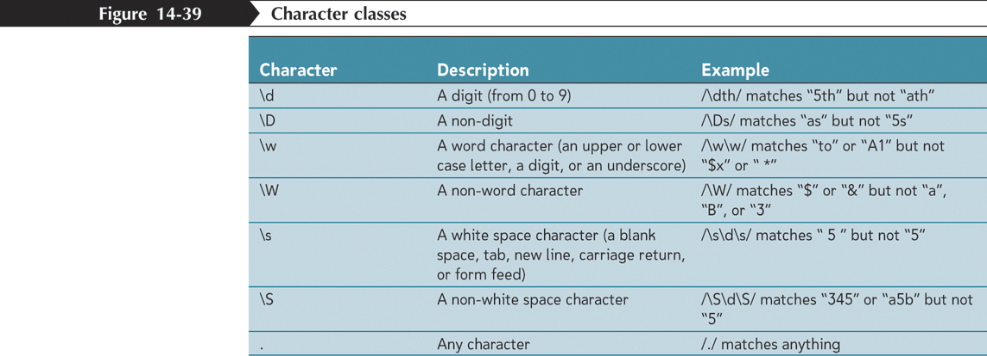
- Defining character positions
  - Can specify a collection of characters known a character class to limit the regular expression to only a select group of characters
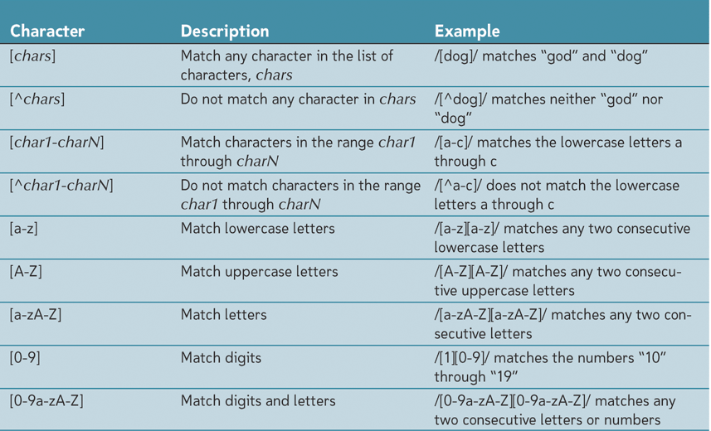

- Repeating characters
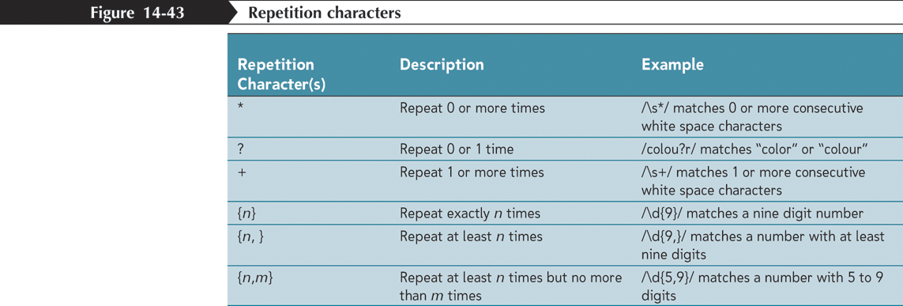

- Escape Sequences
  - An escape sequence is a special command inside a text string that tells the JavaScript interpreter not to interpret what follows as a character
  - The character which indicates an escape sequence in a regular expression is the backslash character \
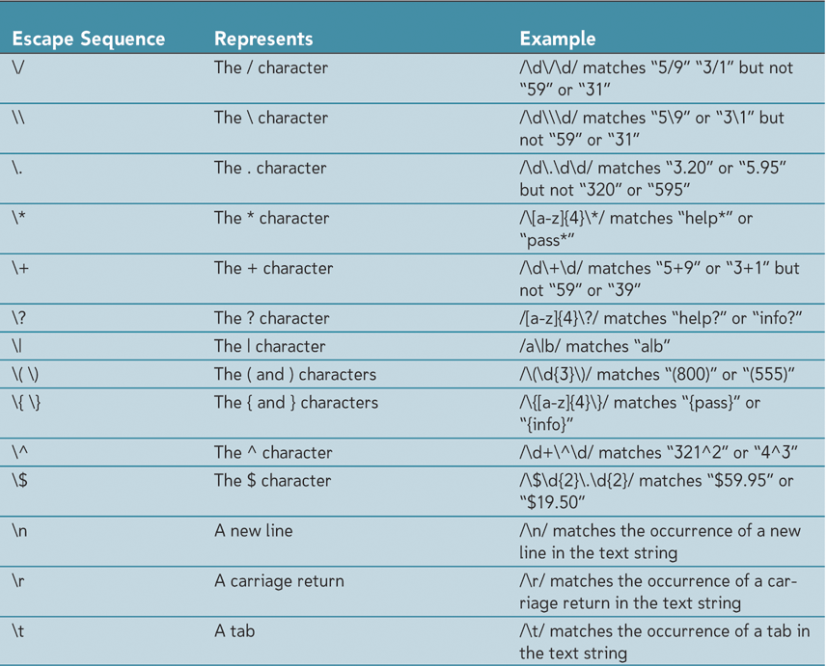

Alternating Patterns and Grouping
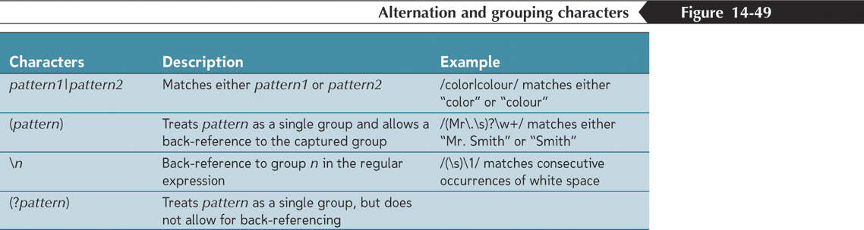

- The regular expression object constructor
  - To create a regular expression object
re = new RegExp(pattern, flags)
  - re is the regular expression object, pattern is a text string of the regular expression pattern, and flags is a text string of the regular expression flags
Regular Expression methods
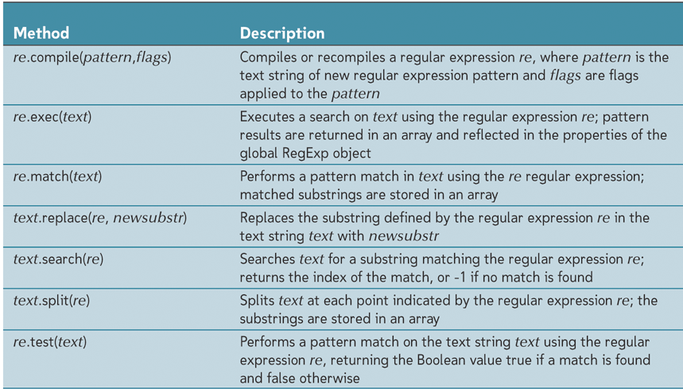

Validating a ZIP code
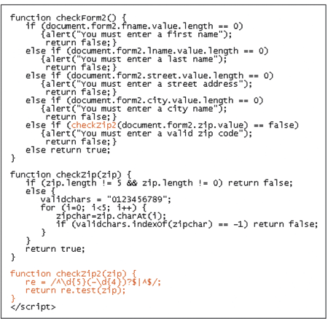

Validating Financial Information
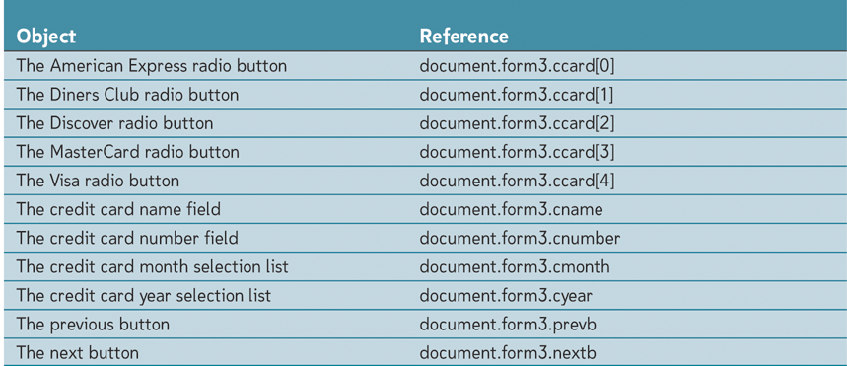

- Removing blank spaces from credit card numbers
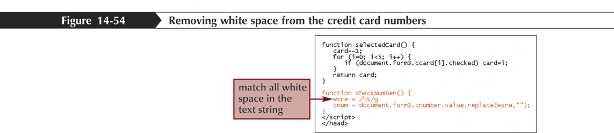
Validating credit card number patterns
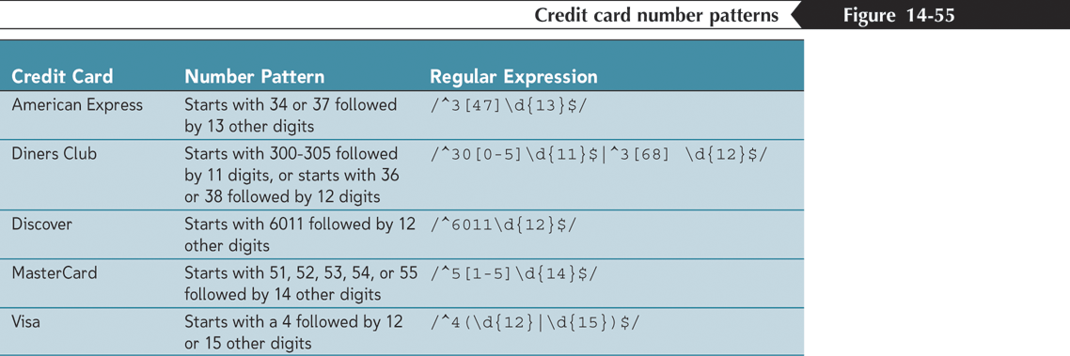
- The Luhn Formula
  - All credit card numbers must satisfy the Luhn Formula, or Mod10 algorithm, which is a formula developed by a group of mathematicians in the 1960s to provide a quick validation check on an account number by adding up the digits in the number
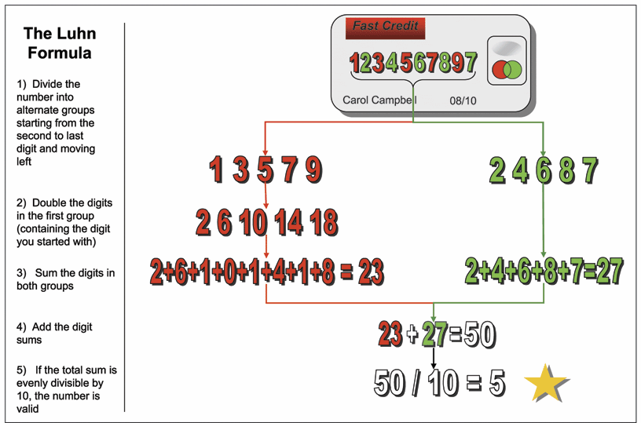

Passing Data from a Form
- Appending data to a URL
  - Text strings can be appended to any URL by adding the ? character to the Web address followed by the text string
<a href="form2.htm?GPS-ware">Go to form2</a>
  - One property of the location object is the location.search property, which contains the text of any data appended to the URL, including the ? character
  - There are several limitations to the technique of appending data to a URL
  - URLs are limited in their length
  - Characters other than letters and numbers cannot be passed in the URL without modification
  - Because URLs cannot contain blank spaces, for example, a blank space is converted to the character code %20

- Appending and retrieving form data
  - Can use the technique of appending data to the URL with Web forms, too
  - Do this by setting a form’s action attribute to the URL of the page to which you want to pass the data, and setting the method of the form to “get”
  - Use the location.search property and the slice() method to extract only the text string of the field names and values
  - Use the unescape() function to remove any escape sequences characters from the text string
  - Convert each occurrence of the + symbol to a blank space
  - Split the text string at every occurrence of a = or & character, storing the substrings into an array
Tips for Validating Forms
- Use selection lists, option buttons, and check boxes to limit the ability of users to enter erroneous data
- Indicate to users which fields are required, and if possible, indicate the format that each field value should be entered in
- Use the maxlength attribute of the input element to limit the length of text entered into a form field
- Format financial values using the toFixed() and toPrecision() methods. For older browsers use custom scripts to format financial data
- Apply client-side validation checks to lessen the load of the server
- Use regular expressions to verify that field values correspond to a required pattern
- Use the length property of the string object to test whether the user has entered a value in a required field
- Test credit card numbers to verify that they match the patterns specified by credit card companies
- Test credit card numbers to verify that they fulfill the Luhn Formula
Summary
Regular expressions are objects that represent patterns in strings. They use their own syntax to express these patterns.
/abc/ | A sequence of characters
/[abc]/ | Any character from a set of characters
/[^abc]/ | Any character not in a set of characters
/[0-9]/ | Any character in a range of characters
/x+/ | One or more occurrences of the pattern x
/x+?/ | One or more occurrences, nongreedy
/x*/ | Zero or more occurrences
/x?/ | Zero or one occurrence
/x{2,4}/ | Between two and four occurrences
/(abc)/ | A group
/a|b|c/ | Any one of several patterns
/\d/ | Any digit character
/\w/ | An alphanumeric character (“word character”)
/\s/ | Any whitespace character
/./ | Any character except newlines
/\b/ | A word boundary
/^/ | Start of input
/$/ | End of input
- A regular expression has a method test to test whether a given string matches it. It also has an exec method that, when a match is found, returns an array containing all matched groups. Such an array has an index property that indicates where the match started.
- Strings have a match method to match them against a regular expression and a search method to search for one, returning only the starting position of the match. Their replace method can replace matches of a pattern with a replacement string. Alternatively, you can pass a function to replace, which will be used to build up a replacement string based on the match text and matched groups.
- Regular expressions can have options, which are written after the closing slash. The i option makes the match case insensitive, while the g option makes the expression global, which, among other things, causes the replace method to replace all instances instead of just the first.
- The RegExp constructor can be used to create a regular expression value from a string.
- Regular expressions are a sharp tool with an awkward handle. They simplify some tasks tremendously but can quickly become unmanageable when applied to complex problems. Part of knowing how to use them is resisting the urge to try to shoehorn things that they cannot sanely express into them.
===============================================================================
Some special cases:
- \\s - matches single whitespace character
- \\s+ - matches sequence of one or more whitespace characters.

Greedy quantifiers
X? X, once or not at all
X* X, zero or more times
X+ X, one or more times
X{n} X, exactly n times
X{n,} X, at least n times
X{n,m} X, at least n but not more than m times

Reluctant quantifiers
X?? X, once or not at all
X*? X, zero or more times
X+? X, one or more times
X{n}? X, exactly n times
X{n,}? X, at least n times
X{n,m}? X, at least n but not more than m times

Possessive quantifiers
X?+ X, once or not at all
X*+ X, zero or more times
X++ X, one or more times
X{n}+ X, exactly n times
X{n,}+ X, at least n times
X{n,m}+ X, at least n but not more than m times

