(3 Point) Design and code a class named Book that holds information about a Book and class named NoteBook which is derived from Book.
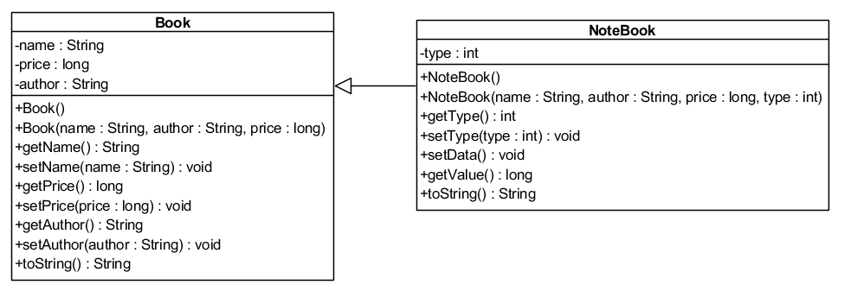

toString(): as a string (name,author,price) for book and (name,author,price,type) for notebook
setData(): uppercase the first letter of first name and last name author
getValue(): price - x if type>30 x=30, type<=30 x=15

Do not format the format the result.
The program output might look something like:
TC = 1 | INPUT:  Enter book name: su that  Enter book author: to an an  Enter book price: 100  Enter notebook type: 31  1. TC = 1 - test toString  2. TC = 2 - test setData()  3. TC = 3 - test getValue()  Your choice: 1  OUTPUT:  (su that,to an an,100)  (su that,to an an,100,31)
TC = 2 | INPUT:  Enter book name: su that  Enter book author: to an an  Enter book price: 100  Enter notebook type: 31  1. TC = 1 - test toString  2. TC = 2 - test setData()  3. TC = 3 - test getValue()  Your choice: 2  OUTPUT:  (su that,To an An,100,31)
TC = 3 | INPUT:  Enter book name: su that  Enter book author: to an an  Enter book price: 100  Enter notebook type: 27  1. TC = 1 - test toString  2. TC = 2 - test setData()  3. TC = 3 - test getValue()  Your choice: 3  OUTPUT:  85
INPUT:
Enter book name: su that
Enter book author: to an an
Enter book price: 100
Enter notebook type: 33
1. TC = 1 - test toString
2. TC = 2 - test setData()
3. TC = 3 - test getValue()
Your choice: 3
OUTPUT:
70

