(3 Point)
Design and code a class named Transaction that holds information about a Transaction.

Transaction | Where:  1. getTime(): String – return time of a Transaction  2. getMoney(): long – return money of a Transaction
-time : String
-money : long
+ Transaction ()
+ Transaction(time:String,money:long)
+getTime() : String
+getMoney() : long

The interface ITransaction is given (DO NOT CREATE THIS ONE). Design and code a class named ListTransaction which will implement interface ITransaction and complete 3 methods which were declared in ITransaction:
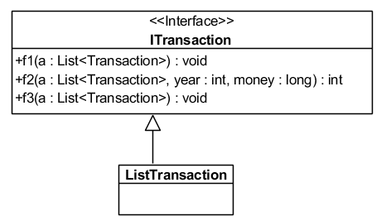
- void f1(a:List< Transaction >) – display the second max money.
- int f2(a:List< Transaction>, year:int, money:long) –count and return count of Transaction has year equal by given and greater than and equal money by given
- void f3(a:List< Transaction >):void – sort a by year (extract from time) descending.

Given some data which is added to list “list” in the Main already:
By using given data, the program output might look something like:

Time | Money
12/10/2019 | 12000
09/12/2019 | 9000
02/04/2020 | 12000
23/08/2021 | 8900
17/03/2020 | 12000
08/10/2018 | 7800

TC = 1 | Enter TC(1- f1; 2-f2; 3-f3): 1  OUTPUT:  02/04/2020: 12000
TC = 2 | Enter TC(1- f1; 2-f2; 3-f3): 2  OUTPUT:  Enter a year: 2020  Enter a price: 10000  2
TC = 3 | Enter TC(1- f1; 2-f2; 3-f3): 3  OUTPUT:  08/10/2018: 7800  12/10/2019: 12000  09/12/2019: 9000  02/04/2020: 12000  17/03/2020: 12000  23/08/2021: 8900

