(2 Point)

You are given an interface named DoSomething (DO NOT CREATE THIS ONE). Design a class MyFunction which will implement the interface DoSomething.

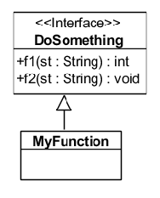

1. int f1(st:String) – count number of special letters

2. void f2(st:String) – display each word and the number of occurrences in st (not case sensitive)
The program output might look something like:
TC = 1 | Enter a string: ngay #& mua gio*  Enter TC(1- f1; 2-f2):1  OUTPUT:  3
TC = 2 | Enter a string: Dem dem ngui mui huong huong mui  Enter TC(1- f1; 2-f2):2  OUTPUT:  mui:2  huong:2  dem:2  ngui:1

