a. The airline with the best on-time performance and the airline with the worst on-time performance

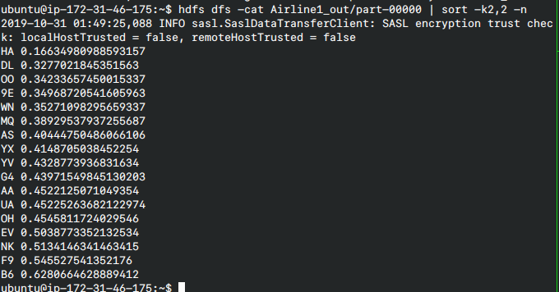

HA had the best on-time performance, with B6 having the worst on-time performance.
This is calculated as number of delays over 15 min divided by the number of total flights, with a delay on departure and arrival counting for 2 delays.

b.
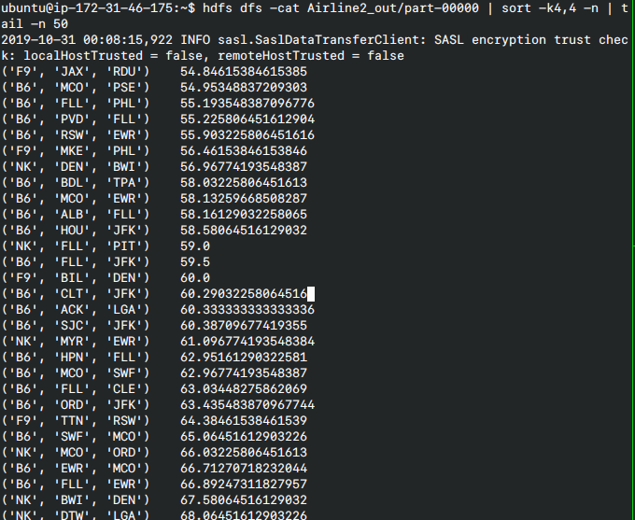
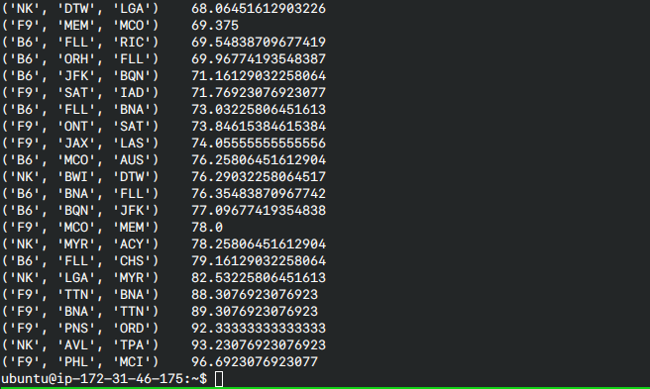
Here we define the worst ones as the ones that are the most late on average for that particular route.

B6
- FLL → CHS
- BQN → JFK
- BNA → FLL
- MCO → AUS
- FLL → BNA
- JFK → BQN
- ORH → FLL
- FLL → RIC
- FLL → EWR
- EWR → MCO

F9
- PHL → MCI
- PNS →ORD
- BNA → TTN
- TTN → BNA
- MCO → MEM
- JAX → LAS
- ONT → SAT
- SAT → IAD
- MEM → MCO
- TTN → RSW

NK
- AVL →TPA
- LGA→ MYR
- MYR→ ACY
- BWI→ DTW
- DTW→ LGA
- BWI →DEN
- MCO→ ORD
- MYR→ EWR
- FLL →PIT
- DEN→ BWI

c. The most common reason for cancellations was code B, for weather.
