IoT-Based Faculty Managing System using Raspberry Pi and Time Activated Power Saving Monitor

Luis Daniel A. Pambid, Trina Ritchell R. Aquino  
*Mapúa University*   
ldapambid@mymail.mapua.edu.ph, trraquino@mymail.mapua.edu.ph

*Abstract*— A faculty managing system is used to track the attendance of the professors as well as the convenience for the students in knowing their consultation time. In our system, Internet of Things is implemented wherein professors can communicate outside the school/university.

Keywords—Internet of Things (IoT), Raspberry Pi, Faculty Management

# Introduction

Students who looks for professors happens inevitably. Students don’t know their whereabouts, one option they have is to look for the schedule posted outside the EECE Department, however, if they are not found in the room of their respective class or don’t have a class at that time, the only option left for students is to ask for them in the EECE Department. Doing that leads to disruption of faculty members who are busy doing their work. Sometimes, they don’t even find the answer even if they ask. The researchers are addressing to the problems of knowing if a faculty member is in the campus through the development of the research “IOT Based Faculty Managing System using Raspberry Pi with Distance and Time Activated Power Saving Monitor”.

A similar research made use of software database architecture uses MySQL for web-based, and SQLite for mobile applications. The system includes different modules that capture daily attendance of faculty members, generate faculty attendance reports and analytics, absences notification system for faculty members, chairperson and dean regarding absences, and immediate communication system concerning the absences incurred. However, the software database that they have used is only for local database, which means that it is not online, and the data is only stored in an SD card, so if the SD card corrupts, all data will be gone and can’t be retrieved. With our project, we have used firebase which is an online database. Data is persisted locally, and even while offline, Realtime events continue to fire, giving the end user a responsive experience. When the device regains connection, the Realtime Database synchronizes the local data, changes with the remote updates that occurred while the client was offline, merging any conflicts automatically. Moreover, the data can be shared to other systems.

This project focused on the development of an application that aids the university administrators to establish an efficient and effective system in managing faculty attendance. The idea of this project is to record the daily attendance of faculty members with the exact time in and time out for students to know whether the professor is inside the campus or not. Other interactive feature is added to the application, like announcement for a specific section of a course they’re handling or for the whole students under EECE department. The time in and time out function is only accessible through the monitor, along with that, they also have the option to posts remarks. An Android application was also made using an Appy builder in order for the faculty members to make some announcement wherever and whenever they want. The GUI software was made using the PyQT, and for the mobile Android application, Appy builder was used. All data is stored securely on a Firebase server managed by the administrator and ensures highest possible level of security.

The main objective of this research is to design and implement a faculty managing system. Specifically, this research aims to (1) make a responsive GUI for the attendance, announcements and faculty database using PyQt; (2) create an Android application that enables faculty members to post remarks; (3) make a database responsible for exporting and importing data in the cloud; (4) test the reliability of the app if the remarks sent is updated in the GUI; test the system’s range detection accuracy.

The system utilizes user authentication, displaying only information necessary for an individual’s duties. Also, the system has security and a level of integrity maintained that allows only authorized users to create or update their information in the system. Additionally, each sub-system has authentication allowing authorized users to create or update information in that sub-system. There is also a student user interface, allowing students to access information that is addressed to their corresponding courses. With the ultrasonic sensor and relay module, it gives the system power saving capability.

This design project focuses mainly on the software inside the raspberry pi, in which that software is used to monitor the attendance of faculty members and to give them an option to make an announcement. For the mobile application that was made for faculty members to post remarks, an internet connection is needed for it to be accessed, moreover, it is only limited to phones that has an Android operating system.

# Review of Related Literature

## Raspberry Pi

The Raspberry Pi (Rpi) is advertised to be able to yield high performance despite its lower cost as a microcomputer which Linux based and uses Python as its main programming language. As such many studies that need a computer for their system utilize the Rpi as a low-cost alternative. Authors Senthilkumar, G., Gopalakrishnan, K., & Sathish Kumar, V. in year 2014 utilized the Rpi for an embedded system to do away with the limitations of portable computers which are its bulkiness, heaviness and the high cost and power consumption in their design for an image capturing and recognition algorithm. Another study in year 2016 by authors Shah, D., & Haradi, V. uses Rpi as a wireless module for the enrolment of biometric characteristics as well as the encryption module for biometric traits that were enrolled.

## Ultrasonic Sensor

An ultrasonic sensor is an instrument that measures the distance to an object using ultrasonic sound waves. An ultrasonic sensor uses a transducer to send and receive ultrasonic pulses that relay back information about an object’s proximity. High-frequency sound waves reflect from boundaries to produce distinct echo patterns.  Ultrasonic sound vibrates at a frequency above the range of human hearing.  Transducers are the microphones used to receive and send the ultrasonic sound. Our [ultrasonic sensors](https://www.maxbotix.com/SelectionGuide/Selection-Guide.htm), like many others, use a single transducer to send a pulse and to receive the echo.  The sensor determines the distance to a target by measuring time lapses between the sending and receiving of the ultrasonic pulse. Ultrasound is reliable in any lighting environment and can be used inside or outside.  Ultrasonic sensors can handle collision avoidance for a robot, and being moved often, as long as it isn’t too fast.  Ultrasonic are so widely used, they can be reliably implemented in grain bin sensing applications, water level sensing, drone applications and sensing cars at your local drive-thru restaurant or bank. Ultrasonic rangefinders are commonly used as devices to detect a collision.

## Relay Module

This is a single channel Relay Module SPDT (Single Pole Double Throw), relays are used to control or switch devices which uses a higher power than what most micro-controllers such as an Arduino or Raspberry Pi can handle. This relay module can control typical household appliance up to 10A. A relay is an electrically operated switch. Many relays use an electromagnet to mechanically operate a switch, but other operating principles are also used, such as solid-state relays. Relays are used where it is necessary to control a circuit by a separate low-power signal, or where several circuits must be controlled by one signal.

Relays work on electromagnetism, When the Relay coil is energized it acts like a magnet and changes the position of a switch. The circuit which powers the coil is completely isolated from the part which switches ON/OFF, this provides electrical isolation. This is the reason we can control a relay using 5V’s from an Arduino and the other end of it could be running a 220 to 240V appliance, the 240V end is completely isolated from the 5V Arduino circuitry.

## Buzzer

An ultrasonic sensor is an instrument that measures the distance to an object using ultrasonic sound waves. An ultrasonic sensor uses a transducer to send and receive ultrasonic pulses that relay back information about an object’s proximity. High-frequency sound waves reflect from boundaries to produce distinct echo patterns.  Ultrasonic sound vibrates at a frequency above the range of human hearing.  Transducers are the microphones used to receive and send the ultrasonic sound. Our [ultrasonic sensors](https://www.maxbotix.com/SelectionGuide/Selection-Guide.htm), like many others, use a single transducer to send a pulse and to receive the echo.  The sensor determines the distance to a target by measuring time lapses between the sending and receiving of the ultrasonic pulse. Ultrasound is reliable in any lighting environment and can be used inside or outside.  Ultrasonic sensors can handle collision avoidance for a robot, and being moved often, as long as it isn’t too fast.  Ultrasonic are so widely used, they can be reliably implemented in grain bin sensing applications, water level sensing, drone applications and sensing cars at your local drive-thru restaurant or bank. Ultrasonic rangefinders are commonly used as devices to detect a collision.

## Firebase Realtime Database

The Firebase Realtime Database is a cloud-hosted database. Data is stored as JSON and synchronized in Realtime to every connected client. When you build cross-platform apps with our iOS, Android, and JavaScript SDKs, all your clients share one Realtime Database instance and automatically receive updates with the newest data. The Firebase Realtime Database lets you build rich, collaborative applications by allowing secure access to the database directly from client-side code. Data is persisted locally, and even while offline, Realtime events continue to fire, giving the end user a responsive experience. When the device regains connection, the Realtime Database synchronizes the local data changes with the remote updates that occurred while the client was offline, merging any conflicts automatically. The Realtime Database provides a flexible, expression-based rules language, called Firebase Realtime Database Security Rules, to define how your data should be structured and when data can be read from or written to. When integrated with Firebase Authentication, developers can define who has access to what data, and how they can access it. The Realtime Database is a NoSQL database and as such has different optimizations and functionality compared to a relational database. The Realtime Database API is designed to only allow operations that can be executed quickly. This enables you to build a great Realtime experience that can serve millions of users without compromising on responsiveness. Because of this, it is important to think about how users need to access your data and then structure it accordingly.

## PyQT

PyQt brings together the Qt C++ cross-platform application framework and the cross-platform interpreted language Python. Qt is more than a GUI toolkit. It includes abstractions of network sockets, threads, Unicode, regular expressions, SQL databases, SVG, OpenGL, XML, a fully functional web browser, a help system, a multimedia framework, as well as a rich collection of GUI widgets. Qt classes employ a signal/slot mechanism for communicating between objects that is type safe but loosely coupled making it easy to create re-usable software components. Qt also includes Qt Designer, a graphical user interface designer. PyQt can generate Python code from Qt Designer. It is also possible to add new GUI controls written in Python to Qt Designer. Python is a simple but powerful object-orientated language. Its simplicity makes it easy to learn, but its power means that large and complex applications can be created. Its interpreted nature means that Python programmers are very productive because there is no edit/compile/link/run development cycle. PyQt combines all the advantages of Qt and Python. A programmer has all the power of Qt but can exploit it with the simplicity of Python.

## Internet of Things

The internet of things, or IoT, is a system of interrelated computing devices, mechanical and digital machines, objects, animals or people that are provided with unique identifiers (UIDs) and the ability to transfer data over a network without requiring human-to-human or human-to-computer interaction.

A thing in the internet of things can be a person with a heart monitor implant, a farm animal with a biochip transponder, an automobile that has built-in sensors to alert the driver when tire pressure is low or any other natural or man-made object that can be assigned an IP address and is able to transfer data over a network.

Increasingly, organizations in a variety of industries are using IoT to operate more efficiently, better understand customers to deliver enhanced customer service, improve decision-making and increase the value of the business.

# Methodology

## Functions Performed by the Users

The user of this software will be the administrator, the dean of the department, subject chairpersons, faculty members and the students. Every user mentioned above, except the students, will have to register their name, provide a password, and indicate which department they belong for that information to be stored in the database. After the registration, an ID would be given to them automatically, this gives each user uniqueness in the case they have a similar name to someone. This system will satisfy the goal of centralized monitoring of the faculty members’ attendance and will be highly reliable. It will automate the manual work of students asking questions inside the EECE Department and faculty members answering their questions whether a professor is around the campus or not.

### Administrator

There will be an administrator, the secretary of the EECE Department, who will be given all rights to access each detail related to the software and the database. This system has Administrator which is at the topmost level with all possible rights.

1. The only person who can access the Database Interface
2. The only person who can register a new faculty to the system
3. The only person who can access the Edit Interface, if a faculty member wants to edit his name or password, they need to contact the Administrator
4. The only person who can edit the time in and time out of the faculty members
5. Can make announcement that can be viewed by all; the one that can be seen in the Announce Interface

### Faculty Members

Faculty has limited access to the system as per their designation. Faculty members will be given a username and password provided by the administrator for them to access the Faculty Interface. Unauthorized access is denied.

On Successful Login:

1. They can time in and time out for attendance purposes
2. They can post a remark for a specific course/section they are handling
3. Can view Attendance Interface
4. Can view Announce Interface

In Addition:

Faculty members who have mobile phones that have an Android operating system can use the application made to post remarks at their convenience.

### Students

1. Can view the Attendance Interface
2. Can access the Student Interface to check if their professors have some announcement
3. Can view the Announce Interface

## Conceptual Framework

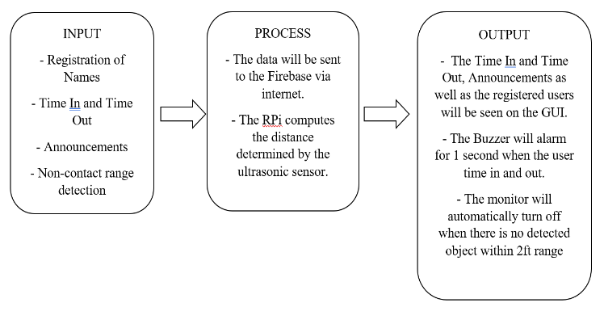

Fig. 1. Conceptual Framework

Based from the conceptual framework on Fig. 1, the input is dependent on the registered users, time in and out, announcements, and the non-contact range detection. The data will be sent to the Firebase via IoT then it will be displayed on the GUI. For the attendance, a Buzzer will alarm whenever a user has timed in and out. Our system has a power saving capability in which the monitor will automatically turn off when there is no detected object/person within 2 feet range. The ultrasonic sensor has the capability of detecting an object’s distance if it’s in the 2 feet range. if it detects an object, the time of detection of the ultrasonic sensor delays in 2 minutes, hence, even if there is no object/person in that 2 minutes range, the monitor remains on. If it reaches 2 minutes and there is still sensed object/person, it will again delay the time detection of the ultrasonic sensor for 2 minutes. However, if it reaches 2 minutes and there is no detected object/person, the monitor automatically turns off and the time of detection of the ultrasonic sensor is every 10 microseconds, so that when it senses an object/person, it will turn on at an instant.

## Proposed Design

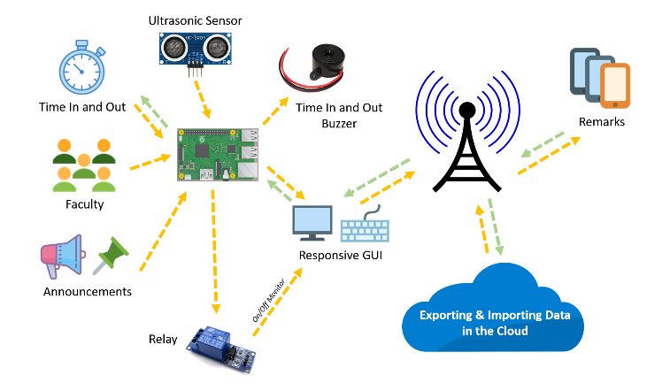

Fig. 2. Schematic Representation of the Purpose of our Prototype

Fig. 2 shows the schematic representation of our faculty managing system. The diagram consists of data transmission of the time in and out as well as the announcements through its wireless technology.

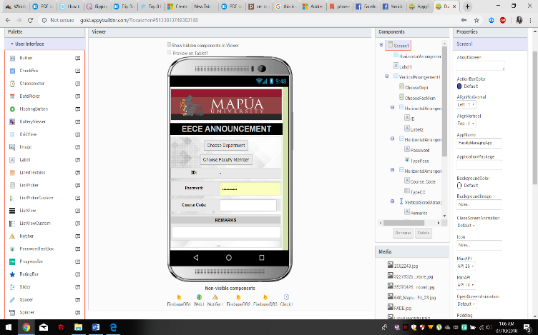

Fig. 3. Android Application (UI)

Fig. 3 shows the Android Application made using Appy Builder, a drag and drop mobile app builder platform that allows anyone to quickly design and build Android mobile apps. The firebase serves as the storage of all the data sent by the Android application. The data stored on the firebase will be transmitted to the Raspberry Pi via IoT, which transfers the gathered data wirelessly that can be seen on the GUI.

TABLE I. Range Detection Accuracy

|  |  |  |
| --- | --- | --- |
| **Location of the user/object (from the Sensor)** | **Detection Time Delay of Ultrasonic Sensor** | **Has the Monitor Turned On/Off? (On or Off)** |
| 0.2 ft | 120 s | ON |
| 0.4 ft | 120 s | ON |
| 0.6 ft | 120 s | ON |
| 1 ft | 120 s | ON |
| 1.5 ft | 120 s | ON |
| 1.8 ft | 120 s | ON |
| 2 ft | 120 s | ON |
| 2.2 ft | 10 us | OFF |
| 2.5 ft | 10 us | OFF |
| 2.8 ft | 10 us | OFF |

TABLE I shows the reliability test of the Ultrasonic Sensor. When there is a detected object/person within 2 feet range, the monitor will remain on, and the delay of time detection of the ultrasonic sensor is every 120 s. If the object/person is beyond the 2ft range, the monitor will turn off and the time of detection of the ultrasonic sensor is every 10 us.

## Data Transmission Test

This test is for the Accuracy of the Data Transmission between the Android Application and the Software in RPi.

TABLE II.Transmitting Data from Android Application to the Software through Raspberry Pi (via Internet of Things)

|  |  |  |  |  |  |
| --- | --- | --- | --- | --- | --- |
| **Trials** | **Sent Data (Remark)** | **Time Sent** | **Received Data** | **Time Received** | **Data Transmitted Accurately?** |
| 1 | TEST1 | 1:05 AM | TEST1 | 1:08 AM | Yes |
| 2 | TEST2 | 7:07 PM | TEST2 | 7:10 PM | Yes |
| 3 | TEST3 | 9:15 PM | TEST3 | 9:16 PM | Yes |
| 4 | TEST4 | 8:01 AM | TEST4 | 8:05 AM | Yes |
| 5 | TEST5 | 11:31 AM | TEST5 | 11:33 AM | Yes |

TABLE II shows the test results for the accuracy of the data transmission via IoT. The data compared are the data sent by the Android application and the data received by the RPi. We compared these strings to see if there’s a loss or addition of unnecessary information that changes the data before and after it was sent. With the results, we can say that the data was transmitted accurately. This test determined whether IoT is a reliable means for wireless transmission. Moreover, the time sent, and the time received aren’t the same since internet connection is a factor to consider. If you have a fast internet connection, then the data will be sent at an instant, in the case you have sent data through the app and you don’t have an internet connection, it cannot be viewed yet in the GUI, but once you have an internet connection, the data will still be received and can now be viewed in the GUI regardless of how long you aren’t connected to the internet.

# Conclusion

Upon the completion of the study, the researchers were able to make a faculty managing system via IoT. The RPi, a microcomputer was used as a core component of the system. We were able to make a database in the cloud, in which it can import and export data through the GUI. Furthermore, the researchers were able to make an Android mobile application in which the user can make an announcement and that it will appear on the GUI. Moreover, our system has a power saving capability in which we made use of an ultrasonic sensor.

Also, the researchers tested the range detection accuracy of the ultrasonic sensor. The obtained result shows that it agrees with the expected outcome.

Lastly, the researchers tested the reliability of the data transmission of the Android mobile application to the GUI via IoT. Based on the obtained result, we can say that the data was transmitted accurately

# Recommendation

In order to improve the study much further, the researchers recommend making an application that can be used by IOS users, because the application we made is only accessible for devices that has an Android Operating System. The researchers also recommend making use of touch screen monitor instead, to lessen the hardware used.

##### References

1. ISO 10014:2006 Quality Management – Guidelines for realizing financial and economic benefits. – International standard. Retrieved from http://www.iso.org/iso/catalogue_detail.
2. Hesham Magd and Adrienne Curry, TQM in Egypt: a case study, An empirical analysis of management attitudes towards ISO 9001:2000 in Egypt, The TQM Magazine, Volume 15 · Number 6 · 2003 · pp. 381-390
3. Walid Zaramdini, An empirical study of the motives and benefits of ISO 9000 certification: the UAE experience, International Journal of Quality &Reliability Management, Vol. 24 No. 5, 2007 pp. 472-491. Retrieved from http://www.ukessays.com/essays/management/literaturereview-about-management-information-systemsmanagement-essay.php.
4. S. R. Bharamagoudar, Geeta R.B.2, S. G. Totad Assistant Professor, Dept. of Electronics & Communication Engg, Basaveshwar Engg. College, Bagalkot, Karnataka1Associate professor, Department of IT, GMR Institute of Technology, RAJAM, Andhra Pradesh2Professor, Department of Computer Science & Engineering, GMR Institute of Technology, RAJAM, Andhra Pradesh 3.