Technical Notes:

Optoelectronics Digital Scout

Frequency Counter

Version 1.0 (JAN2023)

Serial Interfacing

Equipment

-Trendnet TU-S9 serial-to-USB adapter. This is a Prolific USB adapter and tested good under Windows 10 and Kali Linux.

-DB-9 to TRS plug serial cable.

-Tera-Term serial console.

-Laptop running Windows 10

Device Setup and Application

-Digital Scout: set to Reaction Tune, use RS-232C port. Power down unit after settings adjustment. Serial output will begin at power up.

-Tera-Term settings: 9600 8N1

-Serial Cable

Serial Cable

3.5 mm TRS plug (AKA stereo audio plug) to DB-9 connector. This is the audio plug for most PC’s and also the cellphone auxiliary cable found at many electronics stores.

Tip: DB-9 pin 2, RXD

Ring: DB-9 pin 3, TXD

Shield: DB-9 pin 5, GND

Comments

Serial connectivity tested good under Kali Linux using minicom and above hardware. Tested good under Windows 10 with TeraTerm. Minimal setup complexity and minimal troubleshooting. See image and log file, in this directory, for example of output.

Check connection of Txd and Rxd if serial fails to output, in addition to serial settings. Txd and Rxd are easy to get mixed up.

Power Supply

The manual states the Digital Scout needs a voltage between 9-12 VDC with 12 VDC being absolute maximum (pp 3). The Optoelectronics website states the Power Supply Unit, AC-90, provides 9-12 VDC, center positive. Testing the AC-90 shows output of 9.3 VDC. The AC-90 label states “AC/DC Adapter, model KDL-091000, 9V, 1 Amp. This charger costs $25.00.

The Digital Scout was successfully charged with an EnerCell Universal AC/DC Notebook Adapter set to 12 VDC.

The Digital Scout pulls 44 mA (.0437 ADC) at recharge, unit de-energized and 196 mA (.1960 ADC) in operation with the AC-90 PSU. There was a small reduction in current consumption from 196 mA to 194 mA in slow mode, long pulse.

Interestingly, a reduction in current consumption was also observed when the Digital Scout was switched from operating mode to function mode. Current consumption went from 196 mA to 89 mA.

The AC-90 has a 5.5 OD x 2.1mm ID DC barrel plug.

Note: Observations of current and voltage were made with a Fluke 289 True RMS multimeter.

Battery Pack

Battery pack is five ‘AA’ sized nickel-cadmium cells providing 6 VDC and 650 mAh, 3.12 Wh (1.2 VDC per battery). Device run time is approimately 3.3 hours calculated from current consumption of 196 mA. Actual run time will be less.

External Switch  
An external switch is a necessary modification for remote activation. The momentary push button switch on the front panel is not suitable for this functionality. The Digital Scout has four pins found on the rear of the PCB, far right of the device, oriented up (antenna up and to the right). These pins are from the front power switch. There is 6.24 VDC on the pins with RIGHT pin being positive. Refer to photograph 1 for pin identification. Regardless of the switching method, some type of galvanic isolation is required to prevent damage to the device. No power or signal is applied to these pins, simply connect them together momentarily to switch device on and again connect them together momentarily to switch the device off.

Squelch

Squelch adjustment is the critical parameter to control for adequately observing near-field activity in your area. The description of this setting, and observations in the field, ideally with emitters of known frequency, power output and distance, is necessary for best understanding of the capability.

Antenna

The early observations made with the device used the DB-32 antenna. Later observations used a Watson W-889 telescopic antenna. The telescopic antenna is producing better results in the frequencies of interest.

Manual Frequency Hold

While the Digital Scout is scanning spectrum, a frequency of Interest may be observed and that frequency may be “held” by grasping the antenna with the hand. This grounds and shields the antenna from further reception, causing the Digital Scout to stop scanning.

Front Buttons

The front buttons are the C&K Components D6C90F2LFS Switch Key. Optoelectronics was kind enough to provide this information. This is useful information if you lose the internal spring when exploring or repairing the device.

Interior Photographs of Digital Scout

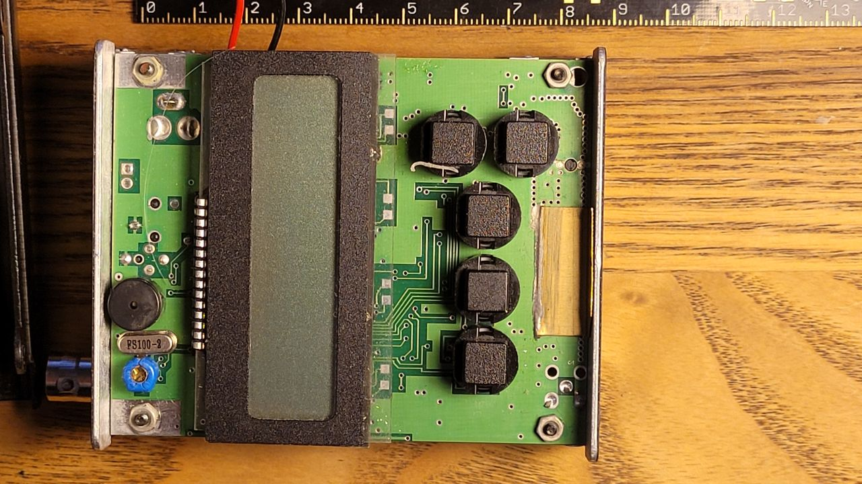Image 1, Front Panel

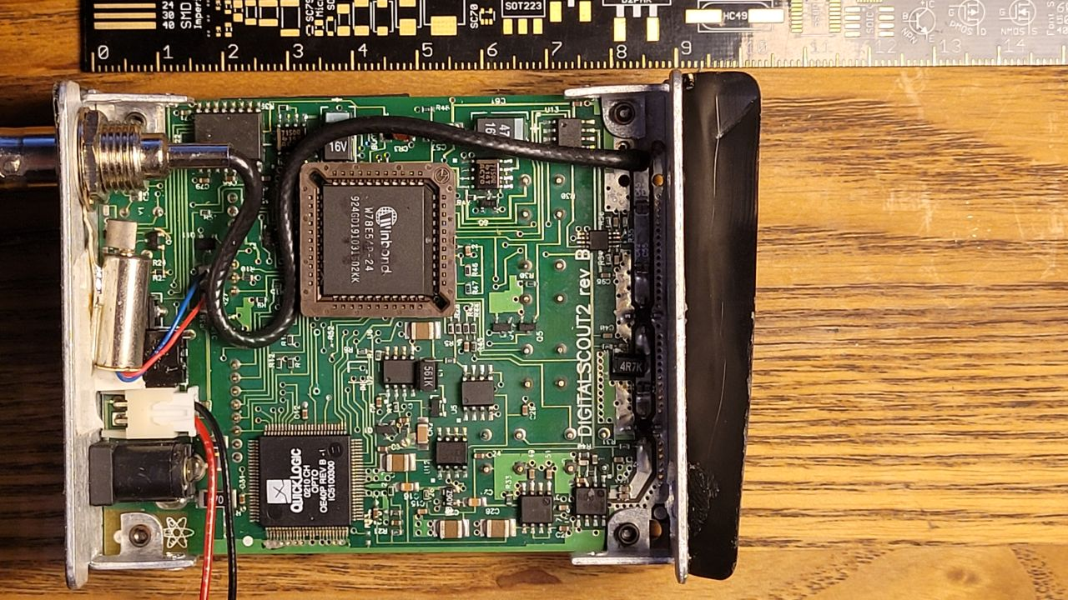Image 2, Interior, Rear

Copyright, © 2022-2023. Prepared by Marc J O’Connor and the Communications Security Research Organization.