CS 148 A

Cole Frost, Kiwan Lee

Assignment: Final Project

Watado!

Version <1.0>

Table Of Contents

**Time Log 2**

**Introduction 3**

Purpose 3

Definitions, acronyms, and abbreviations 3

**Overall Description 3**

**Story Board 4**

**Data Dictionary 5**

**ER- Diagram 7**

**Schema 7**

**Specific requirements 8**

|  |  |  |  |
| --- | --- | --- | --- |
| **Time Log** | | | |
| Estimated time to complete assignment => | | | 50 Hours |
| Date | Time Spent  (in hours) | Description | Author |
| 10/26 | 1.0 | Summary of Project Plan and Role Assignments | Cole Frost |
| 11/1 | 1.0 | Brainstorm draft of DB design (tables and columns) | Cole Frost |
| 11/4 | 3.0 | Constructing DB in phpMyAdmin | Cole Frost |
| 11/9 | 2.0 | Work on DB queries filtering by array – unfinished | Cole Frost |
| 11/10 | 1.5 | Created query that filters by county successfully | Cole Frost |
| 11/13 | 4.5 | Created question and attribute query – filter by selected attributes all working | Cole Frost |
| 11/23 | 7.5 | Created ability to register – DB stores email and salted and hashed pw – validation of email and pw matching – confirmation email – full registration cycle complete | Cole Frost |
| 11/24 | 6.0 | Login completed – buttons in nav change if logged in or not – logout completed – completed query to get favorites for the logged in user only on profile page | Cole Frost |
| 11/25 | 2.0 | Completed ability to favorite/unfavorite activities | Cole Frost |
| 11/27 | 2.5 | Changed images to be stored in server folder instead of directly in DB – started on ability to add activity | Cole Frost |
| 11/28 | 9.0 | Changed images to pull from the folder – completed uploading of image – completed upload activity to DB – completed upload of activities with the activity – completed only shows random activity after questions are answered | Cole Frost |
| 11/29 | 3.0 | Added ability to see activities created by user and button to get to edit form – issues arose with attribute adding and are unresolved | Cole Frost |
| 11/30 | 3.0 | Completed all issues related to updated activity – added code comments – completed ability to delete an activity | Cole Frost |
| 12/3 | 2.0 | Added some real entries to DB – added button to randomly generate a new activity – updated to use a default image if user doesn’t upload one – updated email sent to user and from email | Cole Frost |
|  |  |  |  |
|  |  |  |  |
|  |  |  |  |
|  |  |  |  |
|  |  |  |  |
|  |  |  |  |
|  |  |  |  |
|  | 48.0 | <=Total Time Spent |  |
|  |  |  |  |

|  |  |  |  |
| --- | --- | --- | --- |
| **Time Log** | | | |
| Estimated time to complete assignment => | | | 40 Hours |
| Date | Time Spent  (in hours) | Description | Author |
| 10/26 | 1.0 | Summary of Project Plan and Role Assignments | Kiwan Lee |
| 11/1 | 1.0 | Brainstorm draft of DB design (tables and columns) | Kiwan Lee |
| 11/10 | 1.5 | Starts working on the showcase page – successfully grab each county from the database. Created a side panel to display each county as a menu option | Kiwan Lee |
| 11/11 | 1.5 | Worked on the pagination in the showcase page. | Kiwan Lee |
| 11/12 | 2 | Finished showcase page (backend) | Kiwan Lee |
| 11/15 | 2 | Finished the navigation and the header | Kiwan Lee |
| 11/18 | 1.5 | Made logos – brand, county | Kiwan Lee |
| 11/20 | 3 | Implemented some useful JS functions. | Kiwan Lee |
| 11/24 | 4 | Finished designing showcase page | Kiwan Lee |
| 11/25 | 1.5 | Finished login / register forms | Kiwan Lee |
| 11/26 | 4 | Multi Process form working – including the progression bar | Kiwan Lee |
| 11/27 | 2 | Started working on index page – finished designing the form | Kiwan Lee |
| 11/28 | 3 | Finished index page – working on profile page | Kiwan Lee |
| 11/29 | 4 | Finished both profile and form page | Kiwan Lee |
| 12/2 | 2 | Spent some time to clean up the code including css file | Kiwan Lee |
| 12 /3 | 4 | Finished mobile design | Kiwan Lee |
|  |  |  |  |
|  |  |  |  |
|  |  |  |  |
|  |  |  |  |
|  |  |  |  |
|  | 38 | <=Total Time Spent |  |
|  |  |  |  |

**Introduction**

**Purpose**

The purpose of this document is to describe the requirement specification for the web site “watado.com”.

The intended audience for this document is Robert Erickson, professor of CS 148

**Definitions, acronyms, and abbreviations**

ER Diagram – a diagram to represent the data you want to save with your system

W3 Validation – refers to both Html and CSS validation tool provided by the W3c.org. the html validator is located at:

<http://validator.w3.org/>

with the CSS validator located at:

<http://jigsaw.w3.org/css-validator/>

**Overall Description**

This website will help users decide what to do! I am always having trouble deciding what to do on the weekends, and this website would help you make this decision. It will ask you a few questions and based on your answer it will provide something for the user to do (such as "Hike Camel's Hump!"). There will be multiple activities for each set of answers, so if they already did the activity they were given, they can hit a button to receive another random selection matching their criteria. There is also a showcase where the user may view all the activities by County in Vermont. The website gives the ability to register as a user and create/edit your own activities. In addition, you may favorite activities that you love and wish to remember.

**Story Board**

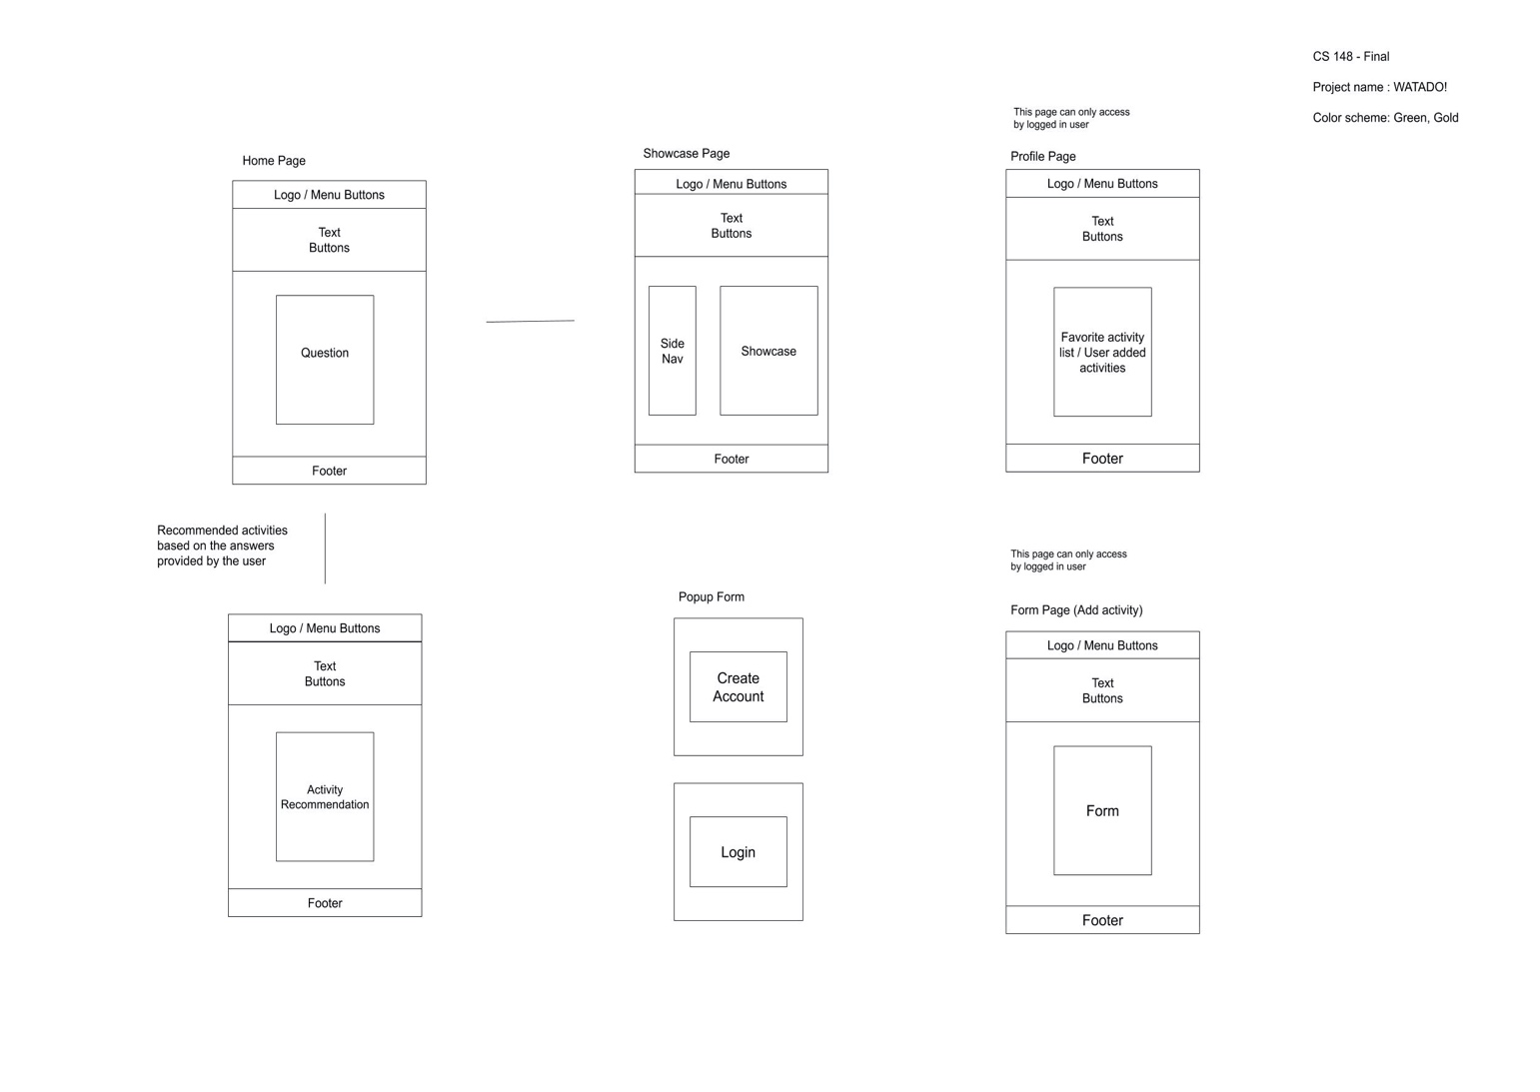

**Data Dictionary**

**Data Dictionary**

**ER- Diagram**

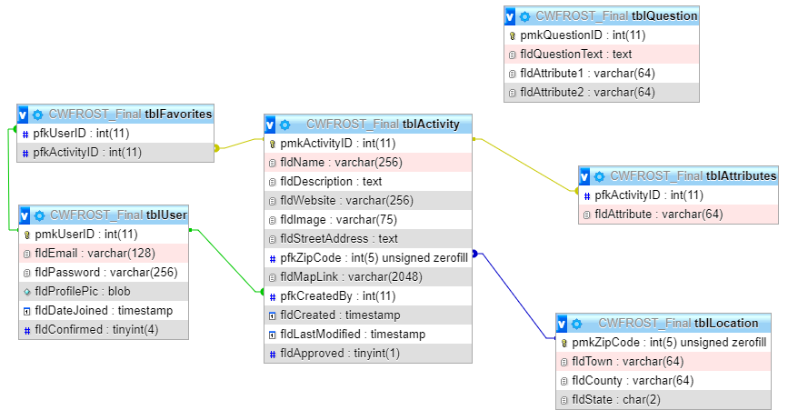

**Schema**

**Specific requirements**

* *Title for main page*: *Watado*
* *Meta Description*: *Find something to do in Vermont!*
* *Meta Character set*: UTF - 8
* *A picture containing tree, nature, outdoor, hill

  Description automatically generatedMain page photo*:

*.*

* Question Quiz on main page – submit will generate a random activity to be displayed that match the 3 answers on the quiz. Button to keep getting a new random activity
* Showcase page – allow user to view activities by county – selecting a new county opens a side menu for selection. Each activity has a favorite button
* Profile page – user can view favorited activities – button to view activities they’ve created – can hit edit and get to edit form – can hit add new and get an empty add new activity form
* Add/edit activity – one page used for both functions – contains fields for all necessary database fields and 3 attributes – contains button to delete the activity from the database
* Button to login / register when not logged in on the top right – opens a modal popup in the center of the window
* When logged in buttons to Profile and logout in the top right