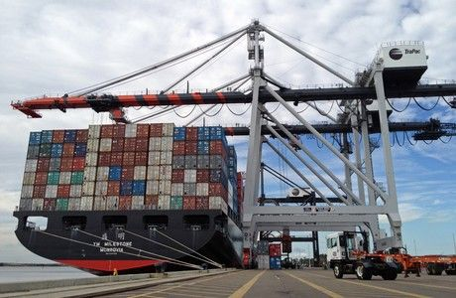
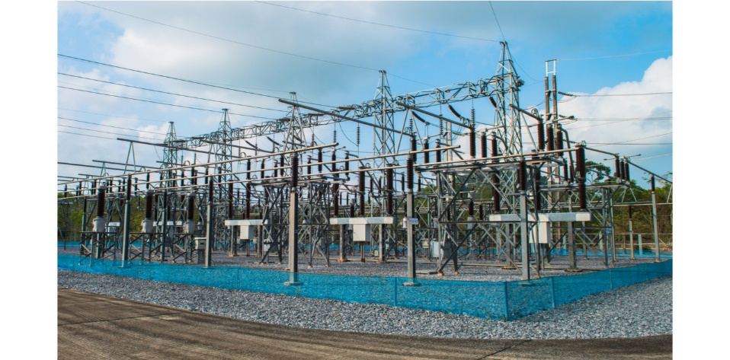
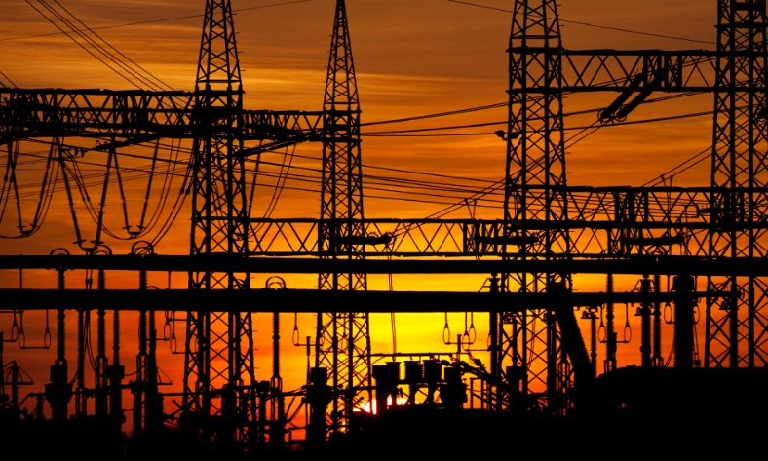
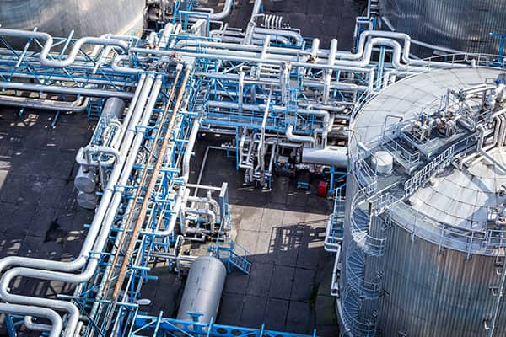
Asset Dependency Assessment

WARNING: This information is FOR OFFICIAL USE ONLY (FOUO). It contains information that may be exempt from public release under the Freedom of Information act (5 U.S.C. § 552). It is to be controlled, stored, handled, transmitted, distributed, and disposed of in accordance with U.S. Department of Homeland Security (DHS) Management Directive 11042.1 relating to FOUO information and is not to be released to the public or other personnel who do not have a valid “Need-to-know” without prior approval of an authorized DHS official.

Publication: TBD
Cybersecurity and Infrastructure Security Agency

Matthew Frost
Protective Security Advisor
Department of Homeland Security
Cybersecurity and Infrastructure Security Agency
Integrated Operations Division | Region 4 | Miami
Cell: 404-518-9273
Email: matthew.frost@cisa.dhs.gov

Contents
PART I – EXECUTIVE DEPENDENCY RISK BRIEF 2
A. EXECUTIVE RISK POSTURE 2
B. DEPENDENCY SNAPSHOT TABLE 2
C. SECTOR ANALYSIS 2
D. CROSS-INFRASTRUCTURE SYNTHESIS 7
E. PRIORITY ACTIONS 7
PART II – TECHNICAL ANNEX 7
Dependency Summary 7
Infrastructure Dependency Vulnerabilities and Options for Consideration 7

Asset Dependency Risk Analysis V1.2

PART I – EXECUTIVE DEPENDENCY RISK BRIEF

A. EXECUTIVE RISK POSTURE
No structural vulnerabilities identified based on provided inputs.
No structural vulnerabilities identified based on provided inputs.
No structural vulnerabilities identified based on provided inputs.

B. DEPENDENCY SNAPSHOT TABLE
No structural vulnerabilities identified based on provided inputs.
No structural vulnerabilities identified based on provided inputs.

D. CROSS-INFRASTRUCTURE SYNTHESIS
No structural vulnerabilities identified based on provided inputs.

E. PRIORITY ACTIONS
No structural vulnerabilities identified based on provided inputs.

PART II – TECHNICAL ANNEX

Annex Overview
Category | Provider Identified | Backup Present | Time to Severe Impact (hrs) | Recovery Time (hrs) | Notes
Electric Power | No | Yes | 1 | 1 | not confirmed
Communications | Yes | Yes | 0 | 0.25 | Verizon
Information Technology | Yes | Yes | 0 | 1 | Comcast
Water | Yes | No | 4 | 1 | WASD
Wastewater | Yes | No | 4 | 1 | WASD
Critical Products | — | — |  |  | Not documented

Sector Reports

ELECTRIC POWER — Dependency Assessment
Figure 1. Electric Power Dependency Curve

Chart Synopsis
Electric Power reaches severe impact in 1 hours with ~95% functional loss absent alternate capability. Alternate capability sustains operations for ~48 hours. Structural posture is weak, provider details are not confirmed, and restoration priority is not established.

Vulnerabilities
No vulnerabilities were triggered based on provided inputs.

COMMUNICATIONS — Dependency Assessment
Figure 2. Communications Dependency Curve

Chart Synopsis
Communications PACE posture includes Primary, Alternate, Contingency, Emergency. Earliest severe degradation across present layers occurs by 0 hours. Emergency layer floor capacity is approximately 0% over the horizon.

Vulnerabilities
No vulnerabilities were triggered based on provided inputs.

INFORMATION TECHNOLOGY — Dependency Assessment
Figure 3. Information Technology Dependency Curve

Chart Synopsis
Information Technology reaches severe impact in 0 hours with ~75% functional loss absent alternate capability. Alternate capability sustains operations for ~96 hours; it does not materially reduce functional loss and primarily extends the sustainment window. Immediate degradation is expected despite sustainment, indicating the alternate does not cover critical dependencies. Structural posture is weak, provider details are confirmed, and restoration priority is not established.
External critical services were not documented in provided inputs.

Vulnerabilities
No vulnerabilities were triggered based on provided inputs.

WATER — Dependency Assessment
Figure 4. Water Dependency Curve

Chart Synopsis
Water reaches severe impact in 4 hours with ~100% functional loss absent alternate capability. No alternate capability is available to sustain operations during an extended outage. Structural posture is weak, provider details are confirmed, and restoration priority is not established.

Vulnerabilities
No vulnerabilities were triggered based on provided inputs.

WASTEWATER — Dependency Assessment
Figure 5. Wastewater Dependency Curve

Chart Synopsis
Wastewater reaches severe impact in 4 hours with ~100% functional loss absent alternate capability. No alternate capability is available to sustain operations during an extended outage. Structural posture is weak, provider details are confirmed, and restoration priority is not established.

Vulnerabilities
No vulnerabilities were triggered based on provided inputs.

