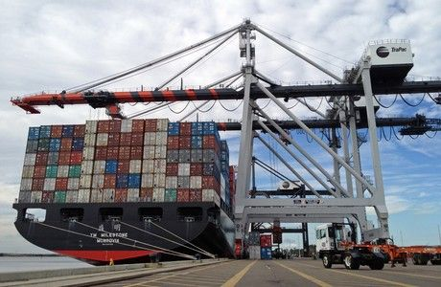
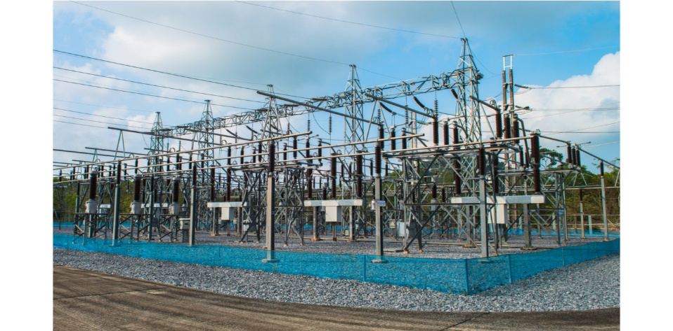
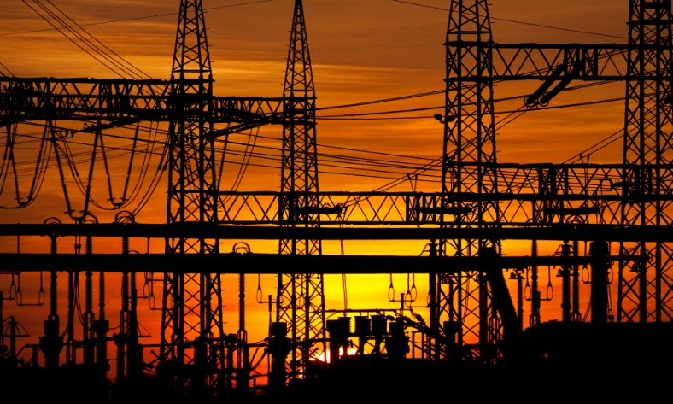
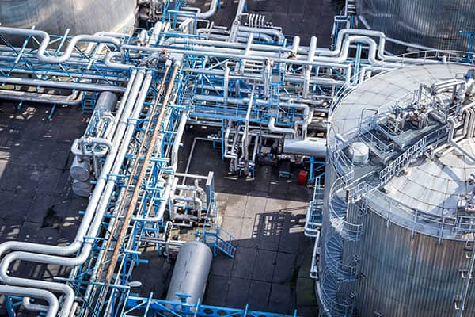
Asset Dependency Assessment

WARNING: This information is FOR OFFICIAL USE ONLY (FOUO). It contains information that may be exempt from public release under the Freedom of Information act (5 U.S.C. § 552). It is to be controlled, stored, handled, transmitted, distributed, and disposed of in accordance with U.S. Department of Homeland Security (DHS) Management Directive 11042.1 relating to FOUO information and is not to be released to the public or other personnel who do not have a valid “Need-to-know” without prior approval of an authorized DHS official.

Publication: TBD
Cybersecurity and Infrastructure Security Agency

“Insert PSA NAME”
Protective Security Advisor
Department of Homeland Security
Cybersecurity and Infrastructure Security Agency
Integrated Operations Division| Region__ | Insert City
Cell: ______
Email:

TABLE OF CONTENTS

Executive Summary 3
Asset Dependency Visualization 3
Energy 4
Communication 4
Information Technology 5
Water 5
Wastewater 6
Vulnerabilities and Options for Consideration 6
Conclusion 18

EXECUTIVE SUMMARY
Category | Requires Service | Time to Impact (hrs) | Capacity After Impact (No Backup) | Has Backup | Backup Duration (hrs) | Capacity After Backup Exhausted | Recovery Time (hrs) | Sources | SLA | PRA
ELECTRIC_POWER | Yes | 4 | 20.0 | Yes | 24 | 75.0 | 48 | 1 (SPOF likely) | No | No
COMMUNICATIONS | Yes | 2 | 40.0 | No |  |  | 12 | 1 (SPOF likely) | No | No
INFORMATION_TECHNOLOGY | Yes | 1 | 10.0 | Yes | 8 | 60.0 | 24 | 1 (SPOF likely) | No | No
WATER | Yes | 12 | 50.0 | No |  |  | 72 | 1 (SPOF likely) | No | No
WASTEWATER | Yes | 24 | 70.0 | No |  |  | 96 | 1 (SPOF likely) | No | No

Infrastructure systems are the backbone of communities. While all infrastructure plays a role, some infrastructure systems are more critical than others. Critical infrastructure are those infrastructure systems and assets that are so vital that their incapacitation or destruction would have a debilitating effect on security, the economy, public health, public safety, or any combination thereof.

Each critical infrastructure system is made up of individual assets that work together as an integrated system. The figures below illustrate the networking of assets using four of the most important critical infrastructure systems as examples. These infrastructure sectors—Energy, Communications, Information Technology, Water, and Wastewater—are critical to the operations of almost all other sectors, as well as each other, and are fundamental to the delivery of the basic societal functions communities seek to provide. While each figure only depicts a single, simplified system within each sector (there are many, and many variations!), they help illustrate the interconnected nature of those systems and their reliance on many individual assets.

This assessment is a supplement to CISA's Security Assessment at First Entry (SAFE) assessment and is intended to elevate the evaluation of a facility's current security posture by identifying vulnerabilities and options for consideration on infrastructure dependencies. Where the SAFE typically identifies physical security vulnerabilities, this accompanying assessment incorporates asset dependency vulnerabilities and applicable options for consideration.

Asset Dependency Visualization
The graphics below are designed to provide owner/operators with a visualization of the dependency curves associated with their facility. The dependency chart(s) in this dashboard were generated for 72-hour external service outages. This time was selected because it corresponds to the Federal Emergency Management Agency (FEMA) recommended preparation duration for the general population and organizations in the event of an emergency resulting in the breakdown of major services.

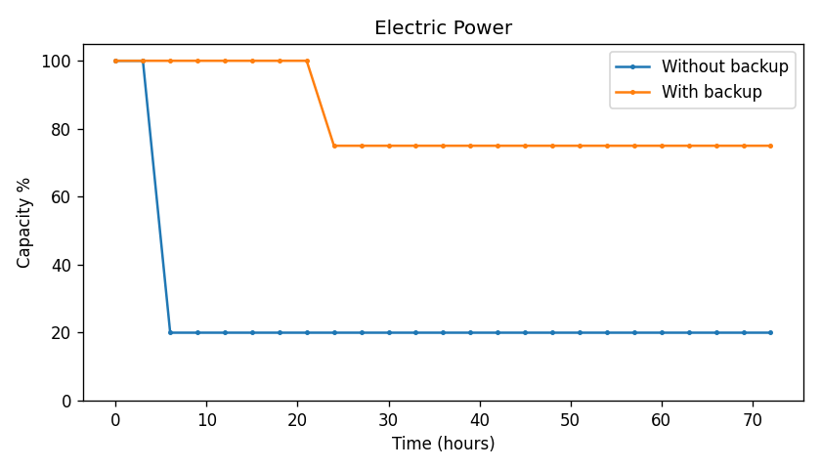
The facility requires electric power service for normal operations. Loss of electric power service would impact operations within 4 hours. Backup systems provide approximately 24 hours of continuity. With backup in place, functional capacity loss is estimated at 25%. Without backup, functional loss would reach 80%. Recovery to normal operations is estimated to require 48 hours following service restoration.

In the above chart, and based on the conversations from the stakeholder, the facility would be impacted at a diminished operational capacity at approximately ____ hours. Without a backup generator, the facility would be reduced to ____ % operational capacity. However, this impact on operations can be mitigated with the use of a _________. Through employing a _________ the facility would only suffer a ____ % loss to its operation.

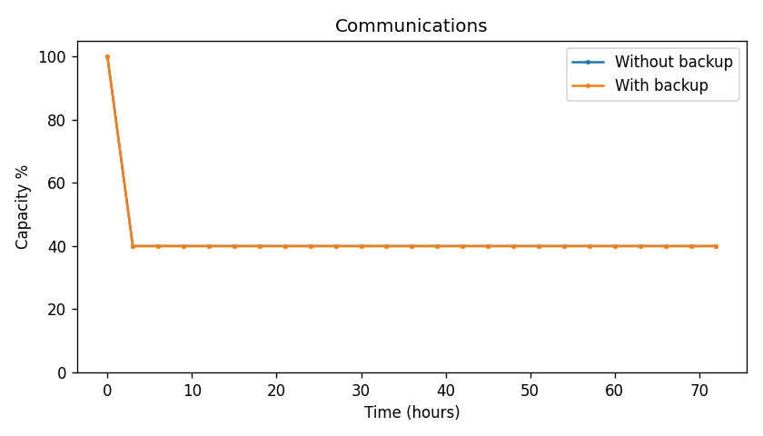
The facility requires communications service for normal operations. Loss of communications service would impact operations within 2 hours. No backup systems are in place. Functional capacity loss is estimated at 60%. Recovery to normal operations is estimated to require 12 hours following service restoration.
Table 3. Communications Dependency Chart

In the above chart, and based on the conversations from the stakeholder, the facility would be impacted at a diminished operational capacity at approximately ____ hours. Without a backup generator, the facility would be reduced to ____ % operational capacity. However, this impact on operations can be mitigated with the use of a _________. Through employing a _________ the facility would only suffer a ____ % loss to its operation.

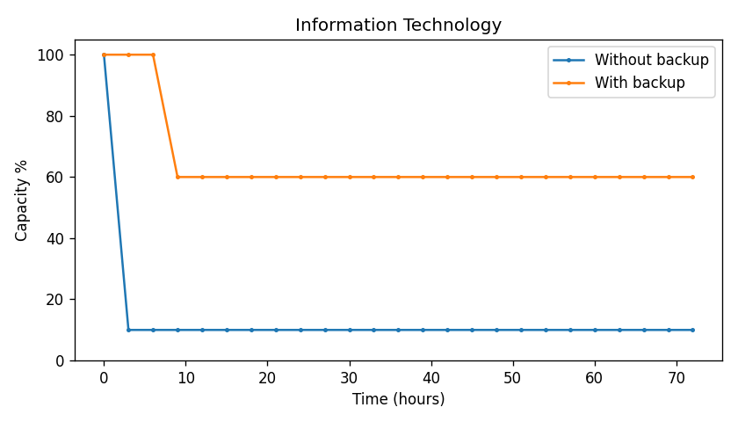
The facility requires information technology service for normal operations. Loss of information technology service would impact operations within 1 hours. Backup systems provide approximately 8 hours of continuity. With backup in place, functional capacity loss is estimated at 40%. Without backup, functional loss would reach 90%. Recovery to normal operations is estimated to require 24 hours following service restoration.


Table 4. Information Technology Dependency Chart

In the above chart, and based on the conversations from the stakeholder, the facility would be impacted at a diminished operational capacity at approximately ____ hours. Without a backup generator, the facility would be reduced to ____ % operational capacity. However, this impact on operations can be mitigated with the use of a _________. Through employing a _________ the facility would only suffer a ____ % loss to its operation.

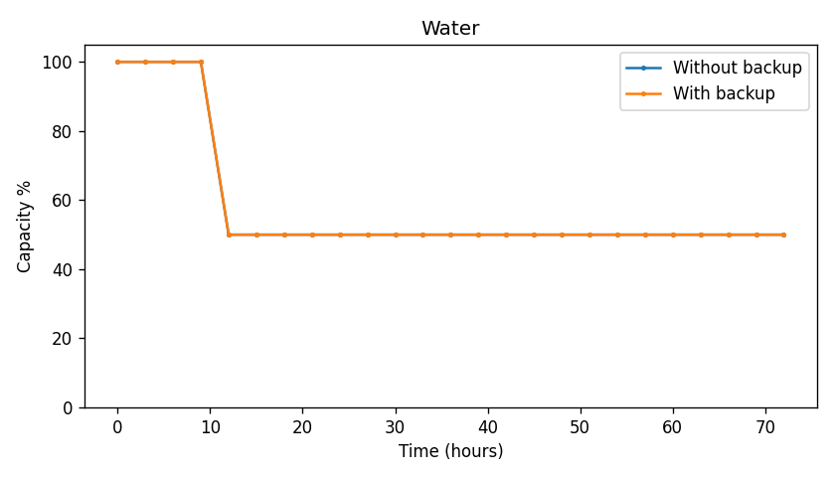
The facility requires water service for normal operations. Loss of water service would impact operations within 12 hours. No backup systems are in place. Functional capacity loss is estimated at 50%. Recovery to normal operations is estimated to require 72 hours following service restoration.

In the above chart, and based on the conversations from the stakeholder, the facility would be impacted at a diminished operational capacity at approximately ____ hours. Without a backup generator, the facility would be reduced to ____ % operational capacity. However, this impact on operations can be mitigated with the use of a _________. Through employing a _________ the facility would only suffer a ____ % loss to its operation.

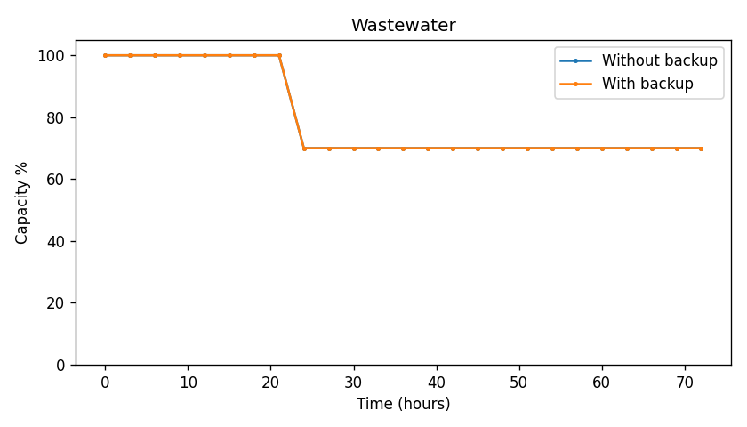
The facility requires wastewater service for normal operations. Loss of wastewater service would impact operations within 24 hours. No backup systems are in place. Functional capacity loss is estimated at 30%. Recovery to normal operations is estimated to require 96 hours following service restoration.

In the above chart, and based on the conversations from the stakeholder, the facility would be impacted at a diminished operational capacity at approximately ____ hours. Without a backup generator, the facility would be reduced to ____ % operational capacity. However, this impact on operations can be mitigated with the use of a _________. Through employing a _________ the facility would only suffer a ____ % loss to its operation.

Vulnerabilities and Options for Consideration
No significant vulnerabilities were identified based on assessed dependencies.

The PSA identified potential vulnerabilities related to the building’s dependencies. The table below lists these vulnerabilities and options for consideration. These options for consideration provide an opportunity for the facility to mitigate vulnerabilities and implement protective measures. The options for consideration are not prescriptive endorsements of specific protective measures to be installed and/or used at the facility. The owner or operator determines for the facility whether the options for consideration provide the desired enhancements considering the facility's current security posture, anticipated growth or organizational changes, budgetary outlook, etc.

Conclusion

This report provides a summary of key findings from the SAFE assessment and the Facility Dependency Assessment and may be used as a guide for the consideration and implementation of future security and resilience enhancement measures. The report integrates with the accompanying Excel Dashboards that visually depict the facility’s security and resilience posture specifically as it relates to utilities and dependencies. This tool is meant to provide a benefit analysis tool for consideration of potential security and resilience changes.

This assessment was conducted by the resident PSA to identify vulnerabilities that common threat actors might exploit and to evaluate them against the consequences disclosed by the stakeholder. The recommendations provided herein aim to enhance security and resilience with the goal of mitigating the facility's vulnerabilities. The survey process offers a snapshot of conditions at the time of our site visit and staff interview. Security and crime prevention efforts should be regarded as dynamic processes. Therefore, it is strongly recommended that the stakeholder continuously monitors their environment and adjusts security practices, policies, and procedures in response to environmental changes.

