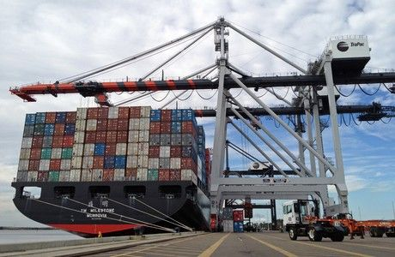
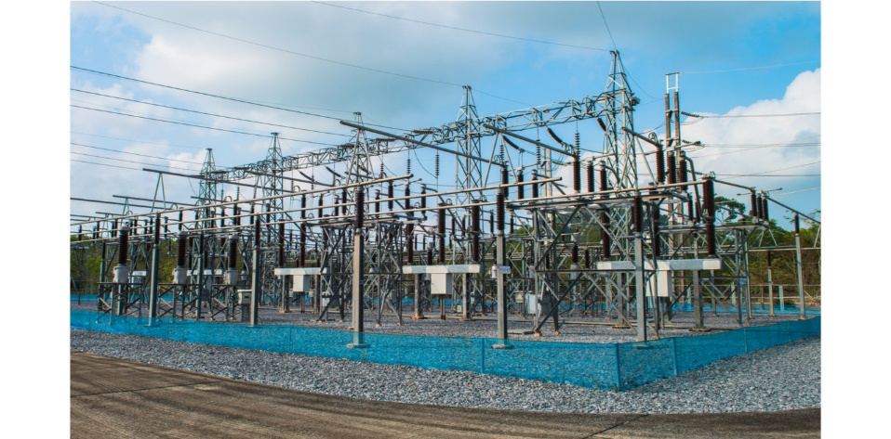
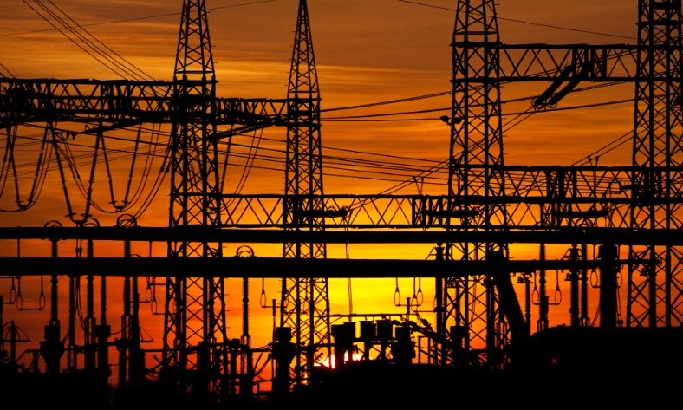
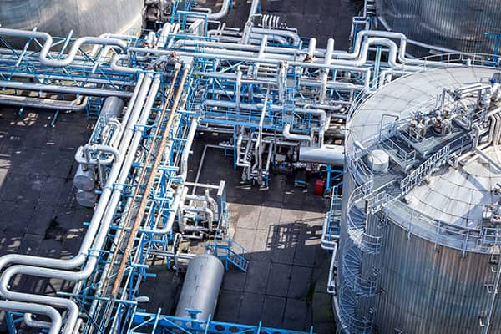
Asset Dependency Assessment

WARNING: This information is FOR OFFICIAL USE ONLY (FOUO). It contains information that may be exempt from public release under the Freedom of Information act (5 U.S.C. § 552). It is to be controlled, stored, handled, transmitted, distributed, and disposed of in accordance with U.S. Department of Homeland Security (DHS) Management Directive 11042.1 relating to FOUO information and is not to be released to the public or other personnel who do not have a valid “Need-to-know” without prior approval of an authorized DHS official.

Publication: TBD
Cybersecurity and Infrastructure Security Agency

Protective Security Advisor
Department of Homeland Security
Cybersecurity and Infrastructure Security Agency
Integrated Operations Division | Region |
Cell: 555-000-0000
Email:

Contents
PURPOSE 2
EXECUTIVE RISK 2
EXECUTIVE SUMMARY 3
CRITICAL INFRASTRUCTURE 4
ELECTRIC POWER 4
COMMUNICATIONS 4
INFORMATION TECHNOLOGY 4
WATER 4
WASTEWATER 4
CRITICAL PRODUCTS 4
CROSS INFRASTRUCTURE SYNTHESIS 4
APPENDIX A. VULNERABILITY INDEX 5
CONCLUSION 5

Asset Dependency Risk Analysis

PART I – EXECUTIVE DEPENDENCY RISK BRIEF

A. EXECUTIVE RISK POSTURE
No structural vulnerabilities identified based on provided inputs.
No structural vulnerabilities identified based on provided inputs.
No structural vulnerabilities identified based on provided inputs.

B. DEPENDENCY SNAPSHOT TABLE
No structural vulnerabilities identified based on provided inputs.
No structural vulnerabilities identified based on provided inputs.

Detailed sector findings, vulnerability drivers, and considerations are provided in Part II – Technical Annex.

D. CROSS-INFRASTRUCTURE SYNTHESIS
No structural vulnerabilities identified based on provided inputs.

E. PRIORITY ACTIONS
No structural vulnerabilities identified based on provided inputs.

PART II – TECHNICAL ANNEX

Dependency Summary

Category | Provider Identified | Backup Present | Time to Severe Impact (hrs) | Recovery Time (hrs) | Notes
Electric Power | No | No | 24 | 12 | not confirmed
Communications | No | No |  | 0 | not confirmed
Information Technology | No | No |  | 0 | not confirmed
Water | No | No |  | 0 | not confirmed
Wastewater | No | No |  | 0 | not confirmed
Critical Products | — | — |  |  | Not documented

Infrastructure Dependency Vulnerabilities and Options for Consideration

ELECTRIC POWER — Dependency Assessment
Figure 1. Electric Power Dependency Curve
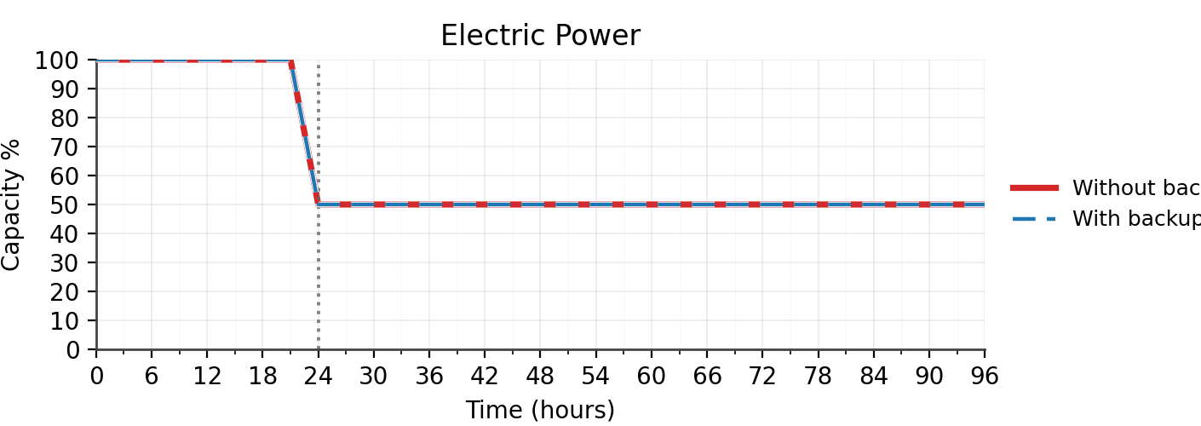

Chart Synopsis
Electric Power reaches severe impact in 24 hours with ~50% functional loss absent alternate capability. No alternate capability is available to sustain operations during an extended outage. Structural posture is weak, provider details are not confirmed, and restoration priority is not established.

Vulnerabilities
No vulnerabilities were triggered based on provided inputs.

COMMUNICATIONS — Dependency Assessment
Figure 2. Communications Dependency Curve
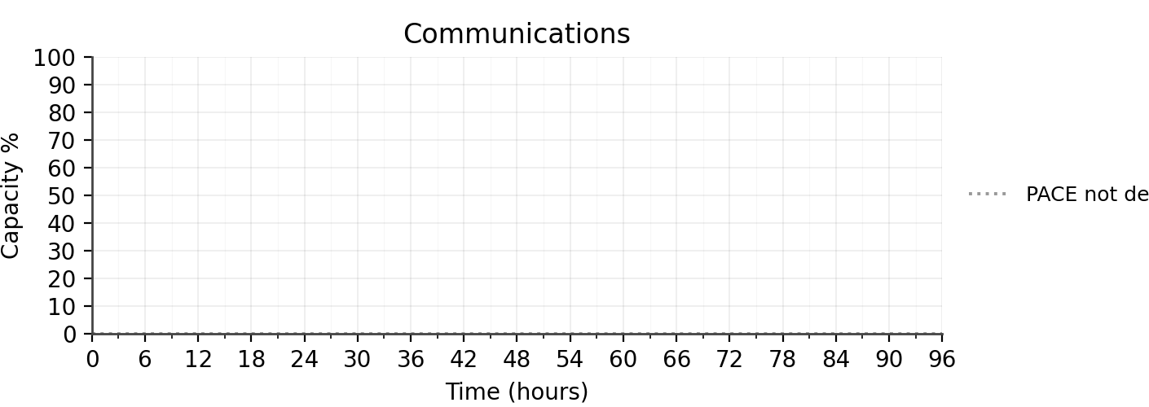

Chart Synopsis
Communications: PACE plan is not defined. Operational capacity over the 0–96 hour horizon cannot be assessed.

Vulnerabilities
No vulnerabilities were triggered based on provided inputs.

INFORMATION TECHNOLOGY — Dependency Assessment
Figure 3. Information Technology Dependency Curve
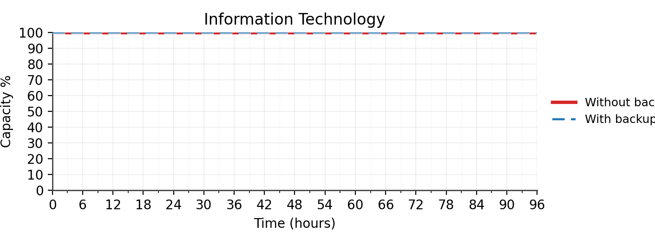

Chart Synopsis
Information Technology: This facility does not require information technology service for normal operations.
External critical services were not documented in provided inputs.

Vulnerabilities
No vulnerabilities were triggered based on provided inputs.

WATER — Dependency Assessment
Figure 4. Water Dependency Curve
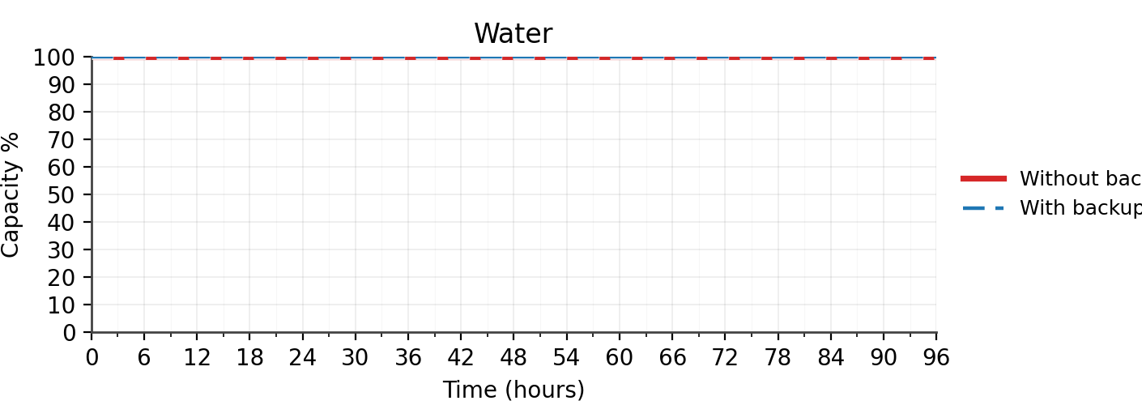

Chart Synopsis
Water: This facility does not require water service for normal operations.

Vulnerabilities
No vulnerabilities were triggered based on provided inputs.

WASTEWATER — Dependency Assessment
Figure 5. Wastewater Dependency Curve
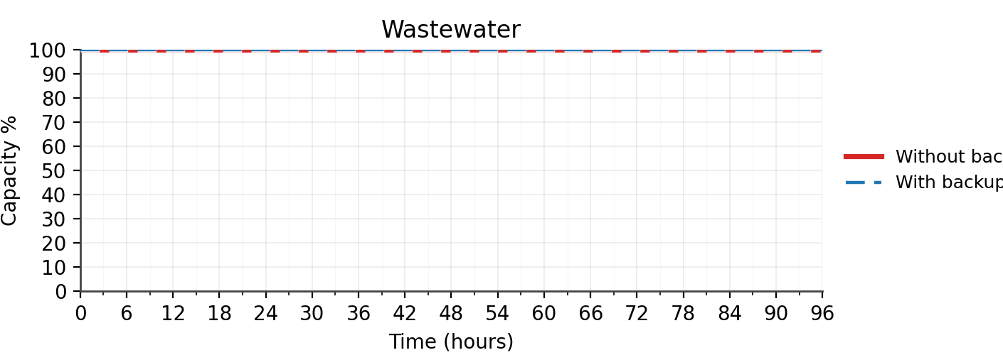

Chart Synopsis
Wastewater: This facility does not require wastewater service for normal operations.

Vulnerabilities
No vulnerabilities were triggered based on provided inputs.

