WARNING: This information is FOR OFFICIAL USE ONLY (FOUO). It contains information that may be exempt from public release under the Freedom of Information act (5 U.S.C. § 552). It is to be controlled, stored, handled, transmitted, distributed, and disposed of in accordance with U.S. Department of Homeland Security (DHS) Management Directive 11042.1 relating to FOUO information and is not to be released to the public or other personnel who do not have a valid “Need-to-know” without prior approval of an authorized DHS official.
Cybersecurity and Infrastructure Security Agency
Protective Security Advisor
Department of Homeland Security
Cybersecurity and Infrastructure Security Agency
Integrated Operations Division | Region X | Test City
Cell: 555-000-0000
Email: test@example.com

Contents
PART I – EXECUTIVE DEPENDENCY RISK BRIEF 2
A. EXECUTIVE RISK POSTURE 2
B. DEPENDENCY SNAPSHOT TABLE 2
C. CROSS-INFRASTRUCTURE SYNTHESIS 3
D. PRIORITY ACTIONS 3
PART II – TECHNICAL ANNEX 4
DEPENDENCY SUMMARY 4
CORE INFRASTRUCTURE OVERVIEW 4
INTERNET TRANSPORT 4
CRITICAL HOSTED SERVICES 4
STRUCTURAL RISK PROFILE 4
INFRASTRUCTURE VULNERABILITIES 4
CROSS-INFRASTRUCTURE ANALYSIS 4

PART I – EXECUTIVE DEPENDENCY RISK BRIEF

A. Executive Risk Posture
HIGH STRUCTURAL SENSITIVITY  Overall dependency exposure is HIGH. Earliest operational degradation begins in Information Technology at 1 hours. Near-term dependency pressure is concentrated in Electric Power, Communications, Information Technology. | Top Risk Drivers
Domains assessed: 5 | Findings: 0 | Earliest severe impact: 1h

B. At-a-Glance Dependency Profile
No structural vulnerabilities identified based on provided inputs.
No structural vulnerabilities identified based on provided inputs.
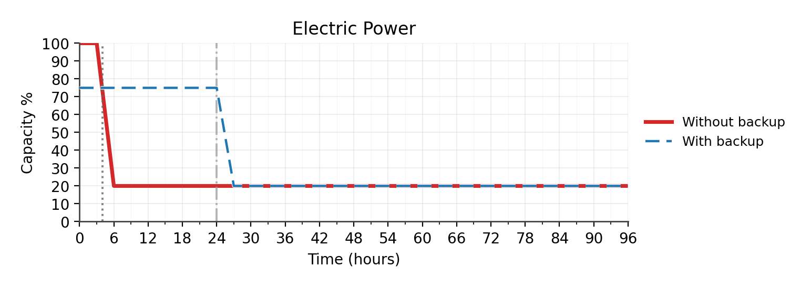
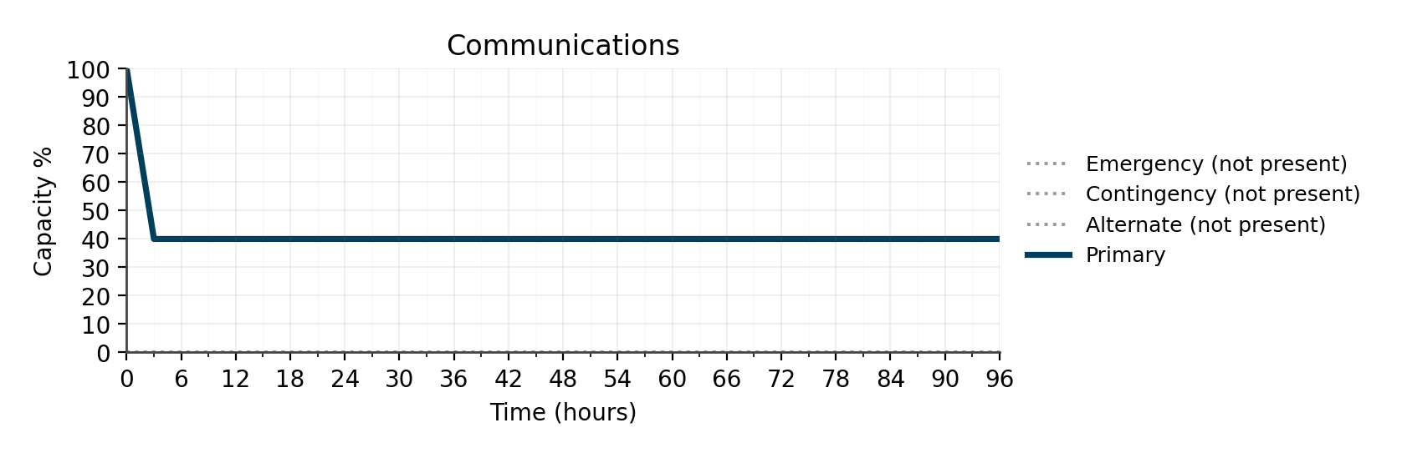
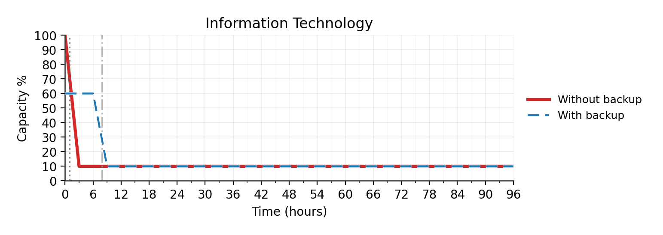
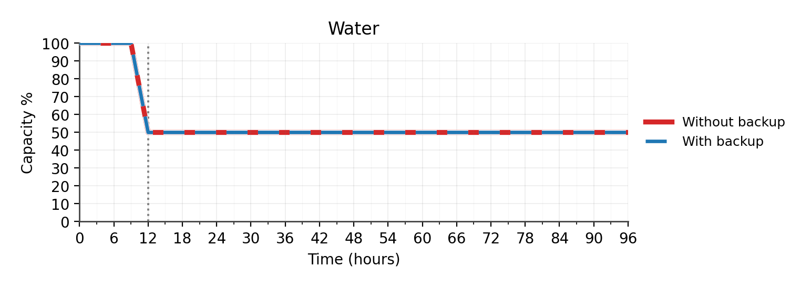
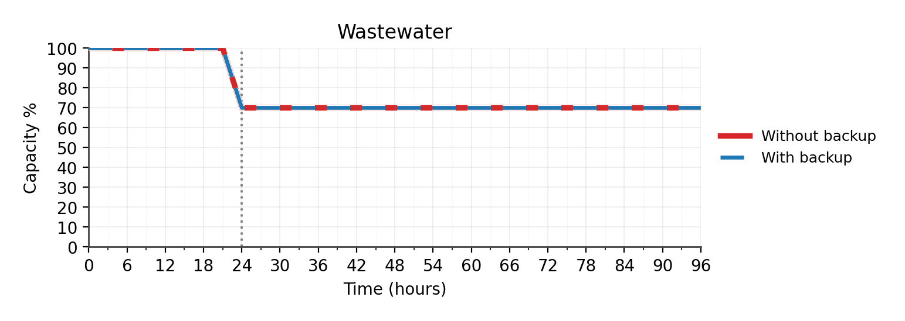

C. Cross-Infrastructure Analysis
No structural vulnerabilities identified based on provided inputs.

D. Priority Actions
No structural vulnerabilities identified based on provided inputs.

PART II – TECHNICAL ANNEX

Annex Overview

Sector Reports

ELECTRIC POWER — Dependency Assessment

Figure 1. Electric Power Dependency Curve

Chart Synopsis
The facility requires electric power service for normal operations. Loss of electric power service would impact operations within 4 hours. Backup systems provide approximately 24 hours of continuity. With backup in place, functional capacity loss is estimated at 25%. Without backup, functional loss would reach 80%. Recovery to normal operations is estimated to require 48 hours following service restoration.

COMMUNICATIONS — Dependency Assessment

Figure 2. Communications Dependency Curve

Chart Synopsis
Communications PACE posture includes Primary. Alternate, Contingency, Emergency are not present. Earliest severe degradation across present layers occurs by 3 hours. Emergency layer is not present. PACE depth is limited.

INFORMATION TECHNOLOGY — Dependency Assessment

Figure 3. Information Technology Dependency Curve

Chart Synopsis
The facility requires information technology service for normal operations. Loss of information technology service would impact operations within 1 hours. Backup systems provide approximately 8 hours of continuity. With backup in place, functional capacity loss is estimated at 40%. Without backup, functional loss would reach 90%. Recovery to normal operations is estimated to require 24 hours following service restoration.

WATER — Dependency Assessment

Figure 4. Water Dependency Curve

Chart Synopsis
The facility requires water service for normal operations. Loss of water service would impact operations within 12 hours. No backup systems are in place. Functional capacity loss is estimated at 50%. Recovery to normal operations is estimated to require 72 hours following service restoration.

WASTEWATER — Dependency Assessment

Figure 5. Wastewater Dependency Curve

Chart Synopsis
The facility requires wastewater service for normal operations. Loss of wastewater service would impact operations within 24 hours. No backup systems are in place. Functional capacity loss is estimated at 30%. Recovery to normal operations is estimated to require 96 hours following service restoration.

STRUCTURAL RISK PROFILE
Structural sensitivity is driven by time-to-severe-impact and alternate capability depth across required sectors. Electric Power: severe impact at 4h; Communications: severe impact at 2h; Information Technology: severe impact at 1h; Water: severe impact at 12h; Wastewater: severe impact at 24h. Immediate-impact exposure (<=1h): Information Technology. Near-term impact exposure (>1h to <=4h): Electric Power, Communications. Extended impact exposure (>4h): Water, Wastewater. Alternate capability not confirmed: Communications, Water, Wastewater.

INFRASTRUCTURE VULNERABILITIES
No vulnerabilities were triggered based on provided inputs.

CORE INFRASTRUCTURE OVERVIEW
Category | Provider Identified | Backup Present | Time to Severe Impact (hrs) | Recovery Time (hrs) | Notes
Electric Power | No | Yes | 4 | 48 | not confirmed
Communications | No | No | 2 | 12 | not confirmed
Information Technology | No | Yes | 1 | 24 | not confirmed
Water | No | No | 12 | 72 | not confirmed
Wastewater | No | No | 24 | 96 | not confirmed
Critical Products | N/A | N/A | N/A | N/A | —

INTERNET TRANSPORT
Role | Provider | Demarcation | Independence | Notes
Primary Internet Provider | Not provided | Not provided | Not provided | —

CRITICAL HOSTED SERVICES
Service | Provider | Operational Impact (Time to Severe Impact) | Service Loss
No critical hosted services identified. | — | — | —

