Case Western Reserve University

The Ocular Motor System

A Quantitative Evaluation

Theodore Frohlich

EBME 318: Biomedical Engineering Laboratory I

Dr. Jonathan Jacobs

27 October 2016

***Abstract—* The abstract goes here.**

1. **Introduction**

The intro goes here

1. **Methods**

Using a collection of equipment including computer-based high-speed digital video eye tracker, rotating chair with head stabilization, laser aimed at a 2-D mirror galvanometer system, amplifiers, and the LabVIEW data acquisition system, we conducted a series of tests of the ocular motor subsystems described in the introduction. These test were performed with two subjects across four experiments:

***Experiment I. Smooth pursuit performance.***

***Experiment II. Visual gain and ocular motor control.***

***Experiment III. Saccadic performance.***

***Experiment IV. Vestibular-ocular reflex performance and control.***

1. **Results**

The results go here

***Question 1.***

The first four trials tested the eye’s ability to maintain a smooth pursuit. For this, we used velocity parameters of 5°, 10°, 20°, and 40°/sec for the trapezoidal target trajectory waveforms. Since, according to our data, the subject’s left eye is consistently more closely aligned with the target, let us single out the left eye for this analysis.

By definition, the smooth pursuit gain, G, is the ratio of eye velocity to target velocity. To perform this calculation, it was necessary to zoom in on very small windows of time in the recorded data to capture unbiased samples of the subject’s eye velocity –i.e. without saccadic interruptions.

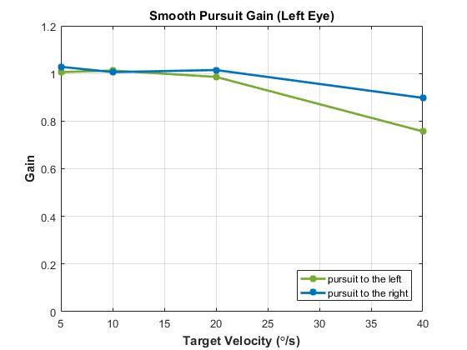

**Fig. 1.** Subject’s smooth pursuit gain (eye velocity/target velocity) versus the four constant target velocities: 5°, 10°, 20°, and 40°/sec. Eye velocities were extracted from brief time windows in Trials 1-4, over the course of which the subject’s ability to maintain accurate smooth pursuit of linear trajectories (constituent of a trapezoidal trajectory waveforms) became significantly more difficult as target velocity was increased.

Coincidentally, the Fig. 1 in Sharpe & Sylvester’s 1978 study shows in smooth pursuit gain in Fig. 1 with that obtained in,

***Question 2.***

***Question 3.***

***Question 4.***

***Question 5.***

***Question 6.***

***Question 7.***

1. **Discussion**

The discussion goes here

1. **Conclusion**

The conclusion goes here

**Acknowledgement**

I would like to take a moment to thank Dr. Jacobs for the opportunity to participate in such a fascinating experiment! Being allowed to use the *state-of-the-art* equipment in the Daroff-Dell’Osso Ocular Motility Laboratory (OMLAB) was especially fun and memorable.

**References**

|  |  |
| --- | --- |
| [1] | L. A. Abel, D. Schmidt, L. F. Dell'Osso and R. B. Daroff, "Saccadic system plasticity in humans," *Annals of NeuroIogy,* vol. 4, no. 4, pp. 313-318, October 1978. |
| [2] | J. A. Sharpe and T. O. Sylvester, "Effect of aging on horizontal smooth pursuit," *Investigative Ophthalmology and Visual Science,* vol. 17, no. 5, pp. 465-480, May 1978. |