 |  | Date: | February 23rd 2009
Subject: | Application Notes for Configuring Avaya Communication  Manager and CMBE for ISDN BRI trunks to France Telecom network  – Issue 0.2 | From:
 | COMPAS ID 140142 |  | Christian COLAS  +33 1 40 94 80 50

ABSTRACT

These Application Notes describe the steps for configuring Avaya Communication Manager and its gateways and Avaya Communication Manager Branch Edition when a connection to France Telecom ISDN BRI trunks is required.

Table of Contents

1. Introduction 3
1.1 Reference Documentation 3
1.2 Reference Configuration 3
1.3 Document history 4
1.4 Acknowledgements 4
2. Euronumeris or Euronumeris + ? 4
3. Point-to-point or Point-to-Multipoint ? 4
4. Layer 1 stable or not stable ? 5
5. TEI auto or TEI Zero ? 5
6. I-frame or U-frame for incoming calls ? 6
7. IP Network stability 6
8. Avaya Communication manager administration 6
8.1 BRI-Trunk-Board administration 6
8.1.1 BRI-Trunk-Board for Euronumeris + 6
8.1.2 BRI-Trunk-Board for Euronumeris 7
8.2 Trunk-Group administration 8
8.2.1 Trunk-Group for Euronumeris + 8
8.2.2 Trunk-Group for Euronumeris 10
8.3 Synchronization administration 11
8.3.1 On a port network (G650) 11
8.3.2 On a Media Gateway (G250 or G350 for instance) 12
9. Avaya Communication manager Branch Edition administration 12
9.1 BRI Ressources administration 12
9.1.1 BRI Ressources for Euronumeris + 12
9.1.2 BRI Ressources for Euronumeris 13
9.2 Trunk-Group administration 14
9.2.1 Trunk-Group for Euronumeris + 14
9.2.2 Trunk-Group for Euronumeris 17
9.3 Synchronization administration 18
10. A trace of layer 2 and layer 2 disconnections after the end of a call 19
10.1 Alcatel E10B example 19
10.2 Ericsson AXE 10 example 19
10.3 Bad effect of an H248 disconnection while setting up a call 20

Introduction

Reference Documentation
[1] ITU-T I411, “ISDN User-Network Interfaces – Reference Configuration”
[2] France Telecom STI6, available at http://www.orange.com/fr_FR/groupe/reseau/documentation/att00001745/STI6-0802.pdf
[3] France Telecom STI7, available at http://www.orange.com/fr_FR/groupe/reseau/documentation/att00001745/STI7_1000.pdf
[4] ETSI ETS 300 012
[5] ETSI ETS 300 402-1 and ETS 300 402-2
[6] ETSI ETS 300 403-1
[7] Form used to subscribe a group of ISDN BRIs to France Telecom, available at http://www.agence.francetelecom.com/doc/contrats/contrat67.pdf
[8] Form used to subscribe a single ISDN BRI to France Telecom, available at
http://www.agence.francetelecom.com/doc/contrats/contrat153.pdf
[9] Maintenance Commands for Avaya Communication Manager (…), 03-300431, available at http://support.avaya.com
[10] Avaya G250 and Avaya G350 CLI Reference, 03-300437, available at http://support.avaya.com

Reference Configuration
The following diagram shows the general configuration which these notes apply to.

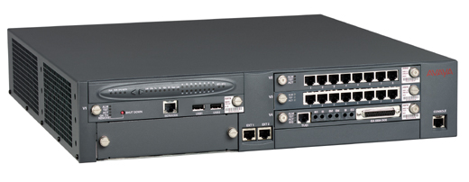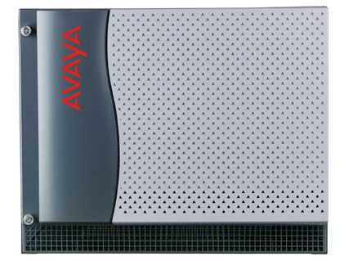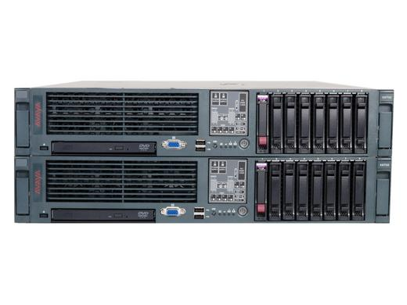
G700 / MM 720
G650 / TN2185
S87XX
NT1
NT1
NT1
NT1
NT1
NT1
France Telecom
PSTN
CMBE / i40-BRI

Document history
1 | December 16th 2008 | Creation
0.2 | February 23rd 2009 | Added paragraph on point to point  Added section on IP network stability  Added traces to show H248 stability impact

Acknowledgements
Thank you Bob Dobbs for your review, support and traces.

Euronumeris or Euronumeris + ?
France Telecom has two ISDN offers, called Euronumeris and Euronumeris +
- Euronumeris is an offer coming from the original national ISDN offer, compatible with ETSI ISDN for the basic call and services. Euronumeris is described in [2]. When Euronumeris is offered, the best matching protocol for Communication Manager is country code 12.
- Euronumeris + is the offer matching all ETSI standards, mentionned in [3], [4], [5] and [6]. When Euronumeris + is offered, the best matching protocol for Communication Manager is country code etsi.
As this document is being written, it seems that a new ISDN subscriber today is offered by default a Euronumeris access.
Conclusion
As a best practise, we recommend that a Euronumeris + subscription is made for Avaya CM installation, since this protocol has a wider coverage, hence benefits more experience. However Avaya CM can certainly cope with Euronumeris, without any problem.

To subscribe a Euronumeris or Euronumeris + access, use form [7] or [8] and tick the right boxes under section 2.3

Point-to-point or Point-to-Multipoint ?
Initially ISDN BRI has been defined as a bus, hence is able to support multiple terminals connected in “parallel” on this bus.
Obviously this is not a configuration we wish when connecting a PBX. The typical configuration in this case is a “point-to-point” configuration, meaning that the network equipment (called NT1 in the ITU-T terminology, see [1]) is connected one single PBX (NT2 in the ITU-T terminology, see [1])
AVAYA documentation states that only point-to-point configuration is supported, meaning that one and only one CM interface is allowed for connection on a trunk BRI
Network providers in EMEA have made a difference between these two configurations for a long time. France Telecom has not. Pr So Euronumeris accesses are delivered just as “point-to-multipoint” accesses, while Euronumeris + accesses can be delivered either as point-to-point or point-to-multipoint.
Conclusion
“Point-to-point” or “point-to-multipoint” delivery is not a problem as long as one single equipment is connected to the BRI, and this is Avaya CM gateway interface. However, if the customer subscribes to a Euronumeris + access, best practise is to request a “point-to-point” interface.
To subscribe a Euronumeris + point-to-point access, use form [7] or [8] and tick the right boxes under section 2.3

Layer 1 stable or not stable ?
A particularity of France Telecom BRI offer is around this question. Most European countries offer a stable layer 1, particulary on “point-to-point” interfaces. This is the reason why “point-to-point” and “stable layer 1” have been very much misunderstood in the past. But these are really two different options.
- Stable layer 1 means that even when there is no call, basic “stand-by” data are exchanged on line between the network provider and the PBX. More than that, in most cases, layer 2 is also preserved, meaning that even if there is no call, a layer 2 supervision is active on line. ISDN layer 2 supervision means an exchange of the so called “RR” frames. This behaviour of a permanent active layer 1 and layer 2 is the normal behaviour for ISDN PRIs.
- Not stable layer 1 means that when there is no call active on the link, the interface is totally idle. Concretely, this means that after all calls have ended, layer 2 is disconnected by exchanging “DISC” and “UA” frames, and then layer 1 is disconnected, by stopping all data exchanges on line. Note that this layer 2 and layer 1 disconnection is the network initiative.
- Having a “not stable” layer 1 implies that for each call, layer 1 and layer 2 need to be re-established, either at the network initiative (incoming calls) or at the PBX initiative (outgoing calls). Avaya Communication Manager is designed to do this with any gateway or port network.

The following statements are important to keep in mind on France Telecom network :
- Whether you subscribe a “point-to-point” or a “point-to-multipoint” interface, you get a “NOT STABLE” layer 1
- Whether you subscribe a Euronumeris or a Euronumeris + interface, you get a “NOT STABLE” layer 1
- Stable layer 1 accesses are available on a per request basis, provided the public switch offers it. As this document is being written, our information tells that this is true just for some Ericsson Axe 10 switches, and we assess its availability to be around 20%. So there is no way that any customer can get a stable layer 1 just by requesting it.

TEI auto or TEI Zero ?
Automatic TEI mechanisms are available at layer 2 of the BRI. It has been made available to dynamically create layer 2 connections when multiple terminals are used on a BRI bus. Each terminal is allocated a different TEI (Terminal Endpoint Identifier, or layer 2 address) by the network entity.
Static TEIs can also be used, and in this case, the normalized TEI to be used by a PBX for the circuit switched service is “0”. This is the typical case we should be using.
Conclusion
- Whenever Avaya Communication Manager is using a France Telecom BRI, we recommend that a fixed TEI of zero is used ; this usage is the standard for a PBX and eliminates the need of additional TEI allocation mechanisms, which will just delay the call setups and add unnecessary protocol.
- Using a zero TEI is allowed on every type of France Telecom BRI : Euronumeris, Euronumeris +, in a point-to-point or point-to-multipoint configuration
Note : it has not been possible to know as we write this document whether a dynamic TEI is allowed on point-to-point Euronumeris + access, but we do not care, we want a fixed TEI of zero only.

I-frame or U-frame for incoming calls ?
This topic is here just for information, as we did not have yet any issues reported because of it. France Telecom sends incoming calls over “Unnumbered Frames”, using at layer 2 a general TEI of 127.
This is a typical “point-to-multipoint” behaviour, as on such bus, you never know which terminal will answer the call, hence you never know which TEI to use at layer 2. This is why incoming calls are sent using the general TEI.
When such a call is sent to Avaya Communication Manager, it replies with its own zero TEI, and then all is fine, and the signaling proceeds using this TEI, and regular “Information frames”. This behaviour is fine with every type of France Telecom BRI.

IP Network stability
Avaya gateways are connected to a main server using H248 protocol over IP. ISDN layer 2 and layer 3 are actually handled by the main server. In case of IP network outage, connection to the main is lost and layer 3 is no more controlled. This results in communications not being properly set up.
When troubleshooting BRI issues on H248 gateways, attention must be brought on whether the gateway had a proper connection to the main server when the customer complains about not being able to set up a call. See section 10.3 as an example.
We need to re-enforce that a reliable H248 connection is instrumental to proper BRI operations.
In case of IP network outage, a gateway may register to an LSP. As of CM5.1, going LSP and failing back to the main once network get available again is not call preserving.

Avaya Communication manager administration

BRI-Trunk-Board administration

BRI-Trunk-Board for Euronumeris +

change bri-trunk-board 1A09 Page 1 of 2
ISDN-BRI TRUNK CIRCUIT PACK

Location: 01A09 Name: BRI FT
Interface Companding: a-law DCP/Analog Bearer Capability: 3.1kHz
T3 Timer Length (sec): 15

Port Interface Side Cntry/Peer TEI TSC SS Synch Layer 1 Detect
Protocol Protocol Source? Stable? Slips?
1: user etsi 0 y n n
2: 0 n y n
3: 0 n y n
4: 0 n y n
5: 0 n y n
6: 0 n y n
7: 0 n y n
8: 0 n y n

change bri-trunk-board 1A09 Page 2 of 2
ISDN-BRI TRUNK CIRCUIT PACK

Port Interwork XID Endpt SPID Endpt SPID Endpt Max
Message Test? Init? ID ID NCA TSC
1: PROGress n n 0
2: PROGress n n 0
3: PROGress n n 0
4: PROGress n n 0
5: PROGress n n 0
6: PROGress n n 0
7: PROGress n n 0
8: PROGress n n 0

Port Directory Directory Port Directory Directory
Number Number Number Number
1: 5:
2: 6:
3: 7:
4: 8:

BRI-Trunk-Board for Euronumeris

change bri-trunk-board 1A09 Page 1 of 2
ISDN-BRI TRUNK CIRCUIT PACK

Location: 01A09 Name: BRI FT
Interface Companding: a-law DCP/Analog Bearer Capability: 3.1kHz
T3 Timer Length (sec): 15

Port Interface Side Cntry/Peer TEI TSC SS Synch Layer 1 Detect
Protocol Protocol Source? Stable? Slips?
1: user 12 0 y n n
2: 0 n y n
3: 0 n y n
4: 0 n y n
5: 0 n y n
6: 0 n y n
7: 0 n y n
8: 0 n y n

change bri-trunk-board 1A09 Page 2 of 2
ISDN-BRI TRUNK CIRCUIT PACK

Port Interwork XID Endpt SPID Endpt SPID Endpt Max
Message Test? Init? ID ID NCA TSC
1: PROGress n n 0
2: PROGress n n 0
3: PROGress n n 0
4: PROGress n n 0
5: PROGress n n 0
6: PROGress n n 0
7: PROGress n n 0
8: PROGress n n 0

Port Directory Directory Port Directory Directory
Number Number Number Number
1: 5:
2: 6:
3: 7:
4: 8:

Trunk-Group administration

Trunk-Group for Euronumeris +
change trunk-group 1 Page 1 of 21
TRUNK GROUP

Group Number: 1 Group Type: isdn CDR Reports: y
Group Name: BRI-G250 COR: 1 TN: 1 TAC: *801
Direction: two-way Outgoing Display? n Carrier Medium: PRI/BRI
Dial Access? y Busy Threshold: 255 Night Service:
Queue Length: 0
Service Type: public-ntwrk Auth Code? n TestCall ITC: rest
Far End Test Line No:
TestCall BCC: 4

change trunk-group 1 Page 2 of 21
Group Type: isdn

TRUNK PARAMETERS
Codeset to Send Display: 6 Codeset to Send National IEs: 6
Max Message Size to Send: 260 Charge Advice: automatic
Supplementary Service Protocol: c Digit Handling (in/out): enbloc/enbloc

Trunk Hunt: cyclical
Digital Loss Group: 13
Incoming Calling Number - Delete: Insert: Format:
Bit Rate: 1200 Synchronization: async Duplex: full
Disconnect Supervision - In? y Out? y
Answer Supervision Timeout: 0
Administer Timers? n

change trunk-group 1 Page 3 of 21
TRUNK FEATURES
ACA Assignment? n Measured: none Wideband Support? n
Maintenance Tests? y
Data Restriction? n NCA-TSC Trunk Member:
Send Name: n Send Calling Number: y
Used for DCS? n Send EMU Visitor CPN? n
Suppress # Outpulsing? n Format: public
Outgoing Channel ID Encoding: preferred UUI IE Treatment: service-provider
Charge Conversion: 1
Decimal Point: none Replace Restricted Numbers? n
Currency Symbol: Replace Unavailable Numbers? n
Charge Type: units Send Connected Number: n
Network Call Redirection: none Hold/Unhold Notifications? y
Send UUI IE? y Modify Tandem Calling Number? n
Send UCID? n
Send Codeset 6/7 LAI IE? y Ds1 Echo Cancellation? n

Apply Local Ringback? n
Show ANSWERED BY on Display? y
Network (Japan) Needs Connect Before Disconnect? n
DSN Term? n

change trunk-group 1 Page 4 of 21
QSIG TRUNK GROUP OPTIONS

SBS? n

QSIG Value-Added? n

change trunk-group 1 Page 5 of 21
TRUNK GROUP
Administered Members (min/max): 1/2
GROUP MEMBER ASSIGNMENTS Total Administered Members: 2

Port Code Sfx Name Night Sig Grp
1: 005V401 2BRIIM
2: 005V417 2BRIIM
3:
4:

Trunk-Group for Euronumeris
change trunk-group 1 Page 1 of 21
TRUNK GROUP

Group Number: 1 Group Type: isdn CDR Reports: y
Group Name: BRI-G250 COR: 1 TN: 1 TAC: *801
Direction: two-way Outgoing Display? n Carrier Medium: PRI/BRI
Dial Access? y Busy Threshold: 255 Night Service:
Queue Length: 0
Service Type: public-ntwrk Auth Code? n TestCall ITC: rest
Far End Test Line No:
TestCall BCC: 4

change trunk-group 1 Page 2 of 21
Group Type: isdn

TRUNK PARAMETERS
Codeset to Send Display: 6 Codeset to Send National IEs: 6
Max Message Size to Send: 260 Charge Advice: automatic
Supplementary Service Protocol: a Digit Handling (in/out): enbloc/enbloc

Trunk Hunt: cyclical
Digital Loss Group: 13
Incoming Calling Number - Delete: Insert: Format:
Bit Rate: 1200 Synchronization: async Duplex: full
Disconnect Supervision - In? y Out? y
Answer Supervision Timeout: 0
Administer Timers? n

change trunk-group 1 Page 3 of 21
TRUNK FEATURES
ACA Assignment? n Measured: none Wideband Support? n
Maintenance Tests? y
Data Restriction? n NCA-TSC Trunk Member:
Send Name: n Send Calling Number: y
Used for DCS? n Send EMU Visitor CPN? n
Suppress # Outpulsing? n Format: public
Outgoing Channel ID Encoding: preferred UUI IE Treatment: service-provider
Charge Conversion: 1
Decimal Point: none Replace Restricted Numbers? n
Currency Symbol: Replace Unavailable Numbers? n
Charge Type: units Send Connected Number: n
Network Call Redirection: none Hold/Unhold Notifications? n
Send UUI IE? y Modify Tandem Calling Number? n
Send UCID? n
Send Codeset 6/7 LAI IE? y Ds1 Echo Cancellation? n

Apply Local Ringback? n
Show ANSWERED BY on Display? y
Network (Japan) Needs Connect Before Disconnect? n
DSN Term? n

change trunk-group 1 Page 4 of 21
QSIG TRUNK GROUP OPTIONS

SBS? n

QSIG Value-Added? n

change trunk-group 1 Page 5 of 21
TRUNK GROUP
Administered Members (min/max): 1/2
GROUP MEMBER ASSIGNMENTS Total Administered Members: 2

Port Code Sfx Name Night Sig Grp
1: 005V401 2BRIIM
2: 005V417 2BRIIM
3:
4:

Synchronization administration
This section gives details about synchronization of gateways and port networks, whatever subscription types is available.

On a port network (G650)
The following screen shows an example where both a PRI and a BRI are available on the port network. In this case, synchronization priority is to be given to the PRI.

change synchronization port-network 1 Page 1 of 2
SYNCHRONIZATION PLAN

SYNCHRONIZATION SOURCE (circuit pack location)

Stratum: 4

Primary: 01A10 Secondary: 01A09

CIRCUIT PACKS AVAILABLE FOR SYNCHRONIZATION
Location Type Name Slip Location Type Name Slip
01A10 DS1 PSTN n
01A09 BRI BRI FT n

On a Media Gateway (G250 or G350 for instance)
Media gateway synchronization is obtained by the following commands, detailed in [10] :
- set sync interface primary v2 1-3
this command will set the BRIs connected in slot v2, on port 1 to 3 as synchronization source
- set sync source primary
this command will force the above declared source to act as a synchronization source
- set sync switching enable
this command will allow switching from an inactive source (as it may be the case for not stable layer 1 BRI) to another active source, even if this source can only be the internal clock of the gateway
The following screed shows synchronization status when the BRI is inactive, which is a very normal situation when no call is active :
G350-003(super)# show sync timing

SOURCE MM STATUS FAILURE
--------- ------------------- ----------------------- ---------------
Primary v3(1) Standby Loss of Signal
Secondary Not Configured
Local v0 Active None

Active Source: v0 Sync Source Switching: Enabled

Done!

Avaya Communication manager Branch Edition administration

BRI Ressources administration

BRI Ressources for Euronumeris +

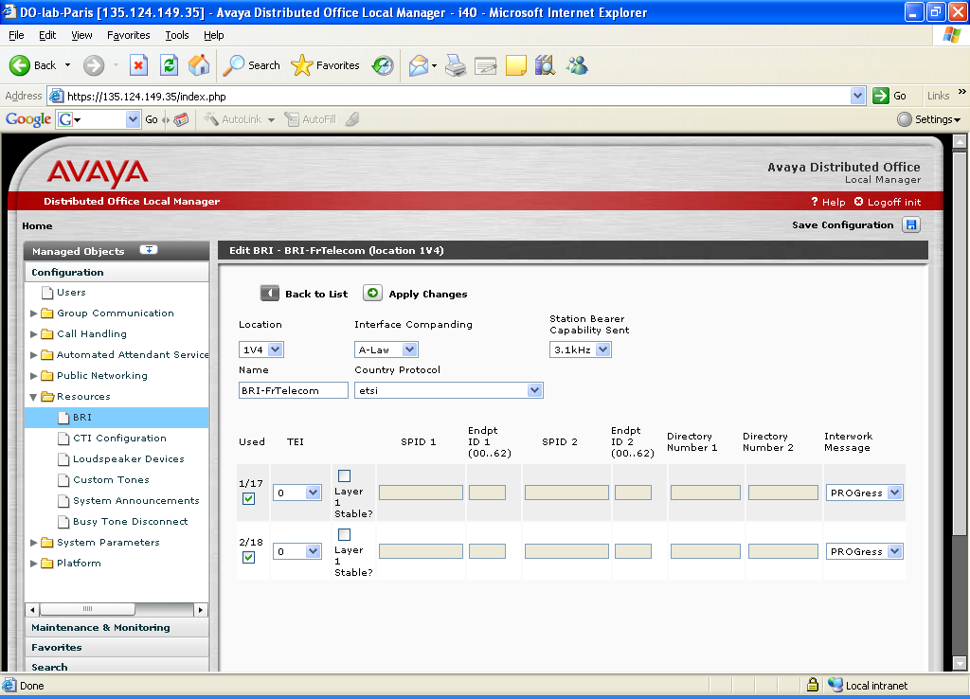

BRI Ressources for Euronumeris

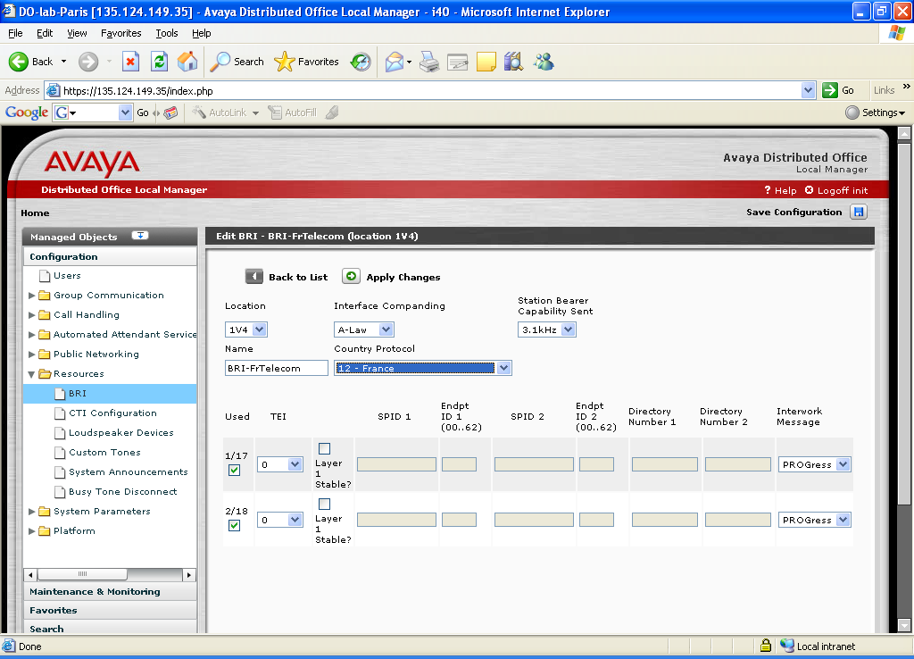

Trunk-Group administration

Trunk-Group for Euronumeris +

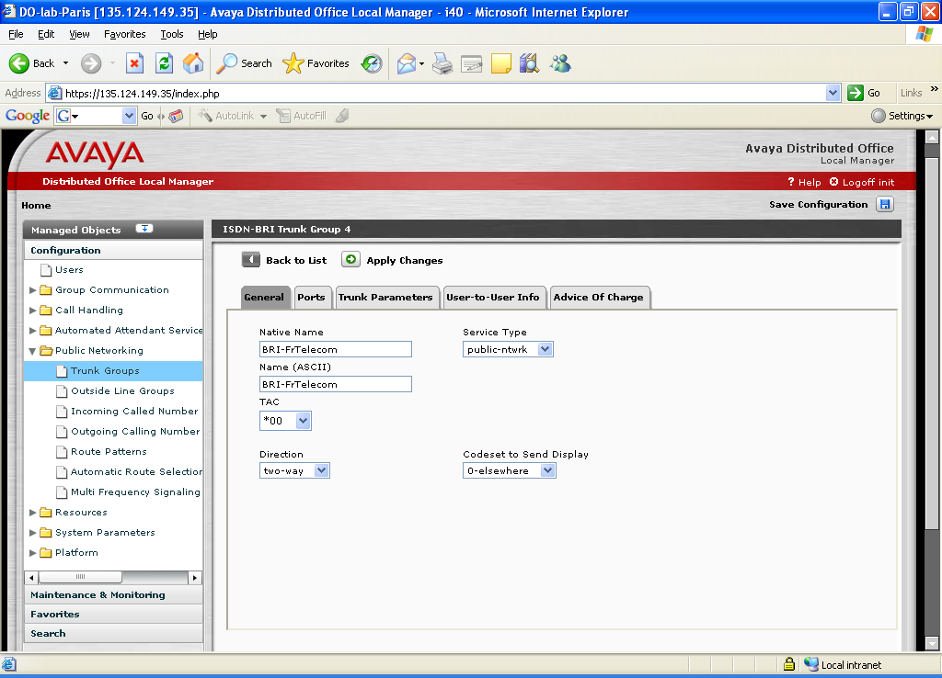

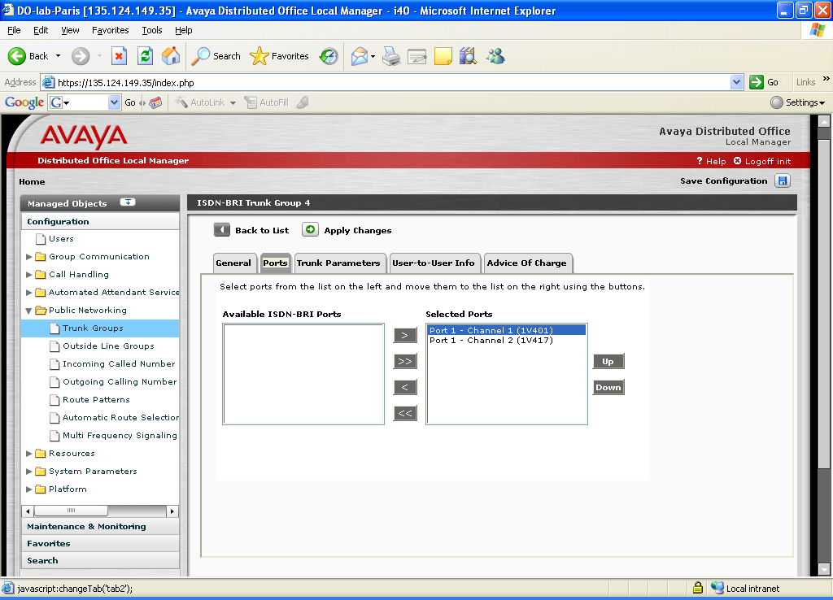

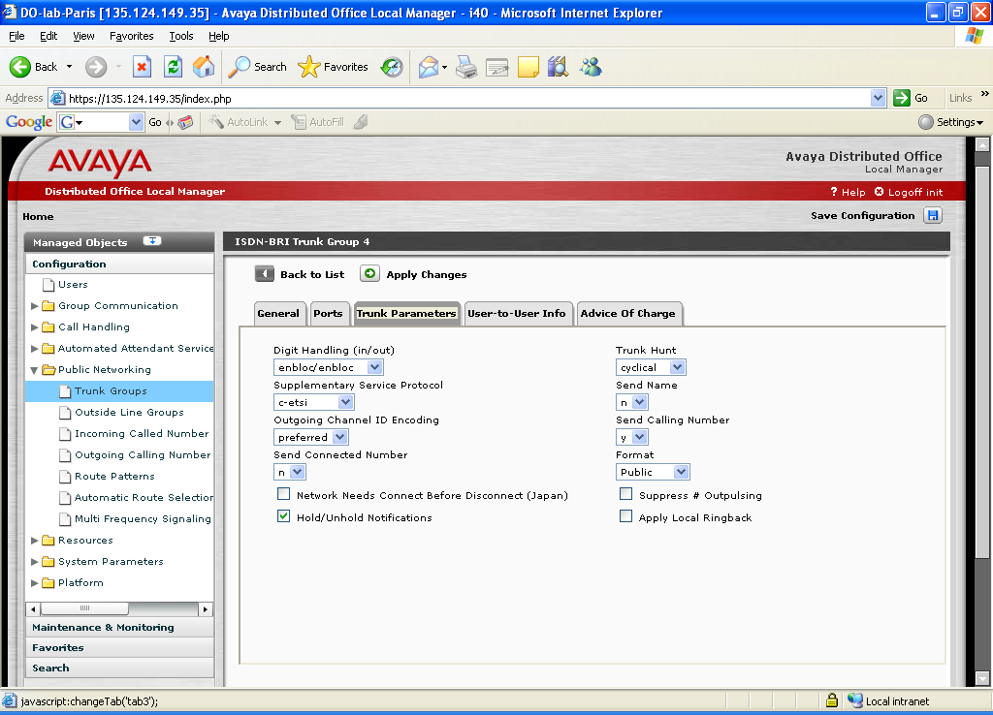

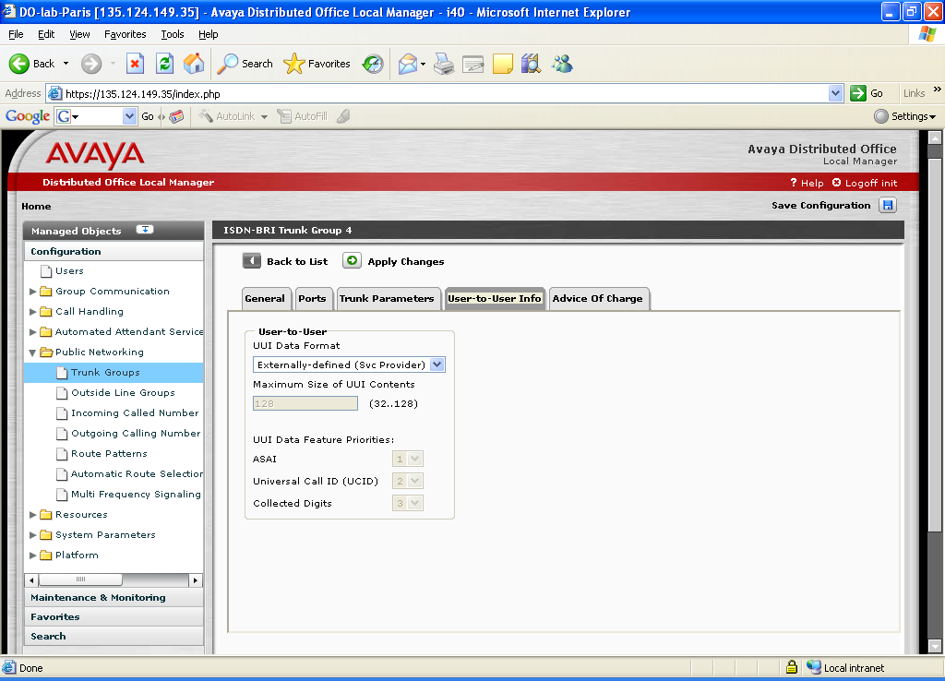

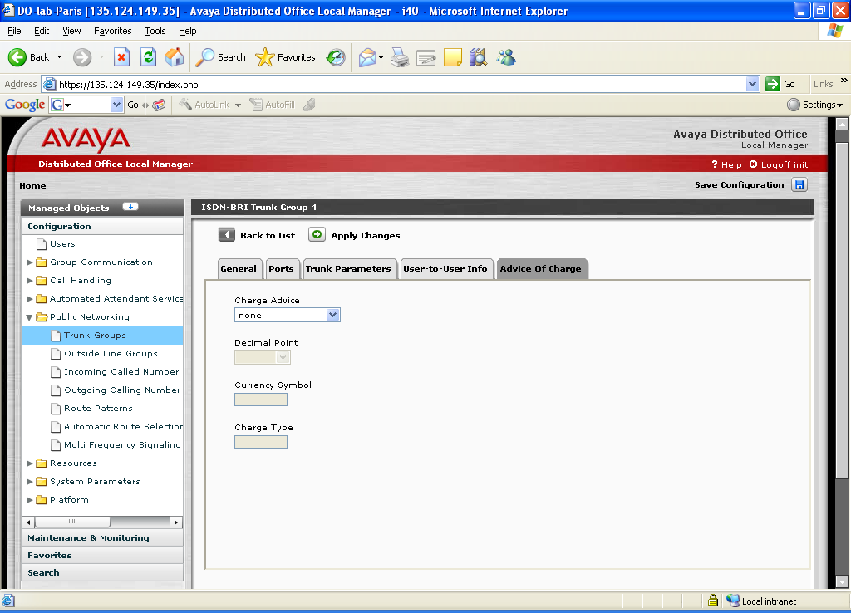
This screen is defined with assumption that AOC is not available or is not interesting to the customer. The other possible choice is “automatic”.
“During on Request” and “End on Request” are not recommended as they can be charged on a per usage basis.

Trunk-Group for Euronumeris
The administration is the same as for Euronumeris +, except for the “Trunk Parameters” tab :

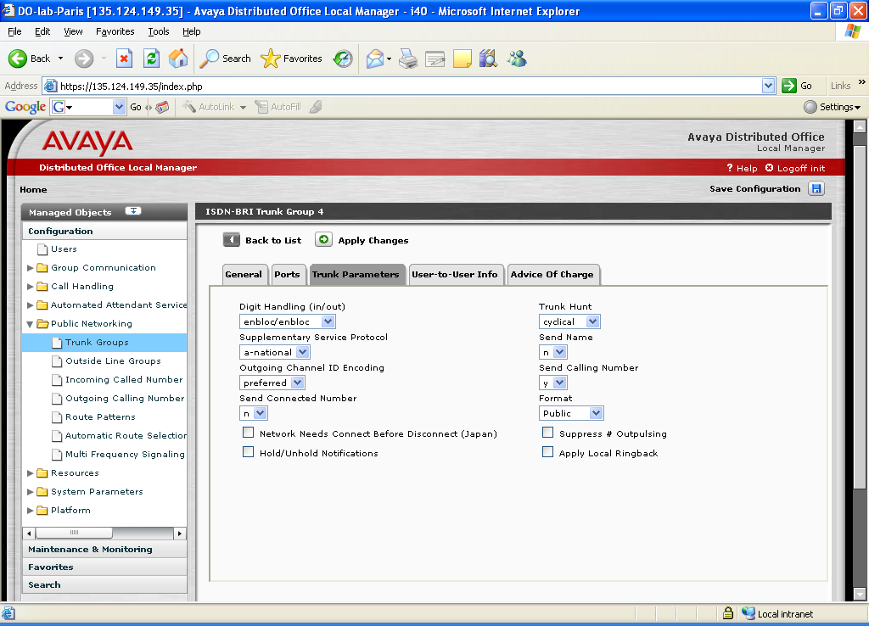

Synchronization administration

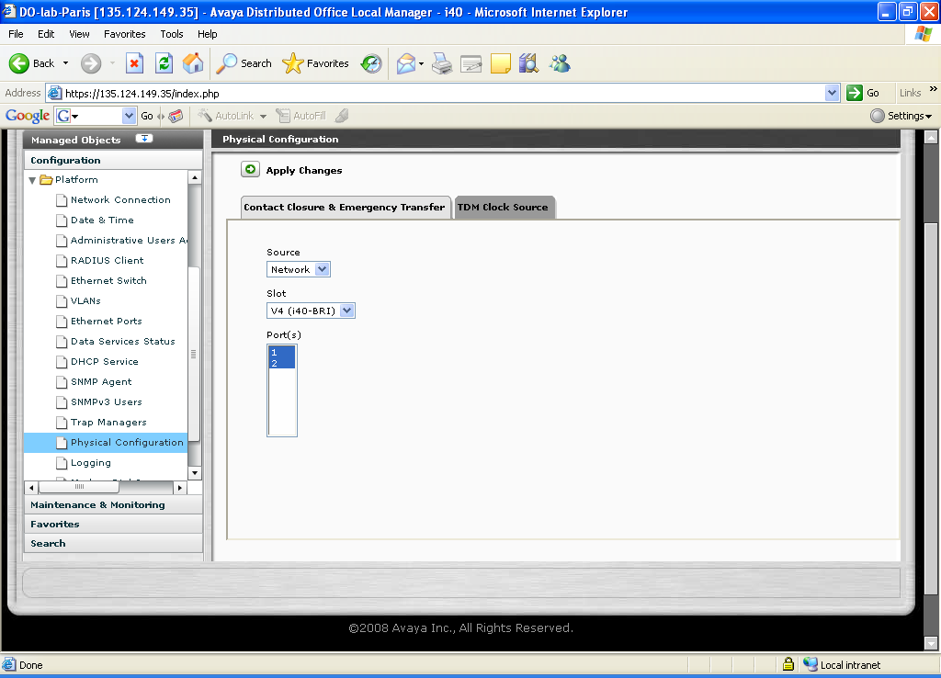

A trace of layer 2 and layer 2 disconnections after the end of a call
This trace is taken with an ISDN analyzer, and shows the initiative of the network which disconnects both layers after the end of a call :

Alcatel E10B example
(AVAYA CM hangs up and sends a DISCONNECT message)
17:30:58/385.5 1- TS D1 BOP FRAME flg=001 [0012]
D2 Q921 (S:00 T:000 C/R:0) I P:0 NR:001 NS:003 [0008]
D3 Q931 Pro:08 Ref:(D,01) DISCONNECT
IE:(0/08) len:2 >> Cause
Oct 3 : -00----- Codage = ITU-T
----0001 Loc = Res. prive-usag. local
Oct 4 : -0010000 016 = Liberation normale
(Layer 2 ack of the previous frame)
17:30:58/407.5 1- RS D1 BOP FRAME flg=001 [0004]
D2 Q921 (S:00 T:000 C/R:0) RR P/F:0 NR:004
(Network sends RELEASE)
17:30:58/697.0 1- RS D1 BOP FRAME flg=001 [0008]
D2 Q921 (S:00 T:000 C/R:1) I P:0 NR:004 NS:001 [0004]
D3 Q931 Pro:08 Ref:(O,01) RELEASE
(Layer 2 ack of the previous frame)
17:30:58/708.5 1- TS D1 BOP FRAME flg=001 [0004]
D2 Q921 (S:00 T:000 C/R:1) RR P/F:0 NR:002
(AVAYA CM sends RELEASE COMPLETE)
17:30:58/725.5 1- TS D1 BOP FRAME flg=001 [0008]
D2 Q921 (S:00 T:000 C/R:0) I P:0 NR:002 NS:004 [0004]
D3 Q931 Pro:08 Ref:(D,01) RELEASE COMPLETE
(Layer 2 ack of the previous frame)
17:30:58/746.3 1- RS D1 BOP FRAME flg=001 [0004]
D2 Q921 (S:00 T:000 C/R:0) RR P/F:0 NR:005
(2 seconds after, the network disconnects layer 2)
17:31:00/802.3 1- RS D1 BOP FRAME flg=001 [0003]
D2 Q921 (S:00 T:000 C/R:1) DISC P/F:1
(Layer 2 disc acked by AVAYA CM)
17:31:00/811.5 1- TS D1 BOP FRAME flg=001 [0003]
D2 Q921 (S:00 T:000 C/R:1) UA P/F:1
(4 seconds after, or 6 seconds after the call ended, the network disconnects layer 1)
17:31:04/324.4 1- »TE: I0 NT: -- source 1: XXX source 2: XXX
(From this point there is no more activity on line)

Ericsson AXE 10 example
The Ericsson switch does not disconnect layer 2 and layer 1 as quickly as the Alcatel. It takes 15 seconds to disconnect layer 2, and then an additional 30 seconds to disconnect layer 1. As a result, there is time for one more layer 2 supervision between the call ends and the layer 2 is disconnected.
Time | Network |  | Avaya CM
T0 | REL_COM | =====➔
T0 + 10 seconds | RR / L2 supervision | =====➔
T0 + 10 seconds |  | ⬅===== | RR / L2 supervision
T0 + 15 seconds | L2 DISC | =====➔
T0 + 15 seconds |  | ⬅===== | L2 UA
T0 + 45 seconds | L1 Info 0 | =====➔
From this point, no activity on line

Bad effect of an H248 disconnection while setting up a call

The following example shows an MST trace, i.e. how an incoming ISDN BRI is seen at the main server level. The very first incoming setup reaches the main server, but unfortunately, the gateway looses connection the, hence is unable to properly transmit the ISDN messages to the PSTN. This results in the phone ringing, but no voice path, from a user experience standpoint.

26837 14:25:02.380 64 40191801 ==> SETUP crv 0_5f
SAPI=00 TEI=00 LinkID=19c4200
Port number: 40191801
Protocol Discriminator: 08 call control
Call Reference Value: 01 5f Origination 5f
Q.931 Message Type: 05 Setup
=> BEARER CAPABILITY 90 90 a3 3.1 kHz audio, 64 kbps, A-law
| coding standard: CCITT
| transfer mode: circuit-mode
| layer 1 indent: layer 1
=> CHANNEL IDENT B1-ch, excl
| interface identifier present: implicitly
| interface type: BRI
| D-channel indicator: not D-ch
=> CALLING PARTY NUMBER .................................. 977996599
| type of number: national
| numbering plan: ISDN/telphny plan E.164/3 |cv ISDN/telphny pln
| presentation ind: presentation allowed
| screening: user-provided verified & passed
=> CALLED PARTY NUMBER ........................................ 2918
| type of number: national
| numbering plan: ISDN/telphny plan E.164/3 |cv ISDN/telphny pln
=> SENDING COMPLETE (a1)

26839 14:25:02.380 66 40191801 <-- CALL_PROC crv 1_5f
SAPI=00 TEI=00 LinkID=19c4200
Port number: 40191801
Protocol Discriminator: 08 call control
Call Reference Value: 01 df Destination 5f
Q.931 Message Type: 02 Call Proceeding
<- CHANNEL IDENT B1-ch, excl
| interface identifier present: implicitly
| interface type: BRI
| D-channel indicator: not D-ch

Here the station rings

26889 14:25:02.380 83 <-- INFO crv 1_0001
From IPAdr: 10.0.6.21 From Port:61442
To IPAdr: 192.168.25.72 To Port:1720 UID: 0x8c76
D-channel port number: 00000000
Protocol Discriminator: 08 call control
Call Reference Value: 02 80 01 Destination 0001
Q.931 Message Type: 7b Information
<- USER-USER ASN1 characters, 44 bytes
| 2c 05 28 10 00 06 a0 01 00 22 01 00 0a 60 86 48 01 86 f8 72 04
| 02 0a 14 14 38 11 20 4c ae e3 1b 5b 00 3b 00 48 1b 5b 02 4b 01
| 3d 20
Decode User Information:
H323-UserInformation SEQUENCE [fieldcount (not encoded) = 1]
h323-uu-pdu H323-UU-PDU SEQUENCE [root fieldcount (not encoded) = 1]
h323-message-body CHOICE [index = 8]
empty NULL [length (not encoded) = 0.0]
NULL
h245Tunneling BOOLEAN [length (not encoded) = 0.1]
FALSE
nonStandardControl SeqOfNonStandardParameter SEQUENCE OF [count = 1]
NonStandardParameter SEQUENCE [fieldcount (not encoded) = 2]
nonStandardIdentifier NonStandardIdentifier CHOICE [index = 0]
object ObjectIdentifier OBJECT IDENTIFIER [length = 10.0]
{ 2 16 840 1 113778 4 2 10 }
data OctetString OCTET STRING [length = 20.0]
0x143811204caee31b5b003b00481b5b024b013d20
Total PDV length = 42.0
Downlink CCMS Value
81A05:VDT_UPD:81A0501:ringer change: DID/attendant ring
81A0501::load display:esc[nul;nulHesc[stxKsoh=_

26909 14:25:02.380 66 40191801 <-- ALERT crv 1_5f
SAPI=00 TEI=00 LinkID=19c4200
Port number: 40191801
Protocol Discriminator: 08 call control
Call Reference Value: 01 df Destination 5f
Q.931 Message Type: 01 Alerting

Here the user answers the call

26968 14:25:22.400 83 <-- INFO crv 1_0001
From IPAdr: 10.0.6.21 From Port:61442
To IPAdr: 192.168.25.72 To Port:1720 UID: 0x8c76
D-channel port number: 00000000
Protocol Discriminator: 08 call control
Call Reference Value: 02 80 01 Destination 0001
Q.931 Message Type: 7b Information
<- USER-USER ASN1 characters, 43 bytes
| 2b 05 28 10 00 06 a0 01 00 21 01 00 0a 60 86 48 01 86 f8 72 04
| 02 0a 13 13 38 11 20 ad e3 1b 5b 00 3b 00 48 1b 5b 02 4b 1b 45
| 40
Decode User Information:
H323-UserInformation SEQUENCE [fieldcount (not encoded) = 1]
h323-uu-pdu H323-UU-PDU SEQUENCE [root fieldcount (not encoded) = 1]
h323-message-body CHOICE [index = 8]
empty NULL [length (not encoded) = 0.0]
NULL
h245Tunneling BOOLEAN [length (not encoded) = 0.1]
FALSE
nonStandardControl SeqOfNonStandardParameter SEQUENCE OF [count = 1]
NonStandardParameter SEQUENCE [fieldcount (not encoded) = 2]
nonStandardIdentifier NonStandardIdentifier CHOICE [index = 0]
object ObjectIdentifier OBJECT IDENTIFIER [length = 10.0]
{ 2 16 840 1 113778 4 2 10 }
data OctetString OCTET STRING [length = 19.0]
0x13381120ade31b5b003b00481b5b024b1b4540
Total PDV length = 41.0
Downlink CCMS Value
81A05:VDT_UPD:81A0501::load display:esc[nul;nulHesc[stxKescE
81A0501:ringer change: off

27009 14:25:24.320 66 40191801 <-- CONN crv 1_5f
SAPI=00 TEI=00 LinkID=19c4200
Port number: 40191801
Protocol Discriminator: 08 call control
Call Reference Value: 01 df Destination 5f
Q.931 Message Type: 07 Connect
<- PROGRESS IND local pvt netwk |cv pub netwrk serv local usr, DESTinat
ion is non-ISDN
<- LOCKING SHIFT TO CODESET 6
<- DISPLAY 10 chars: MESSAGERIE

Here we should see a connect acknowledge but it fails to be sent from the gateway
So we disconnect the trunk

27057 14:25:28.140 66 40191801 <-- DISC crv 1_5f timer expiry !
SAPI=00 TEI=00 LinkID=19c4200
Port number: 40191801
Protocol Discriminator: 08 call control
Call Reference Value: 01 df Destination 5f
Q.931 Message Type: 45 Disconnect
<- CAUSE local pvt netwk |cv pvt netwk serv local usr:102. Recovery on
timer expiry

Here from the gateway logs we see why

0003306980 12/17-14:26:02.00 CCI-STYMINFO-00536 0x1 0xca01 0x14
Last transaction was received 40 seconds ago. Count=1
-------- Press any key to continue -- <Q> to quit --------
0003306979 12/17-14:25:42.00 CCI-STYMINFO-00536 0 0xc9fb 0x14
Last transaction was received 20 seconds ago. Count=0
0003306978 12/17-14:23:57.00 PEV-SYSINFNA-00017 0x3d0004 0x303 0x845a134
15ML

The gateway lost communication to the hub.

