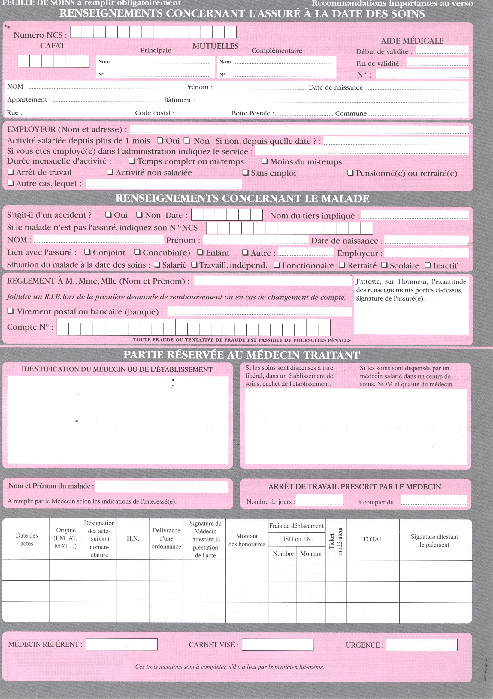
amgid
lastname
firstname
BCI
17499 00010 20596602014 93
cafatid
dob
date |  | <for each="line in o.order_line">  <line.product_id.default_code>  EndFor |  | X |  | <formatLang(o.amount_total,digits=0)> |  |  | <formatLang(o.amount_total,digits=0)>

<o.partner_id.fullname> <o.partner_id.fullname>

