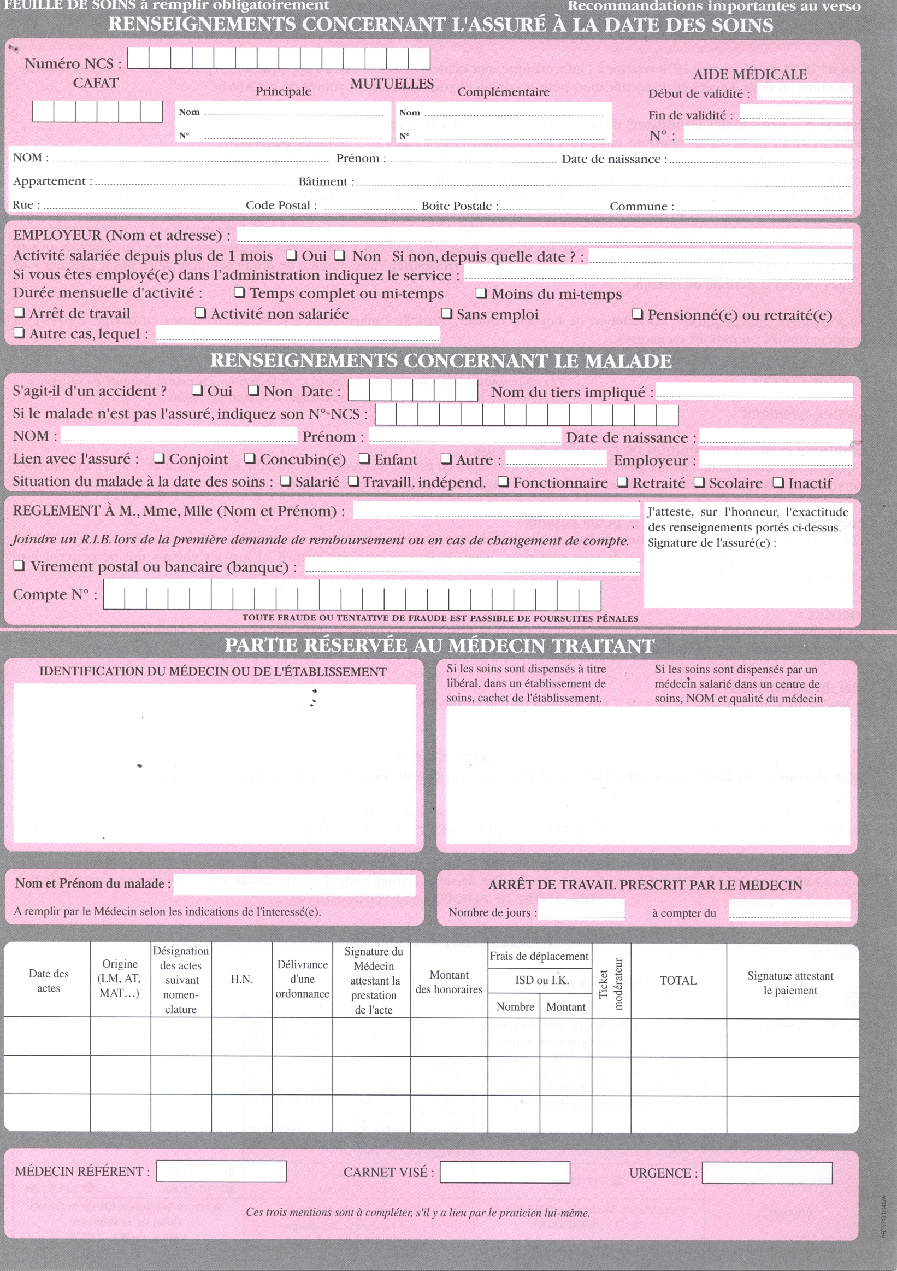

cafatid
amgid
lastname firstname dob

date |  | <for each="line in o.invoice_line">  <line.product_id.default_code>  EndFor |  |  | <o.amount_total> |  |  | <o.amount_total>

