Autonomous Vehicle Design, Spring 2020
Motor Encoder Homework, 100 points
Tyler Angus

Objective: Become familiar with the characteristics of the motor encoders

1. Position Estimation (30 points)

a. What encoder count represents one complete revolution of the motor shaft?

I used the code attached called Problem_1_test. I drew a white line on the shaft and then rotated it once. I did this for the right and left motor shaft. With one rotation my code told me there was 27 encoder counts. I conducted this test several times and kept getting 26-28 encoder counts. This led me to the number 27. Part of the difficulty of this method was the accuracy if my finger shook a little it would count and extra and I would have to start over. The results are shown in the table below.

Test # | Right motor count | Left motor count
1 | 27 | 28
2 | 26 | 27
3 | 28 | 27
4 | 27 | 26
5 | 26 | 27
6 | 27 | 28

b. What encoder count represents one complete revolution of the robot’s wheel?
For this experiment I attached a piece of tape to the wheel and then taped a straight edge to the bot in order to be as accurate as possible. I started with the edge of the tape and straight edge matched up then rotated once around and matched the edges back to each other. The results are captured below in the table. The magnets in the motors make this difficult because the rotation tension is variable. I included pictures of the setup within the zip file
Right motor averaged to 781 and left motor averaged to 782

Test # | Right motor count | Left motor count
1 | 782 | 783
2 | 779 | 780
3 | 780 | 784
4 | 783 | 783
5 | 780 | 781
6 | 782 | 780

c. Assuming both wheels are rotating in the same direction, at the same speed, how far does the robot travel in one complete revolution of its wheels?
Describe the experimental procedure used to determine this. Include any data, plots, images that support your findings. Submit any source code used in testing.

I measured the diameter with a tape measure calculated the the distance traveled after on rotation is 21.0cm. The diameter was .067m. So, 0.067 X pi = .2104867m

I also verified this by rolling one rotation on a table then measuring the distance traveled by using a tape measure and I also came up with 21.0cm.

2. Velocity Estimation (70 points)

Test Procedure
This was actually the first part of the experiment that I started with. I didn’t quite understand what problem one was asking so I moved onto this part of the assignment. I started by getting the code to work with just forward and then I modified it to do a backwards test. Before I got the forward code I had to learn how to implement the pin change interrupt. I had seen this before so this part was not to complicated. I used the same idea utilized in the lessons. After getting everything to work it was easy to see that there was a difference between both motors. The right motor is consistently faster than the left when going backwords. The bar graph below depicts the information and came from my python code. The python code took the test data averages it and then saves it into a file. It then plots it onto this graph. The F 25% means the motor was traveling forward at 25% duty Cycle. Please look at the .txt file to see all the data collected.
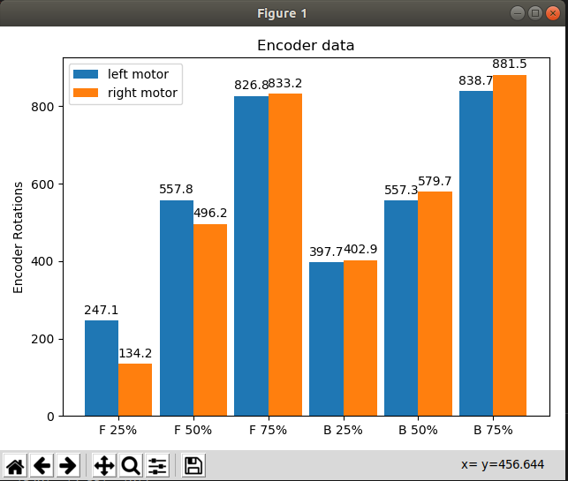

Below is an example of how I calculated the Average Motor Shaft Speed

2471 counts /27 counts per shaft rotation = 91.5 rotations/5sec= 18.3 rotations per second
360degrees per rotation so, 18.3 * 360 = 6589 degrees per second.

Average Wheel Speed Calculation is below:

2471 counts / 782 counts per wheel rotation = 3.1598 rotations/5sec = 0.632 rotations per second
.210*0.632= 0.133 m/s

Due to the voltage not changing significantly during testing I averaged the voltage for all tests

Forward Test | Number Samples | Total Encoder Count | Total  Time | Average Motor Shaft Speed, degrees/second | Average Wheel Speed, m/s | Battery Voltage
¼ speed, left | 10 | 2471 | 5 sec | 6589 | 0.133 | 7.54V
¼ speed, right | 10 | 1342 | 5 sec | 3579 | 0.072 | 7.54V
½ speed, left | 10 | 5578 | 5 sec | 14875 | 0.300 | 7.54V
½ speed, right | 10 | 4962 | 5 sec | 13232 | 0.267 | 7.54V
¾ speed, left | 10 | 8268 | 5 sec | 22048 | 0.444 | 7.54V
¾ speed, right | 10 | 8332 | 5 sec | 22219 | 0.448 | 7.54V

Backward Test | Number Samples | Total Encoder Count | Total  Time | Average Motor Shaft Speed, degrees/second | Average Wheel Speed, m/s | Battery Voltage
¼ speed, left | 10 | 3997 | 5 sec | 10659 | 0.21 | 7.54V
¼ speed, right | 10 | 4029 | 5 sec | 10851 | 0.22 | 7.54V
½ speed, left | 10 | 5573 | 5.001 sec | 14861 | 0.300 | 7.54V
½ speed, right | 10 | 5797 | 5.001 sec | 15458 | 0.312 | 7.54V
¾ speed, left | 10 | 8387 | 5 sec | 22365 | 0.450 | 7.54V
¾ speed, right | 10 | 8815 | 5 sec | 23507 | 0.474 | 7.54V

Conclusion
I learned a lot in this assignment as usual. I spent a large amount of time on it as usual and I believe I got everything working as it is supposed to. I made many mistakes some which took several hours to figure out. It was interesting to see how the motors are traveling a very different speeds because of the hardware and interference etc. I think this information will be vital when we need to make the robot go places and not just balance. Overall the project was very successful.

