Causes and effects:

C1: normal m-f workweek

C2: non-normal m-f workweek

C3: holiday date is on a workday

C4: holiday is not on a workday

C5: Employees day off in lieu of sat or sun

E1: holiday observed

E2: holiday goes to next workday

Intermediate nodes when determining if a day is a regular workweek, irregular workweek, or a day off.

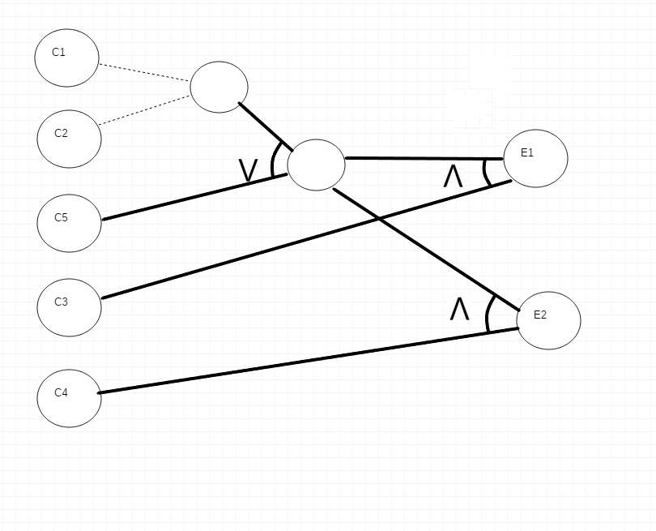

A logical relationship is that regardless of a regular or irregular workweek, if the employee is scheduled to work on a holiday, they observed the holiday that day. If they do not, then it is observed on the next workday.

|  |  |  |  |
| --- | --- | --- | --- |
| Weekday | Employee works | Holiday | Observed? |
| SU | T | T | T |
| SU | T | F | F |
| SU | F | T | F |
| SU | F | F | F |
| M | T | T | T |
| M | T | F | F |
| M | F | T | F |
| M | F | F | F |
| TU | T | T | T |
| TU | T | F | F |
| TU | F | T | F |
| TU | F | F | F |
| W | T | T | T |
| W | T | F | F |
| W | F | T | F |
| W | F | F | F |
| TH | T | T | T |
| TH | T | F | F |
| TH | F | T | F |
| TH | F | F | F |
| F | T | T | T |
| F | T | F | F |
| F | F | T | F |
| F | F | F | F |
| SA | T | T | T |
| SA | T | F | F |
| SA | F | T | F |
| SA | F | F | F |