Assignment 1. HTML & CSS Basics — Project Report
Team Name: KFC Bosses Group: SE-2510 Topic: KFC Kazakhstan Project

1. Team Members & Roles
- Zharkyn Akhmetov
  - Role: Idea creator & JS/CSS stylist
  - Pages Created: index.html, menu.html
- Khantore Orynbassar
  - Role: Executive Chef & HTML Lead Developer
  - Pages Created: schedule.html, contacts.html
- Alnur Bakbergenov
  - Role: True Boss & HTML/CSS Assistant Developer.
  - Pages Created: promos.html, about.html

2. Objective
The main objective of this assignment was to build a foundational, multi-page website using semantic HTML5 and external CSS3 styling without utilizing UI frameworks like Bootstrap. The project aims to demonstrate proficiency in web page structuring, applying the CSS box model, styling typography, and integrating functional UI components like forms, tables, and modal windows.

3. Step-by-Step Description of Tasks
Part 1: HTML Structure
- Step 1: Created a shared project folder and initialized 6 .html files. We included the standard HTML5 boilerplate and linked the external stylesheet (css/style.css) in the <head> of every page. A universal <footer> with our team details was added globally.
- Step 2: Developed the content hierarchy using semantic tags (<h1> to <h3>, <p>). A dedicated "Our Team" page (about.html) was created to introduce the developers using grid-aligned cards.
- Step 3: Implemented a sticky global navigation bar with <ul>, <li>, and <a> tags. We embedded contextual images with proper alt text across the site and used ordered/unordered lists to display dish ingredients and promotion steps.
- Step 4 & 5: Structured tabular data (nutritional info and location schedules) using <table>, <th>, <tr>, and <td>. We built an interactive review submission form in contacts.html containing text, email, select, and textarea inputs.
Part 2: External Styling with CSS & JS Integration
- Step 6 & 7: Developed a custom style.css file utilizing a cohesive red, white, and dark gray color palette stored in CSS variables (:root).
- Step 8 & 9: Applied Element, Class, ID, and Descendant selectors to isolate specific components (e.g., #main-header, .promo-card). Styled the typography and removed default link styling, adding clear :hover states.
- Step 10 & 11: Utilized the CSS Box Model (margins, paddings, borders) and Flexbox/CSS Grid to establish responsive layouts for the main content, news feeds, and team cards.
- Step 12 & 13: Set border-radius: 50% on team member avatars to create circular profile images. We customized all form inputs with borders, focus states, and specific padding. We also added a lightweight vanilla JavaScript script (script.js) to handle the dynamic review feed and the dish customization modal.

4. Live Website URL
GitHub Pages / Netlify URL: https://github.com/frozzeh/WEB-1-Assignment.git

5. Screenshots
- 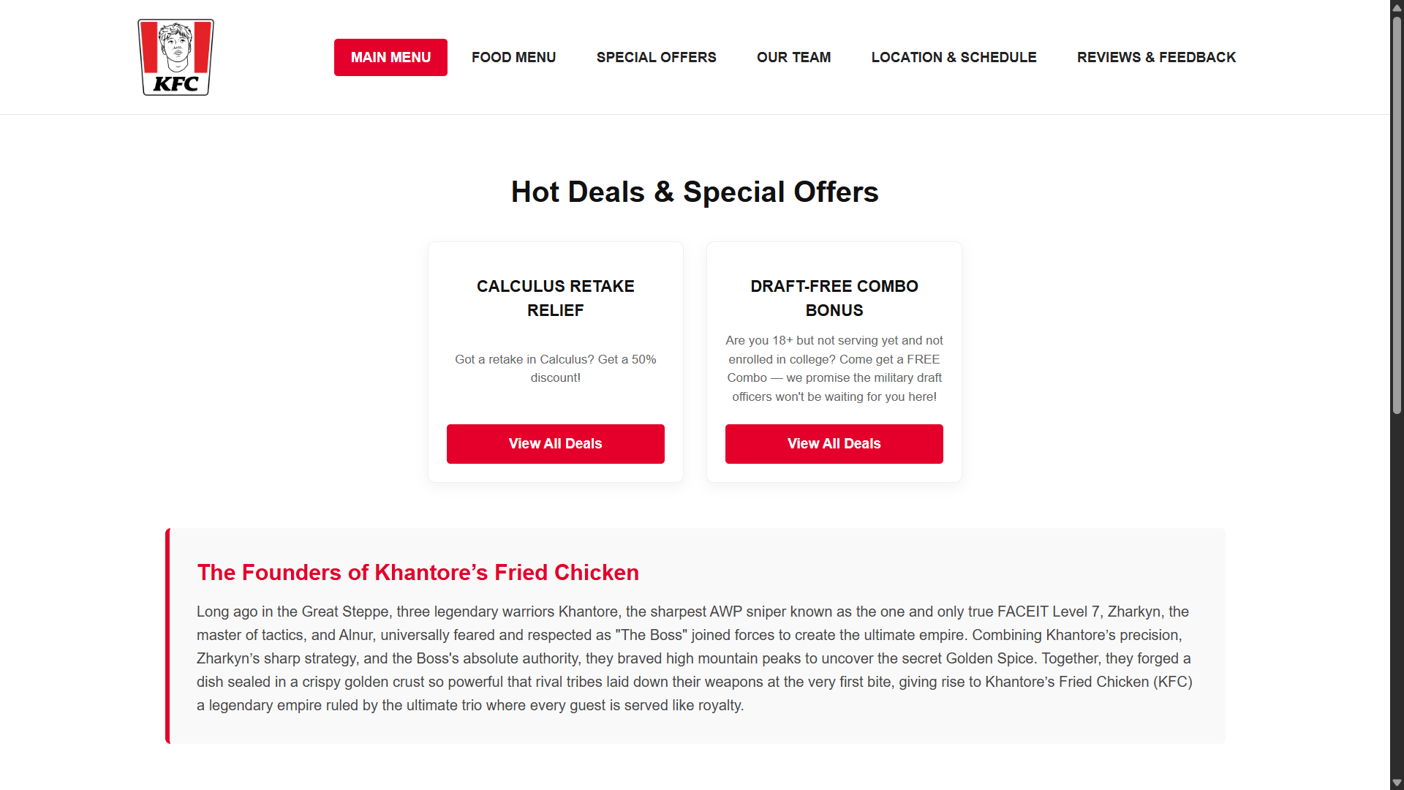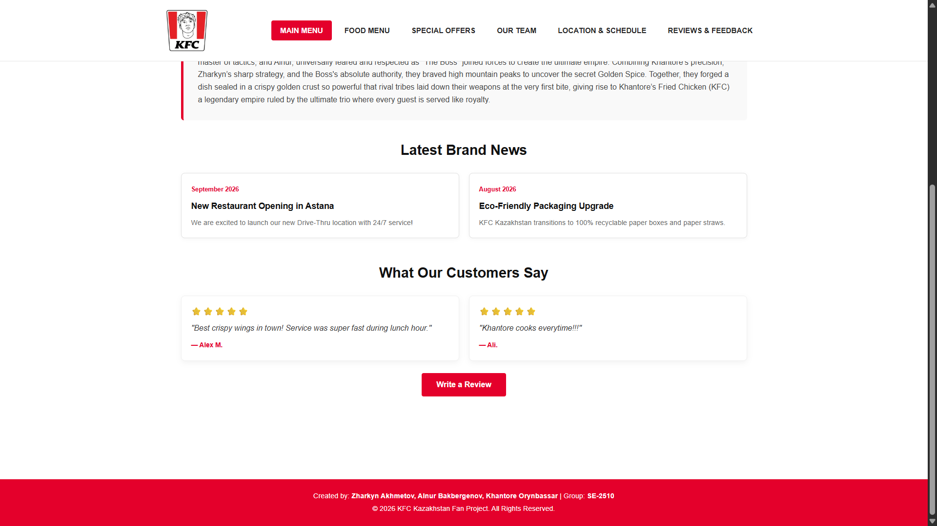- Main Menu.
- 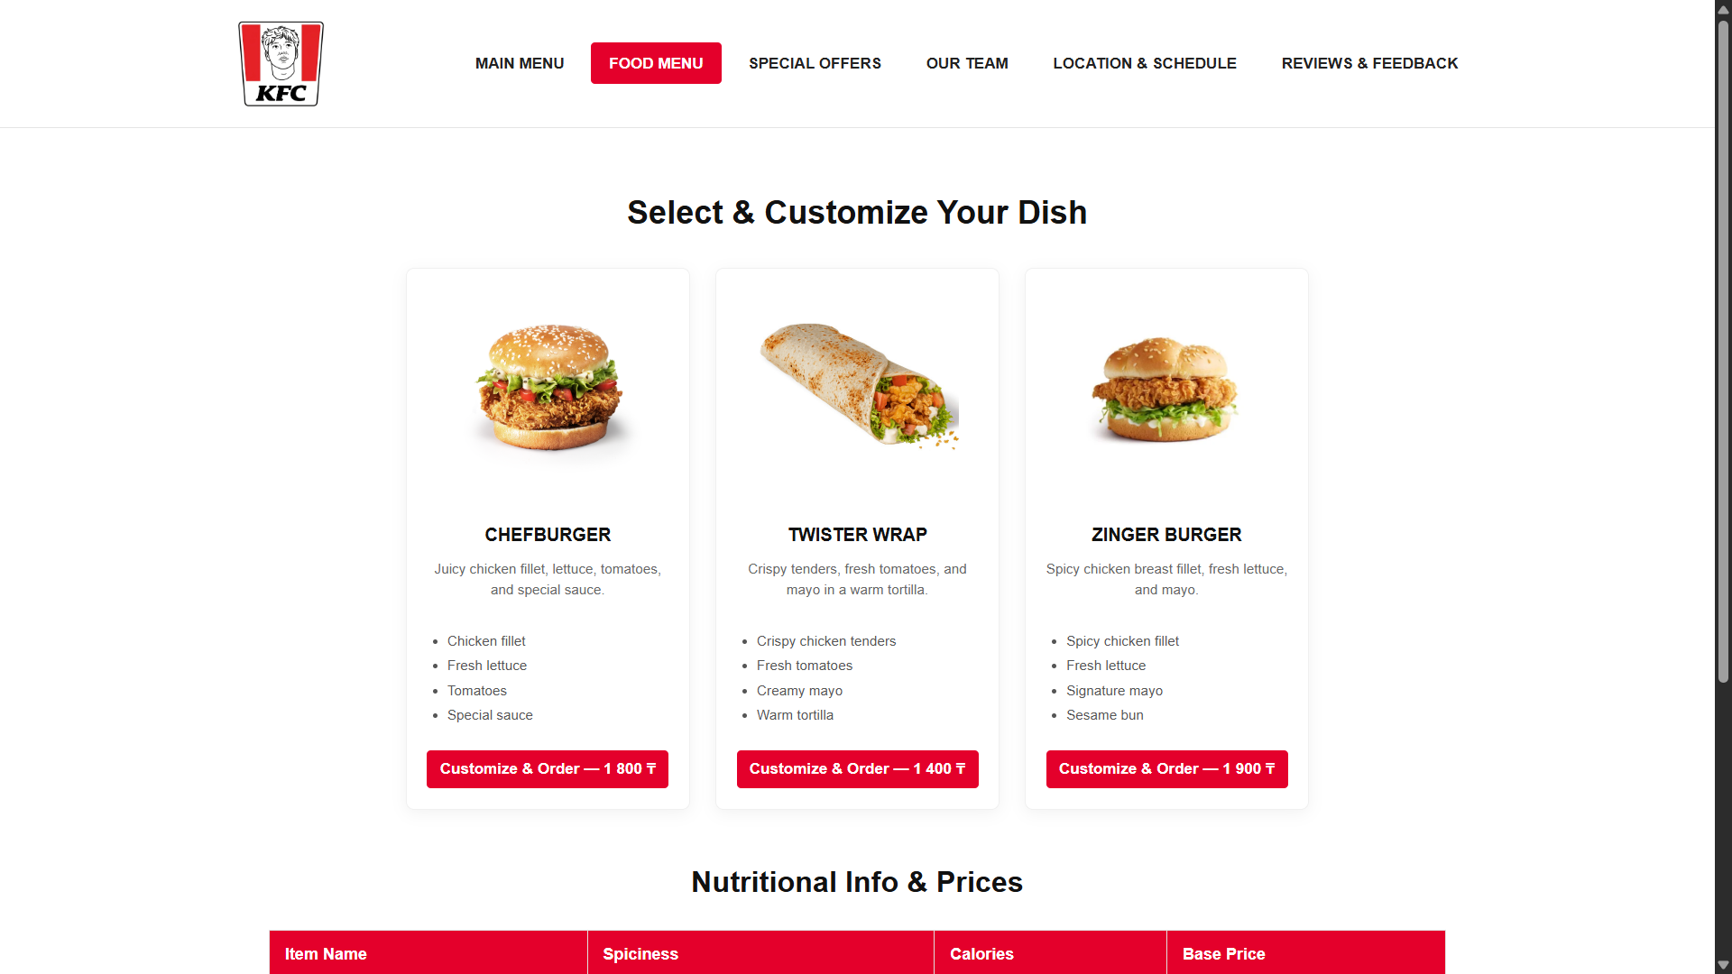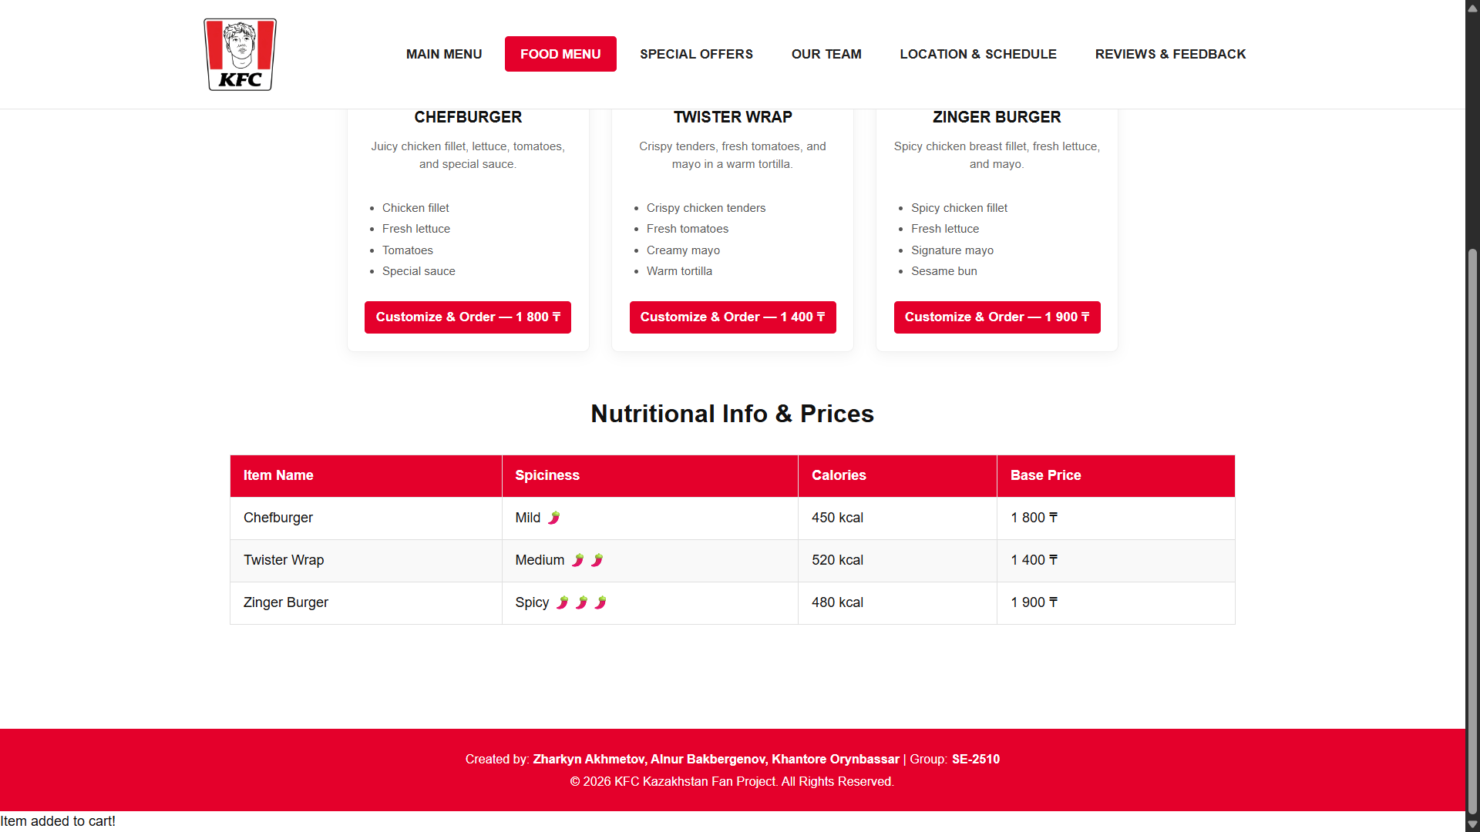- Food Menu.
- 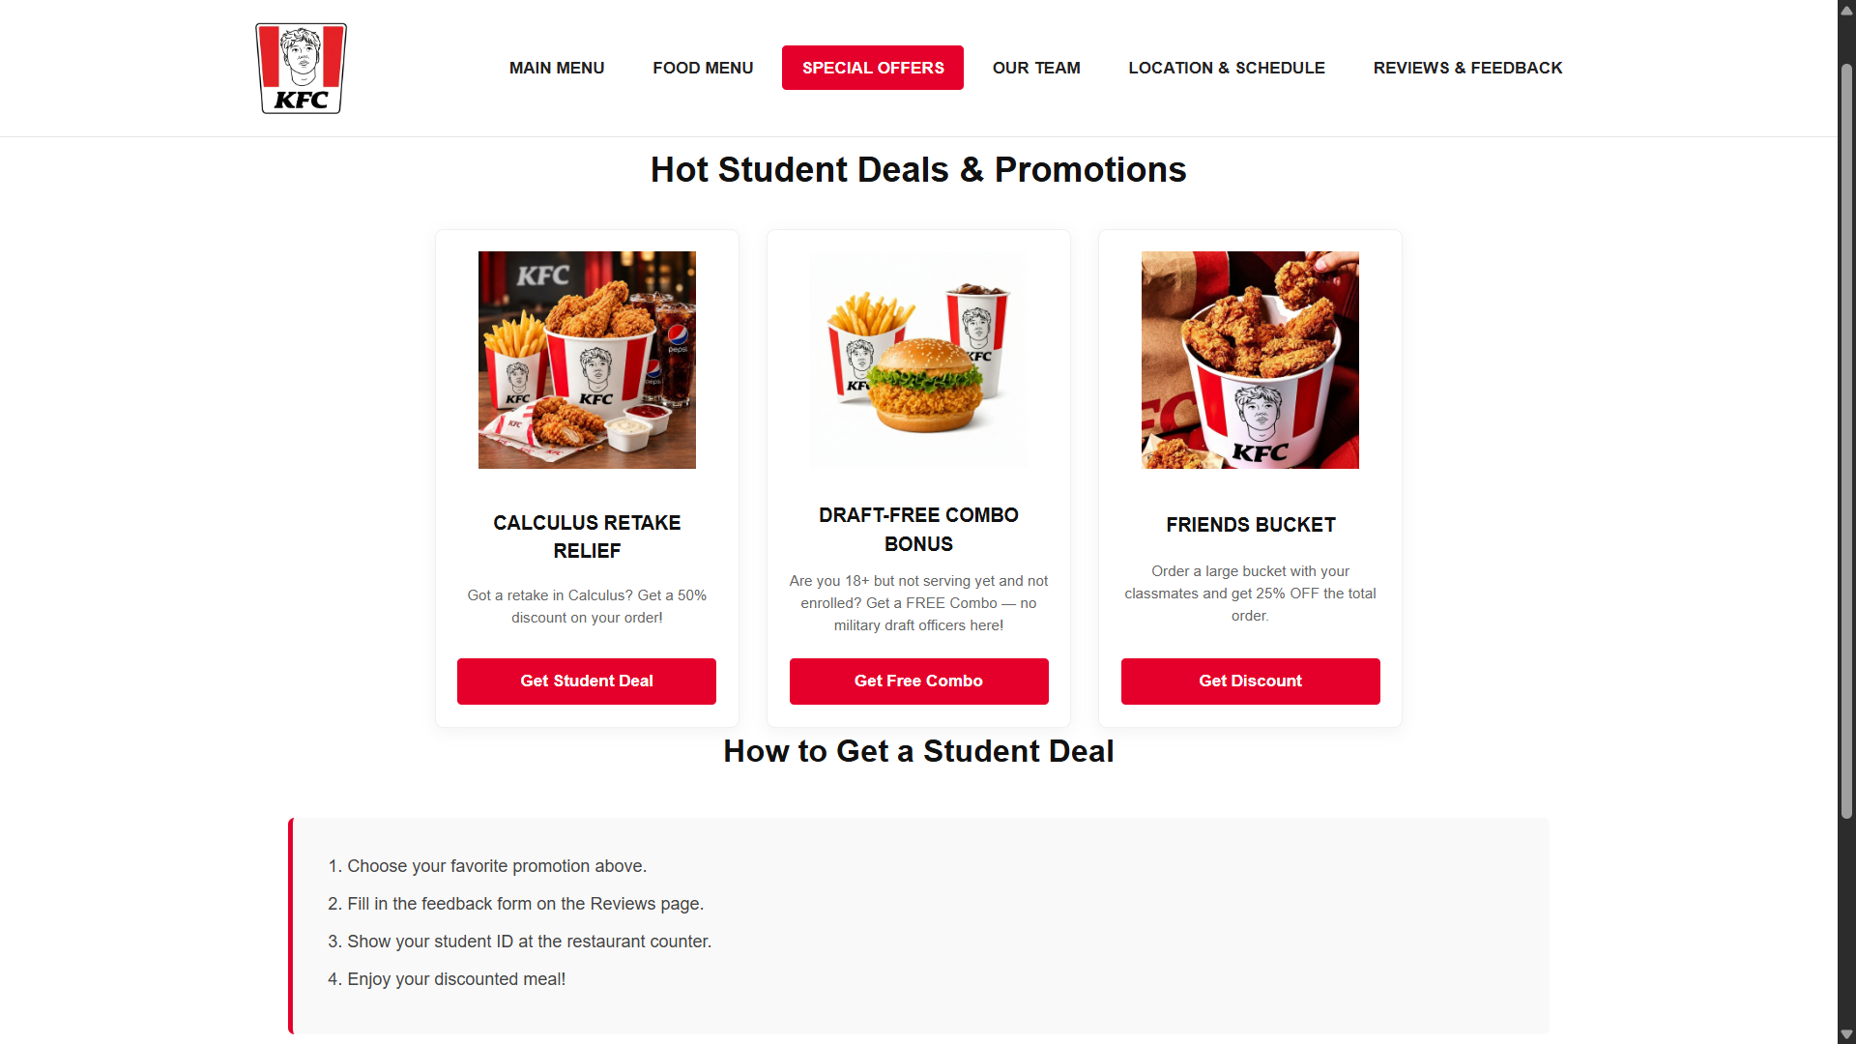- Special Offers.
- 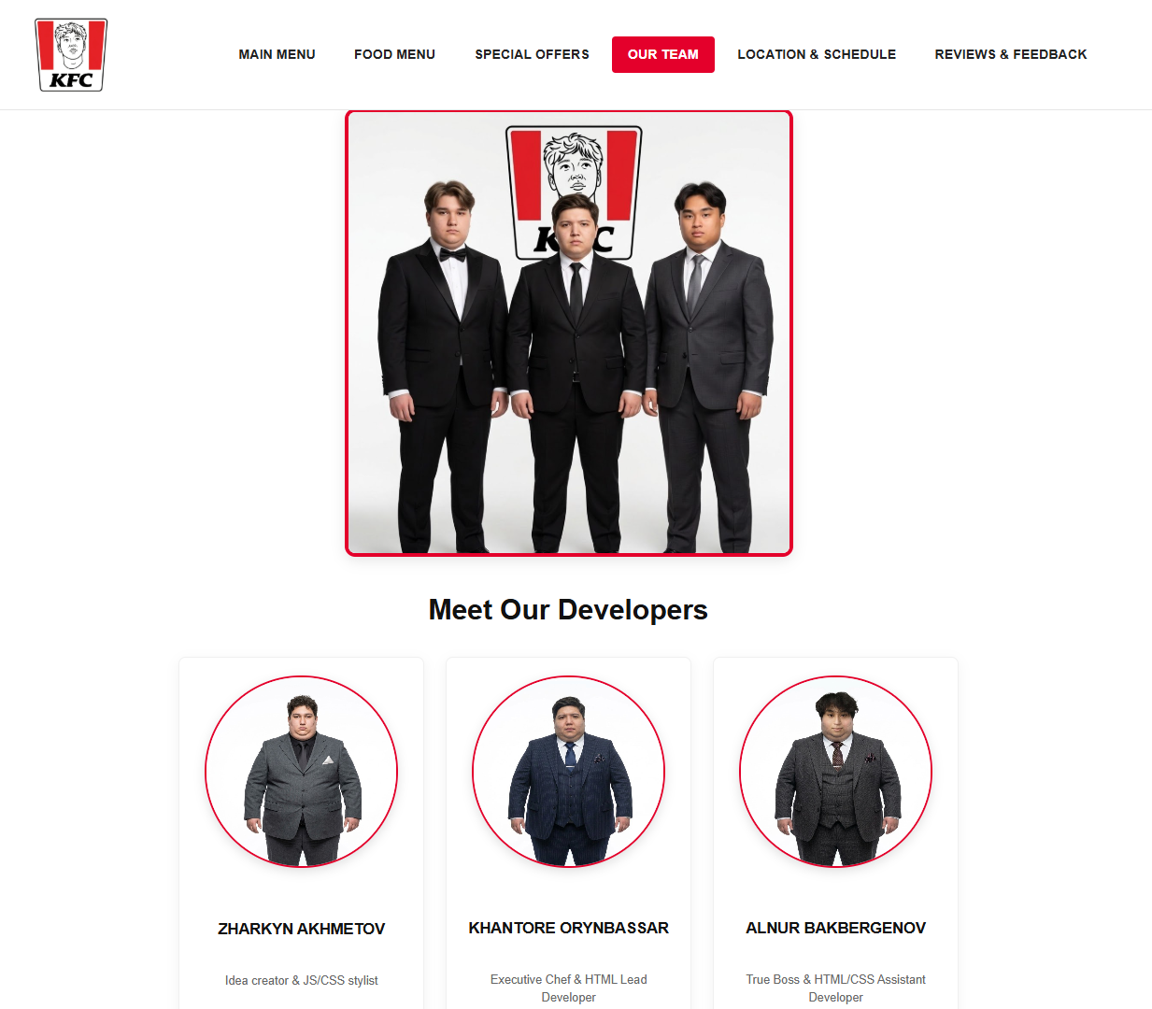- Our Team.
- 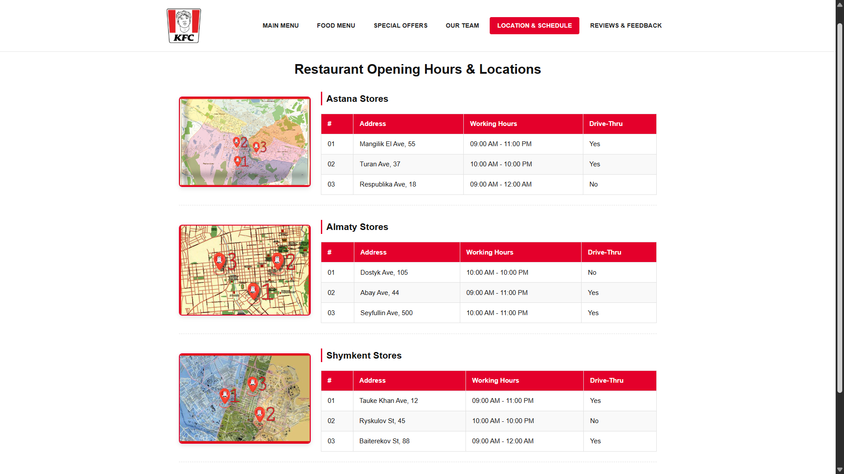- Location & Schedule.
- 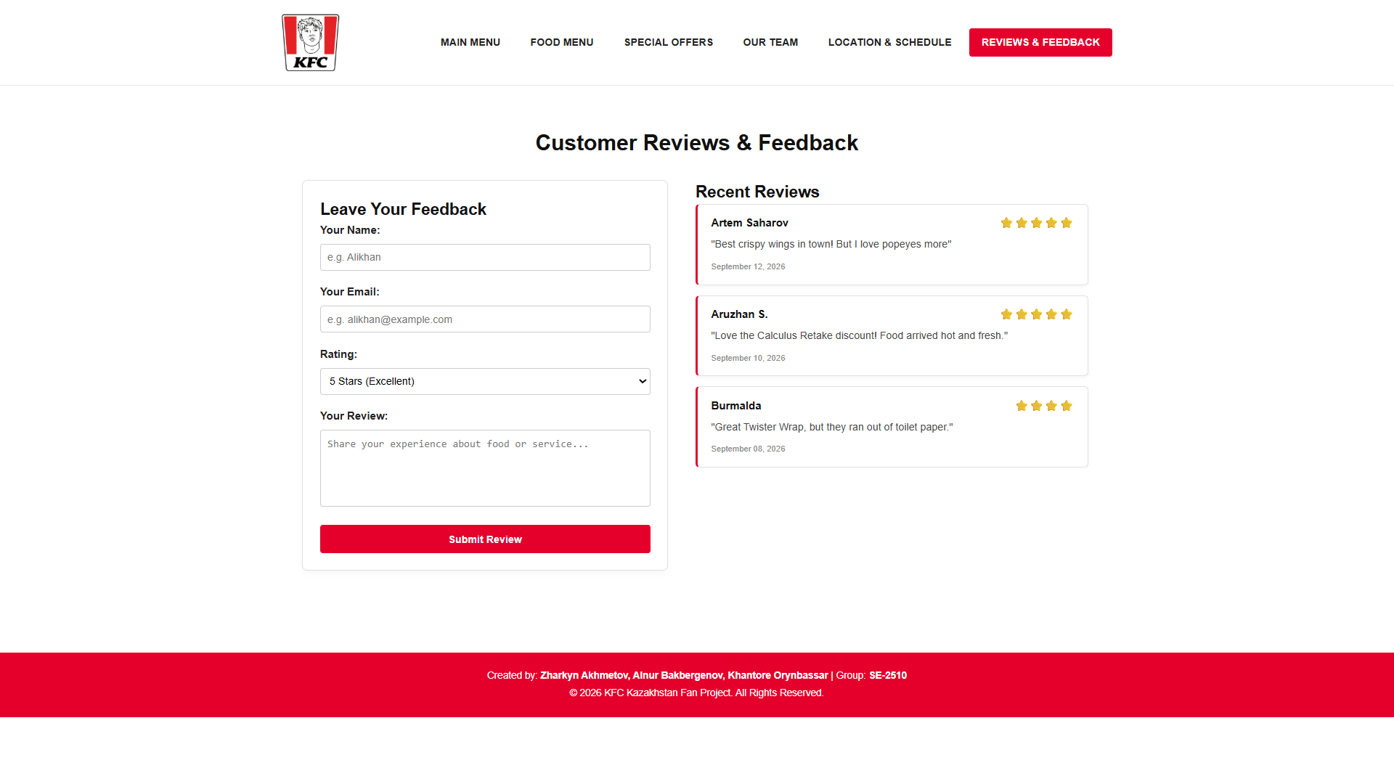- Reviews & Feedback.

