Uuıv›esıww...

Dıss›ewawıou...

Dıss›ewawıou...

**A simulation approach to investigate the interactions between autonomous cars and human drivers**

*Author:*

Aleksander Wıuusz

*Supervisor:*

Eddie Wıusou

September 15, 2016

**Abstract**

This dissertation attempts to find out in which way introducing autonomous cars to the traditional traffic will affect the traffic itself and how human drivers will interact with the driverless vehicles. It is claimed that at least for the next two or three decades we will be observing transition period that will eventually lead to fully autonomous traffic. During that period human drivers will have to coexist with driverless cars and therefore the study on interactions between them is very relevant. The claim is also supported by the fact that the main focus in relevant literature is towards the development of sensors and algorithms while little attention is given to study on the interactions and their possible consequences.

The central part of the project is a simulation of urban traffic. It was run in form of the experiment involving multiple human participants simultaneously connected to the the same simulation. Participants were asked to control one of the vehicles and drive along the track, while avoiding collisions with other participants. The experiment consisted of various sessions in which human drivers were accompanied by a different amounts of autonomous vehicles.

The results obtained from the experiment suggest possible improvements in the traf- fic coming from the presence of autonomous cars themselves. It was shown that au- tonomous cars exhibit smoother driving and very efficient interactions with other self- driving vehicles. However, it was not unequivocally established whether the presence of driverless cars influences the drivers themselves.

Apart from the experiment, the dissertation describes the development of software and car models that allowed to successful run the simulation.

The main conclusion is that the more autonomous vehicles are on the roads, the better is traffic but regardless of that it is the human who remains the most unpredictable and error-prone element of the driving environment.

**Contents**

1. Introduction and Motivation 4

1.1 Driverless cars revolution . . . . . . . . . . . . . . . . . . . . . . . . . . . . . 4

* 1. Implications of autonomous cars revolution . . . . . . . . . . . . . . . . . . . 8
  2. Main challenges to bring autonomous cars to the roads . . . . . . . . . . . . 9
  3. Interactions between human drivers and autonomous vehicles 11
  4. Defining the research scope 12
  5. The experiment 15
  6. Roadmap 16

1. Software Engineering and Model Development 18
   1. Environment choice 18
   2. Software architecture 20
      1. Simulation server application design 20
      2. Client application design 25
   3. Modelling car dynamics 27
      1. Car following models 27
      2. Autonomous car model 28
      3. Human car control 29
   4. Communication between machines 33
2. Experimental Design 36
   1. Principles of the experiment 36
   2. Scenarios 37
      1. Learning phase 38
      2. Scenario 1 39
      3. Scenario 2 39
      4. Scenario 3 40
   3. Client interface 41
   4. Experiment’s execution 42
      1. Questionnaire 43
      2. Minutes 44
3. Results 44
   1. Observations 45
      1. Deceleration mapping 45
      2. Evaluation of participant’s performance 46
      3. Conflicts resolution 49
   2. Hypotheses 52
      1. Hypothesis: Autonomous cars reduce number of accidents 52
      2. Hypothesis: Autonomous cars smooth out traffic 54
      3. Hypothesis: Most efficient traffic could be achieved with solely au- tonomous vehicles 56
4. Conclusions and Discussion 59

# Introduction and Motivation

Autonomous cars are currently a topic of great interest. Around the world the biggest private companies are investing in projects on driverless technology. There are currently 33 global corporations, including giants like Google, Apple and Tesla, that channel significant resources to autonomous driving (CB Insights 2016). The most innovative countries are allocating large sums of money not only to develop the technology, but also to raise public awareness and introduce necessary legislation (UK Department of Transport 2015*b*);(UK Department of Transport 2015*a*).

Although the topic is studied very widely and the amount of corresponding literature is enormous, this dissertation attempts to identify a potential gap in developing a broad under- standing of how autonomous vehicles may impact upon traffic flow, <includoing traditiona human-driven vehiclse>.

The first part of this chapter introduces the topic of autonomous driving. It discusses current technological developments and attempts to identify the main challenges in the up- coming decades. Supported by the literature review section 1.5 states which research gap was identified and why it is worthy to investigate it. Consecutively, a precise statement of research questions is given, followed by a list of aims and objectives of the dissertation. Sec- tion 1.6 describes the experiment which was the central part of the project. It also talks about how the original scope of the project evolved from the initial plan to the current state. Finally, in last section of a chapter a roadmap of the whole project is given; starting from the devel- opment of software, through the design of the experiment and finishing with the analysis of the results.

## Driverless cars revolution

Many experts around the world try to predict how autonomous cars will influence our life in the upcoming decades. It is commonly agreed upon that fully automated traffic will become a reality around the year 2060, although the most optimistic predictions claim it will happen as early as 2040 (Geiger et al. 2012); (Litman 2014); (Sivak & Schoettle 2015). In the next years we will be observing a gradual change on our roads, as the number of self-driving cars will increase.

The key factor that influences the steady shift towards fully automated traffic is a broadly

understood technological advancement. Even though, all the efforts have been leading to- wards building a fully autonomous car, such a vehicle has not yet been constructed (Litman 2014). This section talks about the current development of the self-driving technology. It also touches upon possible scenarios for its future development and discusses the challenges that need to be faced.

**Current development of autonomous cars** The most recent achievements in the field of autonomous cars are probably best presented through cutting-edge commercial projects such as Google’s Self-driving car (Google X 2016), Tesla’s Autopilot (Tesla 2016*b*) or Volvo’s ‘Drive Me‘ project (Volvo 2015). Google (Alphabet) is perhaps the most experienced player as its self-driving car project started as early as 2009. However, it would be an overstatement to say that it is also the most advanced project, as other corporations also reached high levels of the technological advancement and every project focuses on different aspects of autonomous driving (CB Insights 2016).

Google’s car is classified as level 3 in the automated vehicle classification system pro- posed by NHTSA (2013) and also as level 3 in a similar classification proposed by SAE (2013). This level of autonomy means that the car takes full control over all critical safety functions, but at certain times, the driver can be asked to retake the control (and must do so).

The topic is so interesting in that only roughly 60% of companies involved in this business are genuine car-producing companies. Others, like the aforementioned Google and Apple, or like a relatively new player - Uber, saw a new, promising opportunity and decided to expand towards this new emerging market (CB Insights 2016). Figure 1 shows a modified Volvo XC90 that was created in collaboration with Uber.

Another company that achieved significant successes is Audi with its Piloted Driving project. The company managed to develop a racing car capable of beating a professional driver on a racing track. Nonetheless, Audi is also developing technologies for civil driving (Audi 2013).

While vehicles on the 3rd level of autonomy are currently only research projects, there are

increasingly more commercially available vehicles that have features characteristic for the 2nd level of autonomy. The prime example is Tesla’s Autopilot that drives itself on the highway and is able to actively change lanes on a motorway when instructed by the driver (Tesla

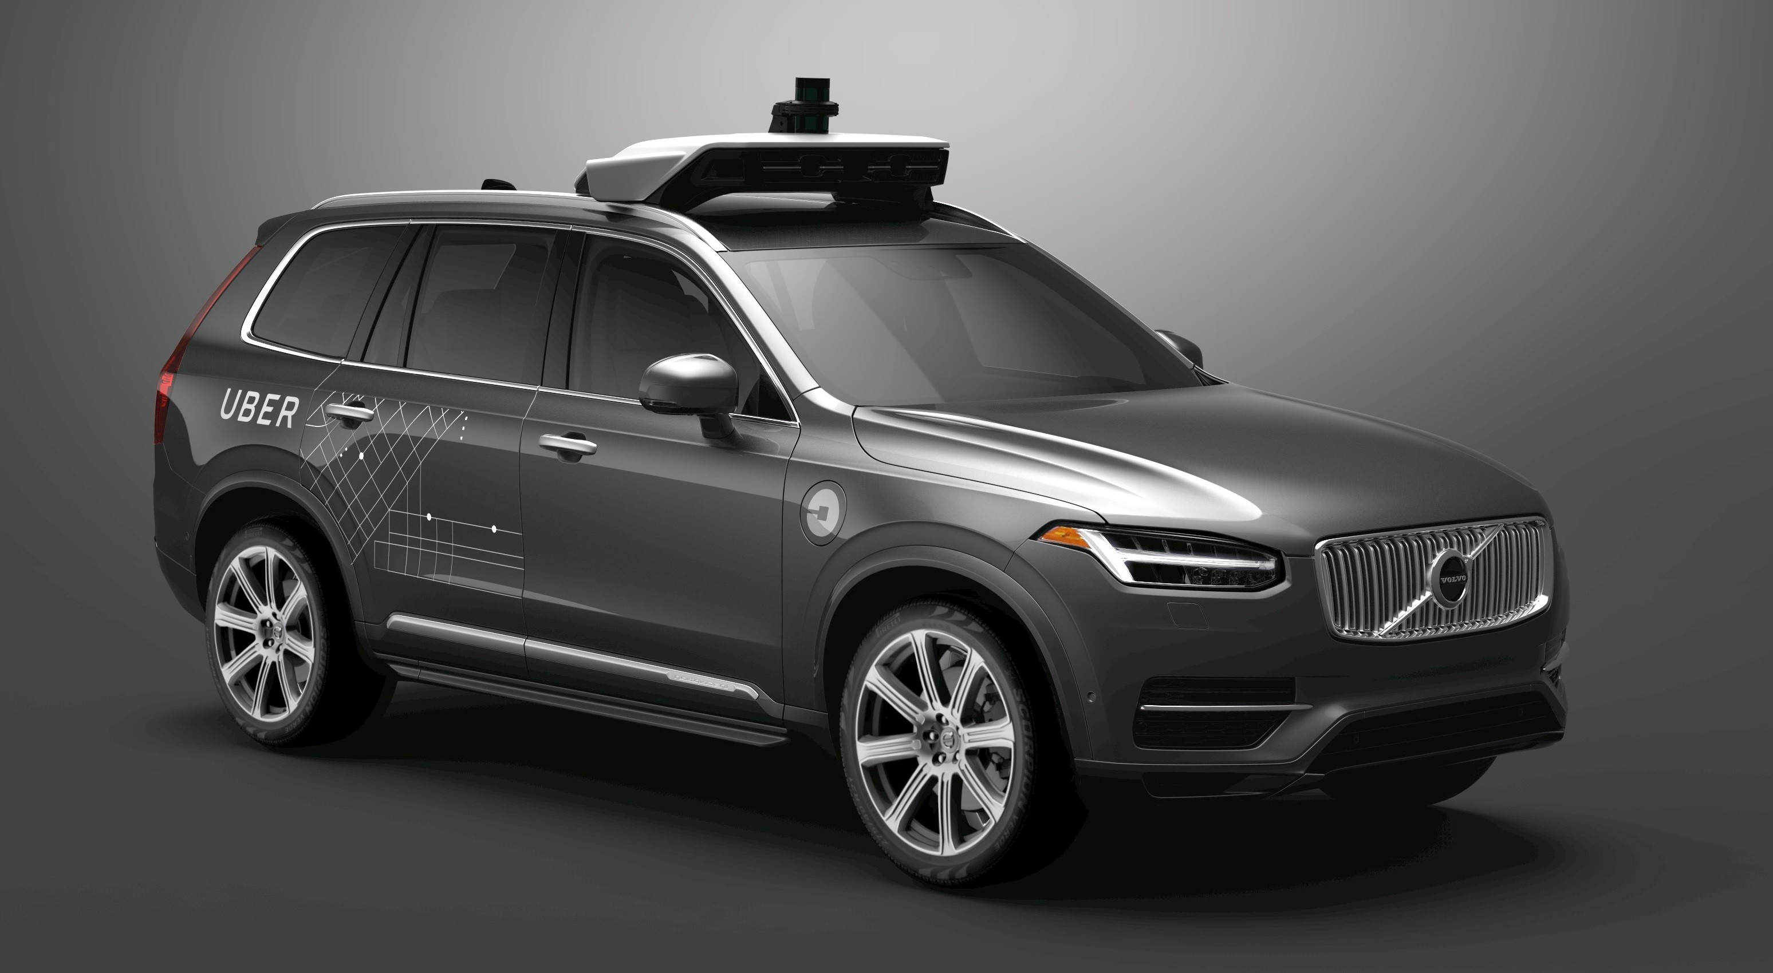

Figure 1: Self-driving Volvo XC90 developed in collaboration with Uber. As of August 2016 pilot project is being launch in Pittsburgh, USA (Bloomberg 2016). Photo reproduced from: Volvo (2015)

2016*c*). Other examples are the latest premium segment cars by BMW and Mercedes that have features such as lane departure warning, adaptive cruise control or traffic jam assistant (BMW 2015); (Mercedes 2015). According to the guidelines by NHTSA, car classified as 2nd level of autonomy must be able to combine at least two of these abilities simultaneously.

Apart from projects run by private companies there are also numerous initiatives sup- ported by public resources. An example of these is the VENTURER Project run by a con- sortium of academic, public and private organizations. The people responsible undertaking this will start testing on regular roads in 2017.

Although most of these projects bloomed in the last decade, the idea of autonomous or automated vehicles is considerably older. The first attempts of automating the whole process of driving or only a part of it were made in year 1977 when researchers at Tsukuba Mechanical Engineering Laboratory in Japan built a car that followed white markers and could reach a speed of 20 mph (Forrest & Konca 2007).

**Views on the future**

In the near future we should observe more and more autonomous vehicles appearing on the roads. As mentioned before, fully autonomous traffic is not predicted to happen before the year 2040. The next 30 years should bring significant technological development, along with much needed new legislation and social changes.

It should soon be possible to create a vehicle classified in the 4th level of autonomy. According to NHTSA (2013), a vehicle featuring the 4th level of autonomy should always be able to perform safety-critical driving operations and the driver will not be asked to take over control in any situation. Ford claims to deliver such a vehicle without a driver, steering wheel and pedals by the year 2021 (Ford 2016).

It is likely that in the midterm future another idea of connected vehicles may become reality. The idea states that vehicles that are close to each other can communicate and therefore increase the safety and add a level of intelligence to their behaviour. Vehicles can also connect to infrastructure and e.g. predict the traffic lights sequence (Narla 2013) ; (Luettel et al. 2012).

Another prediction is that the development of new legislation can be slower than the development of the technology. Although the fully autonomous car may exist, it might be still required to supervise it from the driver’s seat (Luettel et al. 2012). None the less, the UK government claims to be aware of these necessary changes. The report released by UK Department of Transport titled ‘The Pathway to Driverless Cars Summary report and action plan‘ (UK Department of Transport 2015*b*) states that government recognises the benefits of autonomous vehicles and is undertaking actions to aid the development of technologies and law that would allow to bring driverless cars on public roads’. Additionally, the UK Department of Transport (2015*a*) informed that £19 million is currently being provided to allow testing of automated vehicle technology.

Although the majority of the literature focuses on various technical aspects of driverless cars, there are also certain concerns about whether the development is going into the right direction. McBride (2016) gives Oxford University’s Robotcar as an example and says that the pursuit of full autonomy does not properly recognize the separation between a human and a machine. The author claims that self-driving vehicles should not be allowed to drive without being deeply connected to the infrastructure, internet and other users.

All in all, in the next years we will observe more development in all aspects of autonomous driving. During that time, autonomous cars are likely to be still limited to structured, pre-

dictable environments. We may encounter some challenges mentioned in this section or find new ones that we were not able to predict (Luettel et al. 2012).

## Implications of autonomous cars revolution

Experts around the world argue about the consequences of introducing self-driving cars. The report by UK Department of Transport ‘The Pathway to Driverless Cars: Summary report and action plan‘ summarizes some main benefits of having autonomous cars (UK Depart- ment of Transport 2015*b*). The most important points include a significant reduction of time spent in vehicles and largely improved safety. It is stated that an average driver could save up to 6 working weeks of driving time in a single year. The claim on potential safety improve- ments is backed by existing evidence from automated vehicles that are already commercially available and feature level 2 autonomy.

Other important benefits include reduced gas emission and improved congestion. Ac- cording to the UK Department of Transport (2015*b*), vehicles that are connected into one system would be able to drive in the interest of all traffic participants and therefore greatly optimize traffic. Consequently we should observe a reduction in the Total Kilometers Trav- eled and increased access to vehicles for everyone (UK Department of Transport 2015*b*) ; (MIT Senseable City Lab 2013).

On the other hand, it is argued that autonomous vehicles will not be as robust as ex- pected and traffic parameters will, in fact, worsen (Sivak & Schoettle 2015). Additionally, according to Toyota Scientists (Bloomberg 2013) automated cars may in fact boost fuel con- sumption as people will be encouraged to travel farther to work. In the example given in Litman (2014), a family decides to settle further from the city because they can spend time in the car productively rather than controlling the vehicle. In consequence, the benefits of faster and more optimized travel will be counteracted by an overall increase in road demand. Consecutively the traffic parameters may not improve as expected and the amount of VKT will increase (Litman 2014). This concept is also referred to as the Fundamental Law of Traf- fic Congestion. Any factor aiming at the reduction of traffic can encourage people to travel more. Consequently this will raise overall demand and the traffic will reach its new capacity (Duranton & Turner 2011).

Another possible implication is a change in how vehicles are used in general. Concepts

such as the ‘sharing economy‘ and ‘collaborative consumption‘ may result in vehicles being offered as a service rather than being privately owned. The concept of Vehicles-as-a-Service may also eliminate taxi services in the currently known form (Levinson 2015).

## Main challenges to bring autonomous cars to the roads

This sub-chapter attempts to identify the main challenges that have to be overcame in the following years. Apart from the necessary technological advancements discussed in previous sections, it is also important to focus on other factors such as legislation, safety and public acceptance of autonomous cars. Although these issues were identified as major there are also others that were not covered here.

**Law regulations on autonomous driving** Currently one of the main documents defining the law applicable to autonomous cars is the Vienna Convention on Road Traffic. It states that ”every driver shall at all times be able to control his vehicle”. This means that as long as this document remains in power, fully autonomous driving will not be possible (Economic Commision for Europe 1968). However, the UK government has never signed the Con- ventions that was accepted by multiple countries around the world including a majority of European countries. Therefore, the UK is likely to be in the forefront of the development of autonomous driving as it develops its own legislation (The Telegraph 2016).

UK government is aiming to achieve a ‘light-touch‘, non-regulatory approach to introduc- ing new legislation. It is recognised that only a certain level of involvement in the development of technology is necessary in order to achieve the fastest progress.

The UK Department of Transport (2015*a*) document covers wide range of legislation is- sues associated with autonomous driving. The most important matters include possibly to run tests is real traffic, accounting for other road users and responsibility in case of an acci- dent. The latter is a commonly discussed issue as it is nor clear whether the driver, the car manufacturer or someone else should be liable for the actions of an autonomous car.

In USA the statement released by the U.S. Department of Transportation also recognises the significance of autonomous cars underlining the priority of ensuring safety of all traffic participants (NHTSA 2013).

**Safety** Safety is one of the biggest concerns tied to autonomous vehicles. Most sources agree that once autonomous cars will be in common use and will be interacting only with each other, we will be observing a creation on an entirely new driving environment; one that is efficient and accidents-free. Nevertheless, before that happens, multiple questions need to be answered: How will the car behave in the situation when it cannot avoid an accident, how will it solve moral dilemmas, the issue of liability for accident - those are mere examples of such questions (Tech Times 2016).

Before the fully autonomous cars can appear on the roads there is another safety concern regarding human control. It applies to the cars that are not driving entirely on their own and can ask human driver to take control in certain situations. The danger of the handover manoeuvre comes from the fact that once drivers gives control over to AI, his or her reaction time drops dramatically (Merat & Jamson 2009). Recently there was a fatal accident involving Tesla’s Autopilot. The exact causes of the accident have not yet been found yet but one of the theories is that the driver was not able to react quickly enough when the car asked him to reclaim control (The Guardian 2016); (Tesla 2016*a*).

Another safety concern applies to emergency situations when the autonomous car has to suddenly decide between trying to save its passengers or a pedestrian. This dilemma touches on ethical issues as the answer is naturally not obvious (QZ 2015). The questions as to whether the cars should kill their own passengers to save a pedestrian is not an easy one to answer and remains one of the most complicated moral dilemmas that have to be addressed before self-driving cars become reality (Bonnefon et al. 2015).

Another possible issue concerns cyber-security. Autonomous vehicles will be connected to the network and it will be possible for unauthorized individuals to get into the car’s operating system and take control over its actions (Douma & Palodichuk 2012). Another dangerous scenario involves a malware spreading through the car fleet causing damage to the vehicles and putting the drivers’ lives in danger. Proper security measures should be ensured in order to guarantee that such situations will never take place.

**Public acceptance of autonomous driving** The last challenge discussed concerns pub- lic acceptance and awareness. The autonomous car revolution can bring very significant changes to the way we travel. To fully enjoy all benefits, the public opinion has to under- stand the principles of technology and consciously take part in the upcoming changes. This

section analyses results of two surveys asking people from various environments on their opinion on autonomous cars.

The first survey was run in year 2014 and included 1500 people from USA, UK and Aus- tralia. First findings were that around 60% of people have heard about the autonomous cars and in general have positive opinion on the subject. When asked about possible improve- ments that self-driving cars will most likely bring, most participants indicated fewer accidents, reduced severity of crashes, shorter travel time and better fuel economy. Next, people were asked about their main concerns. The most popular answers were legal liability of drivers, data privacy and interactions with non-self-driving-vehicles (Schoettle & Sivak 2014).

The second survey involved 5000 people from 109 different countries and asked similar range of questions as the one previously discussed. The results indicated that respondents were mostly concerned with software hacking/misuse, legal issues and safety. It was also found that respondents from more developed countries were less comfortable about data transmission (Kyriakidis et al. 2015).

## Interactions between human drivers and autonomous vehicles

This section focuses on on-road interactions between traditional and autonomous vehicles. As it is explained later, the matters discussed below lay foundations for the main research questions of this dissertation.

In the next decades driverless cars will be required to successfully cooperate with hu- man drivers. Even when all cars become autonomous, pedestrians, cyclists and other traffic participants must still be able to move around. As discussed in previous section, one of the main public concerns on autonomous vehicles relates to interactions with non-self-driving- vehicles.

Drivewave project conducted by the MIT Senseable City Lab shows how greatly traffic flow can be improved when there are no human drivers present. The simulation shows how traffic lights can disappear and vehicles could continuously pass though intersection with minimal alterations to velocity (MIT Senseable City Lab 2013). For the traffic with both types of vehicles implementing such a system might not be possible but Dresner & Stone (2007) suggest a similar reservation system that could manage traffic at intersection consisting both types of vehicles. The idea is that cars approaching the intersection would send information

to the intersection manager and receive feedback about action that should be taken.

From the macroscopic point of view, it is not clear whether autonomous cars will increase or decrease the average number of accidents. According to the UK Department for Transport (2015) most accidents are caused by human error. The main contributory factors are failure to look properly, failure to judge another’s person speed or path and driver’s carelessness, recklessness or being in a hurry. Driverless cars can potentially be free from these faults.

According to the UK Department of Transport (2015*b*) the number of collisions should drop but as aforementioned, according to Sivak & Schoettle (2015) autonomous cars may be less robust than expected and therefore the number of accident could rise.

Human drivers have certain expectations towards other drivers. Things like eye-contact are often important for successful communication. That kind of interaction will be absent in encounters with autonomous vehicles. Moreover, human drivers often possess skills and experience that may not be easy to quantify and program into a machine. Therefore, driver- less cars can, in fact, perform worse in certain situations and as a result, during the transition period the amount of accidents might in fact increase (Sivak & Schoettle 2015).

## Defining the research scope

This section describes the primary research question addressed in the dissertation. It explains motivation for the study and how it arose from the gap identified in the current state of knowledge. Furthermore, it lists all aims and objectives covered within the scope of the project and later supports their relevance with literature discussed in previous sections.

As it was shown, the interest in autonomous vehicles is enormous. Many corporations and governments are channelling very significant amounts of money to various projects as- sociated with autonomous driving. Every involved organization whose aim is to maximise profits is trying to be at the forefront of this upcoming revolution. The amount of research being done in various aspects of this new field of science is likewise immensely vast.

The majority of attention is given to the development of technology that would allow to construct vehicles with higher level of autonomy. Next area of interest focuses on possible implications of the revolution and other things such as legislation, psychological dilemmas and public acceptance that has to go along with the technological development. There is however, little study on how the traffic itself will change during the upcoming years of the tran-

sition period. Letting autonomous cars drive among traditional ones will bring far-reaching consequences. The main principles of the traffic, as we know it, will have to be redefined to ensure that we experience all of the possible benefits of these changes.

**On the basis of the gap identified in the research, this dissertation attempts to de- velop a broad understanding of how traditional and autonomous vehicles will interact with each other and what will be the consequences of these interactions on a micro and macro scale.**

Further paragraphs describe the main aims and objectives of the project. Aims were distinguished from the objectives as being more abstract and relating rather to contribution while objectives are more real and define specific methods used in the project.

The primary aim of the research was to predict the impact of autonomous vehicles on the traffic. Results obtained were analysed from the point of view of macroscopic traffic param- eters such as average velocity, vehicle density and congestion. The focus of the research was congested, city traffic rather than motorways.

The secondary aim was to inspect particular interactions from the point of view of traffic participants. It was investigated how interactions between two humans compare to interac- tions between two different types of vehicles.

The main objective of the project was to conduct the experiment that would be a simplified simulation of traffic and would involve human drivers and autonomous cars. The experiment should allow for simultaneous inputs from multiple traffic participants. It would consist of a few different scenario that would involve different proportions of human drivers and self-driving cars.

The secondary objective was to engineer the software that allowed to conduct the ex- periment. It had to meet all requirement of the experiment and be able to accommodate for altering number of participants. The main part of the software was a network-based, multi player traffic simulation. Each person participating in the experiment controlled one vehicle and made decisions by observing other traffic participants. By looking into how cars inter- act with each other it should be possible to extract the impact of self-driving vehicles on the traffic.

In order conduct the study a simplified model of autonomous car had to be created. It is important to note that the development of such a model derived from the needs of the primary research and is not a topic of interest itself. Once the right model was established it

remained constant through the whole experiment. The algorithm governing the model was derived from well established principles of common car-following models.

Last major objective was to create a realistically behaving model of car dynamics that would respond to participant’s commands according to his or her expectations.

The main aim of the project was to look into interactions between autonomous and human-driven vehicles. The main method that was used to achieve this was to create a simulation of traffic with both types of traffic participants. By reviewing the literature it was found that there are numerous car-following models that could be used as a model of human driver (Rothery 1992); (Treiber & Kesting 2013). However, no matter how good were these models, they could only work as an approximation of how humans would actually control the cars. It was decided that differences between any of the reviewed car-following algorithms and the unpredictability of real human control are so significant that the study should rely on the experiment involving multiple human participants simultaneously controlling cars in interconnected simulation.

The decision to create such simulation was a key factor that gave shape to the whole project and accounted for the majority of the effort. Out of all work conducted through the project designing and implementing software that would allow to successfully conduct the experiment was the most absorbing and time consuming part.

**Reflection upon original project scope** The original scope of the project included also in- robotico implementation that would be using remotely controlled ”slot-cars” to simulate traffic. It was believed that physical model would have features that could not be accounted for or predicted in computer simulation. It was estimated for around 50% of implementation effort. However, in the final version of the project the physical model was not implemented. After the project went into development the advantages of creating a physical model appeared less and less attractive. Especially compared to the cost of implementation. Original idea assumed using digital slot-car set with cars and track, as well as computer vision to track vehicles on the track and live video streaming to multiple computers. After more careful consideration the benefits of implementing above described would be very minor or none. In addition to this, implementing the computer simulation consumed more time that estimated. It has to be admitted that scope was significantly reduced in terms of implementation. It did not, however, have much impact on the quality of the research and conclusions. One

would even venture to say that project should only consist of computer simulation even if more time and resources were allowed for project execution.

## The experiment

This section discusses the initial design of the experiment. At the start of the software development the exact way in which the experiment will be conducted was not yet known. More and more details on the experiment were being established as the development of the software was progressing. Described below is the level of knowledge on the experiment that was used as the initial guidelines for the development of software.

The experiment was arguably the most important part of the project. All work done before was aimed at successful conductance of the experiment and all work done after was based on the data collected during the experiment.

The experiment was planned to involve ten to twenty people. They would be asked to control one of the vehicles in the simulation. Each of them would sit in front of a computer where they could use the keyboard and observe the screen. On the screen they would see a simplified top-down view of their own vehicle and it’s surrounding. The field of view around each car would be limited to a certain radius around the car to simulate what can be seen from the inside of the vehicle in real life. (maybe figure here alread..?)

The main experiment was planned to consist of a number of different scenarios. Each scenario would be using different shape of the map and would have different number of human-driven and autonomous vehicles. It should be possible to generate maps by giving only the necessary amount of information about the map’s shape. Before each scenario it should be possible to set currently required number of human participant and autonomous cars. Flexibility of these parameters should allow to accommodate for unknown number of people that will show up for the experiment.

Participants would control the vehicles using arrow keys on the keyboard. The vehicle should respond immediately and in a predictable way. Participants should be able to con- trol acceleration of the car and make discrete choices on the turning direction. Additionally participants should be informed about their current speed.

The refresh rate of the simulation should not have impact on the results of the simulation. Participants should be able to perceive the environment without any noticeable delay. It

should be possible to change the rate if necessary. The initial value of the frame rate was 25 frames-per-second and was inspired by traditional frame rate in films. At each iteration the state of the whole simulation should be stored for future analysis.

The model of the autonomous car should be relatively simple. The algorithm behind the model should allow to dynamical move around the map on predefined path and successfully avoid collisions with all other participants. The level of knowledge of the autonomous car could be higher than experiment participants’. This is supported by the view that autonomous cars are likely to have access to knowledge coming from centralized sources or intelligent infrastructure.

In order to encourage people to come to the experiment a monetary reward and catering should be available. There should be a strict control on what information is being revealed to the participants before and during the experiment. The main part of the experiment should be preceded by short questionnaire describing driver’s profile.

## Roadmap

The implementation of the project consisted of three main parts. First one was software development which accounted for around 50% of all efforts. Next chapter is dedicated en- tirely to this topic. It is divided into most significant components that include the reasoning behind the choice of the development environment, design of the simulation server, design of the client’s application, design of autonomous car’s dynamics and the description of network solution used in the project.

Next chapter is dedicated to all aspect of the experiment. First part defines exactly what the experiment consisted of. Next one describes client’s interface design and reasoning behind it. Third one describes the dynamics of the car controlled by participant and compares it with autonomous model. Last section reports about the experiment execution including the survey and minutes.

Next chapter talks about the results of the experiment. It is divided into two main parts: observations and hypotheses. Part on observations relates to patterns that were identifiable in the collected data. Part on hypotheses suggests three assumptions and attempts to verify their genuineness.

Last chapter summarizes the project and draws conclusions. Additionally, it also suggests

ideas for future work.

# Software Engineering and Model Development

Creating software that allowed to successfully conduct the experiment was the longest and most absorbing part of the project. All decisions starting from the choice of programming en- vironment, through deciding on the structure of the software to ensuring simulation reliability were dictated by the requirements of the experiment. From the point of view of software im- plementation the experiment required at least two applications running on multiple machines that would be communicating with each other over the network in real-time.

This chapter outlines all software developed prior to the experiment. First section is dedicated to the choice of the development environment. Next one describes two main components of software: simulation server application and client’s application. The third one characterizes models of car dynamics used in the simulation and reasoning behind choosing them. The last section explains the network solution used in the experiment and the path the led towards it.

## Environment choice

Choosing the right environment to develop software was a key decision that had crucial impact on all components of the project. After a process of careful consideration it was decided to use MATLAB as a sole development environment for all parts of the project.

The initial Project Proposal written by project supervisor, Eddie Wilson suggested using SUMO package as a core of the simulation.

SUMO stands for Simulation of Urban MObility. It is an open source framework used for traffic simulation (Krajzewicz et al. 2002). SUMO was first introduced in 2002 and since then it became a popular tool for scientist as well as people involved in practical traffic planning tasks.

SUMO is a purely microscopic simulation which means every traffic participant is mod- elled separately. The framework is designed to simulate large cities that contain thousands of roads and more than one million of vehicles.

The core of the SUMO package is a logical representation of road layout. Segments of roads separated by junctions are described as nodes and edges. Edges consist of directed lanes. Vehicle’s position is described in terms of edge and lane number and distance from origin node. At every step of the simulation interactions between individual simulation entities

are computed and all parameters updated (Krajzewicz et al. 2002).

It was assumed that a small part of SUMO capabilities would be utilized in combinations with additional software written for the purpose of this project. SUMO features Traffic Control Interface (TraCI) (SUMO 2011) that gives access to the running simulation. The parameters of the simulation like car’s location could be potentially retrieved and manipulated in real-time. The additional software would be responsible for network data exchange, visualizing car’s surrounding and capturing inputs from experiment participants. Most likely the programming language used for this part would be C++.

On the other hand, SUMO was intended for much larger simulations than the one planned. Vast majority of available features would not be used and could rather be a source of potential issues.

A competing idea was to create a tailored application that would be inspired by the struc- ture of SUMO but would be written from scratch. It would be implemented using C++ or MATLAB environment. The main benefit of this approach would be full control of the soft- ware behaviour. The main drawback would be rewriting algorithms and structure that already existed inside SUMO. In terms of subjective software preference MATLAB was considered most familiar and least error prone.

Another key question that had large impact on the decision was how to establish reli- able communication between machines. It was found that MATLAB supports at least three possible ways of communication that could be used in the project including User Datagram Protocol (UDP), Transmission Control Protocol (TCPIP) and Robot Operating System. Out of these three ROS was considered as a primary network solution.

Although ROS is a framework designed for the development of robots, it also provides structured communication layer (Quigley et al. 2009). Applying ROS would allow to reliably send data either as a point-to-point communication or as broadcasting.

This was the main reason why MATLAB was eventually chose for this project. Details of the implementation of network communication are described in the chapter *Communication between machines*.

## Software architecture

The software in the project consists of three main parts. The most important one is simulation server application. It is responsible for all data processing that is essential for the simula- tion. The second piece of software is simulation client application. Each participant used an identical copy of simulation client application to receive information about car’s surroundings and send acceleration and direction orders to the server. Last part of the software is the communication agent which was responsible for aggregating information from all clients and sending it to the server. Its existence was dictated by the requirements of network solution described in further chapters. server, agent and all clients’ applications were running on separate machines.

Central part of the simulation was the main loop that was executing at fixed rate of 16 Hz. All machines used in the experiment were synchronized according to server’s clock. This simplified sequence of events across all applications is described in Table 1.

### Simulation server application design

Simulation Server Application was at the heart of the simulation. It was responsible for all essential computation, managing communication between other entities and executing code at a constant rate.

This section starts with an overview of class structure within the application followed by a description of the sequence of events happening in main simulation loop. It then talks about the server side interface and the structure of messages send between other entities.

The design of server side application consisted of following classes (appendix: class diagram):

* + - * Simulation - Only one object of this essential class existed thoughout the entire simula- tion. The most important methods were accountable for establishing communication, importing parameters and running the main simulation loop.
      * Map - Single Map object was created by Simulation. Among other things it contained all information regarding road layout, references to all vehicles, relations between them and future predictions.

|  |  |  |
| --- | --- | --- |
| **Simulation Server Application** | **Communication Agent** | **Client(s) Application** |
| Starting ROS Core and opening UDP ports for  Clients and Agent | Connecting to ROS node and opening UDP ports | Connecting to ROS node and opening UDP ports |
| Setting up simulation pa-  rameters | Listening to instructions  from Server... | Listening to instructions  from Server... |
| Sending configuration  messages to Clients | Listening to instructions  from Server... | Receiving configuration  messages from Server |
| Sending start order to Clients and Agents.  Starting main loop | Starting main loop | Starting main loop |
| **Main loop** | | |
| Sending individual mes-  sages to each Client | Sending combined orders  from all clients to Server | Sending order to Agent |
| Receiving combined or-  ders from Agent | Trying to receive from ev-  ery client one by one | Receiving my location and  vehicles’ around me |
| Performing all calcula- tions for clients, map and  autonomous cars | Combining orders from all client to one message | Performing calculation and drawing map in  viewport |
| *Waiting for next loop itera-*  *tion* | *Waiting for next loop itera-*  *tion* | *Waiting for next loop itera-*  *tion* |

Table 1: Simplified order of events across all applications. The order of the events in Agent resulted in one frame delay between giving order by Client and receiving it by Server.

* + - * Car - Base class was intended to derive other classes from it. It contained features common for both types of vehicles such as velocity and distance calculations and Gipps model.
      * Car human driven - Derived from the Car class. It contained additional attributes spe- cific to the human-driver but only basic methods as most of essential computation was happening within Map class.
      * Car autonomous - The Intelligent Driver Model and decision making algorithm were en- capsulated within this class. It was receiving limited information about car surrounding from Map object.
      * Participant - Additional class created to separate orders received from participants from car’s logic.

The sequence of events in the main loop of the simulation was as shown in Table 2. While Simulation object hold supervision role over whole process, the Map object was responsible for the majority of tasks. Once Simulation received information from communication agent and passed it to Map, most commands were called on the basis of Simulation object asking Map object to do certain things and return some values which were then passed to e.g. Autonomous Car. An additional feature of Map class was an ability to create large raster images of the whole track. These images were later used by Client Application.

**Server’s graphical interface** In order to simplify the simulation control and supervise sim- ulation status a simple server-side graphical interface was created. It’s two main functions were displaying position of each car on the map and setting up each scenario configura- tion. Figure 2 shows a top-down view of the whole map available in the GUI. The interface capabilities allowed to start the ROS node, open the UDP ports, choose number of cars of each type, choose a map, send configuration messages to other parties and start or stop the simulation.

**Centralized control** Running synchronized processes on multiple machines was a signifi- cant challenge and a source of potential issues. While the details of network communication are described later, additional, high-level measures were taken to simplify simulation man- agement. The messages send between machines were always in the form of formatted

|  |  |  |
| --- | --- | --- |
|  | **Class** | **Event** |
| 1 | Simulation | Sending each Client its location and orientation together with in-  formation about surrounding vehicles. |
| 2 | Simulation | Receiving message from Agent containing movement orders from  all Clients |
| 3 | Simulation | Extracting orders from each individual Client |
| 4 | Simulation | Passing updated cars’ movement orders to Map object |
| 5 | Map | Predicting position of all cars up to 3 seconds ahead based on  current velocity and movement order |
| 6 | Map | Calculating collisions for current time and predictions made in last  step |
| 7 | Map | For each autonomous vehicle finding potential collisions with  other vehicles |
| 8 | Autonomous  Car | Making decision on desired acceleration on the basis of informa-  tion supplied by Map |
| 9 | Human Car | Calculating target acceleration on the basis of received accelera-  tion order |
| 10 | Car | Calculating traveled distance using 4th order Runge Kutta equa-  tions |
| 11 | Map | For each vehicle calculating new position and edge on map topo-  logical structure |
| 12 | Map | For each vehicle calculating new Cartesian coordinates and ori-  entation |
| 13 | Map | Preparing individual messages for each Client |
| 14 | Map | Drawing all vehicles on the map in Simulation Server GUI |
| 15 | Simulation | Saving simulation state at current step. |
| 16 | Simulation | Waiting for next loop iteration |

Table 2: Order of events in main simulation loop in Simulation Server.

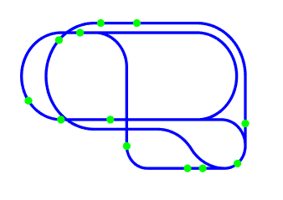

Figure 2: Visualization of current simulation status available via Simulation Server GUI. This example shows third map with 14 autonomous cars.

strings. Throughout entire simulation clients and agent were always listening to messages broadcasted from the server. This allowed to manage the simulation from Server without any additional configuration on each single computer. There were two basic types of messages: configuration messages starting with letter ’c’ and current simulation messages starting with letter ’m’. Configuration messages were usually sent outside of the main loop and contained information about next simulation session such as map size, map name, initial location of vehicle. These messages were also used to start or stop the simulation. To identify the mes- sage the first letter was followed by a 3-digit code that was understandable for both parties. An example of a map size configuration message is shown below.

*c* 108 0 360 0 260 (1)

First number 108 meant that map size is being sent. Rest of the message was then interpreted as x and y dimensions of the current map. Current simulation messages were often more complicated. Below is an example of message send from master to client in running simulation.

*m* 124*.*56 189*.*70 43*.*1 10*.*8 1 2 141*.*5 164*.*9 56*.*2 135*.*5 150*.*4 66*.*8 (2)

First 3 numbers stood for car’s location and orientation. Next two numbers indicated current speed to be displayed on speedometer and binary collision status (participants were informed when collision occurred). Yet another number indicated how many other cars are in the surrounding. All numbers that followed described those cars’ locations and orientations. That data was then used by the client to draw a map and all vehicles in the view field. If the message received was distorted or incomplete and therefore different from what was expected, it was rejected and values from previous iteration were used.

### Client application design

Identical copy of Client Application was deployed on each computer used by experiment participants. Main tasks of Client Application included receiving location and orientation, sending acceleration and turn order, displaying part of the map to the participant and har- vesting inputs from the keyboard. Its design consisted of following classes (appendix: class diagram):

* + - * Simulation client - Main class. Responsible for communication with Server and Agent and management of whole simulation from client’s side.
      * Map client - The most important class. Responsible for such essential tasks as dis- playing the map and cars in GUI
      * Car client - Relatively simple class containing some essential parameters of the car.
      * Participant - Identical to the class used by Simulation Server Application. It contained some attributes that should be separated from Car client object.

The sequence of events happening at each loop iteration is shown in Table 3. As it can be seen, it was considerably simpler than Server Application.

**Displaying map in the view port** Displaying car’s surrounding was one of the main chal- lenges in the implementation of client’s application. As discussed earlier, the experiment design required showing a top-down view of a rectangular area around the car together with the car itself and all other cars contained in the view port. From the beginning of the de- sign process, two, radically different approaches to achieve this goal were analysed. First

|  |  |  |
| --- | --- | --- |
|  | **Class** | **Event** |
| 1 | Simulation client | Sending acceleration and turn orders to Agent |
| 2 | Simulation client | Receiving locations and orientations from Server |
| 3 | Simulation client | Displaying speed and collision status on GUI |
| 4 | Map client | Cropping and rotating map image |
| 5 | Map client | Displaying cropped map image in viewport |
| 6 | Map client | Overlying cars on the map |
| 7 | Simulation client | Waiting for next loop iteration |

Table 3: Order of events in the main simulation loop in Simulation Client.

idea, was to calculate coordinates of each point required to render scene and display the re- sults using one of MATLAB plot functions. This approach would allow for full scalability and could potentially result in appealing map image without visible pixels. On the other hand, the amount of calculations could be much greater, as not only cars and road were to be com- puted but also multiple stationary objects around the road that were supposed to improve the felling of speed (such as trees or houses). The second idea for the representation of view port was to crop and rotate part of the map stored as a large, raster image. The map image was supposed to be 2 to 5 thousand pixels wide and at each loop iteration a part of it would be cropped and rotated according to current car’s location and orientation and then showed on client’s GUI. Subsequently, all vehicles would be plotted over the image. The main advantage of this approach would be a possibility to use complex map image which could be rich in diverse, colourful features. The main drawback would be less attractive, pixelated image as the resolution would be limited. After initial trials with each approach, second one was chosen for the implementation. As it quickly turned out, the main challenge was limited computational power of machines used in experiment. One iteration could not last longer than 0.0625 s and preparing map image was only one of the tasks that had to be executed (the frame rate was limited from 20 FPS in later stages of implementation due to Server Application performance reasons). To overcome this problem, a custom function to crop and rotate was written. It was used instead of MATLAB methods *imcrop* and *imrotate*. The backbone of this function was written by project supervisor, Eddie Wilson. It was later adapted according to the requirement of the GUI. Once the cropped image was displayed

on the GUI, vehicles were plotted over it using MATLAB *patch* function. The overall perfor- mance of this solution was sufficient for the needs of the experiment. It allowed to display images 480 pixels wide and tall with plenty of room left for remaining tasks.

## Modelling car dynamics

One of the requirement of the experiment was to create two models of cars that were meant for two different purposes. One of them was a model of an autonomous car that makes its own decisions and the other one was a model a car that can be controlled by the experiment participant.

This section firstly gives examples of the most significant car-following models and de- scribes how two of them were used to create models for this simulation. Section is summa- rized by a succinct comparison of these two models.

### Car following models

Car following models are the most fundamental part of any microscopic traffic modelling (Treiber & Kesting 2013). They describe car’s behaviour on the basis of the state of the car in front. Nevertheless, a complete car following model is also able to describe behaviour in free flow or when there is a stationary obstacle in front of it. There are various models dedicated to different kinds of research. One of the simplest examples is the Optimal Velocity Model which calculates the acceleration on the basis of the intervehicle distance. It is however, not very robust and the results are unrealistic.

More realistic models are based on various driving strategies. The prime example is the Gipps’ model (Treiber & Kesting 2013); (Rothery 1992). It is able to vary its acceleration depending on the time gap to the vehicle in front. It’s braking manoeuvres always feature constant deceleration and there is no distinction between comfortable and emergency brak- ing. Gipps’ model is considered the simplest accident-free model. Within a certain range of parameters, it produces considerably realistic results.

Although the Gipps’ model is often used in traffic simulations, it is not fully versatile. The simplest complete and accident-free car following model is Intelligent Driver Model. It is capable of dealing with virtually any kind of situation. Its acceleration depends on the distance to the car in front, that car’s velocity, own velocity and few static parameters. What

is more, IDM features Intelligent Braking Strategy. In typical traffic situations its deceleration is limited to some comfortable value. However, during an emergency situation, if something suddenly appears in front of it, the deceleration will rise to minimum value that is necessary to prevent collision (Treiber & Kesting 2013).

### Autonomous car model

Creating an adequate self-driving model was one of the key tasks that had very significant impact on the experiment. The requirements of the experiment stated that autonomous cars should be able to travel among traditional vehicles, avoid collisions and follow default route. In order to ensure validity of the results the model should aim to preserve the most essential features of real autonomous vehicles. The challenge was to identify these features and implement them to the possible extent.

**Deriving model from IDM** From the point of view of other traffic participants it would be ex- pected that autonomous car’s behaviour was familiar and predictable to some extent (Sivak & Schoettle 2015). In order to ensure such performance in this simulation, the model gov- erning the autonomous car was based on Intelligent Driver Model which is briefly introduced in previous section. The model is described with the following formulas:

[

*v*˙ = *a* 1 *−*

( *v* )*δ*

*v*0

( *s∗* (*v,* ∆*v*))2]

*− s*

(3)

*s∗* (*v,* ∆*v*) = *s*0 + *max*

(

0*, vT* +

*v*∆*v* )

*√*

(4)

2 *ab*

Where *a* is maximum acceleration, *v* is current velocity, *v*0 is desired velocity if there are no cars ahead, *δ* is acceleration exponent (the grater the value, the later the reduction of

acceleration when approaching the desired velocity), *s* is current distance to the car ahead and *s∗* is desired distance. In the second formula *s*0 is minimum gap, *T* is minimum time gap

and *b* is comfortable deceleration. The values of these parameters were taken from Sivak & Schoettle (2015) as typical values for city traffic and altered according to the specificity of this simulation (Table 4).

|  |  |
| --- | --- |
| **Parameter** | **Value** |
| Desired velocity *v* | 10 *m*/*s* |
| Time gap *T* | 0*.*8 *s* |
| Minimum gap *s*0 | 7 *m* |
| Acceleration exponent *δ* | 4 |
| Acceleration *a* | 5 *m*/*s*2 |
| Comfortable deceleration *b* | 7 *m*/*s*2 |

Table 4: My caption

**Accounting for traffic coming from different directions** For the purpose of the simula- tion IDM had to be expanded beyond simple car following. Just as a real autonomous car would do, the model used here observes other traffic participants. For every car in the ra- dius of 60 meters it detects it’s current velocity and estimates position from now to 3 seconds ahead. If collision is anticipated, certain parameters of IDM are overwritten. A simplified algorithm governing this behaviour is shown on Figure 3. It allowed for smooth, predictable behaviour in almost all situations.

### Human car control

The way in which cars were controlled had significant impact on the experiment results. From participant’s point of view car’s behaviour should be predictable and similar to how real car behaves. The challenge was to achieve this kind of performance using only discreet inputs from keyboard. Graphical interface used by participants allowed to capture multiple keys pressed simultaneously, however resulting acceleration order had to always be one of the following: speed up, slow down, coast or brake. After analysing relevant literature it was decided that car’s behaviour should be similar to one of the cars following models (Treiber & Kesting 2013). From The Gipps’ Car Following Model given in Spyropoulou (2007) a formula describing acceleration on the basis of current speed was extracted.

*v v*˙ = 2*.*5*a*(1 *− V* )

√ *v*

0*.*025 + (5)

*V*

In the above equation *v* is current velocity, *v*˙ is acceleration available at current speed, *a* is acceleration parameter and *V* is velocity at which car should not be able to accelerate any

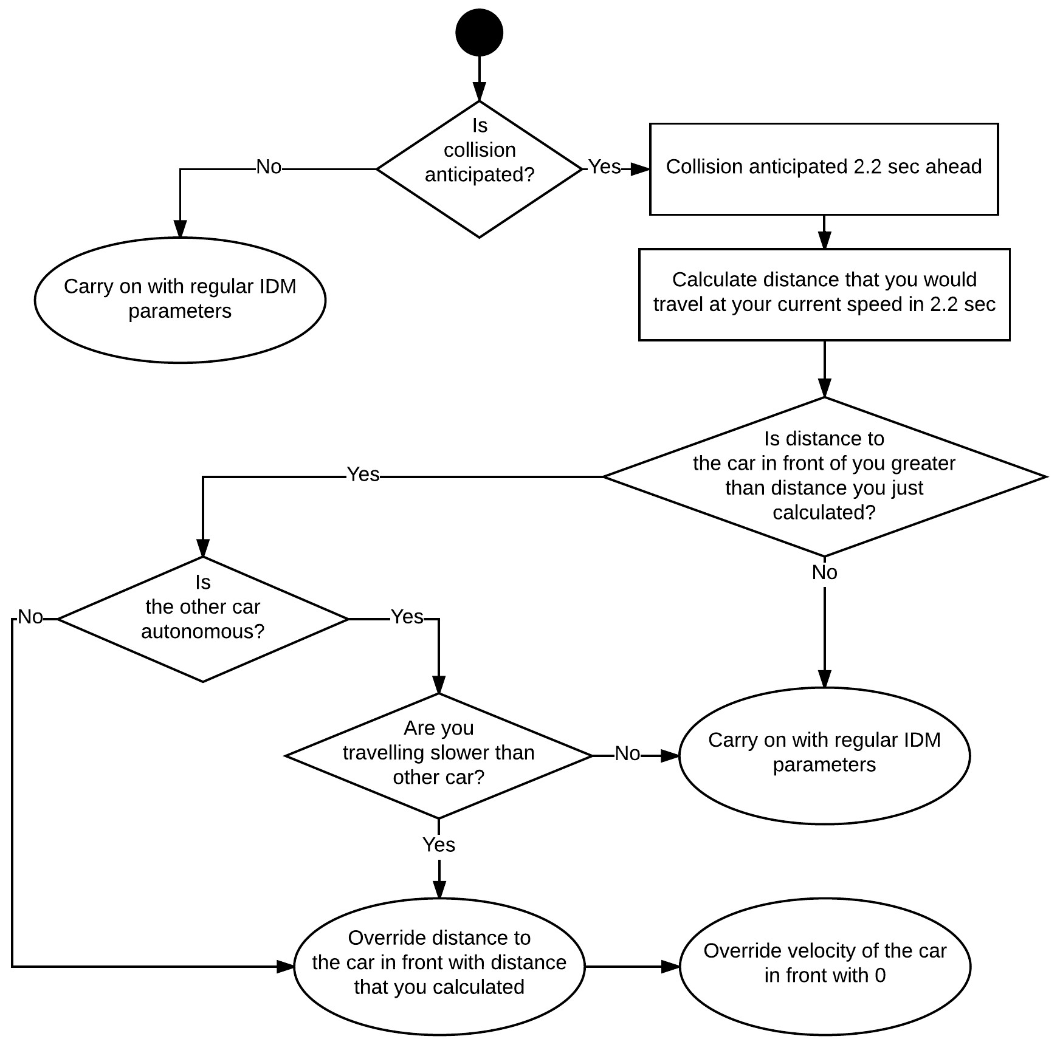

Figure 3: Algorithm governing the behaviour of autonomous car. It was executed for each car at every time step of the simulation. It allowed for very smooth interactions if another autonomous car was encountered and very cautious ones with human drivers.

5

4

Acceleration (m/s2)

3

2

1

0

0 2 4 6 8 10 12 14 16

Velocity (m/s)

Figure 4: Relation between available acceleration and current speed for the model derived from Gipps’ model. As it can be seen the acceleration drops to zero when maximum speed is reached.

more.

Value of *a* was found empirically to be 5. Figure 4 illustrates how the acceleration value depended on the current velocity. Gipps’ model was used only when participant’s order was to accelerate (A key). When the order was to slow down (Z key) the applied value of acceleration was *−*6*.*5 *m*/*s*2. While coasting the acceleration value was 0. To imitate car’s dissipating energy coming from aerodynamic drag and rolling resistance the calculated value of velocity was brought down by 0*.*5% in every loop iteration; This principle applied also to autonomous cars. Last available command influencing car’s velocity was braking (SPACE bar) which gave an acceleration of *−*10 *m*/*s*2.

As the experiment was dedicated to city traffic the maximum velocity of traditional vehicle was limited to 15 m/s. Starting from full stop and heaving acceleration button pressed the car would reach that velocity after 7.1 seconds.

**Comparison with autonomous car model** Figure 5 compares behaviours of autonomous and traditional car. It can be seen that although profiles have fairly similar shape, there are some significant differences. And so, while traditional car’s max speed is higher, its acceleration is slower compared self-driving one. Additionally, braking profile of autonomous car is smoother than human-driven one.

Acceleration Coasting Deceleration

Distance travelled (m)

150

Human-driven

Autonomous

120

90

60

30

0

0 3 6 9 12 15

16

12.8

Velocity (m/s)

9.6

6.4

3.2

0

0 3 6 9 12 15

6

Acceleration (m/s2)

4

2

0

-2

-4

-6

-8

0 3 6 9 12 15

Time (s)

Figure 5: Behaviour comparison of Autonomous and Human-Driven cars in terms of distance travelled, velocity and acceleration. First section on the left corresponds to both types of vehicles accelerating from zero velocity. Middle section shows coasting when Participant’s acceleration is 0 and autonomous car maintains maximum velocity. Section on the right shows Participant slowing down at *−*6*.*5*m*/*s*2 and Autonomous Car detecting stationary object 30 meters ahead.

## Communication between machines

One of the key factors contributing to the successful conductance of the experiment was a reliable communication between machines. As it later turned out, it was probably the biggest single challenge of the entire project.

Possible network solutions were considered already at the begging of the project and had significant impact on the choice of primary development environment. Although the exchange of data was one of undependable parts of the project, the way in which communi- cation was established was irrelevant from the point of view of the rest of the software. The network solution was only supposed to meet certain requirements derived from the experi- ment design.

After reviewing possible ways of implementation, it was decided to use Robot Operating System which was included in MATLAB’s Robotics System Toolbox. Although main intention of ROS was to function as a framework for developing robotics software, it also featured structured communication solution (Quigley et al. 2009). From the point of view of the project, ROS could provide reliable, simple to use way of exchanging data. The initial idea was to create one topic for car’s location and orientation and another one for orders from participants (Figure 6).

To justify this approach, a small game was created that exercised almost exactly the same design principle. Performance of the game proved to be satisfactory and the project carried on using this solution.

However, as the implementation was progressing and tests with multiple clients started, it turned out that subscribing and publishing to the topics takes excessive amount of time and it will be impossible to serve multiple machines and maintain sensible frame rate (which was 20 FPS at that time). In the search for alternative solution other type of ROS communi- cation mechanism was tried which was Services. Nonetheless, this approach proved to be ineffective too.

After further search a new idea of using User Datagram Protocol emerged. MATLAB provided simple way to establish communication using UDP which proved to be distinctly faster from original idea. Sending 100 bytes of data as a single string lasted around 0*.*2 *ms* while receiving took about 3 *ms*. In the final network solution UDP was used in conjunction with ROS. UDP provided fast way to send and receive data while ROS allowed to: execute

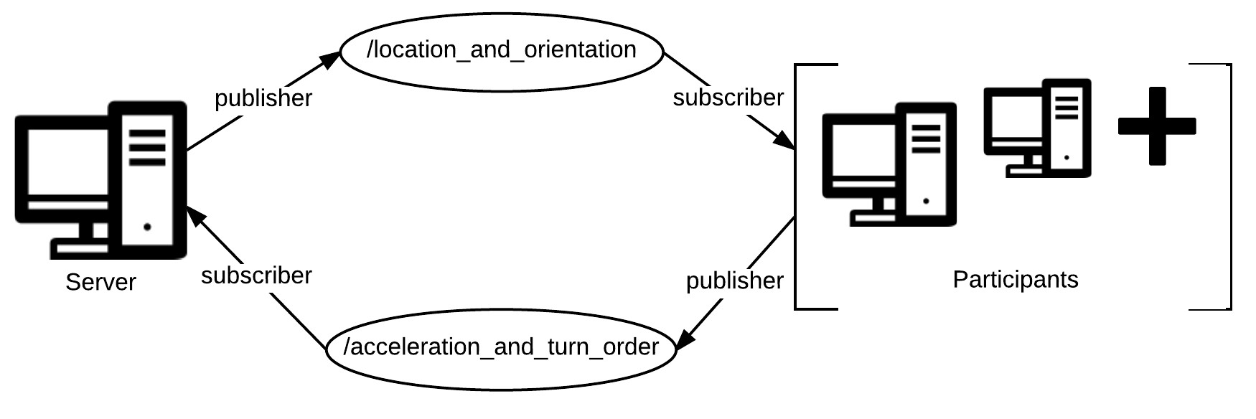

Figure 6: Initial idea for establishing communication using ROS nodes and topics. It was considered to have only one pair of topics for all participants or individual pair for each single participant.

code at fixed rate, synchronize multiple machines to Server’s clock and manage overruns if the code execution took too long.

In order to mitigate the amount of receiving done by the server, an additional entity called Communication Agent was created. This piece of software running on separate machine was responsible for aggregating inputs from all clients, combining them together into one string and sending to Server. The main reason behind this solution was that receiving one long message took less time than receiving multiple short ones.

Figure 7 shows what final communication solution looked like. In tests and during the experiment it proved to be reliable and easy to use, albeit with some limitations.

The way in which data exchange was implemented was a type of Inter-process commu- nication. According to Rajkumar et al. (1995) this is a considerably challenging task which is often underestimated. Among all objectives that should be met by this kind of software, the most essential ones are probably reliability and scalability. In the case of this implementation it can be said that communication was very reliable, however not fully scalable as the frame rate was decreasing if there were more than 7 clients connected at the same time (Rajkumar et al. 1995).

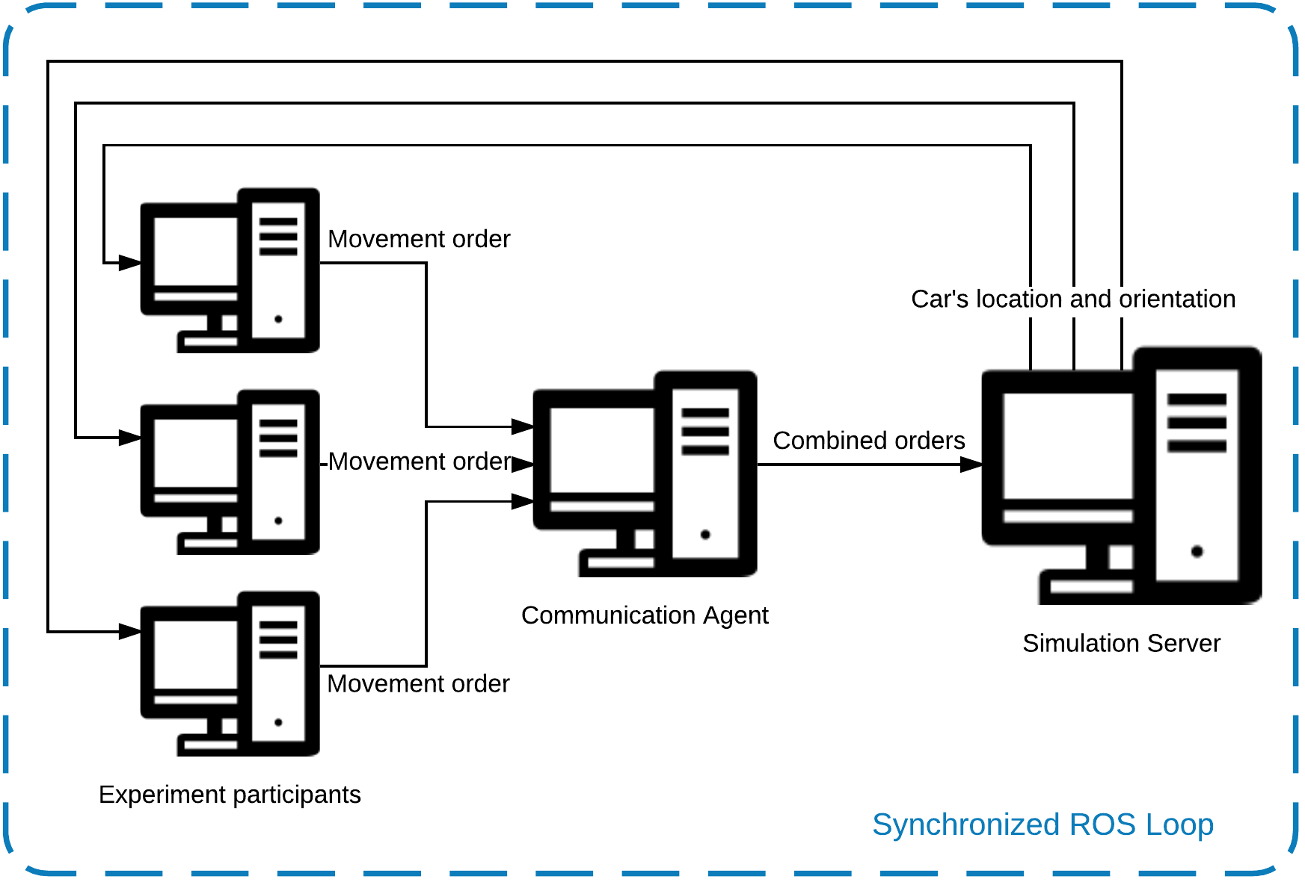

Figure 7: Final communication solution used in the project. A combination of UDP and ROS allowed to have reliable, synchronous exchange of data

# Experimental Design

The experiment was located at the heart of the project. All work done before was planned for successful delivery of the experiment and all work done afterwards was relying on the data collected during the experiment.

This chapter is dedicated to the detailed description of the entire experiment. It starts by restating and expanding the principles of the experiment. Then is follows to describe exact configuration of each scenario. Next section describes client’s interface and explains reasons standing behind its design. Last part includes responses from questionnaire given to participant and describes exact course of event on the experiment day.

## Principles of the experiment

This section redefines and expands the guidelines given in Introduction and Motivation chap- ter.

Final plan for the experiment was to involve around 10 people. Everyone would be asked to control one of the vehicles in the simulation. Each of them would sit in front of a computer where they could use the keyboard and observe the screen. On the screen they would see a top-down view of their own vehicle and it’s surrounding. By using the keyboard they would control the acceleration of their vehicle. The instructions given would encourage to explore the map and avoid collisions with other vehicles.

The experiment was planned to consist of three main sessions and one learning ses- sion. Each session would feature different scenario which determines road layout, number of human-driven cars and number of autonomous cars. During the preliminary session par- ticipants would learn how to control the car, how car responds to their commands,how to turn and what the environment looked like. After learning period the first and second phase would commence. Both phases would use identical map but the proportion of traditional cars to au- tonomous would change. The map shape would be an infinity loop shape where vehicles would have to follow each other and there would be one intersection. It was assumed that such an approach would allow to measure macro parameters of the traffic as both phases would be comparable and the impact of autonomous vehicles could be potentially extracted. The initial choice of measured parameters included average velocity, density, distance cov- ered and other basic statistical parameters such as variance and standard deviation. The

scenario in the third phase would use significantly more complex map with 3-way intersec- tions, road exits and road (accesses?). It would feature a similar number of traditional and autonomous cars. The focus of the analysis would be microscopic interaction between cars in various road situations. Number of autonomous vehicles present on the map depended on the number of people turning up for the experiment. Additionally map used for phase one and two could be scaled according to the total number of cars. The instructions given to experiment participants before each phase stated the following:

1. Cover as long distance as possible
2. Avoid collisions with other cars at all cost
3. Use keys described below to control the car
4. When given a choice to turn at the intersection it’s your decision which direction you want to go
5. Listen to other instructions

At every step of the simulation all relevant data was recorded for further analysis. In the event of collision the cars would be allowed to pass through each other. None the less, the event was captured and collision alert was displayed for drivers involved in the accident. Collisions were unwanted events that were considered a distortion affecting the results. By allowing the cars to pass, the traffic disturbance was mitigated. Another considered ideas such as teleporting vehicles to another place or manually changing the velocities would prob- ably have greater impact on traffic smoothness. Figure 8 show a screen-shot of Participant’s interface.

## Scenarios

Each scenario specifies configuration of the map, number of human drivers, number of au- tonomous cars, initial position of each car and length of the simulation.

While map configuration had to be prepared before, number of vehicles of each type and time of the simulation could be set at the start of the experiment. This flexibility helped to accommodate for unknown number of people that showed up for the experiment. To ensure

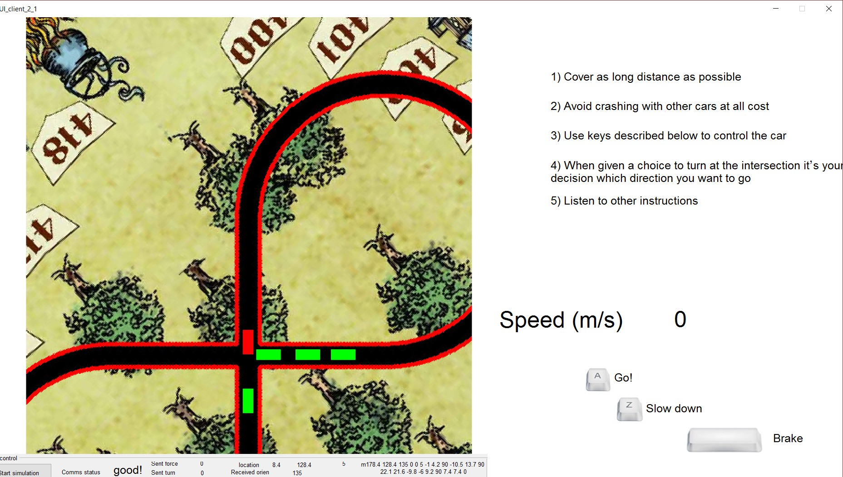Figure 8: Screenshot of participant’s interface. Participant’s car is marked in red and all other cars in green. *comment* part of gui is cutted. will fix

reasonable congestion but yet high number of interactions each map was designed for dif- ferent number of vehicles. A benchmark test with solely autonomous cars and additional empirical tests allowed to establish that every vehicle should correspond to 45 to 80 meters of total track length. In all scenarios participants were not told which car is autonomous and which is controlled by another human. They could, however try to guess the type of the car from how it behaved.

### Learning phase

The learning period involved all participants and one autonomous car. It lasted 2 to 3 minutes and was intended for getting familiar with the simulation. The data from this period was recorded but was not intended for analysis. In that period participants could ask additional questions. The map used in this scenario is presented on Figure 9.

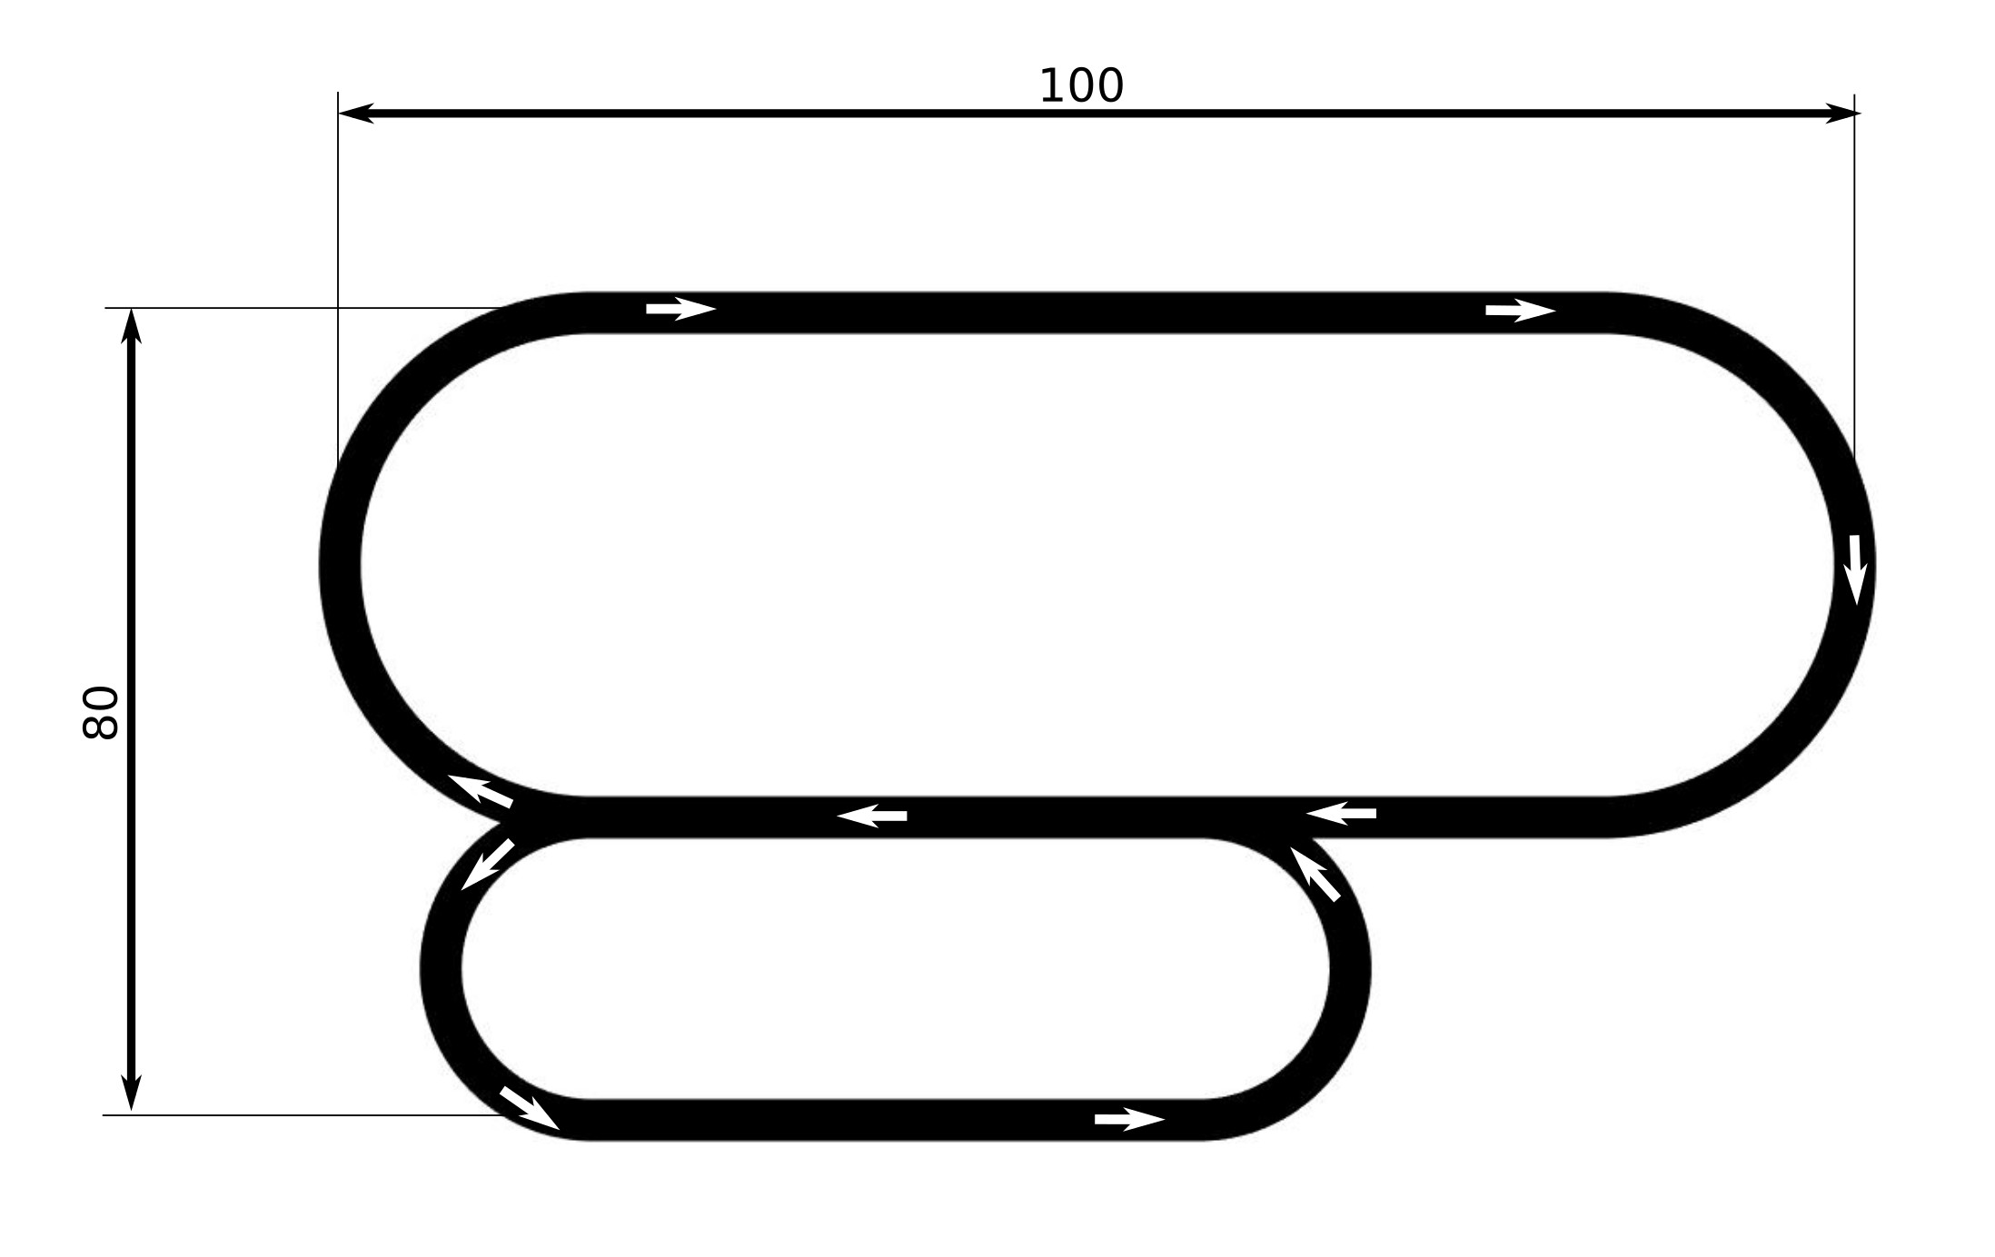

Figure 9: Map used in learning scenario. It featured one road exit and one road split. Di- mensions are given in meters.

### Scenario 1

In the first scenario all participants were involved and there was one autonomous car. The map featured figure of eight shape as showed on Figure 10. The intersection in the middle was uncontrolled as it did not have any priority rule. It was hoped that this way cars would face uncertain situations and interactions will be more vibrant. This scenario was intended to capture interactions in traffic consisting almost entirely of traditional cars. Interactions were either between cars following each other or between cars at the intersection. It was hoped to observe how people are keeping distance to car ahead, how conflicts at intersection are resolved and what are the potential queueing behaviours. Before the simulation started, participants were briefed what is the shape of the map but they were not told how many autonomous cars were in the simulation. This phase was planned to last 4 to 8 minutes depending on the number of participants.

### Scenario 2

In scenario 2 around 35% of people taking part in the first scenario was substituted for au- tonomous cars. This scenario used identical map as scenario 1 (Figure 10) and the total

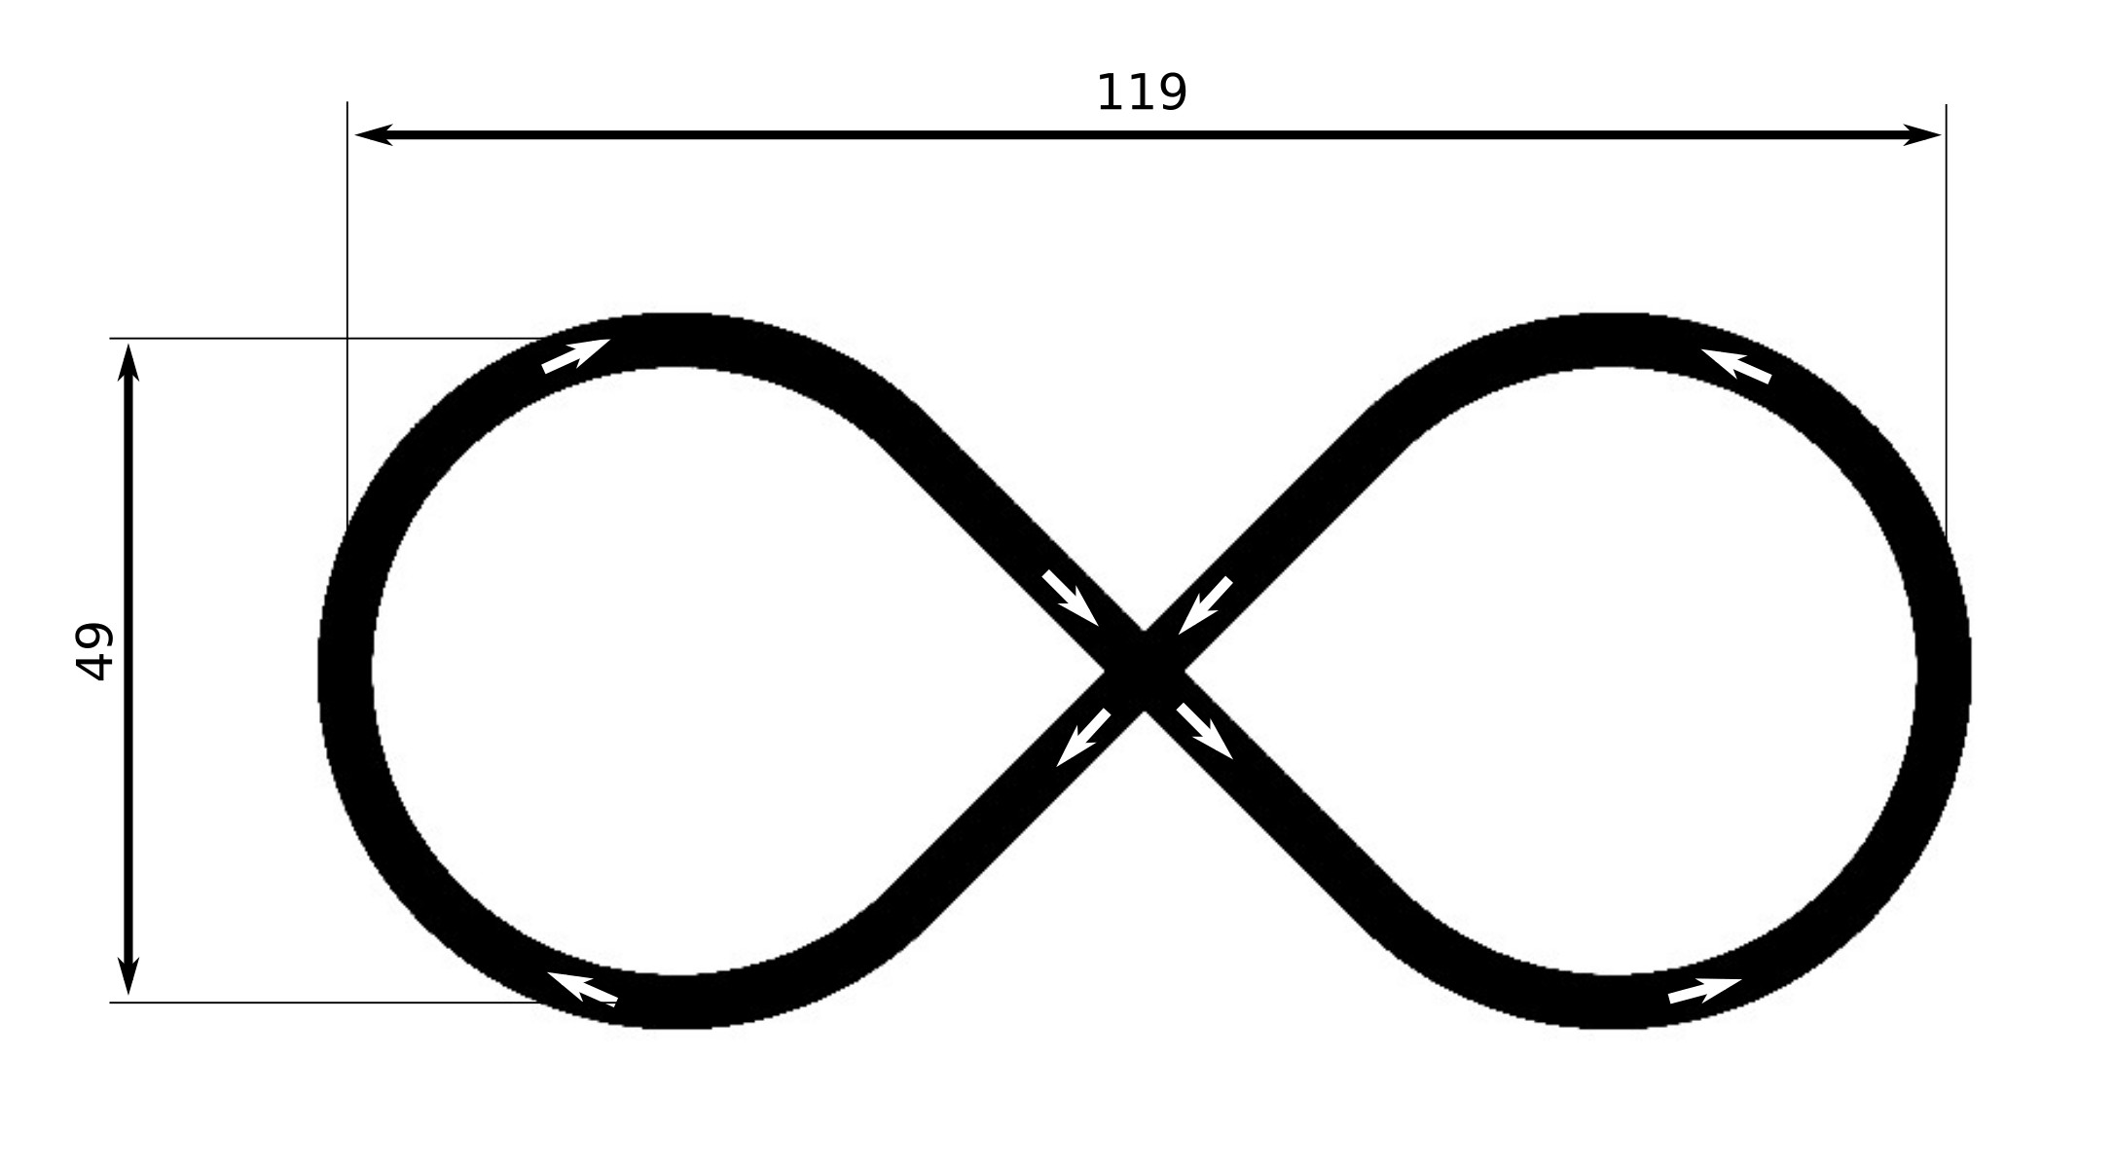

Figure 10: Map used in First and Second scenario. It featured infinity loop shape. There were no road splits and cars had to follow each other. Dimensions are given in meters. Covering the whole map at full speed of 15 *m*/*s* would take 22 seconds. The track was intended for 6 to 10 vehicles.

number of cars didn’t change. It was hoped that this way the results will be comparable to first scenario. Particular interest was in the interactions at the intersection. The autonomous cars were always letting human-driven cars go first if collision was anticipated. The humans however, didn’t know which car is what type and communication happened only via obser- vation of each other’s movement. Similarly to previous scenario the planned length would range between 4 and 8 minutes.

### Scenario 3

Scenario 3 aimed at microscopic interaction between particular pair of vehicles or groups of vehicles. The map used in this scenario featured multiple types of intersections and was much more complex than previous one as it is shown on figure 11. The amount of human- controlled cars was equal to the number of autonomous cars. The total density of all vehicles was two times lower than in previous scenarios but due of multiple intersections the number of interactions stayed high.

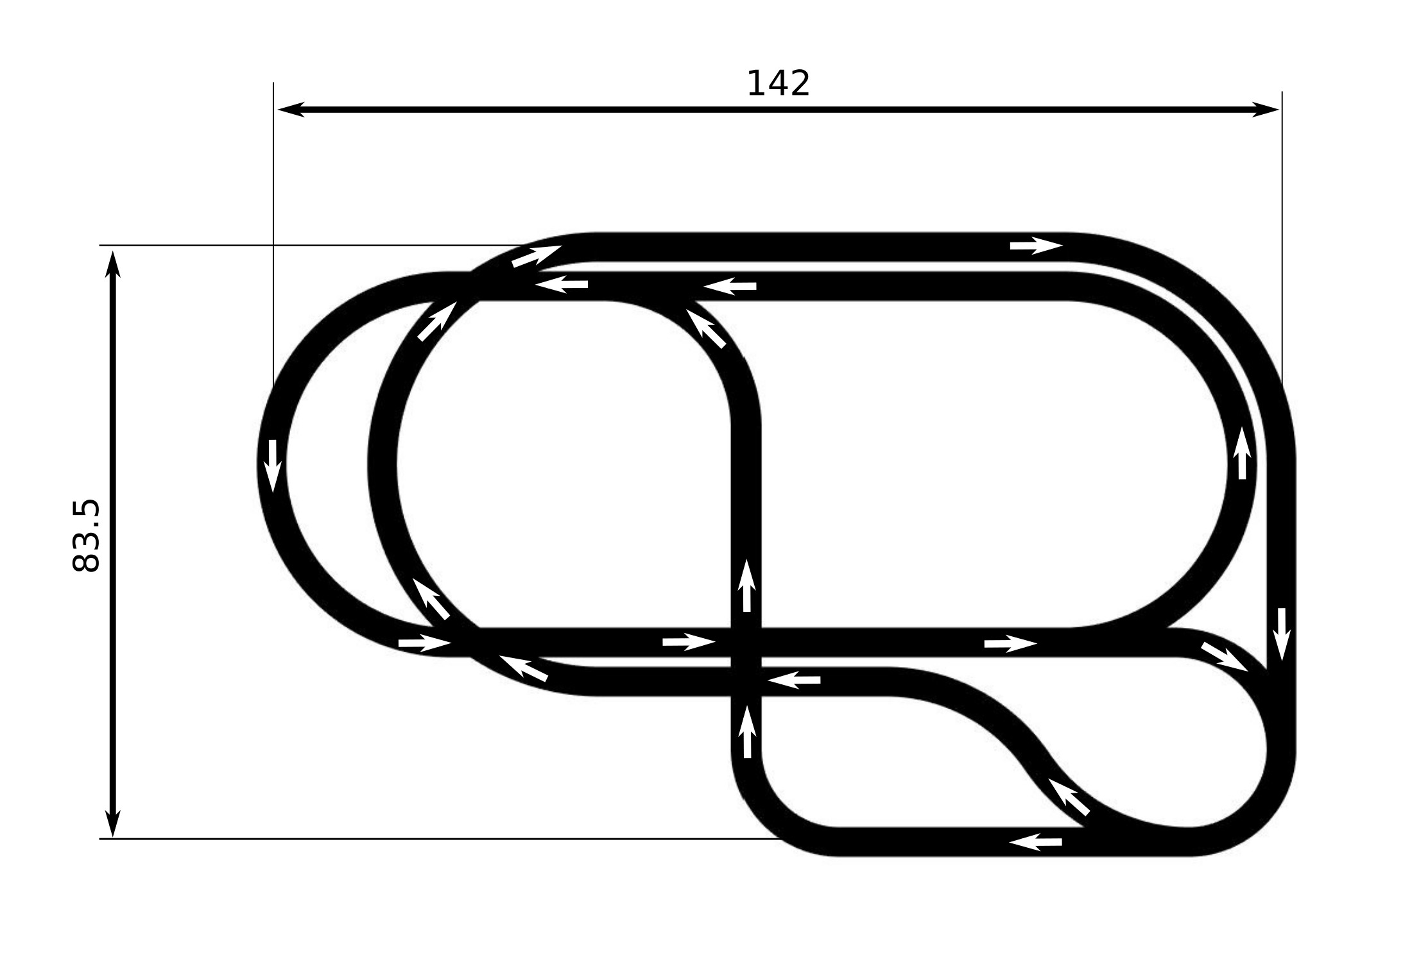

Figure 11: Map used in the third scenario. It featured 2 road splits where drivers could change direction, 2 diagonal intersections,a 3-way intersection and 2 road accesses(?). The total length of all segments was 875 m. Travelling at 15 *m*/*s* it would take 59 seconds to cover that distance. This was the longest track in the experiment and was designed for 8 to 14 vehicles.

## Client interface

The main aim of the graphical interface was to mimic what a person driving a car would actu- ally see from the inside of his or her vehicle. Compared to the real world the representation of the environment had to largely simplified. The challenge was to preserve as much of the realism as possible keeping in mind the main principles of the experiment. The cars were represented as coloured rectangles 2 meters wide and 4.5 meters long. Particular partici- pant’s vehicle was always position in the middle of the screen while map and other vehicles were moving around it. Roads were 4 meters wide, coloured in black with red boundaries. Each track was overlaid on graphical background with many distinctive features to allow for better sensation of speed (Figure 8). Pictire used in the background comes from (n.d.).

**Car control using keyboard** First things to decide on was how the car was controlled. Fundamentally the car had one degree of freedom as it always went along a predefined

path. Only in the event of road split the driver could make discreet choice on which direction to go. The acceleration of the car was controlled by A and Z keys. Pressing A made car accelerate with a value calculated from Gipps’ car following model (discussed later). The maximum velocity was capped at 15 *m*/*s*. Pressing Z key applied constant deceleration of

*−*6*.*5 *m*/*s*2. Additionally drivers could press space bar which functioned as a hand break

and applied deceleration of *−*10 *m*/*s*2. These number were found empirically so that car responded predictably. Backward movement was disabled for greater simplification. The reason for not using arrow keys was that these keys were used to control car’s direction as some intersections featured choice between straight, left and right turn.

**Size of view field** Another design decision concerned the size of driver’s view field. The shape and size of the view field was a square 80 meters by 80 meters where car was po- sitioned 20 meters from the bottom as it is showed on previous Figure 8. It was assumed that for a driver travelling at full speed it should be possible to comfortably slow down to zero when a stationary vehicle suddenly appears in front of it. The amount of time elaps- ing from first sight of the obstacle to coming to full stop includes reaction time and breaking time. According to (Summala et al. 1998) average reaction time for a vehicle without brake lights is about 2 seconds which corresponds to 30 meters travelled. Breaking at *−*6*.*5 *m*/*s*2 from 15 *m*/*s* takes 2.3 seconds which consequently corresponds to 17.2 meters. Therefore minimal distance that driver should be able to see ahead is 47.2 meters. After initial tests this lower-bound value proved to be too small and after few other trials was extended to 60 meters. Another 20 meters of sight distance was added behind the car.

## Experiment’s execution

The experiment took place on the 24th of August 2016. 12 people people turned up for the it. The group was divided into 2 smaller groups of 6 people each. Once first group completed all tasks, another one was asked to begin. The reasons to split people into two groups were of technical and research nature. A technical problem arose shortly before the experiment was due to to start. It turned out that from participant point of view the simulation gets considerably laggy if there are more that 7 people playing at the same time. The original frame rate was dropping to few frames-per-second which was unacceptable as it would greatly distort the

simulation and whole experiment. From the point of view of experiment methodology heaving two groups conducting identical tasks had beneficial impact on the conclusions that could be drawn from the experiment. It is a common practice to run experiment more than once to detect potential anomalies and have more generalized data(***here use Design and Analysis of Experiments,” Handbook of Statistics book).

Experiment was advertised as ”Autonomous Cars Simulation”. Invitations were sent pri- vately to particular persons. The only information revealed to potential participants stated that experiment will consist of a couple of sessions and they will be asked to drive a car in computer simulation. Participants were promised £10 reward in form of Amazon.com® voucher and catering available before and after the experiment.

Each of the participants was asked to sit in front of one of selected computers. In front of them there were 3 documents: Consent Form, Participation Information Sheet and Ques- tionnaire. (link to appendixes) ***some more content here ...?

### Questionnaire

Each of the participants was asked to complete short questionnaire. (link to appendixes). The purpose of the questionnaire was to collect data that later could be used in association with experiment results to create a driving profile for particular person. The exact way in which this data will be used in analysis was not established before the experiment. None the less, it was attempted to ask about things that could be associated with performance of each person.

The survey consisted of 12 questions which can be divided into 4 sections. There were 2 questions asking about gender and age. Next it was asked whether a person played any racing computer games and is familiar with controlling the car with arrow keys. The third section was conditional to the possession of driving licence. If the answer was affirmative, further questions asked about past accidents, subjective evaluation of person’s driving style and irritating behaviours they encounter of the roads. Last question asked about opinion on how the traffic will change when autonomous cars are introduced.

### Minutes

The experiment started by reading the Participation Information Sheet to all participants. First paragraph stated rights of experiment participants and how the collected data will be used. Second one explained the task in short and concise way. The exact instructions that were given stated as follows:

”*If you decide to take part in the study, you will be asked to drive a car in on-line traffic simulation. You will be using computer keyboard to control your car. Your main objectives is to cover as long distance as possible and avoid crashing into other cars. There will be 3 phases. Each will last 8 minutes, feature different map and different amount of autonomous vehicles. First phase will be preceded with 3-minute- long learning period when you will be able to learn how to play the game. All additional instructions will be given to you before each phase in form of power point slides. Before starting the simulation you are asked to complete a short survey to describe your driver profile.*”

Rest of the document considered health warnings such as epilepsy and past accidents. Next, participants were asked to complete the Questionnaire described above and sign the Consent form. Once that was done they were told once again what is their task, how to control the vehicles and what the next phase will look like. Eventually the main part of the experiment commenced. It consisted of consecutive phases as described it table 5.

The lengths of each phase were considerably shorter than planned. The initial schedule, however, did not account for heaving two streams of people. After the main part of the experiment finished, participants were debriefed and invited for catering. Entire experiment lasted around 1.5 hours and in total 31 minutes of simulation data were harvested.

# Results

The analysis of the data could be divided into two parts. First one is dedicated to finding patterns, observing dependencies and evaluating particular group and participants. Second one proposes a range of hypotheses which were consequently tested to prove them right or deny.

Data collected during the experiment was considerably rich in features and lots of regular- ities could be potentially found. On average, participants changed acceleration/deceleration

|  |  |  |  |  |
| --- | --- | --- | --- | --- |
| **Phase** | **Scenario** | **Human-driven vehicles** | **Autonomous vehicles** | **Lenght** |
| **Group 1** | | | | |
| Learning | Learning | 6 | 1 | 1:45 min |
| 1 | Scenario 1 | 6 | 1 | 3:22 min |
| 2 | Scenario 2 | 4 | 3 | 4:12 min |
| 3 | Scenario 3 | 4 | 4 | 4:09 min |
| **Group 2** | | | | |
| Learning | Learning | 6 | 1 | 4:33 min |
| 1 | Scenario 1 | 6 | 1 | 4:07 min |
| 2 | Scenario 2 | 4 | 3 | 5:03 min |
| 3 | Scenario 3 | 4 | 4 | 4:51 min |
| 4 (additional) | Scenario 3 | 6 | 4 | 2:24 min |

Table 5: My caption

commands 73 times per minute. Figure 12 shows a snapshot from the simulation playback. the initial choice of parameters measured across data set was different from what different

from what was calculated in the process of the data analysis.

## Observations

During project’s design stage it was very uncertain what kind of results could be expected. Only during the development stage and after the experiment certain ideas on what patterns in data might be observed were established. This chapter proposes three different observation that are aimed at presenting the outline of the collected data.

### Deceleration mapping

First concept that could help to understand the data, was to visualize how vehicles accel- erated and decelerated. In order to do that, a spatial representation of average decelerations was created, as it it shown of Figure 13. Track was divided into 4-meters-long segments and for each segment the total value of decelerations was summed up over all vehicles and all frames in the current phase. Results were plotted for first and second scenario for group 1.

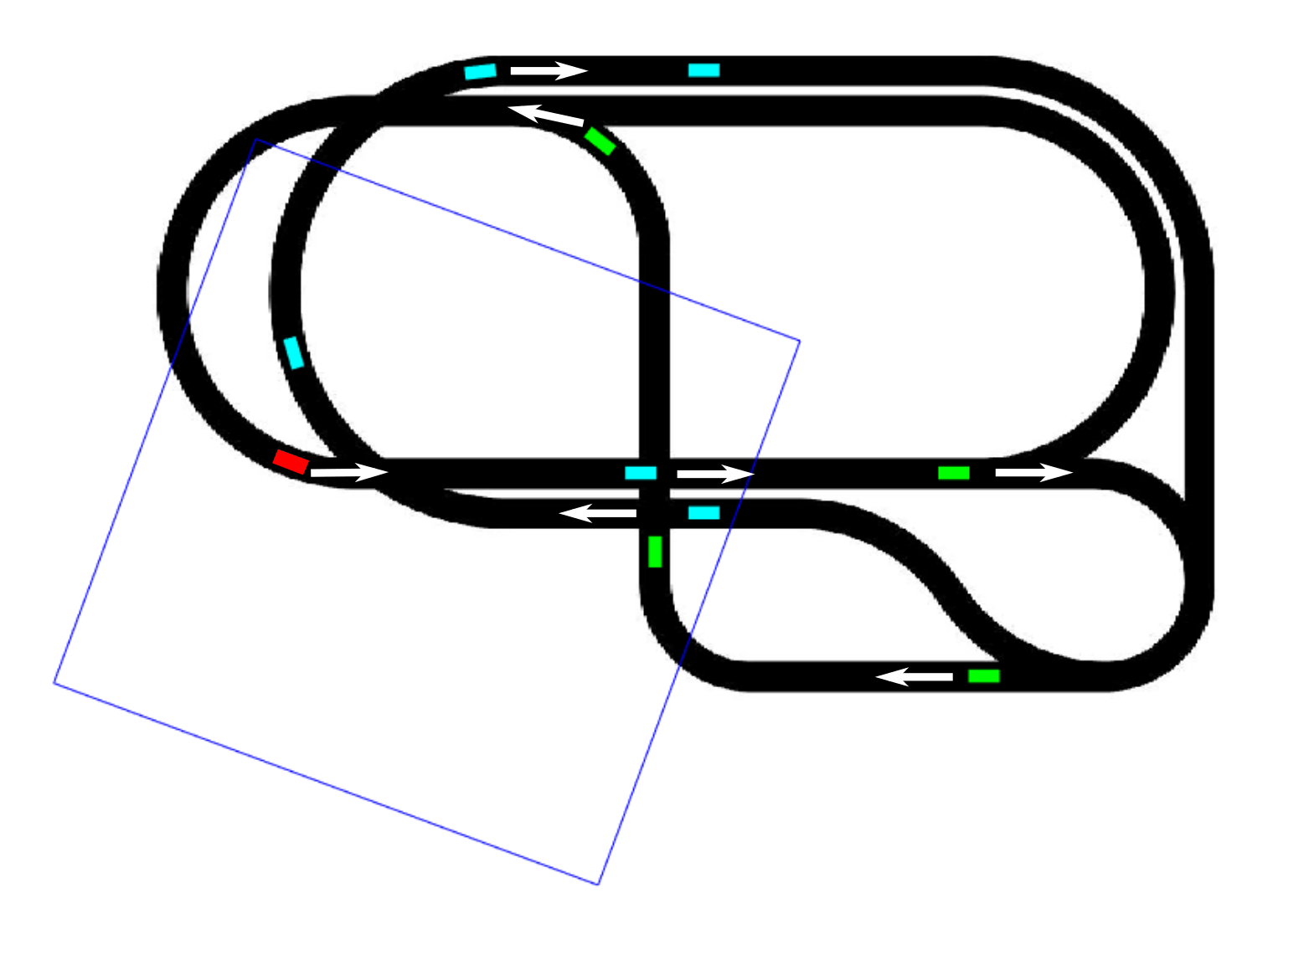Figure 12: Group 2, phase 3. A snapshot from simulation playback. Cyan colour represents human-driven cars and green represents autonomous cars. A dark blue rectangle represents the what area was visible for the car marked in red colour.

It can be observed from the plot that once multiple autonomous cars were introduced, vehicles decelerated harder and more often when approaching the intersection.

### Evaluation of participant’s performance

the number of collisions caused by each participant was evaluated and compared against the questionnaire responses. Single collision always involved 2 cars. A person responsible was always the one whose car’s front line intersected with the other car first. A number of collisions caused by each person is shown on Figure 14. Table 6 shows number of collisions against questionnaire responses. Because the shorter phase lasted 3:22 minutes, values were calculated only for that period for all phases. From these figures it can be seen that:

* + - * Almost every person in the first group performed significantly better in terms of number



1. Group 1, Scenario 1



1. Group 1, Scenario 2

Figure 13: Visual representation of decelerations on map used in first and second scenario. Dark blue represents strong deceleration while light yellow represents weak deceleration. The data was averaged over all vehicles including human-driven and autonomous one.

of collisions than participants from the second group. Because of this reason first group was used more often in further analysis as a sole source of data.

* + - * Autonomous cars were responsible for only one collision throughout the entire experi- ment.
      * In total 52 collisions occurred between two human drivers while 33 happened between human drivers and autonomous vehicles. However, accounting for how much each vehicle spent on the track .... ?

|  |  |  |  |  |  |  |
| --- | --- | --- | --- | --- | --- | --- |
| **Partici- pant** | **Familiar with keyboard car**  **control?** | **Years of driving**  **experience** | **Past accidents** | **Driving skill**  **evaluation\*** | **Driving style\*\*** | **Collisions (H/A)** |
| **Group 1** | | | | | | |
| 1 | Yes | 2 | 0 | 2 | Very careful | **1/2** |
| 2 | Yes | 1 | 1 | 8 | Careful | **4/2** |
| 3 | Yes | 5 | 0 | 8 | Normal | **0/2** |
| 4 | Yes | 6 | 0 | 9 | Careful | **2/2** |
| 5 | Yes | 5 | 2 | 7 | Careful | **3/1** |
| 6 | Yes | 2 | 2 | 10 | Normal | **2/0** |
| **Group 2** | | | | | | |
| 1 | Yes | No licence | - | - | - | **11/5** |
| 2 | Yes | 3 | 1 | 9 | Normal | **7/6** |
| 3 | Yes | 8 | 0 | 8 | Careful | **4/5** |
| 4 | Yes | 15 | 3 | 10 | Normal | **8/5** |
| 5 | Yes | 8 | 2 | 8 | Agressive | **5/1** |
| 6 | Yes | 3 | 0 | 1 | Very careful | **4/1** |

Table 6: Questionnaire responses represented against number of collisions caused by each person. It can be observed that self-assessment of driving did not correspond to the number of accidents. (*Own judgement of driving skills on the scale from 1 to 10. **Own judgement of driving style from very careful to very aggressive. Please refer to appendix for details.)

**Collision througout entire experiment**

16

Collisions with human-drivers Collisions with autonomous cars

Number of collisions (entire experiment)

14

12

10

8

6

4

2

0

Vehicle reponsible for collision

Figure 14: Number of collisions caused by each participant/vehicle in first and second group. (*Humans substituted for autonomous cars in later phases.)

### Conflicts resolution

Interactions between cars can be systematized as one car following another or as a broad range of interactions at intersections. The later was of particular interest because of it’s un- certainty and unpredictability. While all maps featured intersections, figure of eight map used in first two scenarios was aimed at more organized analysis and will be used in this example to visualize how humans and autonomous cars made decisions. Figure 15 shows an exam- ple of interaction between one human-driven and two autonomous car. In this example both vehicles at the front came to full stop. In the ideal situation one vehicle should pass while the other slows down.

Another type are interactions between two autonomous cars as it is shown in Figure 16. When two autonomous cars anticipate collision with each other the one which is slower is or- dered to reduce its speed according to the time-to-collision value while the faster one passes through uninterrupted. In most cases, this relatively simple rule optimizes the interaction re- ducing braking to minimum.

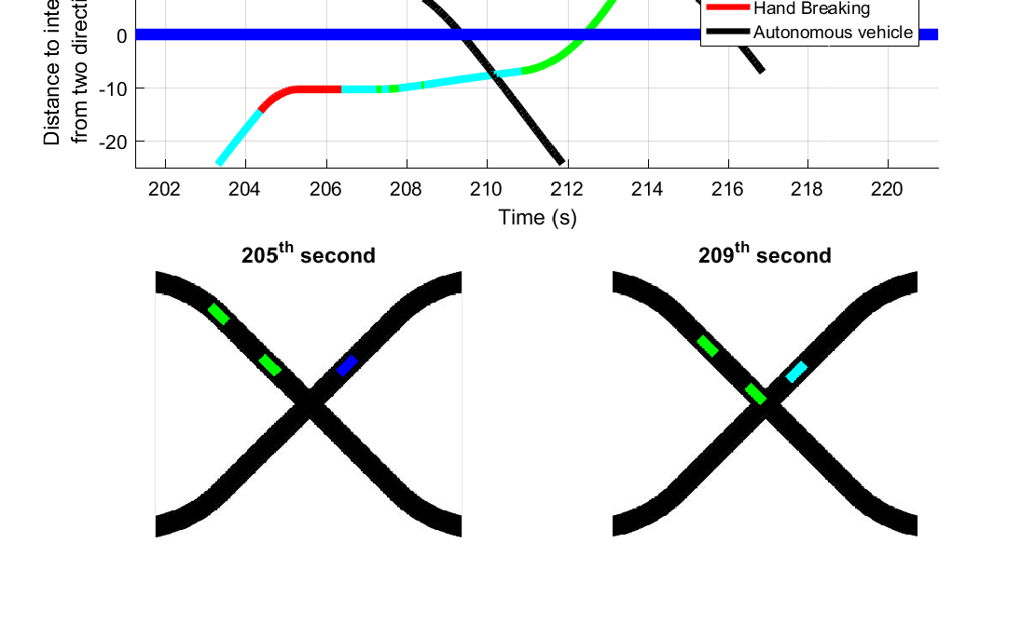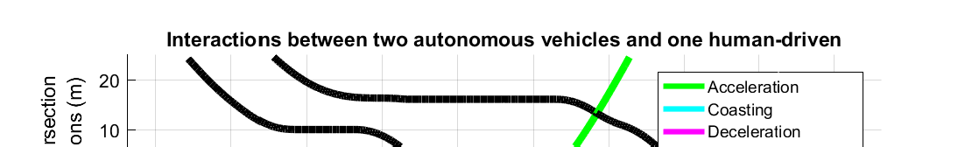

Figure 15: An example of interaction between two autonomous vehicles and one human- driven. In the 204th second both cars started to brake to avoid collision and came to full stop. Human driver was uncertain of how the other car will behave. Autonomous car, on the other hand calculated collision free passage as other vehicle was not moving and starter to move through the intersection in the 208th second. Next, the human passed through and another autonomous vehicle afterwards. (Colours indicate current order from Participant.)

**Interaction between two autonomous vehicles**

20

Deceleration

Maintaining velocity Acceleration

10

Distance to intersection from two directions (m)

0

-10

-20

63 64 65 66 67 68 69 70

Time (s)

Figure 16: An example of interaction at the intersection between two autonomous vehicles coming from different directions. Both cars anticipated collision in the 65th second. In line with the algorithm the slower car started to decelerate as much as it was needed to avoid collision. At each time step new time-to-collision was calculated and velocity adjusted accordingly. The faster car’s velocity remained constant.

## Hypotheses

Hypotheses represent another approach to data analysis after observations. This sub- chapter suggest three hypotheses that were derived from observations described is previous section and from other independent considerations.

### Hypothesis: Autonomous cars reduce number of accidents

Based on the observations from previous section it can be seen that autonomous vehicles were almost never responsible for the collisions. However, there were numerous collisions caused by other traffic participants involving autonomous cars. Based on these premises the following hypothesis was be tested:

#### ”Replacing a number of traditional drivers with autonomous cars reduces number of all kinds of accidents”

**Method of analysis** The hypothesis was tested by comparing number of collisions in phase 1 and phase 2 in both participants groups of participants. In order to ensure validity of the results, an attempt to identify all factors influencing number of collisions was made. As a result a list presented in Table 7 was created.

According to Vangi & Virga (2007) the deceleration of an average car (Renault Clio®), in

good driving conditions, from the speed of 15 *m*/*s* reaches maximum of 12 *m*/*s*2. Although, this value might be greater for cars with better brakes it was accepted as a border value. Any situation when deceleration of autonomous car was greater than 12 *m*/*s*2 was analysed separately and classified as a potential collision.

**Findings** In the first group, there were 11 collisions in the first scenario and 5 collisions in the second scenario. In both scenarios there were 3 situations where deceleration of au- tonomous vehicle reached values below 12 *m*/*s*2. None of them were classified as a potential collision. In the second group there were 37 collisions in the first scenario and 14 collisions in the second scenario. In the first scenario there were 6 situations where deceleration of autonomous car reached values below 12 *m*/*s*2. None of them were classified as potential collision; in fact these rapid changes of velocity often caused collisions with the car located behind, which was then unable to stop. This should be considered as a flaw in the design of

|  |  |  |
| --- | --- | --- |
|  | **Factor** | **Comment** |
| 1 | Density of the vehicles. | In phase 1 and phase 2 total number  of cars remained constant. |
| 2 | Participants improving their skills in vehicle control in consecutive phases. | This factor is hardly accountable for. Its influence was ignored in data analysis however, it was taken into consideration when drawing conclu-  sions. |
| 3 | Initial placement of vehicles. | Placement of vehicles was constant  through first and second scenario. |
| 4 | Length of each phase. | Data was compared over the same  length for each phase. |
| 5 | The algorithm governing au- tonomous cars allows for large,  unrealistic decelerations. | It was attempted to identify the fre- quency of these behaviours and its  impact on traffic was accounted for. |

Table 7: Factors affecting number of collisions.

autonomous car algorithm. In the second scenario in the second group there were 3 situa- tions where collision was likely prevented by abnormal deceleration of one of the autonomous cars. Between the first and the second scenario a number of collisions in first group dropped by 55% and by 45% in the second group(including 3 potential collisions). Therefore, the following conclusion might be drawn:

#### Substituting traditional cars with autonomous ones reduces overall number of ac- cidents.

**Remarks**

* + - * The statement should be verified in further research by accounting for factors men- tioned in Table 7.
      * Large number of collisions with autonomous cars in the third scenario leads to as- sumption that the algorithm governing autonomous cars does not perform satisfactory on more complicated map.
      * Differentiating head-on collisions from all other collisions could have an impact on the results.

### Hypothesis: Autonomous cars smooth out traffic

All interactions can be segregated into 3 different types: autonomous-autonomous, human- autonomous and human-human. As it was shown before, interactions between two au- tonomous cars are usually highly optimized. On the other hand, interactions between two humans are random and uncertain by its nature. The third type of interactions involving both human and autonomous vehicle can potentially contain some level of systematicity and yield better results than those with solely human drivers. On the basis of these premises the following hypothesis was suggested:

#### Replacing part of traditional drivers with autonomous cars smooths out traffic (this is not very precise..sth about being start-stopy)

**Method of analysis** The main measure used to confirm or deny the hypothesis was cal- culating dispersion of velocities and accelerations for particular vehicles and comparing the results between different scenarios. ...(Dixon & Massey Jr 1957)

|  |  |  |  |  |  |
| --- | --- | --- | --- | --- | --- |
| **Parameter** | **Scenario** | **Group 1 (4**  **humans)** | **Group 2 (4**  **humans)** | **Group 1 (all**  **vehicles)** | **Group 2 (all**  **vehicles)** |
| Acceleration  variance | 1 | 9.61 | 12.09 | 9.14 | 12.00 |
| 2 | 7.85 | 11.39 | 5.24 | 8.01 |
| Velocity  variance | 1 | 24.70 | 33.83 | 24.13 | 30.56 |
| 2 | 25.09 | 29.45 | 21.37 | 22.07 |

Table 8: Average acceleration and velocity variance calculated separately for 4 participants (who took part in both scenarios) and for all vehicles in particular scenario. In can be seen that speed and acceleration variance for humans did not change much between two scenar- ios. However, when more autonomous cars were introduced the average variance for whole group dropped significantly.

**Acceleration variance in group 1**

16

Scenario 1

Scenario 2

14

**Acceleration variance in group 2**

16

Scenario 1

Scenario 2

14

12 12

10 10

Variance

Variance

8 8

6 6

4 4

2 2

0 0

Figure 17: Acceleration variance values calculated for 4 participants that took part in first and second phase and 1 autonomous car. The obvious observation is that autonomous car’s acceleration varies very slightly compared to any human driver. Another observation is that variance dropped for 6 out of 8 participants when autonomous cars were introduced.

First parameter calculated was the variance of acceleration. Figure 17 gives variance values for both groups for the first and second scenario for a particular vehicle. In a similar way variance was calculated for velocities as it is shown in Figure 18. Next, mean variances were calculated for 4 people in each group who took part in both phases, and independently for all vehicles, in each phase. Results are summarized in Table 8.

**Velocity variance in group 1**

30

Scenario 1

Scenario 2

25

20

**Velocity variance in group 2**

40

Scenario 1

Scenario 2

35

30

25

Variance

15 20

Variance

15

10

10

5

5

0 0

Figure 18: Velocity variance values calculated for 4 participants that took part in first and second phase and 1 autonomous car. Similar to previous figure the variance values for autonomous cars were lower than those of human. However, for human drivers hardly any pattern is observable between first and second scenario.

**Findings** From one point of view the impact of autonomous cars is clearly visible - average variance dropped significantly. However, if only humans are taken into consideration the differences are considerably slighter. Acceleration variance declined by 18.3% for first group and by 5.7% for the second group. Velocity variance in fact rose by 4.1% for first group and declined by 12.9% for the second group. Additionally, accounting for the fact that people’s driving skill improved each round the hypothesis can only be partially confirmed:

#### From the point of view of a global traffic performance, replacing a part of traditional drivers with autonomous cars smooths out traffic. It does so, because there are fewer human driver, who by nature, drive less systematically than autonomous cars. How- ever, from the point of view of a particular driver the presence of autonomous cars does not prove to have an evident impact on driving smoothness.

### Hypothesis: Most efficient traffic could be achieved with solely autonomous vehicles

According to Litman (2014) most benefits of autonomous cars will be experienced only when human drivers will completely disappear from the roads. In previous section it was shown that autonomous cars exhibit highly efficient interactions with each other. In line with

these examples, very good traffic parameters should be observable for simulation involving only autonomous cars. The following hypothesis was proposed:

#### For traffic consisting solely of autonomous cars parameters such as: total dis- tance covered, acceleration variance and number of collisions should improve in com- parison to traffic consisting of both types of vehicles.

**Method of analysis** In order to evaluate the hypothesis a simulation on the map used in the first and second scenario with 7 autonomous cars and no human drivers was conducted. Apart from measuring parameters mentioned in the hypothesis it was checked whether any kind of equilibrium was reached for this particular shape of the track. In addition to this, trials with different densities of vehicles were made using map from the third scenario.

**Findings** A trial run on the map from the first and second scenario showed there were no collisions at all. Total distance covered by all cars was 13.4 km. For the first group this value was 11.27 km in the first scenario and 9.96 km in the second scenario. Therefore, autonomous cars travelled further even though their velocity was limited to 10 *m*/*s* which was 33% lower than what human-driven cars were capable of. Average variance on the acceleration was 0.7850 which was 11 times smaller than the smallest value from scenario

1. Values for particular vehicles are shown on Figure 19. On the grounds of these finding the hypothesis can be confirmed:

For traffic consisting solely of autonomous cars parameters such as: total distance cov- ered, acceleration variance and number of collisions should improve in comparison to traffic consisting of both types of vehicles.

#### Traffic consisting only of autonomous cars will perform significantly better than traffic consisting of both types of vehicles

As an additional topic of interest, it was investigated whether cars reach a velocity equi- librium. The results showed that indeed on track from the first scenario, the equilibrium is reached after 1.5 minute (Figure 20). However, the value of this measure can be little to none. The simulation was run on a closed track with no intersections and there was no randomization introduced at any point of the simulation apart form the initial placement of vehicles.

**Acceleration variance for autonomous cars only**

1.4

1.2

1

0.8

Variance

0.6

0.4

0.2

0

Car 1 Car 2 Car 3 Car 4 Car 5 Car 6 Car 7

Figure 19: Variances of the acceleration for simulation involving only autonomous cars. The values for each car were multiple times lower than in any trial with human drivers. Addition- ally cars 1 and 7 travelled with even less interruption. This is probably because their initial placement allowed to reach maximum speed before other vehicles. Consequentially, they were always given higher priority at the intersection.

**Velocities in only autonomous car simulation**

|  |  |  |  |  |  |  |  |  |  |  |  |  |  |  |  |  |  |  |  |  |  |  |  |  |  |  |  |  |  |  |  |  |  |  |  |  |  |  |  |  |  |
| --- | --- | --- | --- | --- | --- | --- | --- | --- | --- | --- | --- | --- | --- | --- | --- | --- | --- | --- | --- | --- | --- | --- | --- | --- | --- | --- | --- | --- | --- | --- | --- | --- | --- | --- | --- | --- | --- | --- | --- | --- | --- |
|  |  |  |  |  |  |  |  |  |  |  |  |  |  |  |  |  |  |  |  |  |  |  |  |  |  |  |  |  |  |  |  |  |  |  |  |  |  |  |  |  |  |
|  |  |  |  |  |  |  |  |  |  |  |  |  |  |  |  |  |  |  |  |  |  |  |  |  |  |  |  |  |  |  |  |  |  |  |  |  |  |  |  |  |  |
|  |  |  |  |  |  |  |  |  |  |  |  |  |  |  |  |  |  |  |  |  |  |  |  |  |  |  |  |  |  |  |  |  |  |  |  |  |  |  |  |  |  |
|  |  |  |  |  |  |  |  |  |  |  |  |  |  |  |  |  |  |  |  |  |  |  |  |  |  |  |  |  |  |  |  |  |  |  |  |  |  |  |  |  |  |
|  |  |  |  |  |  |  |  |  |  |  |  |  |  |  |  |  |  |  |  |  |  |  |  |  |  |  |  |  |  |  |  |  |  |  |  |  |  |  |  |  |  |
|  |  |  |  |  |  |  |  |  |  |  |  |  |  |  |  |  |  |  |  |  |  |  |  |  |  |  |  |  |  |  |  |  |  |  |  |  |  |  |  |  |  |
|  |  |  |  |  |  |  |  |  |  |  |  |  |  |  |  |  |  |  |  |  |  |  |  |  |  |  |  |  |  |  |  |  |  |  |  |  |  |  |  |  |  |
|  |  |  |  |  |  |  |  |  |  |  |  |  |  |  |  |  |  |  |  |  |  |  |  |  |  |  |  |  |  |  |  |  |  |  |  |  |  |  |  |  |  |
|  |  |  |  |  |  |  |  |  |  |  |  |  |  |  |  |  |  |  |  |  |  |  |  |  |  |  |  |  |  |  |  |  |  |  |  |  |  |  |  |  |  |
|  |  |  |  |  |  |  |  |  |  |  |  |  |  |  |  |  |  |  |  |  |  |  |  |  |  |  |  |  |  |  |  |  |  |  |  |  |  |  |  |  |  |
|  |  |  |  |  |  |  |  |  |  |  |  |  |  |  |  |  |  |  |  |  |  |  |  |  |  |  |  |  |  |  |  |  |  |  |  |  |  |  |  |  |  |
|  |  |  |  |  |  |  |  |  |  |  |  |  |  |  |  |  |  |  |  |  |  |  |  |  |  |  |  |  |  |  |  |  |  |  |  |  |  |  |  |  |  |
|  |  |  |  |  |  |  |  |  |  |  |  |  |  |  |  |  |  |  |  |  |  |  |  |  |  |  |  |  |  |  |  |  |  |  |  |  |  |  |  |  |  |
|  |  |  |  |  |  |  |  |  |  |  |  |  |  |  |  |  |  |  |  |  |  |  |  |  |  |  |  |  |  |  |  |  |  |  |  |  |  |  |  |  |  |
|  |  |  |  |  |  |  |  |  |  |  |  |  |  |  |  |  |  |  |  |  |  |  |  |  |  |  |  |  |  |  |  |  |  |  |  |  |  |  |  |  |  |

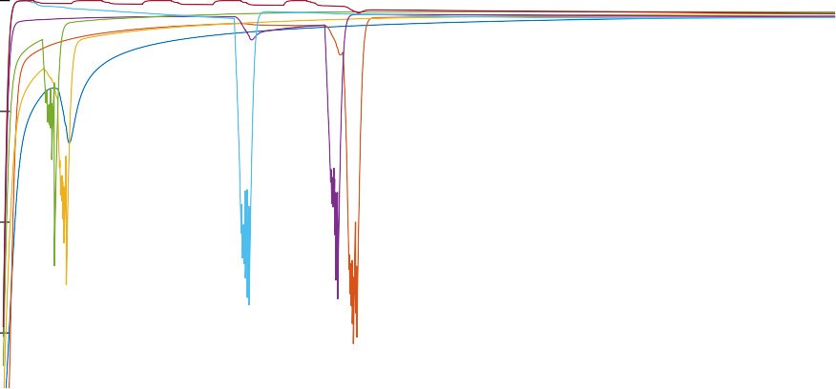10

8

Valocity (m/s)

6

4

0 50 100 150 200

Time (s)