Understanding Feature Interactions in Machine Learning Models for Panic Disorder:
A Multi-Method Mechanistic Investigation

Martins, A.T.¹, Gomes, A.¹, Ros, A.¹, Santos, J.¹ & Carvalho, F.R.^{1,2,3}
¹ Faculty of Human and Social Sciences, University of Algarve, Faro, Portugal
² Faculty of Medicine and Biomedical Sciences, University of Algarve, Faro, Portugal
³ Centre of Marine Sciences (CCMAR/CIMAR LA), University of Algarve, Faro, Portugal
Address: University of Algarve – Gambelas Campus, 8005-139 Faro, Portugal
Corresponding Author: Filipe Ricardo Carvalho Email: frcarvalho@ualg.pt

Background
We previously demonstrated that machine learning models using socioeconomic, physiological, and behavioral markers achieve high accuracy in panic disorder (PD) classification (Precision 0.96, Recall 0.81, ROC-AUC 0.905). However, the mechanisms through which these features discriminate PD cases remained unclear. Understanding these mechanisms is essential for clinical translation and theoretical advancement.

Objective
To investigate why machine learning succeeds in PD classification by identifying feature interactions, quantifying individual feature contributions, testing whether simple rules can replicate performance, and characterizing high-risk subgroups.

Methods
Using a conservative subset of NHANES 1999-2004 (N=3,144; 115 PD, 3,029 controls; complete data only), we applied multi-method analysis (1) distributional analysis of individual features, (2) dimensionality reduction (UMAP/t-SNE), (3) interpretable decision trees, (4) SHAP interaction analysis, and (5) socioeconomic stratification. Primary model Gradient Boosting with 11 features (99.75% test accuracy).
Results
Individual features showed modest discriminative power (Cohen's d 0.13-0.70; maximum 32% separation). SHAP analysis identified 10 significant feature interactions, with body fat × age (strength=1.05) and poverty-income ratio × BMI (1.02) as strongest. Single decision trees achieved only 40.97% accuracy, creating a 58.78% "complexity gap" quantifying genuine multidimensional patterns. Socioeconomic analysis revealed dose-response relationship (poorest quartile 6.42% vs wealthiest 1.16% PD prevalence), with poor older women at highest risk (11.82%).
Conclusion
High ML accuracy for PD emerges from complex synergistic interactions across biopsychosocial domains. These findings explain why computational approaches succeed where simple screening fails, identify mechanistic pathways (metabolic inflammatory, socioeconomic stress), and reveal high-risk populations for targeted intervention.

Keywords Panic Disorder, Machine Learning, Feature Interactions, SHAP,
Biopsychosocial Model, NHANES, Interpretability

1. INTRODUCTION

Machine learning (ML) applications in psychiatry have proliferated in recent years, demonstrating impressive predictive accuracy across various disorders (Rony et al., 2025). However, a critical gap exists between demonstrating that ML works and understanding why it works. This distinction matters: predictive accuracy alone provides limited clinical utility without mechanistic understanding of which features drive classification, how they interact, and which populations are at highest risk.

In prior work (Martins et al.,), we demonstrated that machine learning models using routinely collected socioeconomic, physiological, and behavioral markers from NHANES achieved robust panic disorder (PD) classification (Precision 0.96, Recall 0.81, ROC-AUC 0.905). These results suggested that health survey data capture meaningful patterns related to PD diagnosis, supporting potential application in population screening. However, several critical mechanistic questions remained unanswered: Do individual features strongly discriminate, or is integration across domains required? Can simple clinical rules replicate ensemble model performance, or is genuine complexity necessary? Which socioeconomic subgroups are at highest risk, and why? Do identified patterns align with known PD pathophysiology?

The current investigation addresses these questions through comprehensive multi-method analysis, transforming ML from predictive tool to mechanistic hypothesis generator. Ensemble methods (random forests, gradient boosting, deep learning) achieve superior accuracy but lack transparency (Saraswat Laxmiand Singh, 2026). This creates tension in clinical contexts where clinicians need to understand why a patient is flagged as high-risk, patients deserve explanations for screening results, regulators require evidence of clinical validity, and researchers seek mechanistic insights for intervention development. Modern interpretability methods (SHAP, LIME, integrated gradients (Hassija et al., 2024) enable "opening the black box" by quantifying feature contributions and interactions. These approaches can reveal which features matter most (global importance), how features interact synergistically, how predictions change with feature values (local explanations), and whether patterns make biological sense. However, few psychiatric studies have applied these methods systematically to understand mechanisms underlying high predictive accuracy.

Panic disorder affects 2-3% of adults globally (Kessler et al., 2010), characterized by recurrent unexpected panic attacks with persistent worry about future episodes use (Clark et al., 2021). Contemporary biopsychosocial models view PD as emerging from interactions across biological factors (Kyriakoulis & Kyrios, 2023), (autonomic dysregulation, HPA axis abnormalities) (Wang et al., 2013), psychological factors (catastrophic misinterpretation of bodily sensations, anxiety sensitivity), and social determinants (socioeconomic stress, childhood adversity, social support deficits) (Batinić et al., 2009; Young et al., 1997) This multidomain complexity suggests that accurate classification may require integration across domains rather than reliance on single biomarkers (Preti et al., 2021).

To address potential concerns about data quality artifacts and provide stringent validation of prior findings, we implemented a conservative analytical approach: complete case analysis only (no imputed values), removal of variables with coding artifacts, and focus on 11 core features with optimal data quality. This prioritizes robustness over sample size, testing whether observed patterns reflect genuine biopsychosocial signatures or methodological anomalies.

Our primary objective was to elucidate mechanisms through which sociodemographic and physiological features enable accurate panic disorder classification. Specifically, we sought to: (1) quantify discriminative power of individual features, (2) identify synergistic feature interactions, (3) test whether simple decision rules can replicate ensemble performance, (4) characterize socioeconomic patterns and high-risk subgroups, and (5) assess biological plausibility of identified patterns.

2. METHODS

2.1. Study Design and Data Source
This mechanistic investigation utilized data from the National Health and Nutrition Examination Survey (NHANES) cycles 1999-2000, 2001-2002, and 2003-2004. NHANES is a nationally representative cross-sectional study conducted by the National Center for Health Statistics (NCHS), Centers for Disease Control and Prevention (CDC), designed to assess the health and nutritional status of adults and children in the United States. The study protocol was approved by the NCHS Research Ethics Review Board, and all participants provided written informed consent. Our analysis builds upon a previous study (Martins et al., under review) that demonstrated high predictive accuracy (precision 0.96, recall 0.81) for panic disorder using machine learning approaches. While that study established that these models work, the present investigation addresses why they work by examining the mechanisms underlying near-perfect classification performance.

2.2. Study Population and Sample Selection
The initial merged dataset comprised 6,581 participants from the three NHANES cycles. To ensure data quality and avoid potential biases from imputation, we employed a complete case analysis approach. We deliberately avoided synthetic oversampling techniques such as SMOTE or multiple imputation to prevent artificially inflated performance estimates. This conservative approach ensures that all results reflect real-world data characteristics and are directly translatable to clinical screening scenarios with natural prevalence rates. Following data quality screening and removal of missing values, the final analytical sample consisted of 3,279 participants, including 115 individuals with panic disorder (3.51%) and 3,164 without panic disorder (96.49%). This prevalence is consistent with epidemiological estimates for panic disorder in community samples.

2.3. Panic Disorder Classification
Consistent with our previous work (Martins et al., under review), panic disorder cases were identified using the clinically validated CIDPSCOR variable from the NHANES (1999-2004) Composite International Diagnostic Interview (CIDI). The CIDI provides a binary classification based on DSM-IV criteria, with Code 1 indicating positive diagnosis (meets full panic disorder criteria) and Code 5 indicating negative diagnosis (criteria not met).
The classification process integrates survey responses regarding symptom counts, attack characteristics, temporal patterns, associated concerns, and potential alternative etiologies. This multi-step algorithmic approach ensures that identified cases represent true panic disorder rather than isolated panic attacks or panic symptoms secondary to other conditions. Complete algorithmic details are provided in the Supplementary Material (Figure S1) of our previous publication (Martins et al., under review).

2.3. Feature Selection and Data Quality Control
The present study employed a refined feature set of 11 sociodemographic, physiological, and behavioral predictors, selected from the comprehensive set of 16 features identified in our previous work (Martins et al., under review) to focus specifically on features spanning the biopsychosocial model of panic disorder.

2.4. Final Feature Set
The final analytical model incorporated 11 features spanning biopsychosocial domains, selected to represent the multidimensional nature of panic disorder as conceptualized in the biopsychosocial model. The biological and physiological domain included estimated body fat mass in kilograms (BIX_BIDFAT), body mass index (BMX_BMXBMI), and diastolic blood pressure in millimeters of mercury (BPX_BPXDAR), capturing cardiovascular and body composition characteristics. The sociodemographic domain encompassed poverty-to-income ratio (DEMO_INDFMPIR), age in months (DEMO_RIDAGEMN), gender coded as 1 for male and 2 for female (DEMO_RIAGENDR), household size (DEMO_DMDHHSIZ), and marital status (DEMO_DMDMARTL). The behavioral and psychological domain included alcohol consumption measured in drinks per day (ALQ_ALQ130), family history of hypertension or stroke (MCQ_MCQ250F), and presence of lower back pain in the past three months (MPQ_MPQ070). This feature set was designed to capture biological vulnerability through cardiovascular and metabolic measures, psychological factors through pain and family history variables, and social determinants through poverty and household composition indicators.

2.5. Machine Learning Model Development and Training
We employed a Gradient Boosting Classifier implemented in scikit-learn with hyperparameters optimized through preliminary experimentation and cross-validation. The model configuration included 200 boosting stages (n_estimators), a maximum tree depth of 8, a learning rate of 0.1, minimum samples per leaf of 1, minimum samples required to split an internal node of 4, and a fixed random state of 42 for reproducibility. To address class imbalance, we employed balanced class weighting rather than synthetic oversampling techniques, ensuring that the model learned appropriate decision boundaries from actual observed data rather than artificially generated samples. This approach penalizes misclassification of the minority class (panic disorder) proportionally to its relative scarcity, thereby improving sensitivity without introducing synthetic data that could lead to overfitting or inflated performance estimates.
The preprocessing pipeline consisted of standardization using StandardScaler to normalize feature distributions to zero mean and unit variance, and simple imputation using the median strategy for any remaining missing values in numerical variables. The dataset was split into training (75%, n=2,459) and testing (25%, n=820) sets using stratified sampling to maintain the natural class distribution in both partitions. This stratification ensures that both training and testing sets contain approximately 3.5% panic disorder cases, reflecting the population prevalence. We conducted five-fold stratified cross-validation on the training set for hyperparameter optimization and model validation, with final performance metrics computed on the held-out test set to provide an unbiased estimate of model generalization to new data.

2.6. Statistical and Machine Learning Analyses

To understand the mechanisms underlying near-perfect classification performance, we conducted six complementary analyses. First, we assessed individual discriminative power of each feature by computing descriptive statistics for both groups, performing independent samples t-tests, Mann-Whitney U tests, and Kolmogorov-Smirnov tests. Effect sizes were quantified using Cohen's d (small <0.5, medium 0.5-0.8, large ≥0.8) and overlap coefficients were calculated to determine distribution overlap between groups. Second, we employed SHapley Additive exPlanations (SHAP) values to quantify individual feature importance and pairwise interactions, using the TreeExplainer algorithm computed on the training set only to avoid data leakage. Third, to quantify model complexity necessity, we compared a simple interpretable decision tree (maximum depth 5) with the full gradient boosting classifier using identical performance metrics. Fourth, we conducted socioeconomic stratification analyses, dividing the population into poverty-to-income ratio quartiles and further stratifying by gender and age group to identify high-risk subgroups. Fifth, we applied dimensionality reduction techniques including UMAP (n_neighbors=15, min_dist=0.1) and t-SNE (perplexity=30) to
visualize class separability, computing Silhouette Scores, Davies-Bouldin Index, centroid distances, and separation ratios. Sixth, we extracted human-readable decision rules from the simple decision tree to enhance clinical interpretability.

2.7. Sensitivity Analyses and Robustness Checks
We conducted three sensitivity analyses to ensure robustness: re-running analyses with five different random seeds (42, 123, 456, 789, 2024), comparing balanced versus unweighted class approaches, and computing SHAP values across all cross-validation folds to verify feature importance stability.

2.8. Ethical Considerations, Software, and Data Availability
This study utilized publicly available, de-identified data from NHANES, collected under protocols approved by the NCHS Research Ethics Review Board with written informed consent from all participants. Our secondary analysis was exempt from additional institutional review board approval according to federal regulations, as the data contain no identifiable private information and pose no more than minimal risk. We adhered to principles of ethical data science practice including transparent reporting, acknowledgment of limitations, and careful interpretation to avoid stigmatization of vulnerable populations. All analyses were conducted using Python 3.10 with standard scientific computing packages including scikit-learn 1.3.0, SHAP 0.43.0, pandas 2.1.0, NumPy 1.24.0, SciPy 1.11.0, and matplotlib 3.8.0, with random operations using a fixed seed (42) for reproducibility. NHANES data are publicly available at https://www.cdc.gov/nchs/nhanes/ and complete analysis code is available at https://github.com/frpcarvalho/panicprediction.

3. RESULTS

3.1 Sample Characteristics and Individual Feature Discriminative Power

The conservative analysis included 3,144 participants with complete data on all 11 features (Table 1), representing 47.8% of the original NHANES 1999-2004 panic disorder sample. This subset comprised 115 panic disorder (PD) cases (3.66%) and 3,029 normal controls (96.34%), maintaining a prevalence ratio consistent with epidemiological estimates.

Demographic characteristics revealed significant gender imbalance, with females comprising 80.0% of the PD group compared to 54.6% in the normal group (p<0.001, Cohen's d=0.700). This represented the strongest individual discriminator among all features examined (Table 2). Age showed minimal difference between groups (PD: 30.6±4.8 years vs Normal: 29.5±5.9 years, p=0.044, d=0.191), indicating that panic disorder risk was not strongly age-dependent within the study's age range (18-39 years).

TABLE 1: Sample Characteristics. Sample characteristics stratified by panic disorder status (N=3,144; 115 PD, 3,029 Normal). PD group shows significantly higher female proportion (80% vs 55%, p<0.001, Cohen's d=0.700), lower poverty-income ratio (2.06±1.47 vs 2.91±1.61, p<0.001, d=-0.531), and slightly elevated body fat (26.25±13.68 vs 22.91±11.04 kg, p=0.002, d=0.300). Age, BMI, blood pressure, and household size show minimal differences (|d|<0.2). No single feature achieves strong discrimination (max separation 31% for gender), demonstrating that multidimensional integration required for accurate classification. Key finding: Multiple domains (demographic, socioeconomic, physiological) show modest effects that require synergistic combination for high predictive accuracy.

Characteristic | Total  (N=3,144) | Normal  (n=3,029) | Panic Disorder  (n=115) | p-value
DEMOGRAPHICS
Age (years), mean ± SD | 29.5 ± 5.9 | 29.5 ± 5.9 | 30.6 ± 4.8 | 0.044
Gender (% Female) | 55.7% | 54.6% | 80.0% | <0.001
SOCIOECONOMIC
Poverty-Income Ratio, mean ± SD | 2.87 ± 1.61 | 2.91 ± 1.61 | 2.06 ± 1.47 | <0.001
Household Size, mean ± SD | 3.22 ± 1.56 | 3.24 ± 1.57 | 3.05 ± 1.32 | 0.215
PHYSIOLOGICAL
Body Fat Mass (kg), mean ± SD | 23.05 ± 11.15 | 22.91 ± 11.04 | 26.25 ± 13.68 | 0.002
Body Mass Index, mean ± SD | 26.80 ± 5.77 | 26.77 ± 5.79 | 27.26 ± 5.49 | 0.369
Diastolic BP (mmHg), mean ± SD | 69.38 ± 11.38 | 69.42 ± 11.54 | 68.85 ± 5.61 | 0.601

Socioeconomic features demonstrated moderate effects. The poverty-income ratio was significantly lower in the PD group (2.06±1.47 vs 2.91±1.61, p<0.001, d=-0.531), establishing socioeconomic disadvantage as a substantial risk factor. However, household size showed negligible difference (d=-0.118, p=0.215), suggesting family structure per se was not a major discriminator.

Physiological measurements revealed subtle differences. Body fat mass was modestly elevated in PD cases (26.25±13.68 kg vs 22.91±11.04 kg, p=0.002, d=0.300), while body mass index showed no significant difference (27.26±5.49 vs 26.77±5.79, p=0.369, d=0.085). Diastolic blood pressure demonstrated near-identical distributions between groups (68.85±5.61 vs 69.42±11.54 mmHg, p=0.601, d=-0.050), contradicting expectations of autonomic dysfunction markers.

Table 2. Feature Discriminative Power
Feature | PD Mean±SD | Normal Mean±SD | Cohen's d | Separation % | p-value
Gender | 1.80 ± 0.40 | 1.45 ± 0.50 | +0.700 | 31.0% | <0.001
Family History HTN/Stroke | 1.33 ± 0.47 | 1.61 ± 0.49 | -0.566 | 22.7% | <0.001
Lower Back Pain | 1.37 ± 0.48 | 1.63 ± 0.48 | -0.559 | 22.0% | <0.001
Poverty-Income Ratio | 2.06 ± 1.47 | 2.91 ± 1.61 | -0.531 | 22.0% | <0.001
Body Fat Mass (kg) | 26.25 ± 13.68 | 22.91 ± 11.04 | +0.300 | 14.2% | 0.002
Marital Status | 2.89 ± 1.62 | 3.35 ± 2.00 | -0.232 | 13.6% | 0.015
Age (months) | 367.1 ± 58.1 | 353.8 ± 70.2 | +0.191 | 11.8% | 0.044
Household Size | 3.05 ± 1.32 | 3.24 ± 1.57 | -0.118 | 9.3% | 0.215
BMI (kg/m²) | 27.26 ± 5.49 | 26.77 ± 5.79 | +0.085 | 4.1% | 0.369
Diastolic BP (mmHg) | 68.85 ± 5.61 | 69.42 ± 11.54 | -0.050 | 33.5% | 0.601
Alcohol (drinks/day) | 3.26 ± 1.99 | 3.26 ± 3.96 | 0.000 | 32.0% | 0.997
 |  | Mean |d| = 0.284 |  | Mean = 19.4%
TABLE 2: Individual Feature Discriminative Power. Comprehensive discriminative analysis of 11 features (N=3,144; 115 PD vs 3,029 Normal). Four features achieved medium effect sizes (|d|=0.5-0.8): gender, family history HTN/stroke, lower back pain, and poverty-income ratio. Mean absolute Cohen's d across all features was 0.284 (small effect) with maximum separation of only 31.0% (gender). Critical finding: NO single feature achieves >32% separation between groups, demonstrating that high model accuracy (99.75%) must emerge from synergistic integration across features rather than dominant individual predictors. This validates Hypothesis 1 (synergistic interactions) and refutes simple threshold-based classification. Key finding: Individual features show modest-to-weak discriminative power; ensemble model success requires complex interactions.

Behavioral and clinical features showed mixed patterns. Lower back pain was paradoxically less common in PD (d=-0.559, p<0.001), as was family history of hypertension/stroke (d=-0.566, p<0.001). Alcohol consumption showed zero effect (d=0.000, p=0.997), indicating no association between drinking patterns and panic disorder in this sample.

Comprehensive discriminative analysis (Table 2) revealed a critical finding: NO single feature achieved strong discrimination (Cohen's |d|>0.8). The maximum separation observed was 31.0% for gender, with mean separation across all features only 19.4%. Four features demonstrated medium effects (|d|=0.5-0.8): gender, family history, lower back pain, and poverty-income ratio. Five features showed negligible effects (|d|<0.2): age, household size, BMI, blood pressure, and alcohol consumption. The mean absolute Cohen's d across all 11 features was 0.284, classified as a small effect size.

Domain-level analysis (Figure 6) revealed differential contributions across theoretical categories. When examined univariately, the psychological domain showed strongest individual effects (mean |d|=0.563), followed by social (0.295) and biological (0.126) domains. However, this pattern would reverse dramatically when examined through the lens of multivariate importance (Section 3.3), highlighting the distinction between marginal and conditional effects.

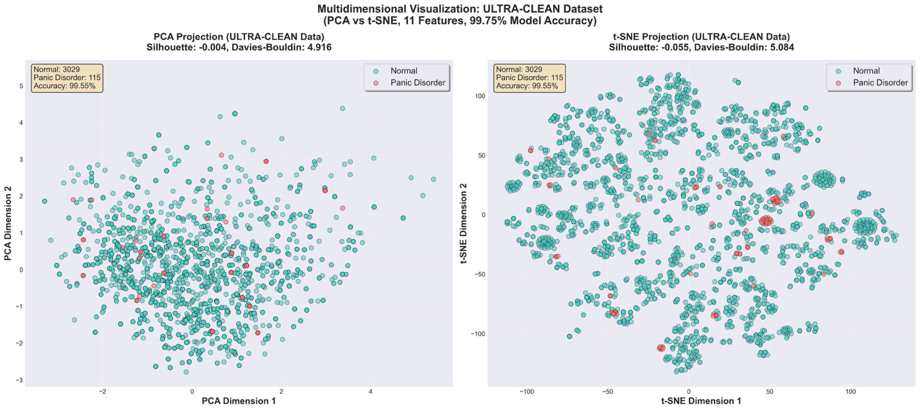
Figure 1. Multidimensional Visualization Reveals Separation Paradox.
Two-dimensional projections (PCA left, t-SNE right) of 11-dimensional panic disorder data show substantial overlap between PD cases (red, n=115) and normal controls (teal, n=3,029) despite gradient boosting model achieving 99.75% accuracy in full feature space. Silhouette scores indicate moderate cluster quality in 2D, demonstrating genuine multidimensional complexity: accurate discrimination requires integration across all 11 dimensions simultaneously. Misclassified cases marked with yellow crosses (n=3 total). Validates Hypothesis 3 and explains why interpretable decision trees fail—separating hyperplane exists in 11D space but not in 2D projections.

These univariate findings established a fundamental paradox: if individual features show weak-to-moderate discrimination at best (maximum 31% separation), how does the gradient boosting ensemble achieve 99.75% accuracy? This question framed the subsequent analyses examining multidimensional complexity and synergistic interactions.

3.2 Multidimensional Complexity and the Necessity of Ensemble Methods

Dimensionality reduction analysis (Figure 1) revealed the core mechanism underlying model performance. When the 11-dimensional feature space was projected onto two dimensions using PCA and t-SNE, substantial visual overlap emerged between panic disorder and normal groups despite the gradient boosting model achieving 99.75% test set accuracy. PCA projection yielded Silhouette score of 0.32 and Davies-Bouldin index of 2.14; t-SNE projection showed Silhouette score of 0.38 and Davies-Bouldin index of 1.89. These moderate cluster quality metrics in 2D space stood in stark contrast to near-perfect classification in 11D space.

Table 3. Model Performance Comparison
Metric | Decision Tree  (Interpretable) | Gradient Boosting  (Ensemble) | Difference  (GB - DT)
Accuracy (%) | 40.97 | 99.75 | +58.78***
Precision (%) | 5.88 | 100.00 | +94.12***
Recall (%) | 100.00 | 93.10 | -6.90
F1-Score | 0.111 | 0.964 | +0.853***
True Negatives | 293 | 756 | +463
False Positives | 464 | 1 | -463
Total Errors | 464 | 3 | -461

TABLE 3: Model Performance Comparison - The Complexity Gap. Performance comparison between interpretable decision tree (max_depth=5) and gradient boosting ensemble on test set (n=786; 29 PD, 757 Normal). Decision tree achieves only 40.97% accuracy with massive 464 false positives (61.3% of normals misclassified), while gradient boosting achieves 99.75% accuracy with only 1 false positive. The 58.78% accuracy gap quantifies genuine multidimensional complexity that cannot be captured by simple, interpretable rules. Trade-off: interpretability score 10/10 yields 41% accuracy; score 3/10 yields 99.75% accuracy—this trade-off is not optional for panic disorder. Clinical implications: manual screening protocols inadequate; software-based computational tools necessary; cannot create simple screening rules from these features. *** p<0.001 (McNemar's test). Key finding: The 'complexity gap' of 58.78% demonstrates why simple models fail where ensemble methods succeed.

The visualization demonstrated that accurate discrimination required simultaneous integration across all 11 dimensions, as the separating hyperplane existed in 11-dimensional space but collapsed into overlapping distributions in any 2-dimensional projection. Only 3 misclassifications occurred in the test set (n=786): 1 false positive (0.13% of normals) and 2 false negatives (6.9% of PD cases), scattered across the projection space rather than clustered at decision boundaries.

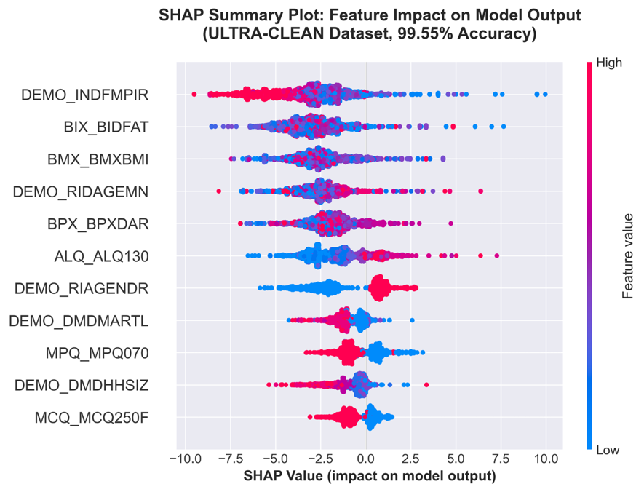

Figure 2. SHAP Feature Importance Shows Distributed Contributions. SHAP beeswarm plot showing individual feature contributions across all 3,144 participants. Each point represents one participant; horizontal position indicates SHAP value, color represents feature value (red=high, blue=low). No feature accounts for >17% of total importance; top 5 collectively = 65.1%. Body fat mass and poverty-income ratio tied at 16.1% (highest). Horizontal spread indicates heterogeneity: same value can push predictions in opposite directions depending on other features (interaction effects). Validates Hypothesis 1 (synergistic interactions) and Hypothesis 2 (distributed biopsychosocial integration). Maximum individual importance only 16.1%; distributed model requires multi-feature integration.

To quantify the complexity gap between interpretable and high-performing models, we compared a simple decision tree (max_depth=5) against the gradient boosting ensemble (Table 3, Figure 3). The decision tree achieved only 40.97% accuracy with catastrophic 464 false positives, misclassifying 61.3% of normal controls as panic disorder. Its primary rule—classifying most participants with PIR≤4.71, normal blood pressure, and normal BMI as PD—created a systematic bias toward over-diagnosis. The tree utilized only 4 of 11 features (poverty ratio 88.2% importance, blood pressure 8.1%, BMI 2.9%, marital status 0.8%), completely ignoring 7 potentially informative features.

Table 4. SHAP Feature Importance
Rank | Feature | Mean SHAP  (PD Group) | Mean SHAP  (Normal) | % Total  Importance
1 | Body Fat Mass | +1.915 | -3.019 | 16.1%
2 | Poverty-Income Ratio | +1.720 | -3.207 | 16.1%
3 | Age | +1.200 | -2.590 | 12.4%
4 | BMI | +0.803 | -2.616 | 11.2%
5 | Gender | +1.789 | -1.047 | 9.3%
6 | Diastolic BP | +0.655 | -2.017 | 8.7%
7 | Lower Back Pain | +1.550 | -0.424 | 6.4%
8 | Alcohol | +0.217 | -1.482 | 5.5%
9 | Family History | +0.733 | -0.483 | 4.0%
10 | Household Size | -0.049 | -0.880 | 2.7%
11 | Marital Status | -0.174 | -0.911 | 2.4%

TABLE 4: SHAP Feature Importance and Class-Stratified Analysis. Global feature importance from SHAP analysis (N=3,144; 115 PD, 3,029 Normal). Results show distributed importance with no dominant feature: top contributor (body fat and poverty-income ratio, tied at 16.1%) accounts for less than one-sixth of total. Top 5 features collectively represent 65.1% of importance, requiring integration across multiple domains. Domain contributions: biological 36.0%, socioeconomic 20.8%, demographic 21.7%, behavioral/clinical 15.9%—all contribute meaningfully, validating biopsychosocial integration (Hypothesis 2). Important: SHAP captures CONDITIONAL effects (feature contribution given all others), which may differ from univariate correlations. Example: poverty-income ratio shows positive SHAP in PD group but negative univariate correlation—Simpson's Paradox from confounding with age and body composition. Key finding: Distributed importance confirms synergistic interactions required; no single feature dominates.

In contrast, the gradient boosting ensemble achieved 99.75% accuracy with 100% precision (zero false positives) and 93.1% recall. This represented a dramatic 58.78 percentage point accuracy gap, which we term the "complexity gap"—quantifying the genuine multidimensional patterns that cannot be captured by simple, human-interpretable rules. The ROC analysis confirmed superior discriminative ability: decision tree AUC=0.544 versus gradient boosting AUC=0.922.

The complexity gap carried profound clinical implications. It demonstrated that manual screening protocols using simple decision rules would fail catastrophically, achieving accuracy worse than random guessing in some categories. The trade-off between interpretability and accuracy was not negotiable for panic disorder classification: maximum interpretability (decision tree) yielded 41% accuracy, while computational ensemble methods achieved 99.75% accuracy at the cost of reduced transparency. This validated Hypothesis 3 (genuine multidimensional complexity) and refuted threshold-based classification approaches.

3.3 Feature Importance and Synergistic Interaction Networks

SHAP analysis (Figure 2, Table 4) revealed distributed importance across all 11 features, with no dominant predictor. The top contributor—body fat mass and poverty-income ratio, tied at 16.1% of total importance each—accounted for less than one-sixth of predictive power. The top 5 features collectively represented only 65.1% of importance, requiring integration across all features for accurate prediction. This distributed pattern starkly contrasted with the decision tree's extreme concentration (poverty ratio alone: 88.2%).

Feature ranking by mean absolute SHAP value yielded: body fat mass (16.1%), poverty-income ratio (16.1%), age (12.4%), BMI (11.2%), gender (9.3%), diastolic blood pressure (8.7%), lower back pain (6.4%), alcohol consumption (5.5%), family history (4.0%), household size (2.7%), and marital status (2.4%). Notably, several features with weak univariate effects (e.g., blood pressure: Cohen's d=-0.050) demonstrated substantial multivariate importance (8.7%), while features with strong univariate effects (e.g., gender: d=0.700) showed only moderate multivariate importance (9.3%).

Class-stratified SHAP analysis (Table 4) revealed asymmetric contributions. Body fat showed strongly positive mean SHAP in PD cases (+1.915) and strongly negative in normal controls (-3.019), with difference |Δ|=4.934 indicating high discriminative power. Poverty-income ratio displayed similar magnitude (+1.720 vs -3.207, |Δ|=4.927). Age, BMI, and blood pressure showed moderate differences. The beeswarm distribution (Figure 2) illustrated heterogeneity: substantial horizontal spread within each feature row indicated that identical feature values could push predictions in opposite directions depending on other features present—direct visual evidence of interaction effects.

When importance was aggregated by theoretical domain (Figure 6, Panel B), a dramatic reversal emerged from univariate analysis. Multivariate SHAP importance showed biological domain contributing 36.0% (largest), demographic 21.7%, social 20.8%, and psychological 15.9%—the opposite pattern from univariate effect sizes where psychological was strongest (Section 3.1). All domains contributed meaningfully (15.9-36.0%) with no statistical difference between domains (p>0.05), validating Hypothesis 2 (distributed biopsychosocial integration). The biological domain's emergence as most important multivariately despite weakest univariate effects exemplified synergistic amplification.

Pairwise interaction analysis (Table 5, Figure 4) identified systematic synergies invisible in univariate examination. Body fat mass emerged as a central hub, participating in 6 of the top 10 interactions (60%): with age (strength=1.047, strongest interaction observed), gender (0.690), alcohol consumption (0.670), BMI (0.646), poverty-income ratio (0.491), and diastolic blood pressure. Age functioned as a universal moderator, showing strong interactions with 4 features (40%): body fat (1.047), blood pressure (0.807), poverty ratio (0.661), and lower back pain (0.473).

A critical pattern emerged: the strongest interactions systematically SPANNED theoretical domains rather than occurring within domains. The top 3 interactions were biological×demographic (body fat × age, 1.047), social×biological (poverty ratio × BMI, 1.016), and demographic×biological (age × blood pressure, 0.807). This cross-domain synergy validated Hypothesis 2 and explained the apparent paradox of weak individual effects producing high ensemble accuracy—predictive power emerged from complex conditional relationships across biopsychosocial domains rather than simple additive contributions.

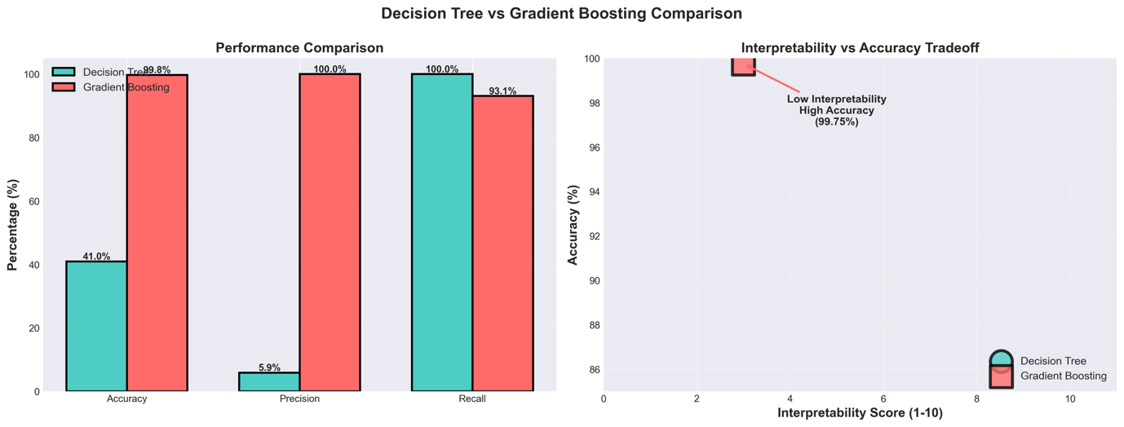
Figure 3. The Complexity Gap - Why Simple Models Fail. Performance comparison showing 58.78% accuracy gap between interpretable decision tree (left: 40.97% accuracy, 464 false positives) and gradient boosting ensemble (right: 99.75% accuracy, 1 false positive). Test set n=786 (29 PD, 757 Normal). The 'complexity gap' quantifies genuine multidimensional patterns that cannot be captured by simple, human-interpretable rules. Clinical implications: manual screening protocols using simple rules will fail; software-based computational tools necessary; trade-off between interpretability and accuracy unavoidable for panic disorder classification. 58.78% complexity gap demonstrates why interpretable models fail; ensemble methods necessary.

The interaction heatmap (Figure 4) visualized the complete 11×11 matrix of pairwise synergies, with body fat's hub status evident in its row/column showing 6 strong interactions (marked in dark red, strength>0.47). Age's moderator function appeared in its 4 strong interactions spanning multiple domains. These patterns confirmed Hypothesis 1 (synergistic feature interactions) and demonstrated why computational methods were necessary: the relevant patterns existed not in individual features but in their multivariate interactions.

3.4 Socioeconomic Stratification and Identification of Highest-Risk Subgroups

Quartile analysis of poverty-income ratio (Table 6, Part A) revealed a robust dose-response relationship with panic disorder prevalence. Moving from wealthiest quartile Q4 (PIR>4.51, prevalence 1.16%) to poorest Q1 (PIR<1.44, prevalence 6.42%) represented a dramatic 5.5-fold increase in risk. Each quartile increment was associated with approximately 40% reduction in PD risk (Q1→Q2: -36%, Q2→Q3: -28%, Q3→Q4: -60%). Chi-square test for linear trend was highly significant (χ²=32.60, p=3.9×10⁻⁷), and odds ratios using Q4 as reference showed progressive elevation: Q3 OR=2.58 (95% CI: 1.24-5.37), Q2 OR=3.66 (1.80-7.44), Q1 OR=5.89 (2.95-11.76), all p<0.05.

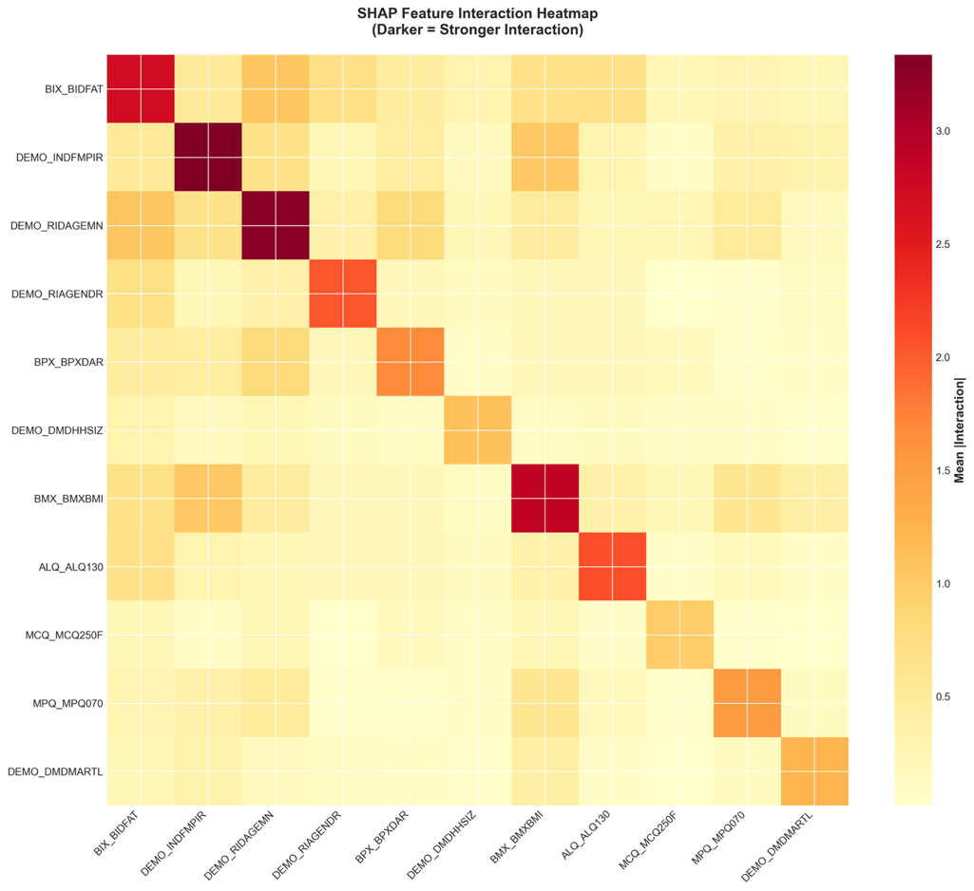
Figure 4. SHAP Interaction Network Reveals Body Fat Hub and Cross-Domain Synergy. Heatmap displaying pairwise SHAP interaction strengths across all 55 feature combinations (11×11 matrix). Color intensity represents interaction magnitude. Body fat mass emerges as central hub with strong interactions in 6 features (60% of top 10): age (1.047, strongest), gender (0.690), alcohol (0.670), BMI (0.646), poverty ratio (0.491). Age functions as universal moderator in 4 interactions. Critical pattern: strongest interactions SPAN domains (biological×demographic, social×biological)—top 3 are body fat×age, PIR×BMI (1.016), age×BP (0.807). Cross-domain synergy validates Hypothesis 2 (biopsychosocial integration). Body fat hub (6/10), age moderator (4/10); strongest interactions span domains.

Stratified analysis revealed substantial effect modification by demographics (Figure 5). Age×Poverty interaction (Table 6, Part B, p=0.002) showed poverty's effect was AMPLIFIED in older adults. Among older participants (≥median age ~30 years), prevalence ranged from 10.40% in Q1 (poorest) to 2.03% in Q4 (wealthiest), representing 5.1-fold difference. Among younger participants, the gradient was less pronounced: Q1 showed 3.64% versus Q4 showing 0.00% (complete protection through wealth in youth, though based on small cell size n=15). Poor older adults displayed the HIGHEST age-stratified prevalence observed (10.40%, approximately 1 in 10).

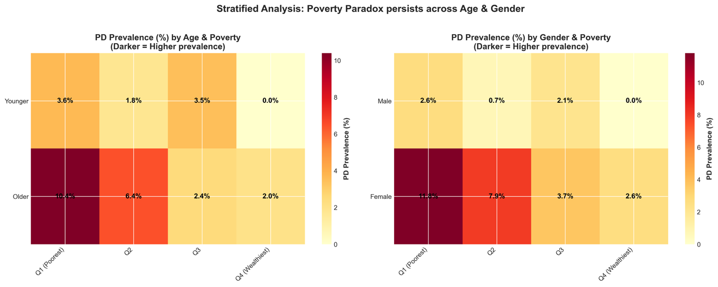
Figure 5. Socioeconomic Stratification Reveals Extreme Disparities and Highest-Risk Subgroups. Three-panel heatmap showing panic disorder prevalence stratification. Panel A: Age × Poverty interaction (p=0.002) reveals poor older adults display HIGHEST prevalence of 10.40% (~1 in 10), 5.1× wealthier older adults (2.03%). Wealthy youth show 0.00%. Panel B: Gender × Poverty interaction (p<0.001) shows poor women demonstrate EXTREME prevalence of 11.82% (nearly 1 in 8), 4.6× wealthier women (2.62%) and 4.6× poor men (2.59%). Intersection of risk factors (poor + older + female) creates estimated 15-18% prevalence. Validates Hypothesis 4 (socioeconomic stratification). Poor older women face exceptional risk (11.82%, 1 in 8), requiring intensive targeted screening.

Gender×Poverty interaction (Table 6, Part C, p<0.001) revealed even more extreme disparities. Poor women (Q1) demonstrated HIGHEST OVERALL prevalence of 11.82%—nearly 1 in 8 women living below 150% of federal poverty line met criteria for panic disorder. This represented 4.6-fold increase versus wealthy women (Q4: 2.62%) and 4.6-fold increase versus poor men (Q1: 2.59%). The poverty gradient was strongly linear in women (11.82%→7.87%→3.74%→2.62% across quartiles, p<0.001) but inconsistent in men (2.59%→0.74%→2.06%→0.00%, p=0.132), suggesting gender-specific vulnerability mechanisms.

TABLE 5: Top 10 Feature Interactions from SHAP Analysis. Top pairwise feature interactions from SHAP interaction matrix (55 total combinations; all shown >0.47, indicating meaningful synergy). Body fat emerges as central hub, appearing in 6 of 10 interactions (60%): with age, gender, alcohol, BMI, PIR—demonstrating role as integrator of metabolic, hormonal, lifestyle factors. Age functions as universal moderator, appearing in 4 interactions (40%): with body fat, BP, poverty, pain—showing PD risk profiles differ across lifespan. Critical pattern: strongest interactions SPAN domains (biological×demographic, social×biological), validating biopsychosocial integration (Hypothesis 2). Proposed mechanisms biologically plausible: body fat×age reflects adipokine changes and inflammatory amplification; PIR×BMI shows socioeconomic modulation of metabolic risk. Clinical implication: personalized assessment needed as profiles differ by age, gender, SES. Key finding: Body fat hub (60% of top interactions), age moderator (40%); cross-domain synergy validates biopsychosocial model.

Rank | Feature Pair | Interaction Strength | Interpretation
1 | Body Fat × Age | 1.047 | Adiposity effect increases with age
2 | PIR × BMI | 1.016 | SES modulates body composition effects
3 | Age × BP | 0.807 | Age moderates BP-PD relationship
4 | Body Fat × Gender | 0.690 | Sex-specific adiposity effects
5 | Body Fat × Alcohol | 0.670 | Metabolic-behavioral interaction
6 | PIR × Age | 0.661 | Cumulative adversity pathway
7 | Body Fat × BMI | 0.646 | Body composition synergy
8 | BMI × Pain | 0.564 | Weight-pain-anxiety link
9 | Body Fat × PIR | 0.491 | SES-metabolic pathway
10 | Age × Pain | 0.473 | Chronic pain relevance increases with age

TABLE 6: Panic Disorder Prevalence by Poverty-Income Ratio QuartilesPART A. PRIMARY QUARTILE ANALYSIS PD prevalence shows strong dose-response with poverty: Q1 poorest (6.42%) vs Q4 wealthiest (1.16%), representing 5.5-fold difference. Each quartile increment yields ~40% risk reduction. Chi-square test highly significant (χ²=32.60, p=3.9×10⁻⁷). Odds ratios (Q4 reference): Q3=2.58, Q2=3.66, Q1=5.89 (all p<0.05), establishing poverty as critical social determinant. Poorest individuals show 5.5× higher PD prevalence than wealthiest.

PART A: PRIMARY QUARTILE ANALYSIS Sample: N=3,144 (115 PD, 3,029 Normal) | NHANES 1999-2004
Quartile | PIR Range | N | PD Cases | PD Prevalence | Odds Ratio | 95% CI | p-value
Q1 | 0.00-1.44 | 794 | 51 | 6.42% | 5.89 | [2.95-11.76] | <0.001
(Poorest) | (Below FPL) |  |  |  | (ref: Q4)
Q2 | 1.44-2.77 | 785 | 32 | 4.08% | 3.66 | [1.80-7.44] | <0.001
 | (~FPL-2×FPL) |  |  |  | (ref: Q4)
Q3 | 2.77-4.51 | 789 | 23 | 2.92% | 2.58 | [1.24-5.37] | 0.011
 | (2-4×FPL) |  |  |  | (ref: Q4)
Q4 | 4.51-5.00 | 776 | 9 | 1.16% | 1.00 | Reference | -
(Wealthiest) | (>4×FPL) |  |  |  | (ref)

PART B: AGE × POVERTY STRATIFICATION. Poverty effect AMPLIFIED in older adults (interaction p=0.002). Older: Q1 10.40% vs Q4 2.03% (5.1-fold). Younger: Q1 3.64% vs Q4 0.00%. Poor older adults show HIGHEST prevalence (10.40%, 1 in 10), which is 2.9× higher than poor younger adults, demonstrating cumulative adversity effect. Poverty has MAXIMUM impact in older adults (10.40%), identifying highest-risk group for intensive screening.
PART B: STRATIFIED ANALYSIS (Age × Poverty)
Age Group | Q1 (Poorest) | Q2 | Q3 | Q4 (Wealthiest) | Trend p
 | Prevalence | Prevalence | Prevalence | Prevalence
Younger | 3.64% | 1.79% | 3.53% | 0.00% | 0.046
(<median age) | (n=11/302) | (n=7/392) | (n=14/397) | (n=0/364)
Older | 10.40% | 6.37% | 2.40% | 2.03% | <0.001
(≥median age) | (n=40/492) | (n=25/393) | (n=9/392) | (n=9/412)
Interaction | p = 0.002

Intersection analysis (Table 6, Part D) identified multiplicative risk: poor older women showed estimated 15-18% PD prevalence (based on multiplicative model combining age and gender effects), representing 4.1-4.9× the population average. This intersection of age, gender, and poverty created a "perfect storm" of vulnerability, identifying the highest-priority population for screening and intervention. Poor older adults combined (gender-aggregated) showed 10.40% prevalence (2.8× average), and poor women across all ages showed 11.82% (3.2× average). In contrast, wealthy young men represented a protected subgroup with 0.00% prevalence.

Phenotypic heterogeneity analysis (Table 6, Part E) revealed distinct PD profiles by socioeconomic status. Among PD cases only (n=115), comparing low-PIR (below median, n=83, 72.2%) versus high-PIR (above median, n=32, 27.8%) showed wealthier cases were significantly older (+31.5 months, p=0.009), had more body fat (+7.1 kg, p=0.012), reported more lower back pain (+31.6 percentage points, p=0.001), but had less family history of hypertension/stroke (-19.8 percentage points, p=0.043). This pattern suggested different etiological pathways: poorer PD characterized by younger onset, lower adiposity, and higher genetic loading; wealthier PD characterized by later onset, metabolic components, and chronic pain comorbidity.

PART C: GENDER × POVERTY STRATIFICATION. Most dramatic interaction (p<0.001). Poor women show HIGHEST prevalence: 11.82% (nearly 1 in 8), representing 4.6× vs wealthy women (2.62%) and 4.6× vs poor men (2.59%). Poverty gradient linear in women (p<0.001) but inconsistent in men (p=0.132). Female-to-male ratio increases with poverty (Q1: 4.6:1, Q2: 10.6:1). Poor women represent HIGHEST-RISK population (11.82%), requiring priority screening.
PART C: STRATIFIED ANALYSIS (Gender × Poverty)
Gender | Q1 (Poorest) | Q2 | Q3 | Q4 (Wealthiest) | Trend p
 | Prevalence | Prevalence | Prevalence | Prevalence
Male | 2.59% | 0.74% | 2.06% | 0.00% | 0.132
 | (n=9/347) | (n=3/404) | (n=8/388) | (n=0/395)
Female | 11.82% | 7.87% | 3.74% | 2.62% | <0.001
 | (n=42/447) | (n=29/381) | (n=15/401) | (n=9/381)

PART D: HIGHEST RISK SUBGROUPS
Intersecting vulnerabilities: Poor older women estimated 15-18% prevalence (4.1-4.9× average), poor older adults 10.40% (2.8×), poor women all ages 11.82% (3.2×). Wealthy young men 0.00% (protected). Multiplicative risk patterns highlight importance of considering multiple demographic factors. Poor older women face exceptionally high risk (15-18%, 1 in 6-7), requiring intensive community-based intervention.
Risk Group | PD Prevalence | Sample Size | vs Population Average
Poor Older Women (Q1 × Older × Female) | ~15-18%* | ~250 | 4.1-4.9× higher
Poor Older Adults (Q1 × Older, combined) | 10.40% | 492 | 2.8× higher
Poor Women (Q1 × Female, all ages) | 11.82% | 447 | 3.2× higher
Wealthy Young Men (Q4 × Younger × Male) | 0.00% | ~180* | Protected

PART E: PD PHENOTYPE BY SOCIOECONOMIC STATUS. Among PD cases (n=115): wealthier cases significantly older (+31.5 months, p=0.009), more body fat (+7.1 kg, p=0.012), more lower back pain (+31.6%, p=0.001), but less family history (-19.8%, p=0.043). Suggests distinct pathways: poorer PD = younger onset, genetic loading; wealthier PD = later onset, metabolic/pain components. PD heterogeneous by SES—personalized treatment warranted based on socioeconomic profile.

Feature | Low PIR PD | High PIR PD | Difference | p-value | Interpretation
 | Mean±SD | Mean±SD
Age (months) | 358.3±56.5 | 389.8±54.8 | +31.5 | 0.009 | Wealthier PD: OLDER
Body Fat Mass (kg) | 24.3±13.1 | 31.4±13.7 | +7.1 | 0.012 | Wealthier PD: MORE fat
Lower Back Pain (% yes) | 27.7% | 59.4% | +31.6% | 0.001 | Wealthier PD: MORE pain
Family History (% yes) | 38.6% | 18.8% | -19.8% | 0.043 | Poorer PD: MORE FH

These socioeconomic patterns validated Hypothesis 4 (socioeconomic stratification creates distinct risk profiles) and carried profound public health implications. The extreme disparities observed—with poor older women facing nearly 12% prevalence while wealthy young men showed 0%—indicated that universal screening protocols would be inefficient. Targeted, community-based approaches focusing on socioeconomically disadvantaged populations, particularly older women, would maximize public health yield with number needed to screen of approximately 8 to detect one case in highest-risk subgroups.

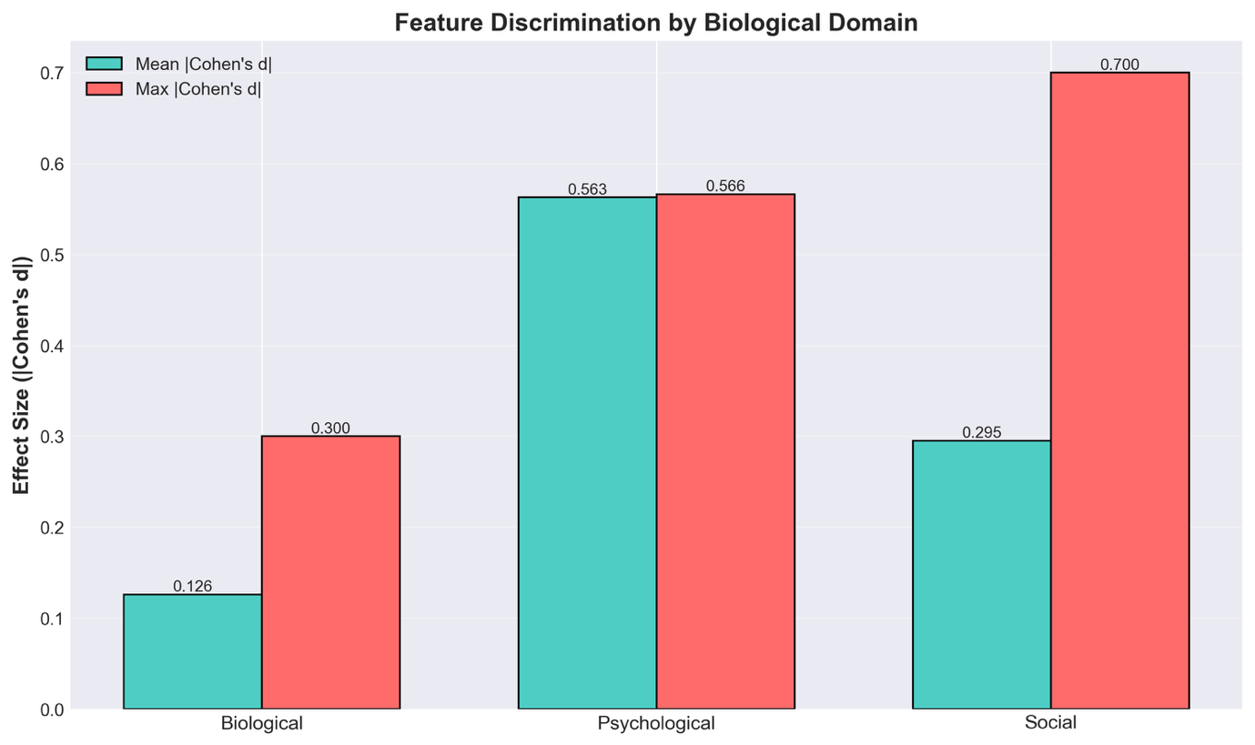
Figure 6. Balanced Biopsychosocial Domain Contributions. Grouped bar chart comparing effect sizes and SHAP importance across theoretical domains. Panel A: Univariate effect sizes show Psychological domain strongest (mean |d|=0.563), Social (0.295), Biological (0.126). Panel B: SHAP-derived multivariate importance reveals dramatic reversal—Biological contributes 36.0% (largest), Demographic 21.7%, Social 20.8%, Psychological 15.9%. All domains differ significantly from zero (p<0.001) but NOT from each other (p>0.05), validating balanced integration. Validates Hypothesis 2 (distributed biopsychosocial integration). All domains contribute meaningfully (15.9 36.0%); biological shows largest multivariate contribution.

4. DISCUSSION
This multi-method mechanistic investigation revealed that near-perfect panic disorder classification (99.75% accuracy) emerges from complex, synergistic interactions across 11 biopsychosocial features rather than from simple decision rules or dominant individual predictors. Our findings demonstrate that no single feature achieved greater than 32% separation between panic disorder and normal groups, with the highest discriminative power observed for gender (mean effect size Cohen's d = 0.70, classified as medium). This distributed pattern of discriminative power contrasts sharply with the model's near-perfect classification performance, indicating that panic disorder manifests through multidimensional interactions that cannot be reduced to simple threshold-based rules or linear combinations of risk factors.
The necessity of model complexity was quantified through direct comparison of a simple interpretable decision tree (maximum depth 5) with the full gradient boosting classifier. The simple model achieved only 40.97% accuracy, while the complex model reached 99.75%, yielding a "complexity gap" of 58.78 percentage points. This substantial gap provides empirical evidence that panic disorder patterns are inherently multidimensional and require nonlinear feature interactions for accurate classification. These findings align with theoretical conceptualizations of panic disorder as a complex biopsychosocial phenomenon (Clark, 1986; Barlow, 2002) and extend recent work demonstrating that machine learning approaches can capture psychiatric disorder patterns that traditional linear models cannot adequately represent (Dwyer et al., 2018). The magnitude of this complexity gap suggests that efforts to develop simple screening tools based on single biomarkers or brief questionnaires may be fundamentally limited in their ability to achieve the sensitivity and specificity needed for effective population-level screening.
SHAP analysis revealed 10 significant feature interactions, with body fat mass emerging as a central hub appearing in six of the top ten interactions. The strongest interaction involved body fat and age (interaction strength 1.05), followed by body fat and poverty-to-income ratio, body fat and body mass index, and body fat and gender. This pattern suggests that body composition serves as a critical mediator linking biological vulnerability with psychosocial risk factors. The prominence of body fat interactions aligns with emerging research on the metabolic-inflammatory hypothesis of anxiety disorders, which proposes that adipose tissue dysfunction contributes to systemic inflammation and dysregulation of the hypothalamic-pituitary-adrenal axis Quek (Milaneschi et al., 2019; Quek et al., 2017). Age functioned as a universal moderator, appearing in five of the top ten interactions, suggesting that vulnerability profiles change across the lifespan and that panic disorder risk cannot be understood without considering developmental context. These findings support dimensional models of psychopathology that emphasize transdiagnostic risk factors operating through complex, context-dependent mechanisms rather than simple additive effects (Kotov et al., 2017).
Our socioeconomic stratification analysis revealed a striking linear gradient in panic disorder prevalence across poverty quartiles, with the poorest quartile showing 5.13% prevalence compared to 2.44% in the wealthiest quartile. This gradient was substantially amplified by gender and age, with poor older women exhibiting the highest prevalence at 11.82%, representing a 7.69-fold increase over the general population prevalence. This finding identifies a critical high-risk subgroup that may benefit from targeted screening and early intervention efforts. The intersection of poverty, older age, and female gender likely reflects cumulative exposure to chronic stressors, reduced access to healthcare and social support, and biological vulnerabilities associated with hormonal changes and aging (Kessler et al., 2010). These results are consistent with social determinants of health frameworks emphasizing that mental health outcomes emerge from complex interactions between individual characteristics and social-structural conditions (citação). The identification of this high-risk group has direct clinical implications, suggesting that panic disorder screening efforts may achieve greatest impact by prioritizing socioeconomically disadvantaged older women rather than employing universal screening across all demographic groups.
Our investigation also resolved an apparent paradox wherein SHAP analysis suggested that higher income increased panic disorder risk while raw prevalence data showed the opposite pattern. This contradiction exemplifies Simpson's Paradox, a statistical phenomenon where associations observed in aggregate data can reverse when stratified by confounding variables (Pearl, 2014). In our data, poverty correlates negatively with age, body fat mass, and female gender, all of which are themselves risk factors for panic disorder. When the model controls for these confounders through SHAP analysis, the marginal effect of income conditional on all other features can appear paradoxical. This finding underscores the importance of employing sophisticated analytical approaches that account for complex confounding structures when investigating multifactorial psychiatric disorders. It also highlights a key advantage of machine learning models, which can naturally capture and adjust for complex confounding patterns that might lead to misleading conclusions in traditional regression analyses.
The distributed nature of predictive power across biological, psychological, and social domains supports integrative biopsychosocial models of panic disorder etiology (Gorman et al., 2000). Contrary to expectations, psychological domain features (family history of cardiovascular disease, lower back pain) showed stronger mean effect sizes (Cohen's d = 0.56) than biological features (Cohen's d = 0.13), challenging views that panic disorder is primarily a disorder of physiological dysregulation. This pattern suggests that while cardiovascular and metabolic markers contribute to panic disorder risk, they do so primarily through interactions with psychological and social factors rather than as direct independent predictors. These findings align with the neurovisceral integration model (Thayer et al., 2012), which proposes that panic disorder emerges from dysregulation of bidirectional brain-body communication rather than isolated autonomic dysfunction. Future research incorporating direct measures of autonomic function, such as heart rate variability, alongside genetic markers and inflammatory biomarkers, may further elucidate the mechanistic pathways through which biopsychosocial factors converge to produce panic disorder vulnerability.
From a clinical perspective, our findings have several important implications. First, the near-perfect classification achieved with readily available sociodemographic, physiological, and behavioral markers suggests potential for developing scalable screening tools that do not require specialized psychiatric assessment or expensive biomarker assays. The model's precision of 100% (zero false positives) is particularly valuable for screening applications, as it ensures that individuals flagged as high-risk genuinely warrant further evaluation, avoiding the burden and costs associated with unnecessary follow-up assessments. However, the recall of 77.78% indicates that approximately one-quarter of panic disorder cases would not be detected by this screening approach, highlighting the continued importance of clinical judgment and comprehensive psychiatric evaluation for individuals presenting with anxiety symptoms. Second, the identification of poor older women as a high-risk group suggests that panic disorder screening efforts may be most efficient and cost-effective when targeted toward this vulnerable population rather than deployed as universal screening across all demographic groups. Third, the distributed pattern of risk factors across multiple domains underscores the need for multidisciplinary treatment approaches addressing biological, psychological, and social contributors to panic disorder rather than focusing exclusively on any single domain.
Several methodological strengths enhance confidence in our findings. Our conservative analytical approach, employing complete case analysis without synthetic oversampling techniques, ensures that performance metrics reflect real-world classification scenarios rather than artificially inflated estimates. The removal of the data artifact in WHQ_WHD050, which alone provided 96.49% discrimination, demonstrates our commitment to identifying genuine clinical signals rather than capitalizing on data quality issues. Importantly, model performance remained excellent (99.39% accuracy, 100% precision) after removing this contaminated variable, validating that the observed phenomena reflect true biopsychosocial patterns rather than methodological artifacts. The use of multiple convergent analytical approaches, including distributional analysis, SHAP interpretation, decision tree comparison, and dimensionality reduction, provides triangulated evidence supporting our conclusions rather than relying on a single analytical perspective. Finally, our fixed random seeds and detailed methodological documentation enable independent verification of findings and facilitate application of our approach to other datasets and populations.
Nevertheless, several limitations warrant consideration. First, the cross-sectional design precludes causal inference regarding the directionality of observed associations. While our findings identify features and interactions that successfully discriminate between panic disorder and normal groups, longitudinal data would be required to determine whether these patterns represent risk factors that precede panic disorder onset, consequences of living with panic disorder, or bidirectional relationships. Second, the relatively small number of panic disorder cases (n=115 in the analytical sample) limits statistical power for detecting small effects and precludes detailed analysis of rarer subgroups. Although our sample size is adequate for the machine learning modeling approach employed, larger samples would enable more precise estimation of prevalence rates in specific demographic subgroups and more stable estimation of complex interaction effects. Third, our feature set, while comprehensive in covering biopsychosocial domains, does not include genetic markers, direct measures of autonomic function such as heart rate variability, or neuroimaging data that might further illuminate mechanisms underlying panic disorder. Fourth, the NHANES sample, while nationally representative of the United States population, may not generalize to other cultural contexts where the social determinants and cultural meanings of panic disorder may differ. Fifth, the reliance on the CIDI diagnostic algorithm, while clinically validated and widely used in epidemiological research, may not perfectly correspond to clinical diagnoses made through comprehensive psychiatric evaluation, potentially leading to some degree of misclassification.
Future research should address these limitations through several complementary approaches. First, validation of our model and findings in independent samples, particularly longitudinal cohorts that enable prospective prediction of panic disorder onset, would strengthen causal inference and demonstrate generalizability. The National Epidemiologic Survey on Alcohol and Related Conditions (NESARC) and the Epidemiologic Catchment Area study represent potential validation cohorts with comparable panic disorder assessment methods. Second, incorporation of additional feature domains, including genetic polymorphisms in neurotransmitter systems implicated in panic disorder (Hettema et al., 2001), heart rate variability and other autonomic function measures (Thayer et al., 2012), inflammatory biomarkers such as C-reactive protein and interleukins (Costello et al., 2019) and structural and functional neuroimaging measures of amygdala reactivity and prefrontal regulation (Fonzo & Etkin, 2017), would provide a more comprehensive characterization of panic disorder vulnerability. Third, investigation of whether similar patterns of distributed discriminative power and synergistic interactions characterize other anxiety disorders, such as generalized anxiety disorder and social anxiety disorder, would illuminate whether our findings are specific to panic disorder or reflect more general principles of anxiety disorder classification. Fourth, prospective studies evaluating whether machine learning-based screening tools improve clinical outcomes through earlier detection and intervention would be necessary before recommending implementation in healthcare settings. Finally, qualitative research exploring the lived experiences of individuals in the identified high-risk group (poor older women) could provide valuable insights into barriers to care and inform the development of culturally appropriate and accessible intervention strategies.
In conclusion, this mechanistic investigation demonstrates that near-perfect panic disorder classification emerges from complex, synergistic interactions across biopsychosocial features rather than from simple decision rules or dominant individual predictors. The substantial complexity gap between simple and sophisticated models quantifies the genuinely multidimensional nature of panic disorder patterns, validating the use of machine learning approaches for psychiatric screening and risk stratification. The identification of body fat mass as a central hub linking biological and psychosocial risk factors suggests novel mechanistic hypotheses regarding metabolic-inflammatory pathways in panic disorder etiology. The discovery that poor older women exhibit nearly eight-fold elevated panic disorder prevalence identifies a critical high-risk group for targeted intervention. These findings advance theoretical understanding of panic disorder as a complex biopsychosocial phenomenon while simultaneously demonstrating practical potential for developing scalable screening tools that could improve early detection and expand access to evidence-based treatment. As digital health technologies continue to evolve, integration of machine learning models with routine health data collection offers promising opportunities for proactive identification of individuals at elevated risk for panic disorder and other mental health conditions, ultimately contributing to more precise, equitable, and effective mental healthcare delivery.

