Fig 1. Schematic illustration of the Random Dot Motion (RDM). On each trial, participants viewed a motion display in which a proportion of dots moved coherently either left or right. They first completed four practice trials (25% or 50% coherence), followed by 40 experimental trials presented in random order: 20 high-precision trials (15% coherence) and 20 low-precision trials (5% coherence). On each trial, the motion direction was randomly assigned. Participants indicated whether the coherent motion was left or right using only their left hand (“A” for left, “S” for right) and were instructed to respond as quickly and accurately as possible. After each trial, they provided a confidence rating on a 0–10 scale.
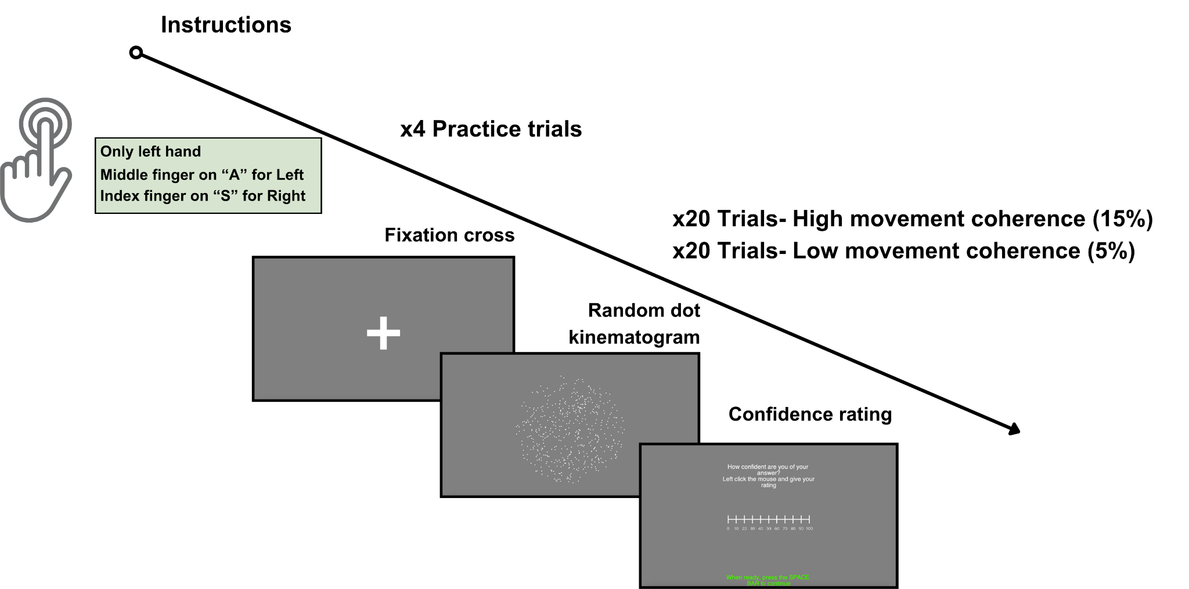

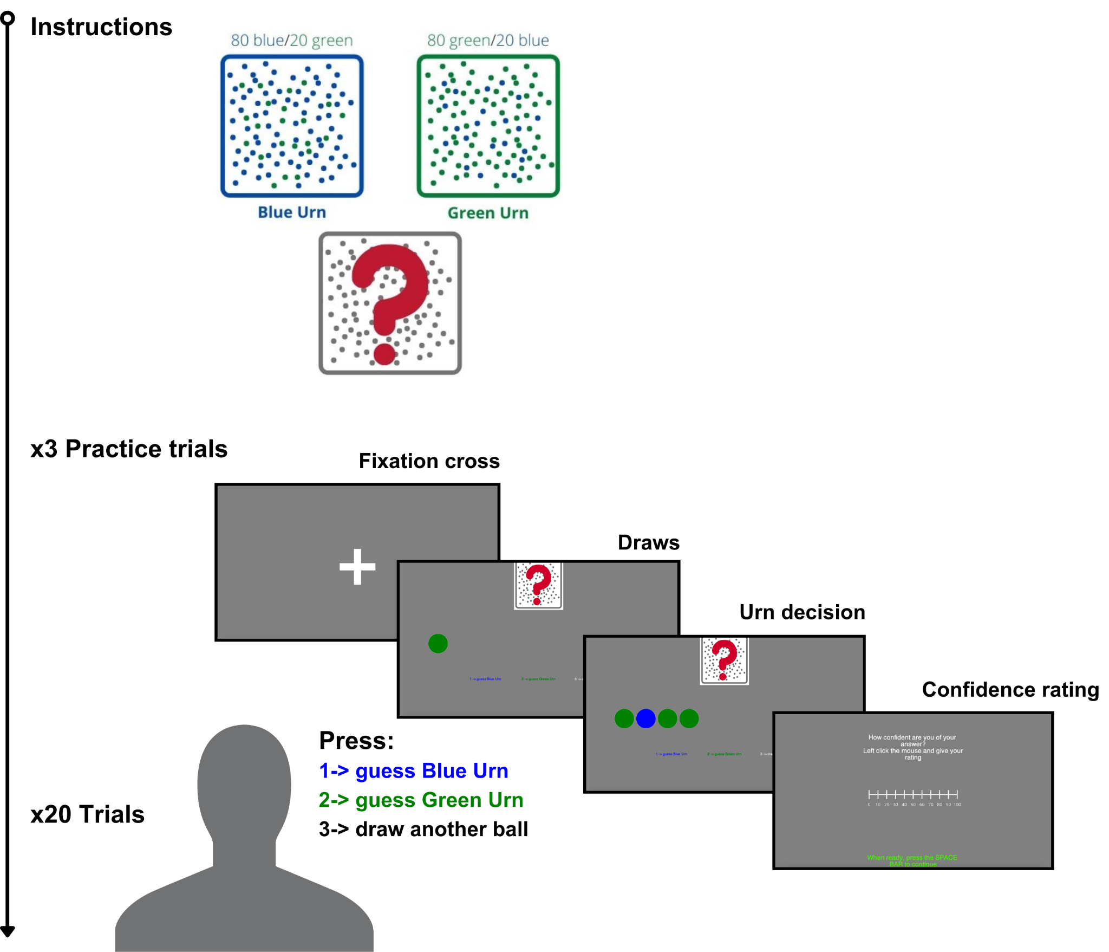
Fig 2. Schematic illustration of the Beads Task (BT). Participants performed a draws-to-decision task involving two hypothetical urns with an 80/20 colour ratio (80 blue/20 green vs. 80 green/20 blue). On each sequence, beads were drawn one at a time from a hidden urn, and after each draw participants could guess the blue urn (“1”), guess the green urn (“2”), or draw again (“3”), up to a maximum of 10 draws. After four practice sequences, they completed 20 experimental sequences (10 per urn type), presented in random order. After each sequence, participants reported confidence on a 0–10 scale. The primary measure was draws-to-decision (DTD): the number of beads drawn before committing to an urn.

Fig 3. Schematic illustration of experimental procedure and TMS protocol. The study consisted of an online phase and an in-person laboratory session. Online, participants completed study information, a screening questionnaire, demographic items, and two self-report measures (PDI and CAPS). Participants were required to be right-handed to control for hemispheric lateralisation. Eligible participants were then invited to the laboratory. Participants were randomly assigned to receive either 1 Hz TMS or sham TMS over P4. Immediately after TMS, participants completed the three behavioural tasks (RDM, SRT, BT) in a randomised order.
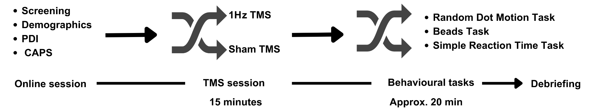

Fig 4. Between group hierarchical drift diffusion model (HDDM). The diagram illustrates the hierarchical structure of the model used to estimate drift rate (v), decision threshold (a), and non-decision time (t) for PDI/CAPS groups, TMS sessions and , and dot motion coherence levels. At the top level, HDDM-default hyperpriors constrain the group-level distributions from which condition-level parameters were drawn. Condition-level parameters vary across combinations of PDI/CAPS (low/high), session (sham/TMS), and coherence (low/high). For each participant i and trial t, reaction times (RT_{i,t}) and accuracy responses (Response_{i,t}) are observed and assumed to follow a drift diffusion process parameterised by the corresponding condition-level parameters.
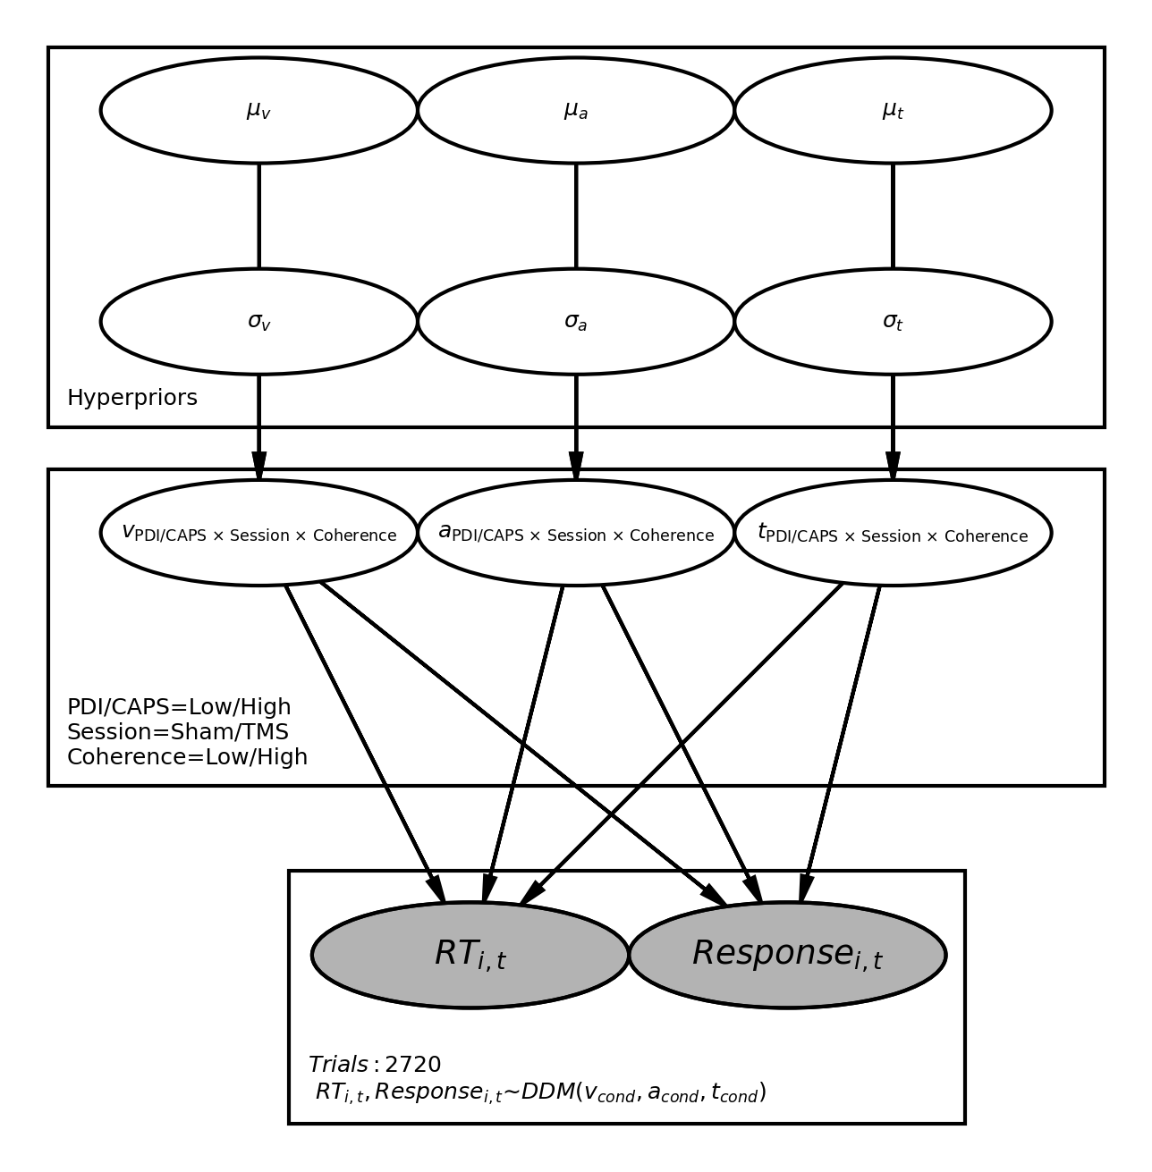

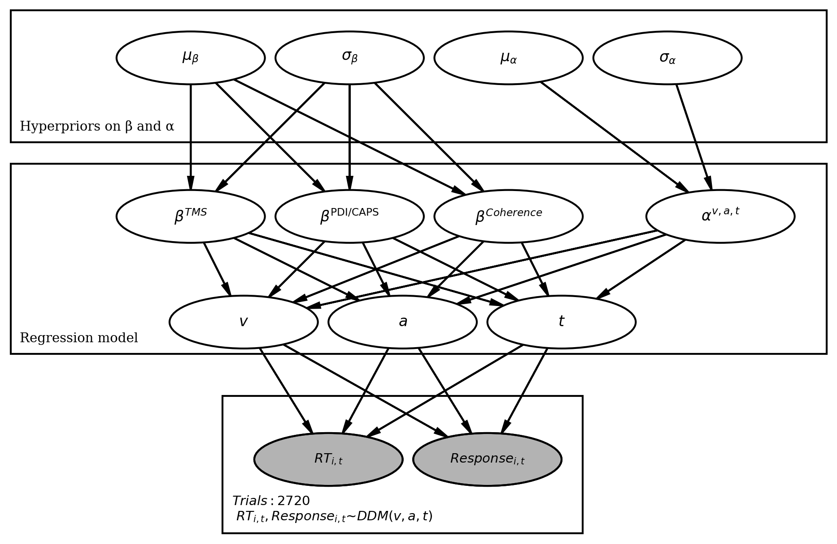
Fig 5. Regression-based hierarchical drift diffusion model (HDDM). The diagram illustrates the fixed-effects hierarchical regression models used to estimate intercept and slope parameters at the population level. HDDM-default weakly informative hyperpriors constrain the distribution of regression coefficients for TMS condition, PDI/CAPS score, and dot motion coherence. Separate hyperpriors constrained the intercept term. Each DDM parameter (v, a, t) was estimated as a deterministic function of these regression coefficients. Reaction times (RT_{i,t}) and accuracy responses (Response_{i,t}) for each of the 2720 trials are assumed to arise from a drift diffusion process parameterised by the corresponding regression-defined values of v, a, and t.

Fig 6. HDDM parameters for psychotic phenotype groups. Drift rate (A), decision threshold (B) and non-decision time (C) posterior probability distributions from HDDM-TMS-PDI-C (top) and HDDM-TMS-CAPS-C (bottom). Parameters are compared for different TMS conditions (Sham vs. TMS; unbroken lines) and for low and high motion coherence, PDI groups and CAPS groups (dashed lines).
