Supplementary materials

1. Distributions of psychotic phenotype measures
For a full display of the psychotic phenotype data in our sample, we report here the medians (red vertical lines) and the frequency distributions in sample percentage for PDI, CAPS and ASI (Figure S1-A-B-C).

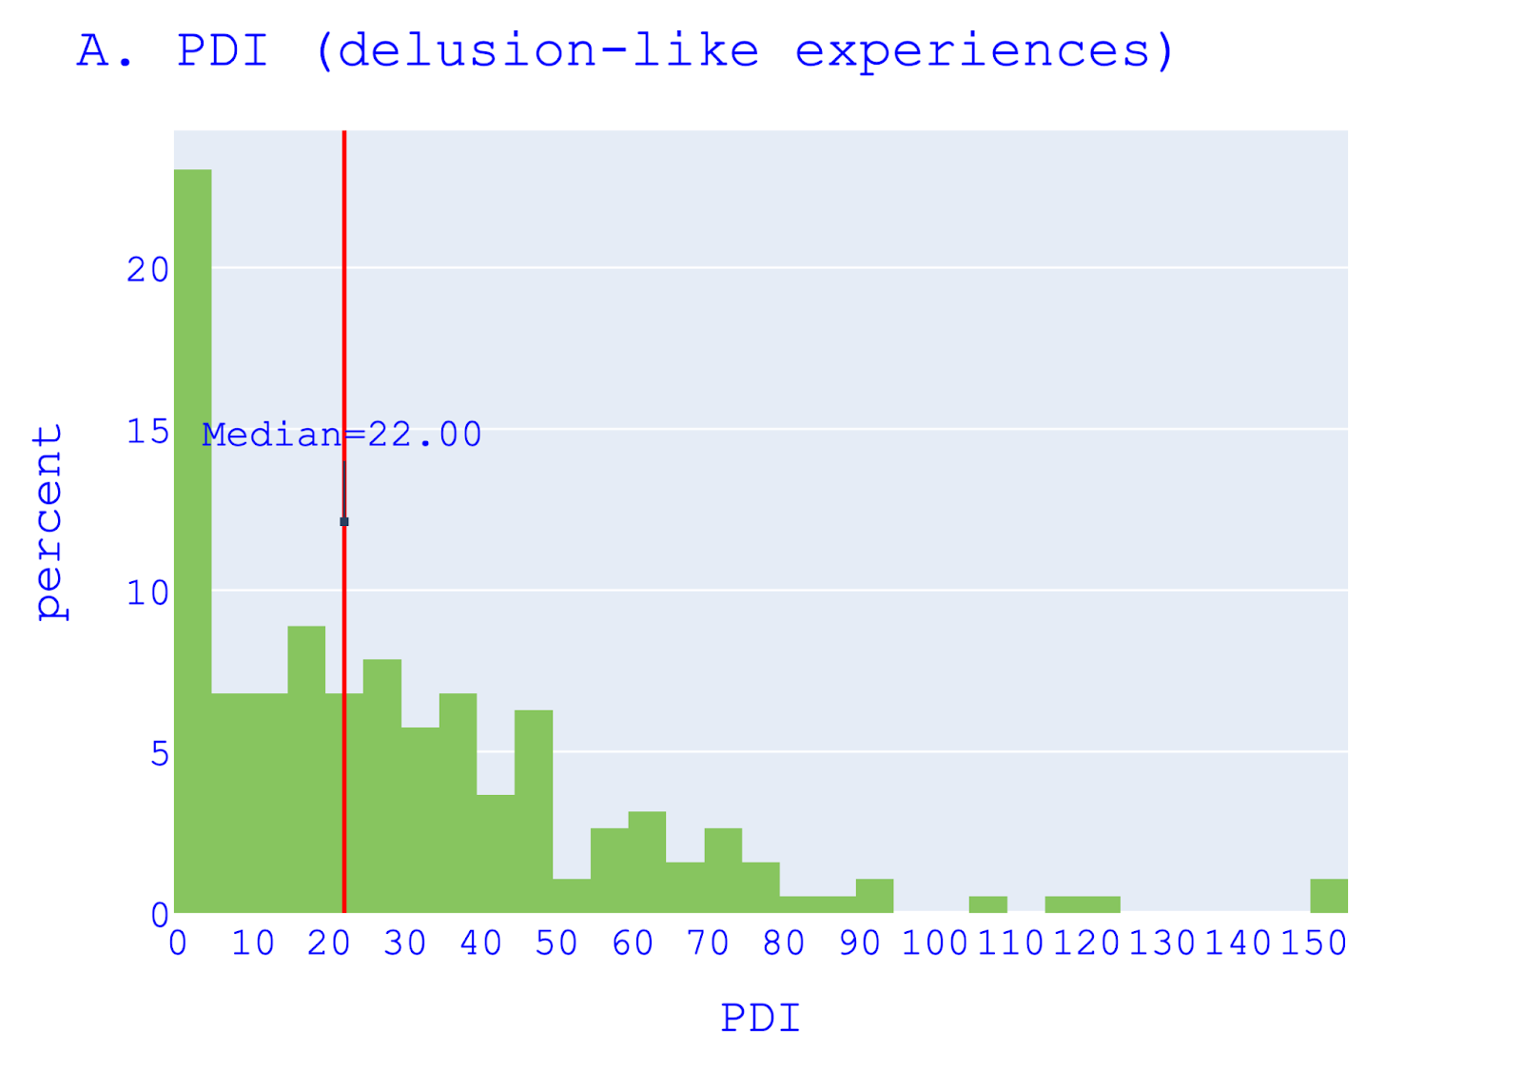
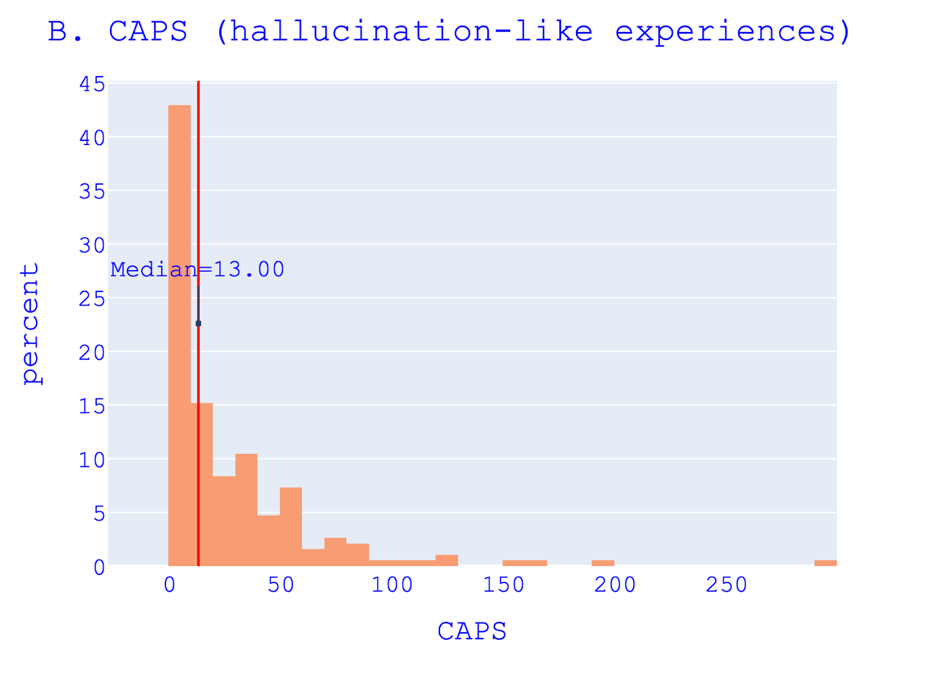
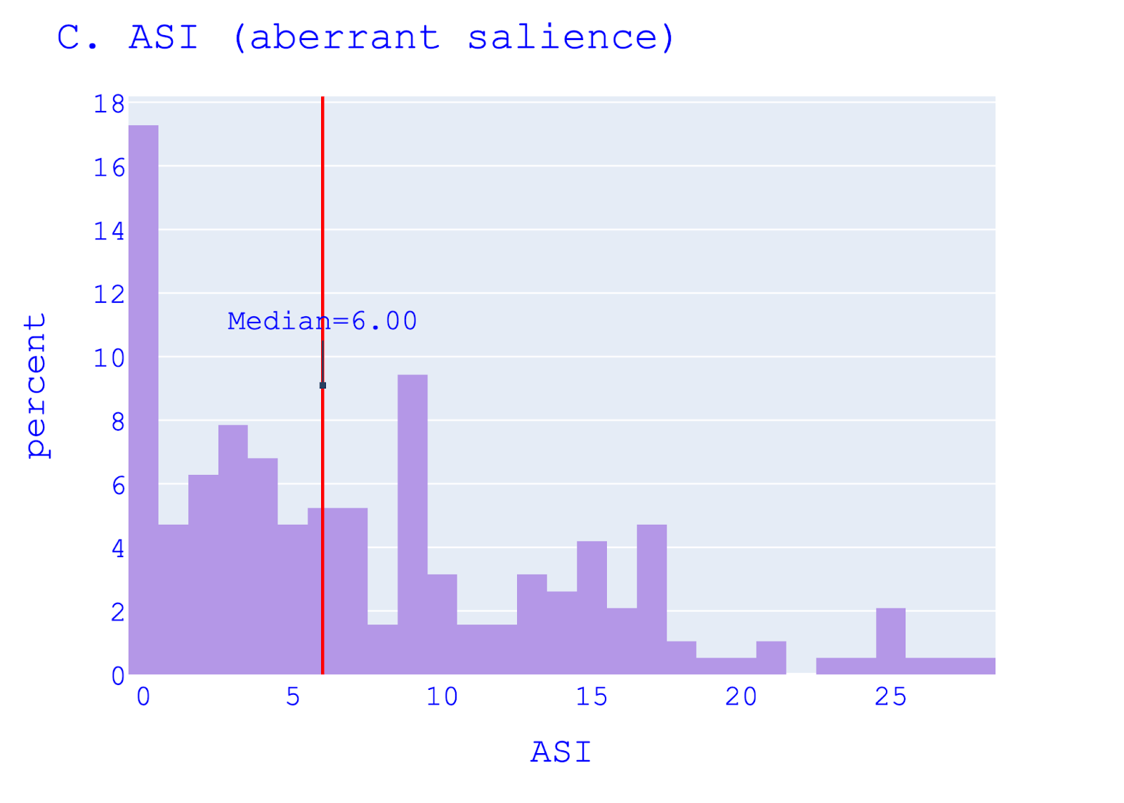

Fig S1. Frequency distribution of psychotic phenotype measures. Distribution in participant percentage of (A) Peters et al. Delusion Inventory (PDI), (B) Cardiff Anomalous Perceptions Scale (CAPS) and (C) Aberrant Salience Inventory (ASI).

2. Data Simulation and Parameter Recovery
We provide here a comprehensive overview of the performance of the hierarchical drift-diffusion models (HDDMs) best-fitted to the participant choices from the Random Dot Motion task (RDM). Following good practice guidance in computational modelling of behaviour (Vandekerckhove & Tuerlinckx, 2007; Wiecki et al., 2013; Wilson & Collins, 2019), we assessed the validity of our models through two main steps: simulation of data and recovery of parameters. By evaluating the performance of our models, we also evaluated the relative merits of different modelling techniques, including median split versus regression techniques with a view to developing modelling guidance for future studies. Here, we present a qualitative comparison between observed and simulated data, followed by the recovery of the estimated parameters. In Section 1, we present the methodology we used, and in Sections 2 and 3 the results of data simulation and parameter recovery. Finally, in the Discussion Section, we comment and draw conclusions from Sections 2 and 3.

2.1 Methodology
Data simulation. We used the hddm.generate.gen_rand_data(...) function of the HDDM 0.8.0 package (Wiecki et al., 2013) to simulate reaction times (RTs) and correct and error responses given the mean and standard deviation of DDM parameters. The function allows specification of the values of parameters for different discrete levels (e.g., conditions or groups), and reproduces the size and structure of the data in terms of the number of trials and participants per level. For between-group HDDMs, we inputted the mean and standard deviation of the fitted parameters for each condition/group level and obtained RTs and responses for each group/condition.
For regression HDDMs, more steps than for the between-group HDDMs were needed to simulate data sets that reproduce the structure of the observed ones. In fact, in the regression HDDMs, we had a two-level dummy coded variable (motion-coherence) and a continuous variable (PDI or CAPS) predicting each parameter of interest (drift rate or decision threshold). One obstacle in the data simulation was to inform the simulation function of the effect of the continuous variable on the parameters. In fact, hddm.generate.gen_rand_data(...) simulates data given discrete parameter values. We approached this problem by computing a mean predicted value of parameters for each level of the dummy coded variable including the regression coefficients of the continuous variable in each level as shown below in Equation 1 and Equation 2.

- $c=(0,1)$ , $Y_{}=a+b_{1}(c)+b_{2}(X)$

In Equation 1, Y denotes the vector of predicted values (e.g., drift rate) for the level of the dummy coded variable c (c=0 ∨ c=1), X the continuous variable predictor (e.g., PDI or CAPS) and a the intercept. We computed Y for both c=0 and c=1 and obtained two vectors, one for each level of the dummy coded variable, of the predicted parameters Y₀ and Y₁. We then averaged the values for each array and obtained the average Y₀ for level 0 and average Y₁ for level 1, which are the mean predicted parameters to be inputted to hddm.generate.gen_rand_data(...). To simulate the models, we needed to include in the simulated dataset a value of the continuous variable (PDI and CAPS) per simulated participant. Since the data were simulated employing a stochastic approximation of the effect of the continuous variable on the parameters (i.e., the mean predicted value), we took a similarly stochastic approach and pooled randomly from our empirical data values of PDI and CAPS and assigned them to the simulated participants.
To capture how well the models whose results we reported predict participants’ raw data, we simulated 100 datasets and averaged the 10th, 30th, 50th, 70th and 90th quantiles of the simulated RT distributions for correct and error responses. We then plotted in a linearity plot (or QQ plot, shown in Figure S3 and Figure S5) the observed RT quantiles on the x-axis and the simulated quantiles on the y-axis to obtain a line that we contrasted with an “optimal simulation line” drawn by plotting observed quantiles on both axes. To quantify the distance between the simulated and the observed quantiles, we took as metrics the root-mean-squared error (RMSE) and the Standardised Mean Difference (SMD; also known as Cohen’s D). RMSE is a measure of the average difference between predicted and observed values and it is expressed in the units of the variable value. The SMD is the ratio of the difference between the means and the sum of the standard deviations of the two distributions. Unlike the RMSE, the SMD is a standardised metric suitable for comparing the prediction performance across different magnitudes of RTs (e.g. between correct and error responses, the latter usually slower).

Parameter recovery. We performed the parameter recovery for between-group and regression HDDMs reported in the Results section. In the between-group HDDMs, drift rate and decision threshold were allowed to vary for motion-coherence (high vs. low) and median-split groups. In the regression models, drift rate and decision threshold were free to vary as the response variable of a linear regression model with motion-coherence and PDI (HDDM-LR-PDI-C), CAPS (HDDM-LR-CAPS-C) or ASI (HDDM-LR-ASI-C) scores as predictors. We refer here to these models as empirical models, because their parameters were estimated from fits to human RTs and accuracy rather than to simulated data. For each empirical model, we simulated one dataset (following the procedures described in the preceding paragraph) and fitted an equivalent simulation model. We evaluated the distance between the distributions of the simulated and empirical parameters using RMSE and SMD. For between-group HDDMs, we computed RMSE and SMD between the estimated and simulated distributions of DDM parameters per group (e.g. low-PDI) or condition (e.g. high motion-coherence). For regression HDDMs, we computed the RMSE and SMD between the empirical and simulated β coefficients. Lower RMSE and SMD between estimated and simulated parameters indicate a better recovery and a more precise estimation of the true parameters for groups, conditions or predicted variables. Additionally, we considered whether the simulation models could reproduce the DDM parameter differences and β estimates reported in the results of the empirical models. If the simulated parameters adequately recover the effects observed, it suggests that the model is accurately capturing the processes that produced the empirical data.
Overall, the recovery of parameters is an essential step in validating computational models of behaviour as it helps to establish the reliability, validity, and generalizability of the model's results, and increases confidence in the model's ability to accurately describe and explain data from different samples of the same population (Vandekerckhove & Tuerlinckx, 2007; Wiecki et al., 2013; Wilson & Collins, 2019).

2.2 Data simulation and parameter recovery results

Here, we report the data simulation and parameter recovery for between-group and regression HDDMs. In Figure S2, we show the distribution of RTs inputted to these models.
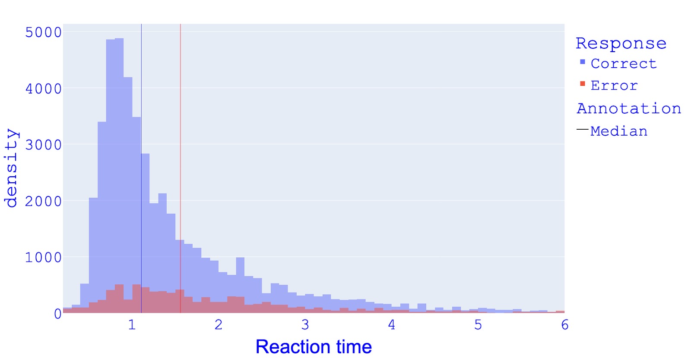
Fig. S2 RT distribution Study1. Distribution of reaction times (in seconds) for correct and error responses as inputted to HDDMs in Study 1; fast outliers cut-off: 0.2 s; slow outliers cut-off: 6 s.

Between-group HDDMs

Figure S3 plots the quantiles of simulated RT distributions against the observed RT quantiles for the between-group winning model HDDM-CAPS-C.
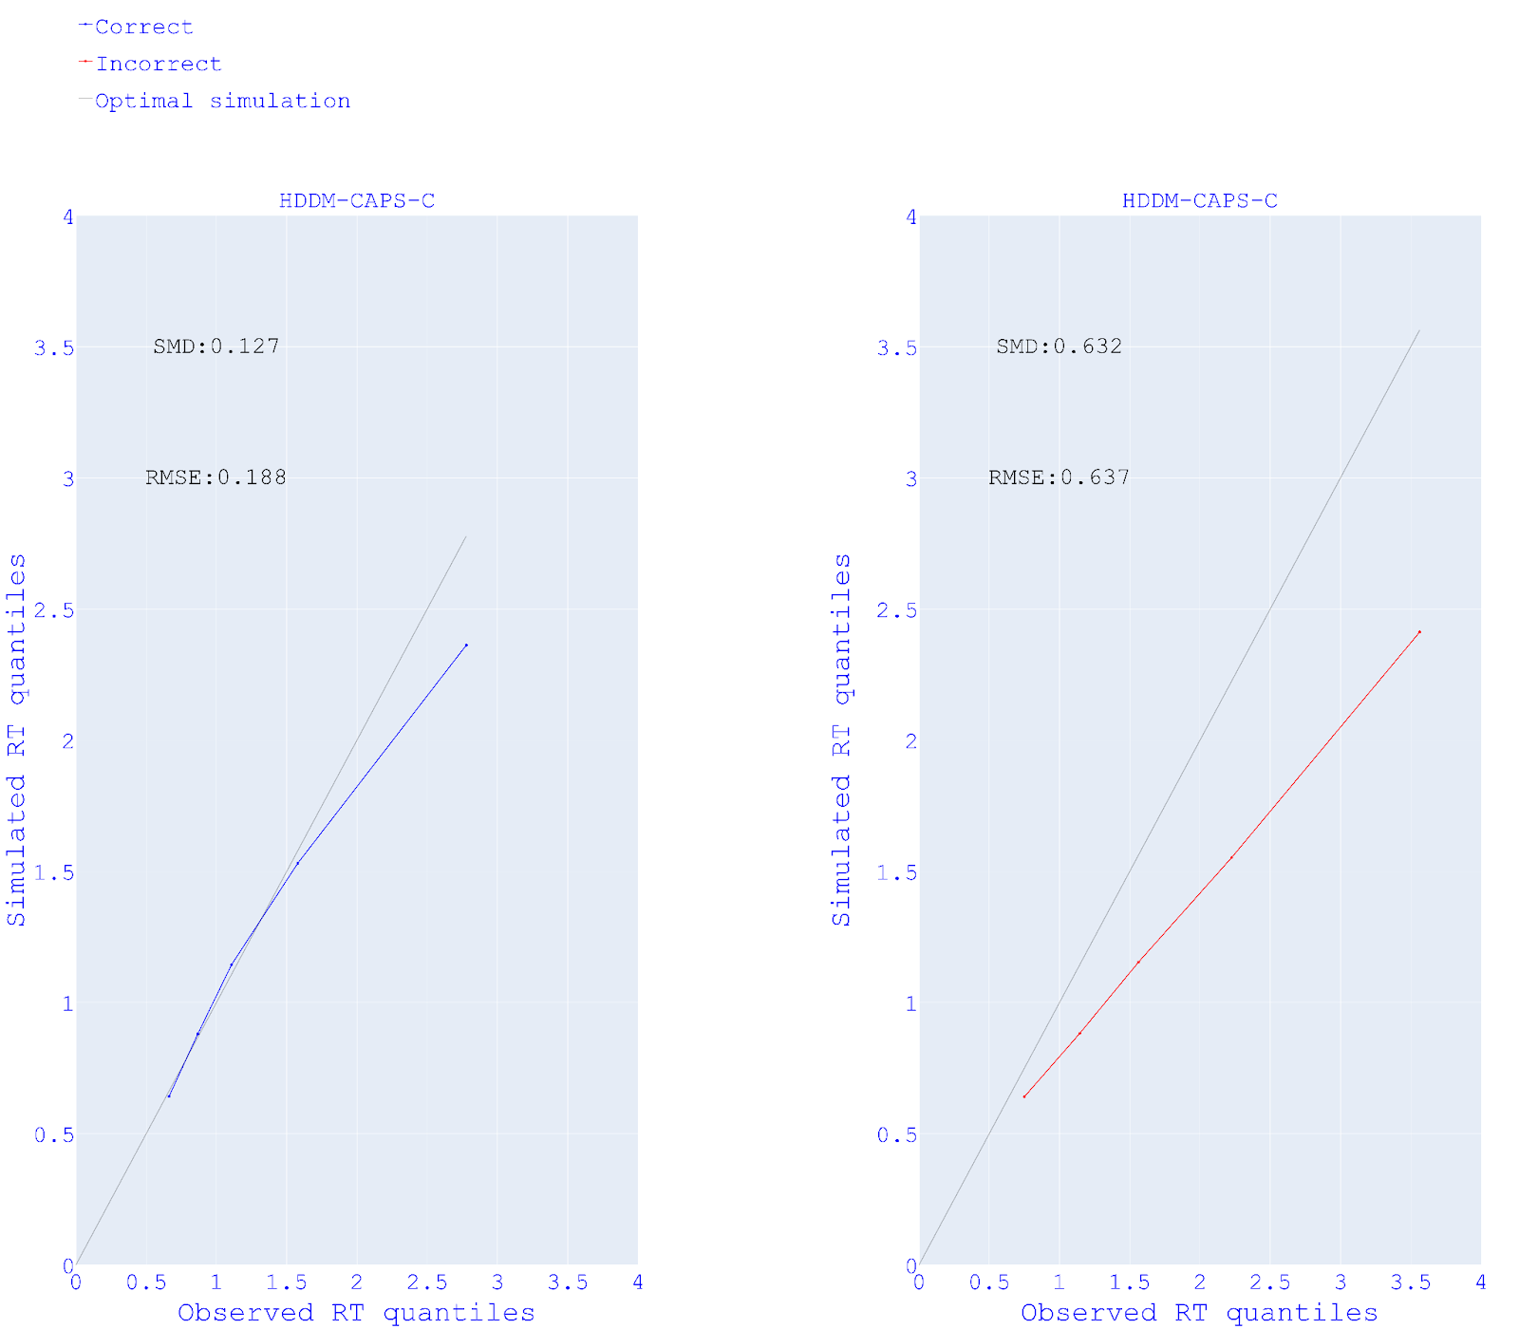
Fig.S3 RT predictions of between-group HDDMs Study 1. Linearity plots of observed reaction time (RT) quantiles (x-axis) and simulated RT quantiles (y-axis) for correct and error responses of between-group models in Study 1. SMD= Standardised mean difference; RMSE= Root mean squared error.

In Figure S4, note that simulated parameters tend to be higher than the estimated parameters. This overestimation did not prevent the recovery of the significant difference in parameter estimates between CAPS median-split groups shown by the empirical model (see: Figure S4 top-left and Figure S4 bottom-right).
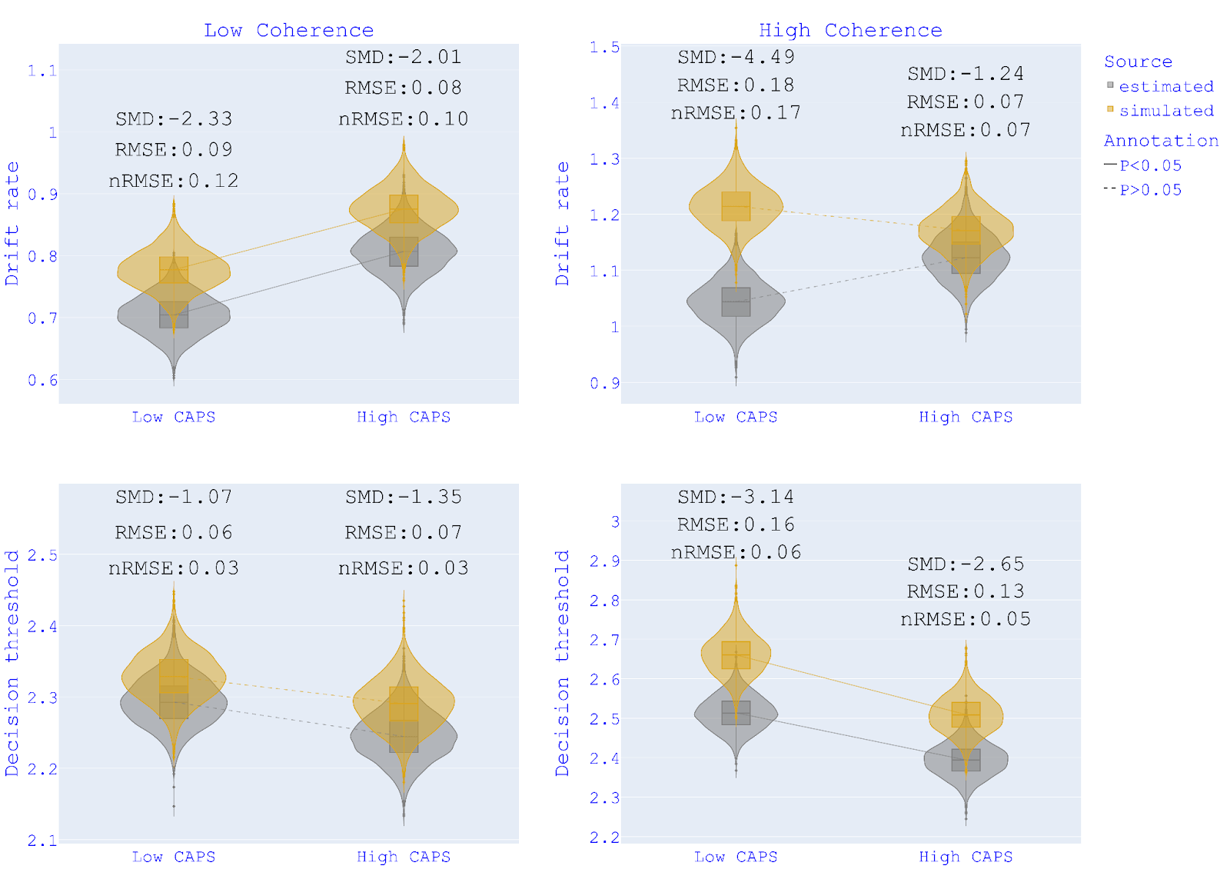
Fig. S4 Parameter recovery HDDM-CAPS-C. Recovery of drift rates and decision thresholds for HDDM-CAPS-C (motion-coherence - CAPS groups). The ends of the boxes show the lower and upper quartiles of the distributions, while the line inside the box marks the median.
SMD = Standardised mean difference; RMSE = Root mean squared error; nRMSE= RMSE normalised over true (estimated) parameter's mean.

Regression HDDMs
In Figure S5, we show the quantiles of simulated RT distributions against the observed RT quantiles for the winning regression models.
The simulated models reproduced the positive effect of PDI on drift rate (see Figure-S6 top-left). While the recovered effects of CAPS only nonsignificantly trended in the same direction as the effects of CAPS shown by the participants, the recovered effects of PDI more fully reproduced the pattern of participants’ behaviour(Figure S6 right). For the effect of motion-coherence, both the effects on drift rate and decision threshold were well recovered in both models (see Figure-S7). The effects of psychotic phenotypes (PDI and
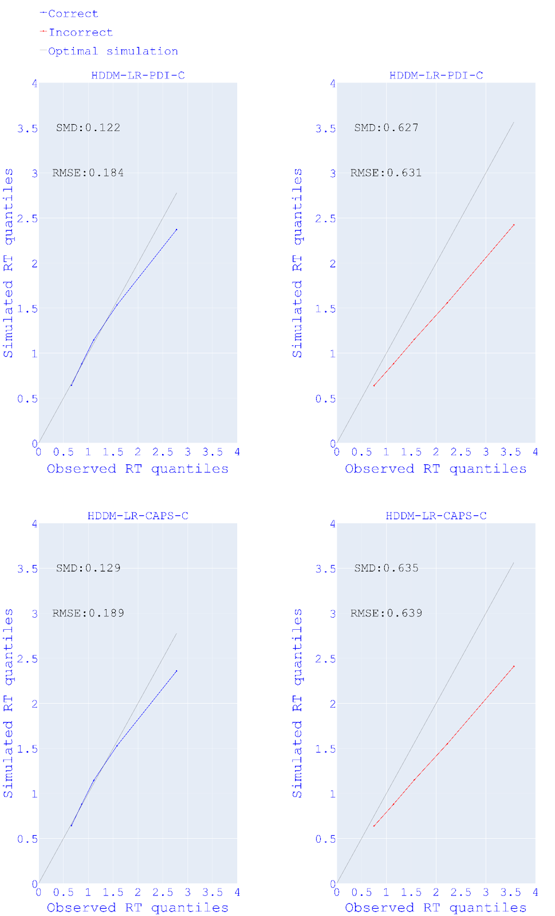

Fig.S5 RT predictions of regression HDDMs Study 1. Linearity plots of observed reaction time (RT) quantiles (x-axis) and simulated RT quantiles (y-axis) for correct and error responses of regression models in Study 1. SMD = Standardised mean difference; RMSE = Root mean squared error.

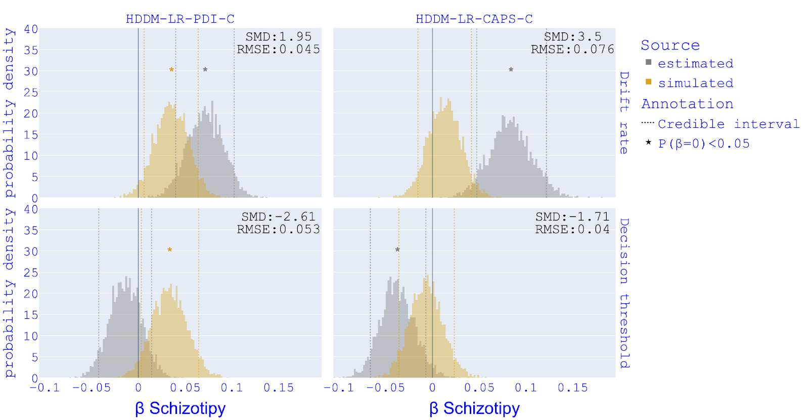
Fig. S6. Parameter recovery for psychotic phenotype HDDM-LR-PDI-C, HDDM-LR-CAPS-C . Recovery of β for Schizotopy in HDDM-LR-PDI-C (motion-coherence - PDI groups), HDDM-LR-CAPS-C (motion-coherence - CAPS groups). SMD = Standardised Mean Difference; RMSE = Root mean squared error.

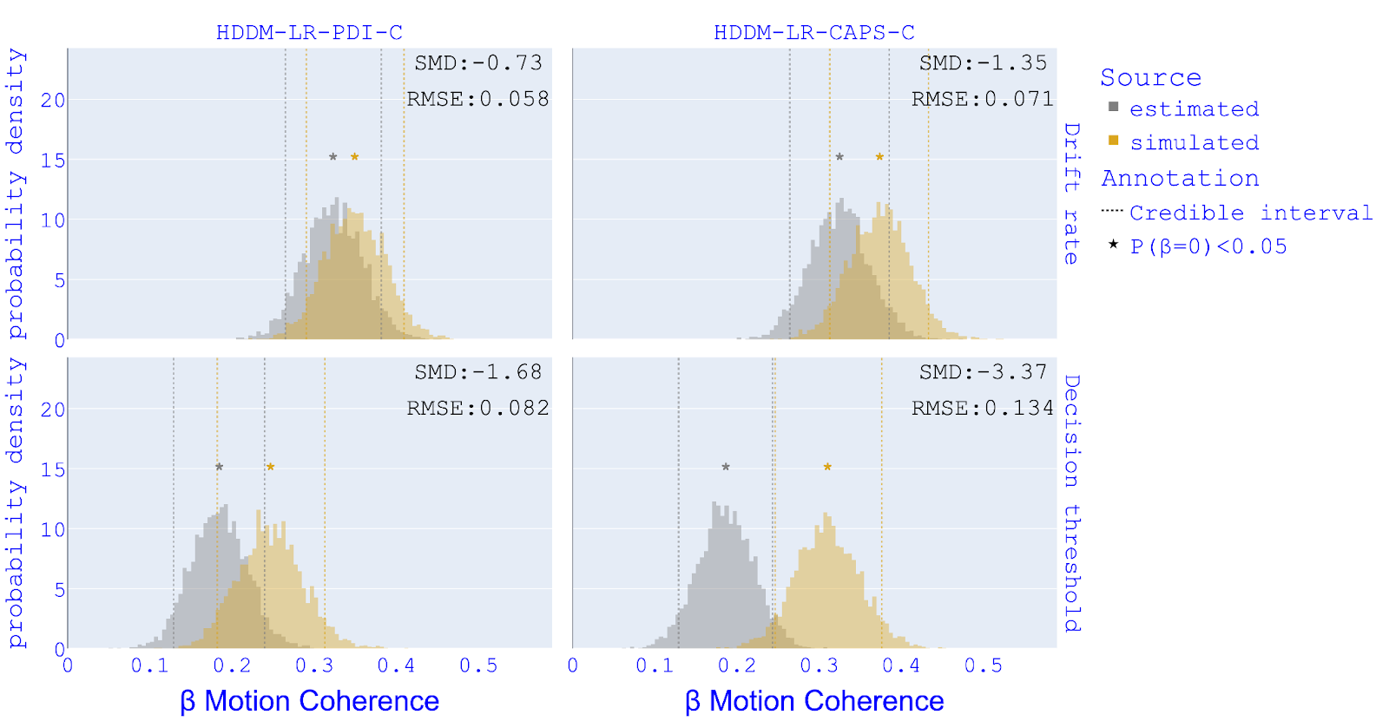
Fig. S7. Parameter recovery for motion-coherence HDDM-LR-PDI-C, HDDM-LR-CAPS-C. Recovery of β for motion-coherence in HDDM-LR-PDI-C (motion-coherence - PDI groups), HDDM-LR-CAPS-C (motion-coherence - CAPS groups). SMD = Standardised Mean Difference; RMSE = Root mean squared error.

CAPS) on DDM parameters were better recovered in the between-group models than in the regressions. However, overall, the RT predictions of regression HDDMs were as good as the ones from between-group HDDMs, which led us to report results from both modelling approaches.

2.3 Discussion
We performed data simulation and parameter recovery of the HDDMs and evaluated to what extent our models were able to capture the hidden causes that produced our data. We specifically looked at whether our models were able to simulate the empirical data and recover the effects identified in the empirical models within the simulated sample. We recognised five common patterns that we will comment on before going into the specifics of the models.
(1) From the comparison between simulated and empirical RT quantiles, we notice a systematic difference in models’ predictions for correct and error responses. In fact, in simple perceptual decision-making tasks (as the RDM), correct responses outnumber to a great extent error responses, as exemplified by the RT distribution in Figure-2. With more data available, the models were hence better at predicting RT for correct responses than for error responses. In future experiments, the collection of larger samples might improve predictions of RT for error responses.
(2) Generally, all models underestimated RTs. This prediction error is mainly driven by an underestimation of slow RTs and increases for slower RTs (see Figure S3 and Figure S5).
(3) Between-group models overestimated drift rates. This overestimation seems to be a systematic bias of the models that affected median-split groups uniformly and did not prevent the good recovery of the effects of grouping on the parameter. This overestimation might have produced in the simulated data the aforementioned underestimation of RTs, as RTs are inversely related to the drift rate.
(4) In one case, the simulation models produced what we can call “synthetic false positives” (see Figure S6 bottom-left), meaning significant effects that were not present in the empirical models. Synthetic false positives could potentially indicate a lack of reliability in the null effects found in the empirical models, but it is uncertain if they can represent actual false negatives in the empirical results.
Although drift rates have been generally overestimated by the models, the simulations reproduced the differences in drift rate between the median-split groups present in the empirical data and reported in the Results section. Simulated estimates of decision threshold were also generally higher than the empirical estimates. This overestimation did not prevent the recovery of the negative effect of CAPS on decision threshold.
Regression HDDMs were as good as between-group HDDMs at predicting empirical RTs (see Figure S3 and Figure S5) and recovered all the effects of motion-coherence on DDM parameters. Nevertheless, for psychotic phenotypes, only the negative effect of PDI on the drift rate was well-recovered by regression HDDMs. The trending but nonsignificant CAPS effects in the simulated regression HDDMs presents us with a scenario where we see two types of models, the between-(median-split)-group and regression HDDMs, where the same CAPS effect was detected in the empirical data in both types of HDDM but was in one case well recovered (between-group HDDM) but less so in the other (regression HDDM). This suggests that the associations between DDM parameters and CAPS are present in the data but are better captured by models that make the parameters vary between median-split groups rather than linearly.

3. Results of preregistered analysis

HDDM. We report here the results from hierarchical drift-diffusion models (HDDMs) we preregistered. The models we preregistered assessed the between-group effects of psychotic phenotypes regardless of motion coherence in all trials (HDDM-1, HDDM-2, HDDM-3), only in trials with 15% motion-coherence (HC-HDDM-1, HC-HDDM-2, HC-HDDM-3) and only in trials with 25% motion-coherence (EC-HDDM-1, EC-HDDM-2, EC-HDDM-3). However, these models could not account for between-participant psychotic phenotype and within-participant variability across different motion-coherence conditions, potentially leading to less precise parameter estimation compared to models we presented in the paper that accounted for both motion-coherence and psychotic phenotype effect at the same time. These preregistered models showed results consistent with the ones presented in the main body of the paper. The model where parameters varied for the CAPS group for all trials (HDDM-2) showed a DIC significantly lower relative to the null-model (See Table S1). In Figure S8 we show the results from HDDM-2 that correspond to the results from HDDM-CAPS-C that we showed in the main body of the paper. In the models where only one condition-type trials were used, none of the models showed a DIC value difference higher than 10 compared to the relative null-model (see Table S2 and Table S3), although EC-HDDM-2 (CAPS groups for 25% motion coherence trials) reached a DIC difference of 9.4 (see Table S3).

Table S1. DIC between-group HDDMs. Values of Deviance Information Criterion (DIC) for each model in descending order (lower DIC, better fit); differences in DIC (∆ DIC) between each model and the Null-model (parameters not varying for any variable).

All trials | DIC | Δ DIC Null-model
HDDM-2 (CAPS) | 16148.83 | -14.36*
HDDM-1 (PDI) | 16155.58 | -7,61
HDDM-3 (ASI) | 16158.86 | -4.33
Null-model | 16163.19 | 0.0
*DIC significantly lower
(Δ DIC< -10)

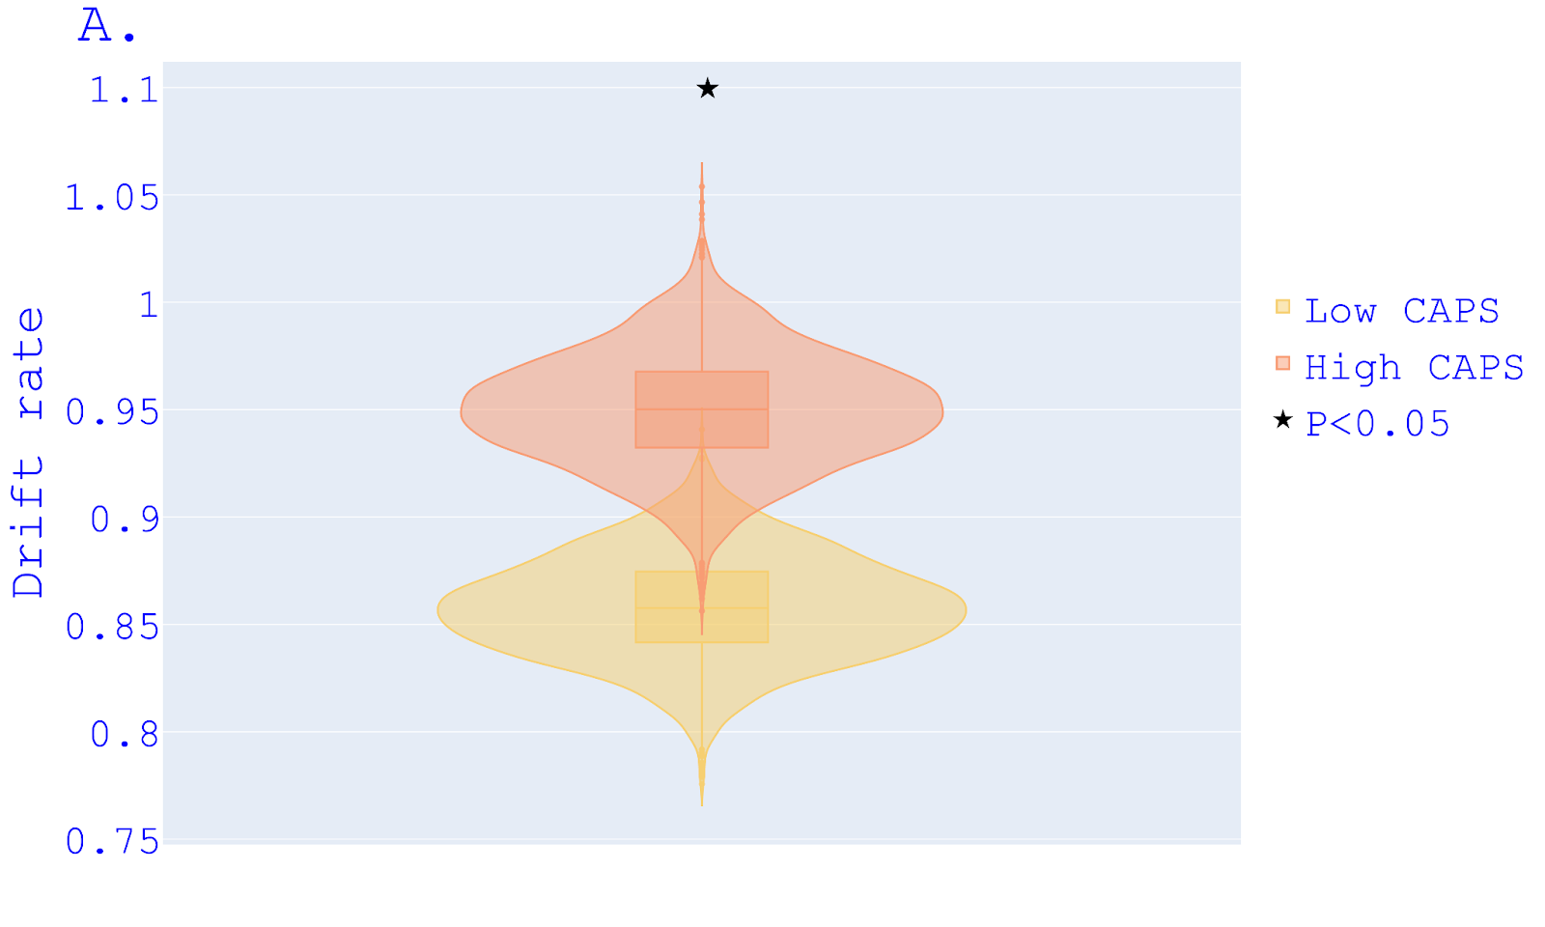
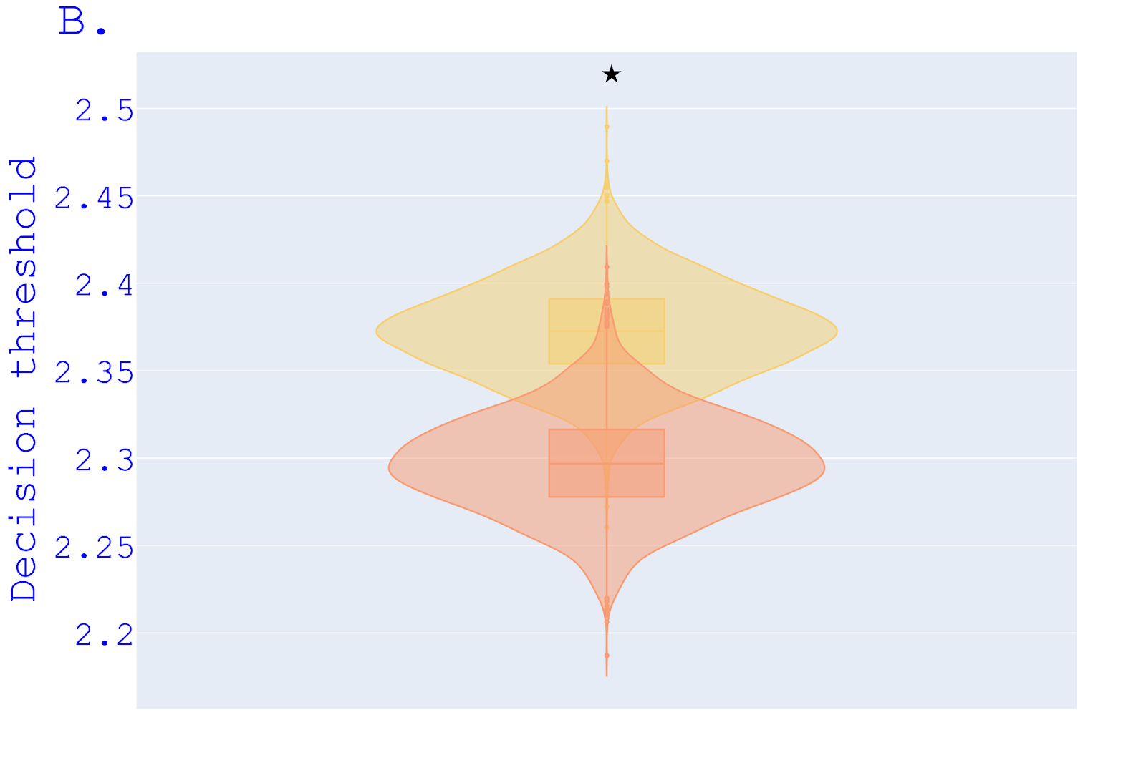
Fig S8. Between-group comparison of winning preregistered model HDDM-2. Posterior probability density distributions of drift rate (A) and decision threshold from HDDM-2 for high-CAPS and low-CAPS groups. The ends of the boxes show the lower and upper quartiles of the distributions, while the line inside the box marks the median.

Table S2. DIC between-group HDDMs motion coherence=15%. Values of Deviance Information Criterion (DIC) for each model in descending order (lower DIC, better fit); differences in DIC (∆ DIC) between each model and the Null-model (parameters not varying for any variable).

15% motion coherence | DIC | Δ DIC Null-model
HC-HDDM-2 (CAPS) | 8680.42 | -4.17
HC-HDDM-1 (PDI) | 8681.56 | -3.03
Null-model-15 | 8684.59 | 0.0
HC-HDDM-3 (ASI) | 8686.09 | 1.5
*DIC significantly lower
(Δ DIC< -10)

Table S3. DIC between-group HDDMs motion coherence=25%. Values of Deviance Information Criterion (DIC) for each model in descending order (lower DIC, better fit); differences in DIC (∆ DIC) between each model and the Null-model (parameters not varying for any variable).

25% motion coherence | DIC | Δ DIC Null-model
EC-HDDM-2 (CAPS) | 7388.06 | -9.4
EC-HDDM-3 (ASI) | 7394.42 | -3.04
EC-HDDM-1 (PDI) | 7397.18 | -0.28
Null-model-25 | 7397.46 | 0.0
*DIC significantly lower
(Δ DIC< -10)

Linear regression. Here, we show the results from the ordinary least squares models we preregistered (see Fig 2). Because of the violation of the assumption of normal distribution of outcome variables, we did not include them in the main body of the paper. These results do not vary from the quantile regression results reported in the main body of the paper except for the PDI association with Conf-N which here does not reach significance.

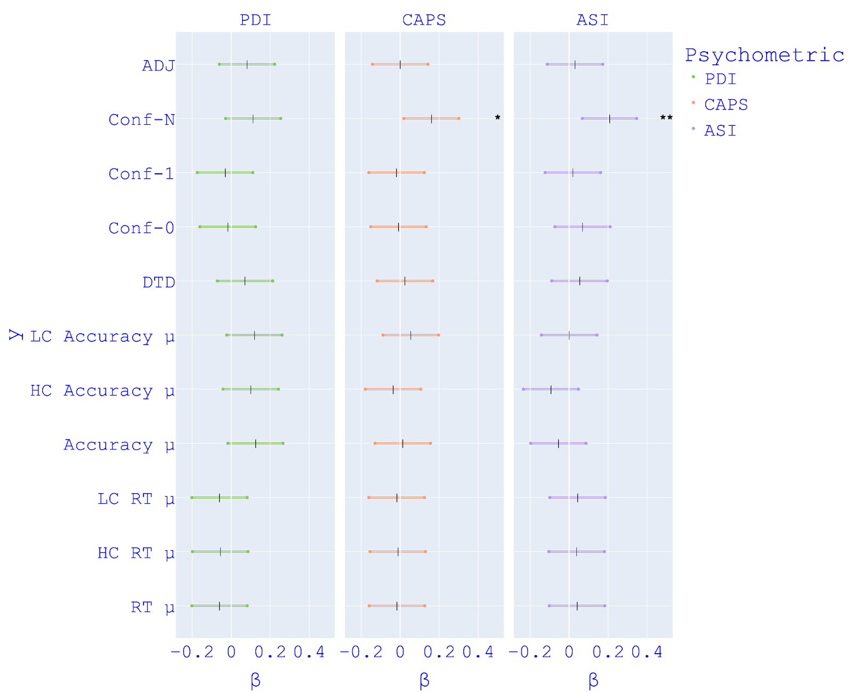

Fig S9. OLS regression models. Results from ordinary least squares models, each with PDI, CAPS and ASI as the predictor. Coloured lines indicate the estimates for β.
HC=High motion-coherence  LC=Low motion-coherence  RT=Reaction time  DTD=Draws to decisions | Conf-0= Confidence at 0 draws  Conf-1= Confidence at the first draw  Conf-N= Confidence at the last draw  ADJ = Belief adjustment | *p<0.05  **p<0.01

4. Results of alternative between-group analysis

We report the results from HDDMs between-group analysis suggested by reviewers. For each measurement of psychotic phenotype (PDI, CAPS, AS), we divided participants into two groups: low (score = 0) and high (score ≥ 80th percentile). The model selections showed that the HDDM-CAPS-C was the only model to outperform both the corresponding Null-model and the HDDM-C model (see Table S4). Figure S10-B shows that decision thresholds were significantly lower for the high-CAPS group compared to the low-CAPS group in both coherence conditions.
In Figure S11, we show the quantiles of simulated RT distributions against the observed RT quantiles for HDDM-CAPS-C-S. The parameter recovery for HDDM-CAPS-C-S showed

Table S4. DIC between-group HDDMs. The table shows values of Deviance Information Criterion (DIC) for each model in descending order (lower DIC, better fit), differences in DIC (∆ DIC) between each model and the corresponding Null-model (parameters not varying for any variable), and ∆ DIC between each model and the corresponding C-model (parameters varying for motion-coherence only). In the first column of the left, we show number of participants for each grouping.

PSYCHOMETRIC | MODEL | DIC | Δ DIC Null-model | Δ DIC HDDM-C
CAPS  N=99  N-Low-CAPS= 60  N-High-CAPS= 39 | HDDM-CAPS-C-S | 7888.77 | -55.6* | -15.31*
 | HDDM-C–S | 7904.08 | -40.29* | 0.0
 | Null-model-S | 7944.37 | 0.0 | 40.29
PDI  N=83  N-Low-PDI= 41  N-High-PDI= 42 | HDDM-C-S | 6759.34 | -46.99* | 0.0
 | HDDM-PDI-C-S | 6760.29 | -46.04* | 0.95
 | Null-model-S | 6806.33 | 0.0 | 46.99
ASI  N=74  N-Low-caps= 33  N-High-caps= 41 | HDDM-C-S | 6019.49 | -24.83* | 0.0
 | HDDM-ASI-C-S | 6025.21 | -19,11* | 5.72
 | Null-model-S | 6044.32 | 0.0 | 24.83
*DIC significantly lower (Δ DIC< -10)

Fig. S10 Between-group comparison. Posterior probability density distributions of drift rate (A) and decision threshold (B) for Low-CAPS and High-CAPS groups from HDDM-CAPS-C-S . The ends of the boxes show the lower and upper quartiles of the distributions, while the line inside the box marks the median.

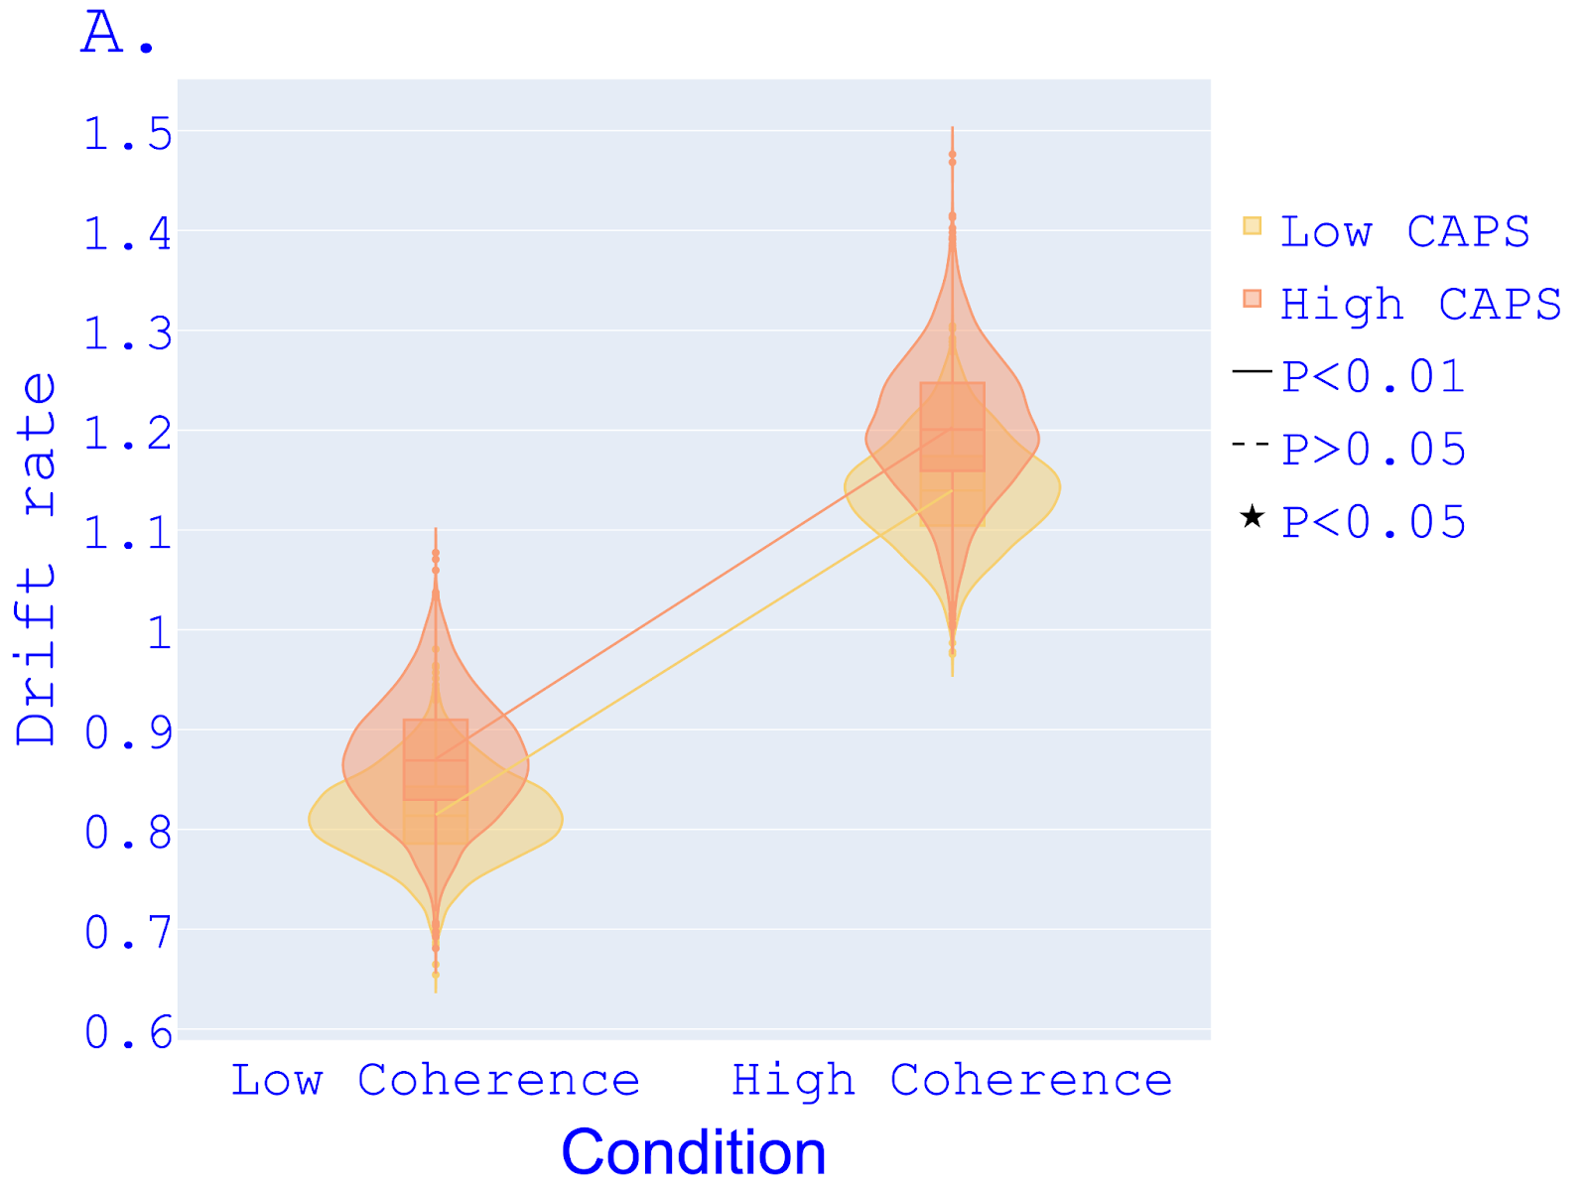
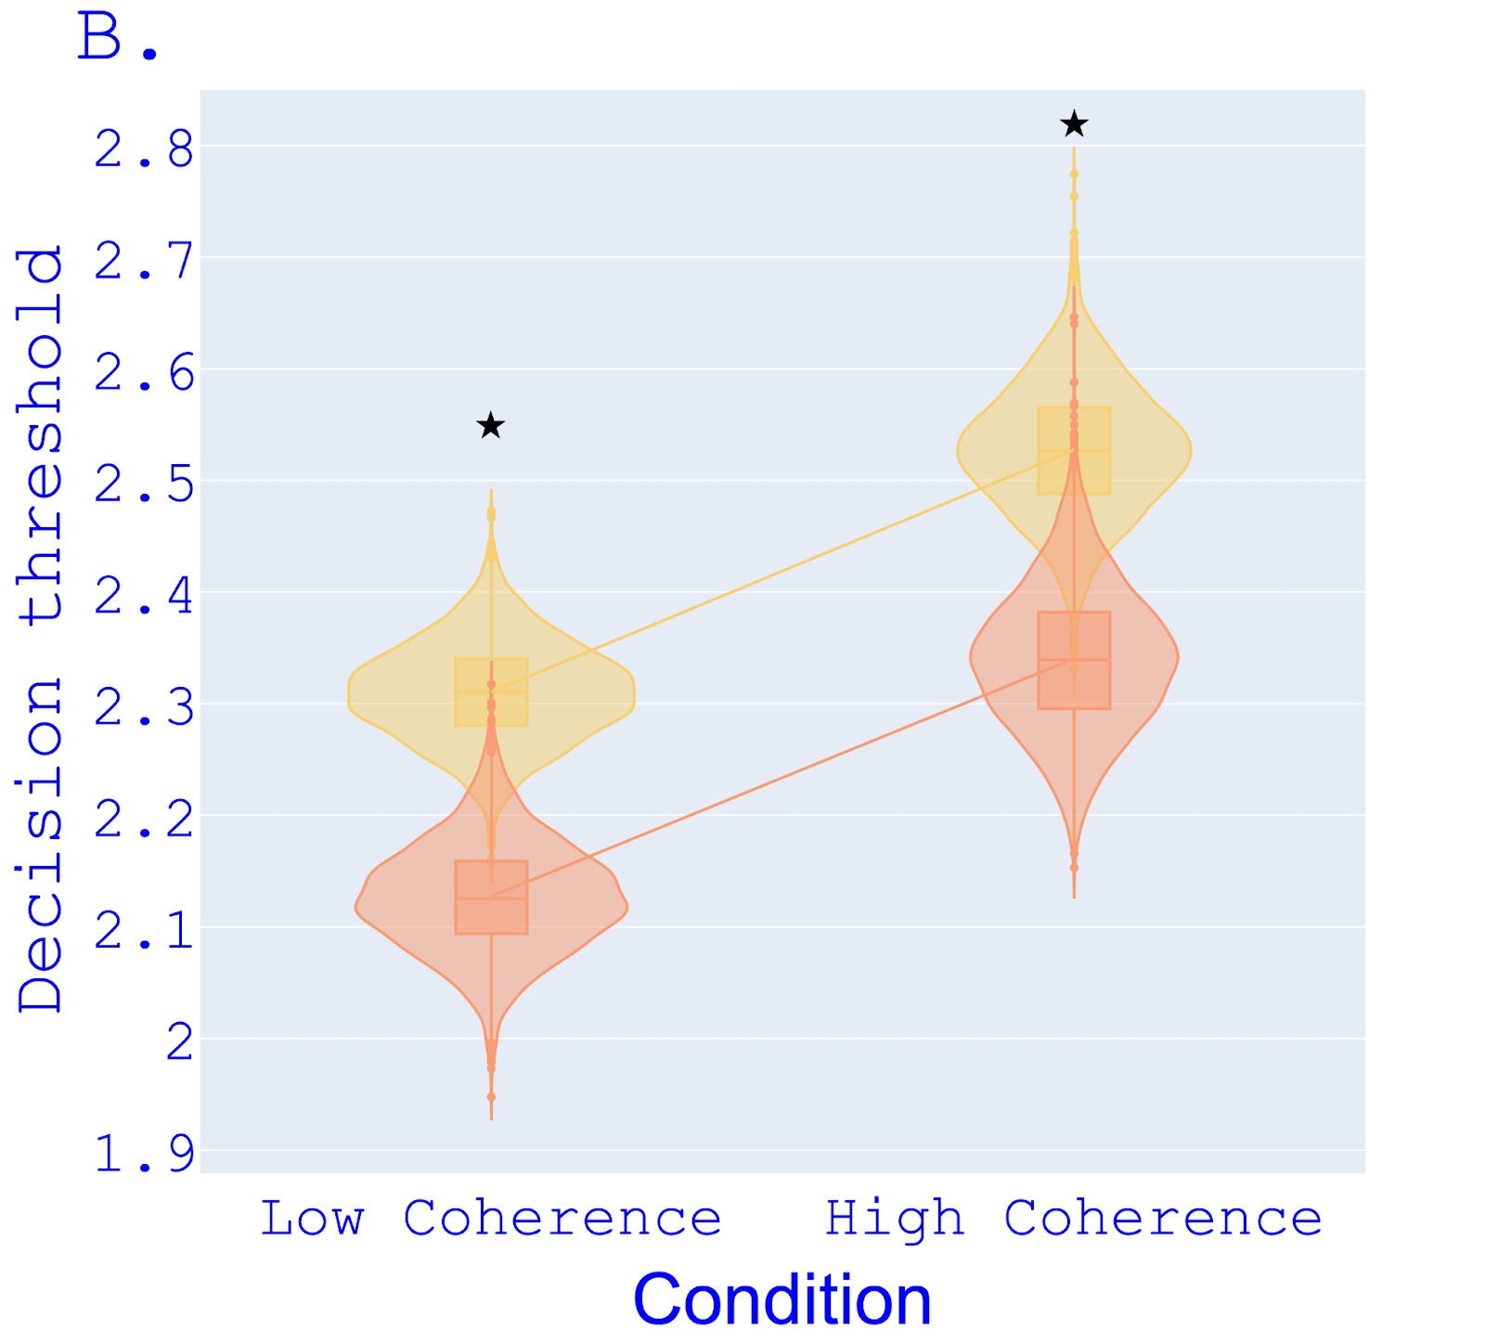
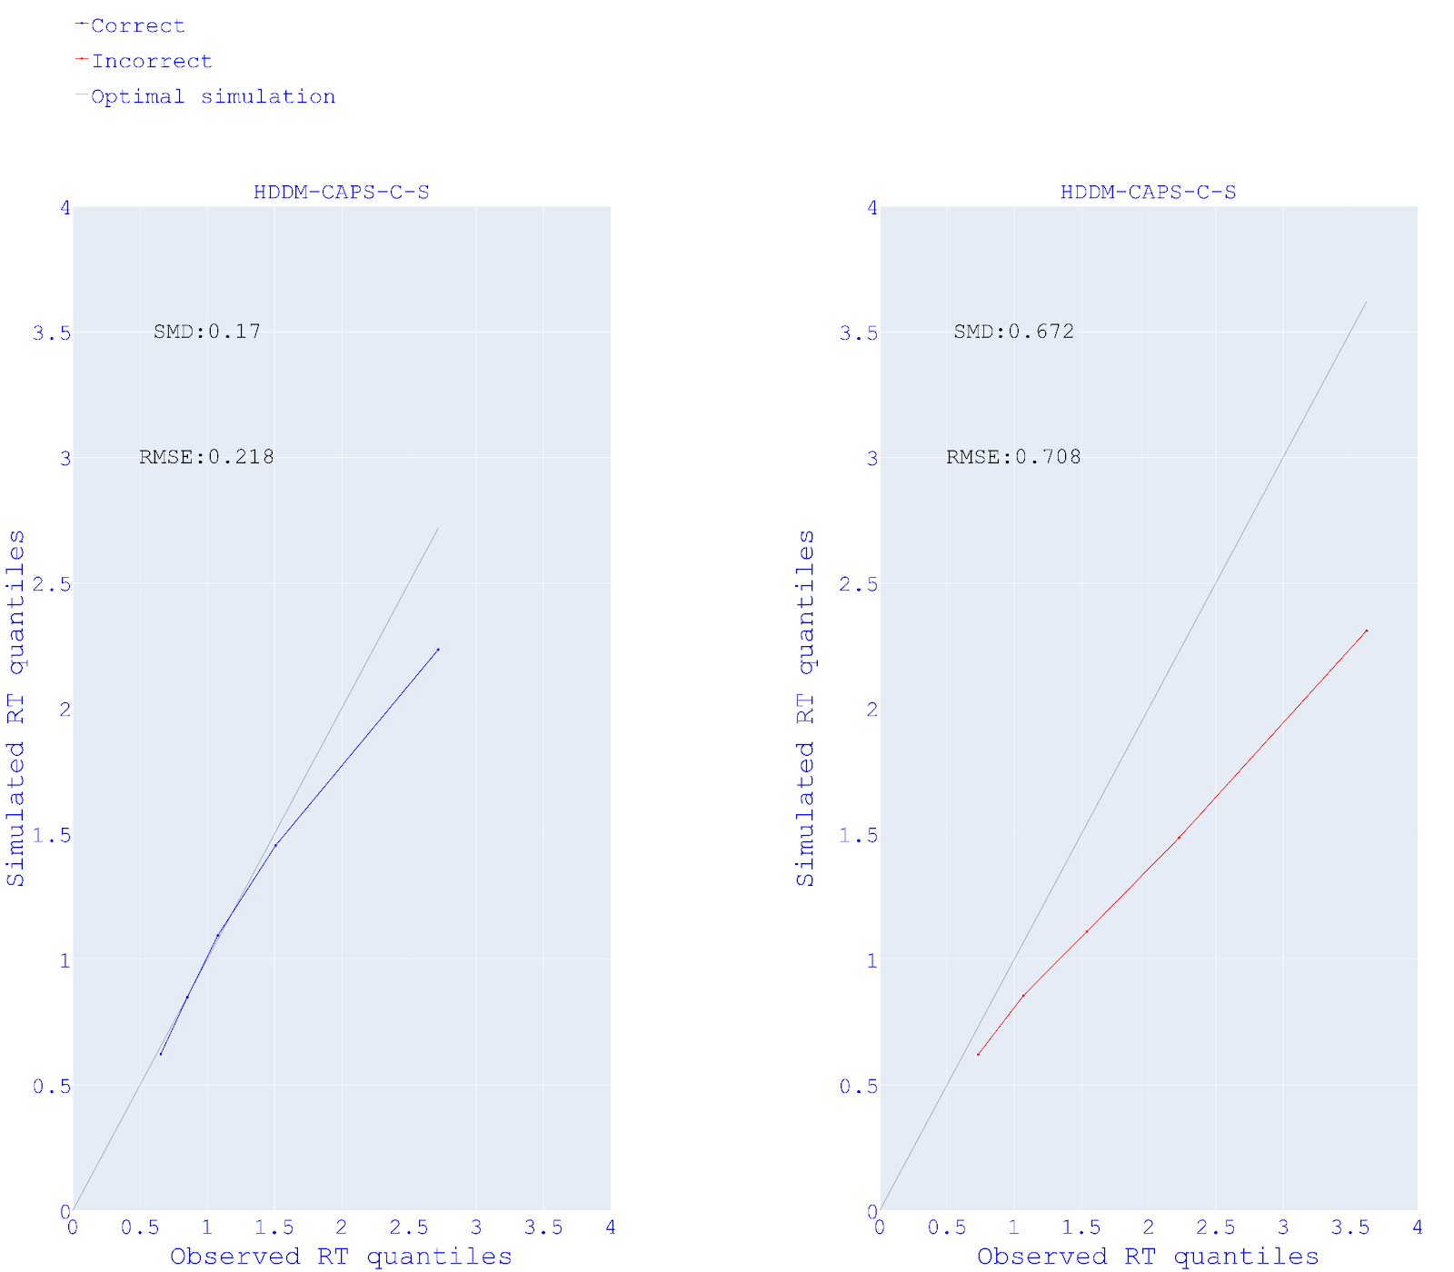
Fig.S11 RT predictions of between-group for HDDM-CAPS-C-S. Linearity plots of observed reaction time (RT) quantiles (x-axis) and simulated RT quantiles (y-axis) for correct and error responses of between-group models in Study 1. SMD= Standardised mean difference; RMSE= Root mean squared error.

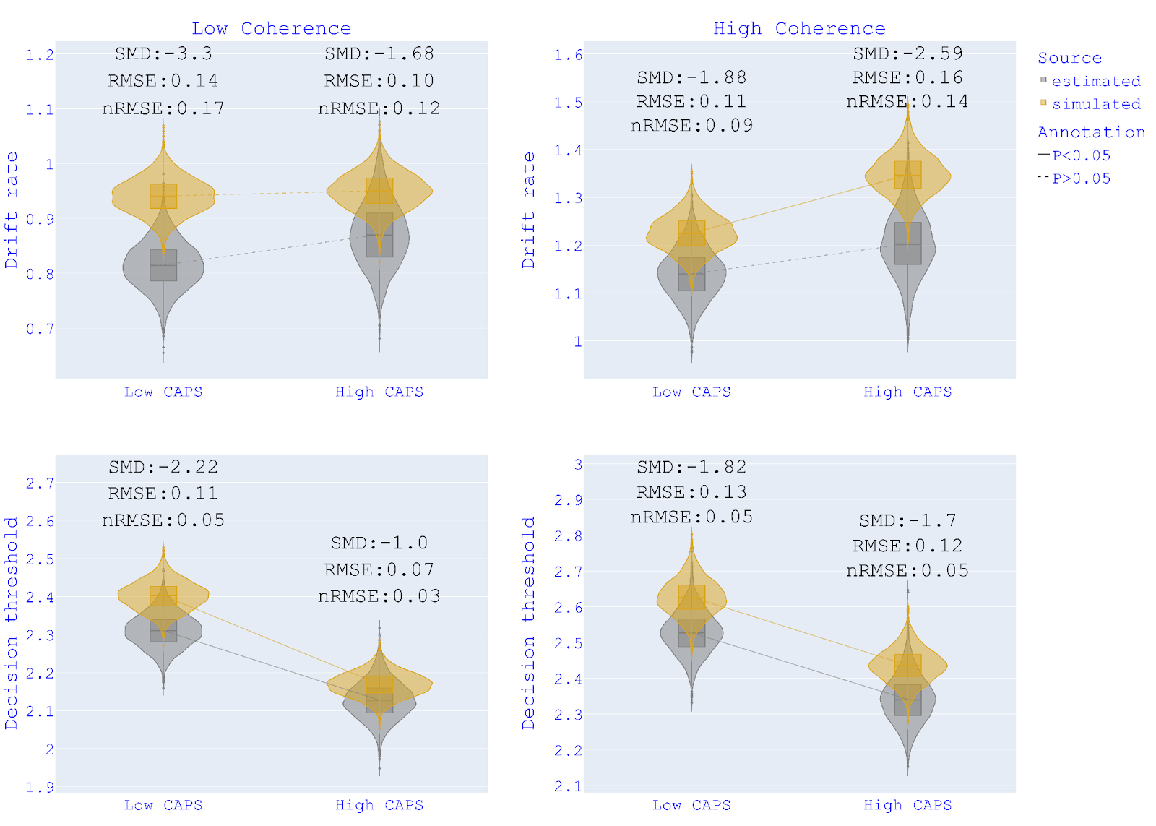
Fig. S12 Parameter recovery HDDM-CAPS-C-S. Recovery of drift rates and decision thresholds for HDDM-CAPS-C-S (motion-coherence - CAPS groups). The ends of the boxes show the lower and upper quartiles of the distributions, while the line inside the box marks the median.
SMD = Standardised mean difference; RMSE = Root mean squared error; nRMSE=RMSE normalised over true (estimated) parameter's mean.

References

Davies, D. J., Teufel, C., & Fletcher, P. C. (2018). Anomalous Perceptions and Beliefs Are Associated With Shifts Toward Different Types of Prior Knowledge in Perceptual Inference. Schizophrenia Bulletin, 44(6), 1245–1253. https://doi.org/10.1093/schbul/sbx177
O’Callaghan, C., Hall, J. M., Tomassini, A., Muller, A. J., Walpola, I. C., Moustafa, A. A., Shine, J. M., & Lewis, S. J. G. (2017). Visual Hallucinations Are Characterised by Impaired Sensory Evidence Accumulation: Insights From Hierarchical Drift Diffusion Modeling in Parkinson’s Disease. Biological Psychiatry: Cognitive Neuroscience and Neuroimaging, 2(8), 680–688. https://doi.org/10.1016/j.bpsc.2017.04.007
Vandekerckhove, J., & Tuerlinckx, F. (2007). Fitting the ratcliff diffusion model to experimental data. Psychonomic Bulletin & Review, 14(6), 1011–1026. https://doi.org/10.3758/BF03193087
Wiecki, T. V., Sofer, I., & Frank, M. J. (2013). HDDM: Hierarchical Bayesian estimation of the Drift-Diffusion Model in Python. Frontiers in Neuroinformatics, 7, 14. https://doi.org/10.3389/fninf.2013.00014
Wilson, R. C., & Collins, A. G. (2019). Ten simple rules for the computational modeling of behavioral data. eLife, 8, e49547. https://doi.org/10.7554/eLife.49547

