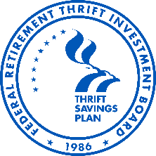
Federal Retirement Thrift Investment Board

2026 Board Meeting Calendar

Tuesday  January 27, 2026  10:00 A.M. | Tuesday  February 24, 2026  11:00 A.M. | Tuesday  March 24, 2026  10:00 A.M.
Tuesday  April 28, 2026  10:00 A.M. | Thursday – Joint ETAC  May 28, 2026  10:00 A.M. | Tuesday  June 23, 2026  10:00 A.M.
Tuesday  July 28, 2026  10:00 A.M. | Tuesday  August 25, 2026  10:00 A.M. | Tuesday  September 22, 2026  10:00 A.M.
Tuesday  October 27, 2026  10:00 A.M. | Thursday  November 19, 2026  11:00 A.M. | Thursday  December 17, 2026  11:00 A.M.

Meetings are generally held the 4th Tuesday of each month (except where noted).

Federal Holidays in 2026 (observed):
Thursday, January 1st – New Year’s Day
Monday, January 19th – Birthday of Martin Luther King, Jr. Monday, February 16th – Presidents Day
Monday, May 25th – Memorial Day
Friday, June 19th – Juneteenth
Friday, July 3rd – Independence Day
Monday, September 7th – Labor Day
Monday, October 12th – Columbus Day
Tuesday November 11th – Veterans Day
Thursday, November 26th – Thanksgiving Day
Friday, December 25th – Christmas Day

