

This strange machine
MPF-2 is singular. Small, it has a good quality Minitel style keyboard in the spirit of 1b and 1P models. Ridiculously sold in France with the FSK-MPF option, a second gummy external keyboard makes operations more passable. We particularly appreciate the "Multitech logo" key which is useless. This strongly feels the reuse of pre-existing components.

Compatibility
The MPF-2 is mostly a big scam like DEF-3000: Apple II Applesoft Basic compatible. Even less, some instructions do not act the samewy or are missing like FLASH for text command. CALL, PEEK ans POKE won't refer to the same addresses. It means that BASIC code will have to be rewritten. All programs use ROM calls to operate. But sold at an unbeatable price, it was bought by a lot of beginners believing to find in this machine the seed of Apple II. Unfortunatly, the architectural differences are such that it seems difficult to adapt the system. It was said at the time, however, that a ROM change would ensure full Apple compatibility. Looking back and comparing architectures, this seems very unlikely. But maybe a few smart handymen have adapted a little better the machine.

Floppy controller
As a cartridge, the floppy controller interface connects two Apple Disk II compatible drives. The organization of the disks (the FAT) is the same as on the Apple 2. Unfortunatly, the controller is located in $C100 instead of the classic $C600 of the slot 6. It seems that the MPF-DOS is a forgery adaptation of the DOS 3.3 Apple .This controller was launched in 1983 for $ 400. There is also single connector version.
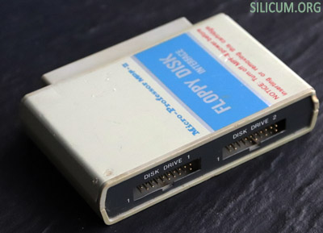
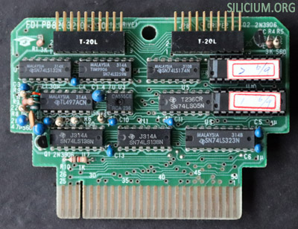

Thermal printer
A nice little printer, Centronics and Epson MX-80 (Model PRT-MPF-2)
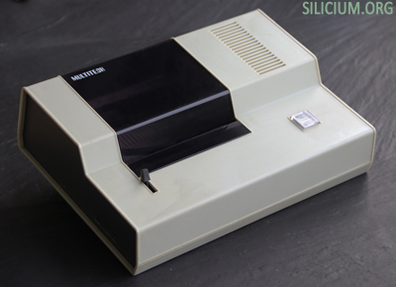
Multitech MPF-2 with external keyboard, printer and floppy controller
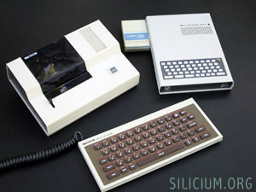

Export
It seems that the MPF-2 has seduced the Brazilians who have dedicated a clone of the clone, the excellent Microdigital TK-2000. It is a machine with a better software library than the MPF-2 . Unfortunatly, it is mainly rewrited Apple 2 software. It would be really interesting to study this machine to know its architecture.
Multitech announced in 1983 the possibility of creating regionalised ROMs. These were cartridges for Basic dialects, in Chinese, French, German and Japanese. It is possible that a Portuguese version was created for the very closed market of Brazil. There is also a demonstration cartridge of the machine.
Silicium is looking for more info on this machine and other fruity clones : Lemon, Pineapple, Pear II, in order to make a beautiful fruit salad.

Complements
By opening the MPF-2, we discover a neat and compact construction. The motherboard hosts a daughter card or is arranged the small keyboard. A second daughter card encodes video in PAL or SECAM. The latter is a French adaptation and offers a large number of straps and a DIN-6 plug which unfortunately replaces the connector CINCH composite. It's a shame, but the place was missing.
Digging on the hardware architecture, we understand that the MPF II was not really compatible with Apple 2. The documentation details the memory organization, modeled on the Apple 2 but different. These variations really make think of an effort to make believe that the machine is not a vulgar copy.
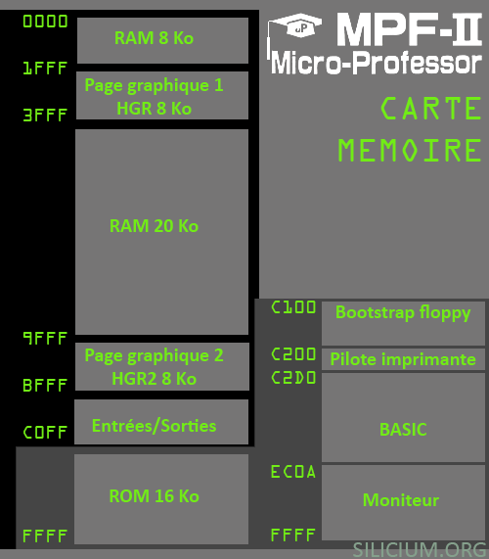
Obviously, the memory map is different from the Apple. The HGR2 graphic page is not in $ 4000 but in $ A000. Therefore, it is easy to understand that a change of ROM would not be enough to allow the execution of programs written for the Apple 2. Even more, the TEXT1 page overlaps the HGR page.
As on the Apple 2, the ROM overlaps the high RAM and can be selected alternatively by software. But the 4 KB in $D000 that exists in the language RAM does not exist on MPF-2. It is therefore impossible to use certain applications or systems.
Finally, the architecture of the MPF-2 is simplified compared to the Apple 2. There is only one slot and it is not compatible pin with that of an Apple 2.
The floppiy ROM is not in $C600 (for slot 6 of the Apple 2), but in $C100.
Another quirk, the joystick does not have a specific port. It connects to the keyboard door and simulates keys.
Jean-Marc gives us his testimony:
"I do not quite agree on being fucked by buying it, I used it for several years for my studies instead of an Apple II whose model was really too expensive.It lacks a little info on the backup, audio cassette that allowed a big saving compared to the expensive floppies.
Thanks for the information on the power connector and good initiative than all these summary pages."
Microprofesor was a computer made for Jean-Marc. Jean-Marc enlights us :
"I am another Jean-Marc and I think like him. This machine served me two years. At the time, I think it was the BASIC that was built in, no floppie to manage, no way to buy an Apple II, and as the BASIC was the same, It was much more handy than the Apple II, like a good laptop back in these days, even with a seperate power and the need of a TV set. In short, me neither, hadve the impression to have been screwed. I finally gave it to a collector."
Martin worked for a distributor :
I used to modify MPF-II games from tape and put them on diskette. I also made a fast loading DOS 3.3 as well as a demo to illustrate the capabilities of the machine. This demo was made for the Swedish Multitech distributor. It’ a demonstration cartridge. There’s one made by Multitech which is not very good. Back in the day, me and a friend of mine made a much better demo for this Swedish distributor.
Regarding tape cassettes, I'm pretty sure that they aren't compatible with Apple II. I know from my early days and it’s like almost 40 years ago now, that it is a bit tricky to set the correct volume etc. to make it read/work properly.
The floppy drive is identical to the Apple Disk II. So you can surely exchange them to verify hardware. My controller actually only have one connector and can only handle one drive. I don't know if it is an early design or something.
The DOS is identical to Apple II DOS regarding "FAT". The main difference is in the bootable part which ends up in RAM when booted, but still, it's a modified Apple II DOS 3.3 which Multitech modifies to their own when converted. It's why they didn't supply a Apple II DOS 3.3 diskette and that you, as a user should make the conversion and the "illegal" part yourself as long as you could find a suitable source to it.

