This simulation aimed at simulating generic wireless topology with two access points and each access point associated with two stations and find out the changes to some parameters and availability when there is failure of one access point

The capture below shows the topology
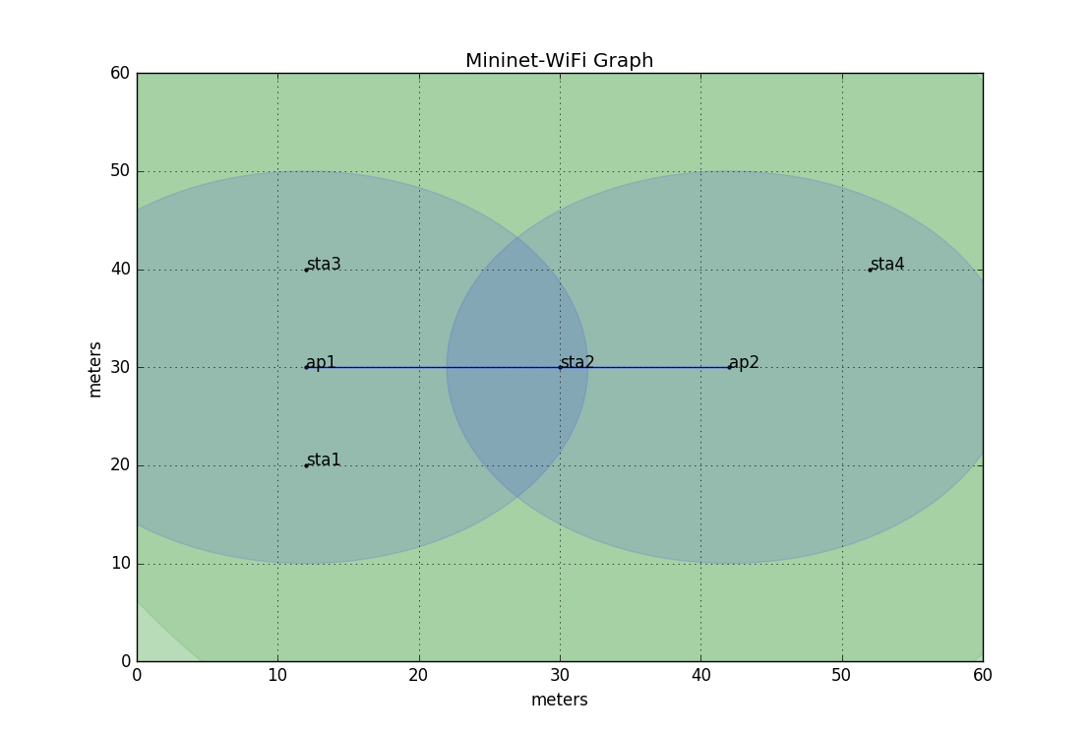

Sta2 is associated to ap1

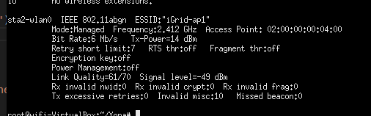

Before failure of ap1 bandwidth between sta2 and sta4 is as given below
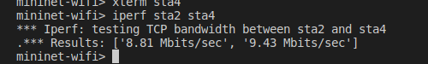

After ap1 fails sta2 finds another association to another access point in the near by place and get associated to ap2 as shown
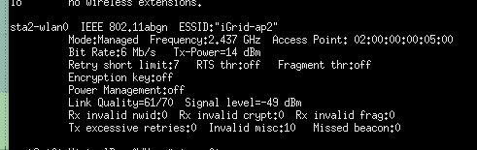

The bandwidth between sta2 and sta4 changes as shown

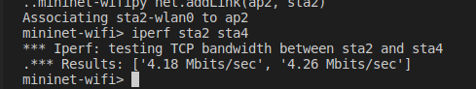

This shows that the bandwidth has decreased due to increased loss when sta2 has associated to ap2

The attached is the pcap file for further analyses

