## Homework 3 JavaScript Programming Exercises.

Due: Thursday, February 28th. End of the day.

Total points: 45pts.

**These basic JavaScript/DOM programming exercises are great warming up for our next bigger assignment for UI control. It is also a good prep for the upcoming mid-term exam.**

For each question, create a .html and .js. Zip all of your files in a folder that has your name on it!! Submit to blackboard before due date. You are expected to finish this homework alone.

I will grade this by run your .html and then look at your .js and .css

**Please do not copy from codes from the web and also do not copy from each other. Only high level discussion are allowed. Cheating has serious consequences and might result in failure of the class. If you have questions, please come to office hours or arrange to see the TA.**

**Grading scheme:**

100% All code run without any error and user interface makes perfect sense. The code is well documented and has efficient algorithm. **All the code must be written with Unobtrusive JavaScript.**

85% All code run without any error but user interface is not friendly or the code is not efficient**. Code is not written in Unobtrusive way.** HTML and CSS do not pass validation. Points will be reduced if we found JS code in HTML and CSS code in JS.

75% Code run with errors but still compiled.

30% Code broke or does not generate correct results.

0% No significant code is written.

0 (5pts) Warm ups.

Write a JavaScript function that takes an array of strings or numbers and output the most frequent member of the array.

E..g. array1 = [‘3’,’1’,’1’,’a’,’a’,’3’,’b’,’f’,’a’,1,’a’] -> ‘a’ 4 times

You can use document.write to directly output the results or

You can create a button in your .html and use onclick to evoke your function.

This question can be solved a variety of algorithm. You don’t have to use any fancy methods. A simple nested loop can do.

1. (15Pts ) Grade calculator

Write **an unobtrusive JavaScript** code to add behavior to the page that has a user interface for entering grades on homework assignments. You can download the HTML and CSS code in the folder Question 1.

You will compute the percentage of points earned, with an optional **curve**. When "Compute!" is clicked, your JS code should use the values in the text boxes to compute the percentage (rounded to the nearest percent). If the **"Curve +5"** checkbox is checked, add +5 percent up to a maximum of 100% total.

You should insert the percentage into the page as a new div added to the end (bottom) of the existing page section with the id of resultsarea. If the overall percentage is 60% or more, give your newly created div a CSS class of pass; otherwise give it a class of fail. Each time the user clicks **"Compute!",** you will insert such a new div; this means that several divs would be there after several clicks of "Compute!".

In the code shown there are 3 assignments, but your code should work for any number of assignments ≥ 1. When **"Clear"** is clicked, all text in all of the input text boxes should be erased. Assume valid input; that is, assume that when "Compute!" is clicked, the user will have already typed valid text into every box that can be interpreted as an integer. You may assume that Prototype is also included in the page.

The current screen shots show the initial state after scores have been entered and Compute has been clicked as well as when the Curve+5 is checked.

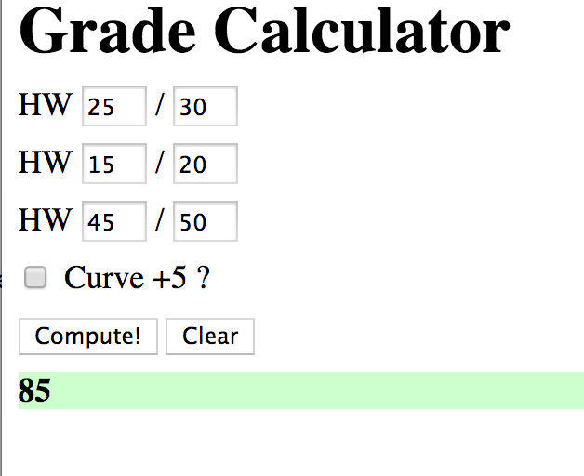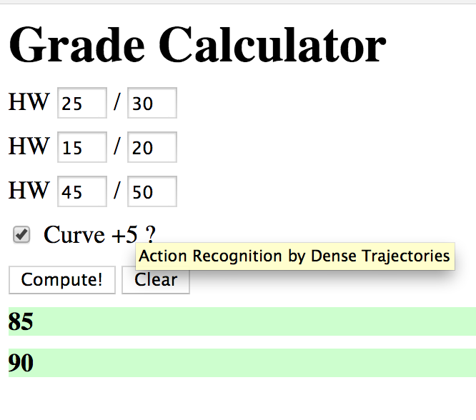

Hint: Write two functions. ComputeClick() and ClearClick()

You might use : document.querySelectorAll() to access different classes.

1. (15pts) Make a ball bouncing. The ball can be an image (Redball.png as attached). You are welcome draw your own, which might be better. You are expected to submit three files: ball.html, ball.css, and ball.js

You can access its tyle attribute by using document.getElementByID(‘ball’). You can create a .css for the html so that the ball and its box look like this:

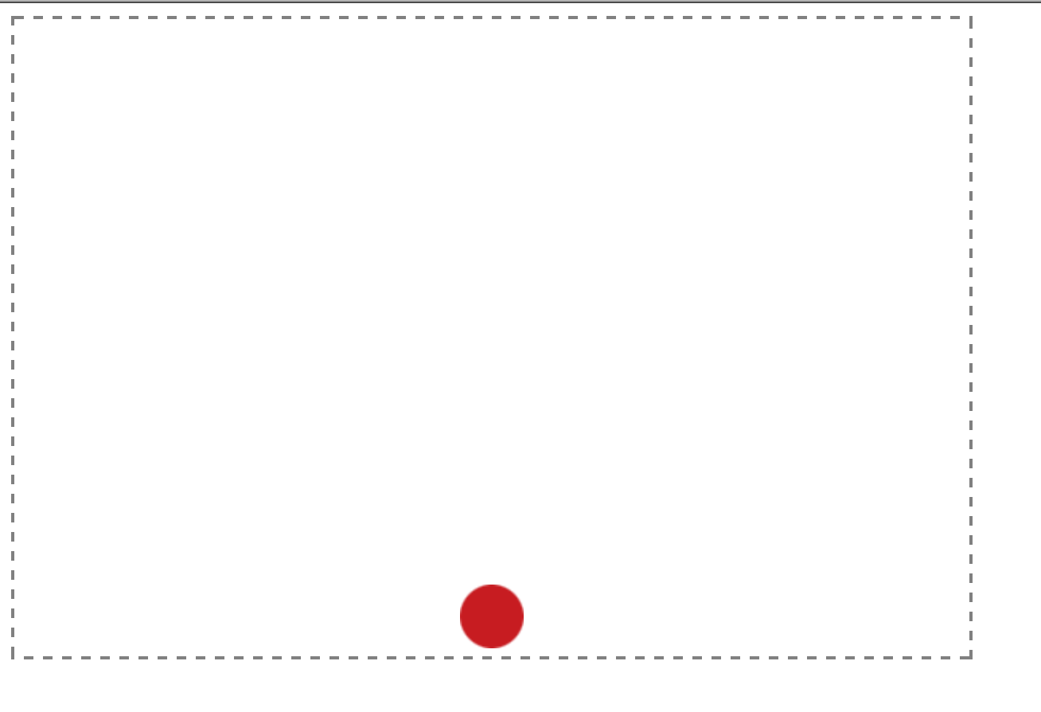

The ball should start bouncing as soon as the web page is loaded (look up window.onload). E.g. window.onload = function()

Write two separate .js file and make sure your code can do the following:

1. (4pts) The ball keep bounces at a constant speed without decay( constant bouncing).
2. (3pts) The ball bounces but the speed decays to zero.
3. (3pts)The ball bounces but also moves to the right end of the wall and disappears.
4. (5pts) Modify your code so that when you press the Z key, the ball slows down, and when you press the X key, it speeds up. Once that is working, use C to make the ball smaller and V make it larger.

Hint: the animation is created by changing the position of the ball.

You might find the following code snippets helpful:

var ball = document.getElementById("ball");

ball.style.top = ballY + "px";

**You do not need HTML5 Canvas element for this exercise.** There are a variety of solutions on the Internet. A lot of them use API are overly complicated. You can look at them but don’t copy them blindly and if I caught you copying the solution, you will be reported to as cheating to the university.

You can solve this question with simple Math object and conditionals that we have learned.

3). (10pts total)

(7pts) Tip calculator UI. Create a tip calculator that helps the user determine how much tip they want to pay based on the price of the service. You will have to write your own tip.html, tip.css, and tip.js files. The final amount will be displayed beneath the forms. The tip percentage field will become “red” if the percentage is below 15% but not if the percentage is above 15%. Here is an example of the user-interface:

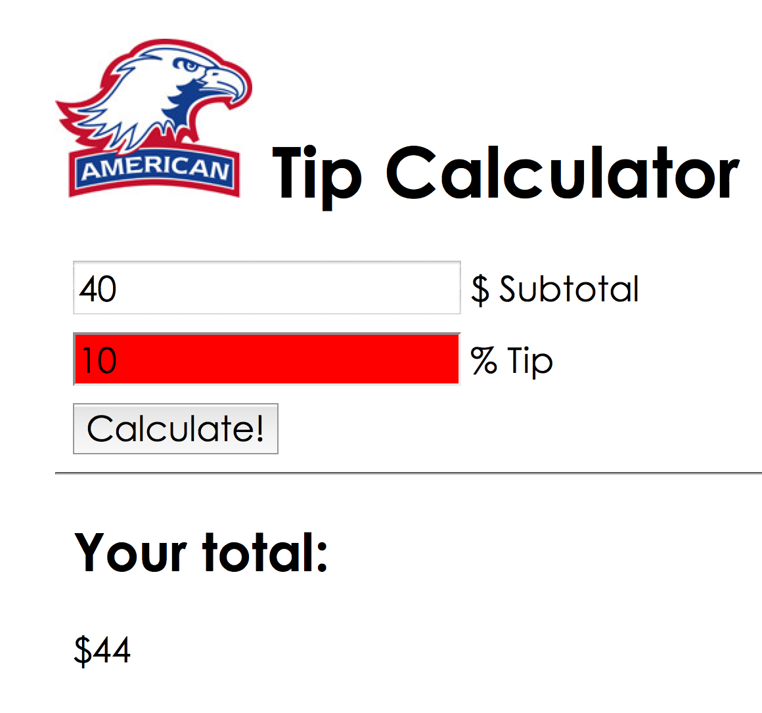

(3pts) Change the UI instead of asking user to enter the percentage by type in the number, use a slider to indicate the amount of tips. For example, one end of the slider is zero and another is 50%. Think of how to divide your slider. You can also get rid of the “calculate” button all together so that when user stopped the slider, the final amount will show up. You should also display the tip amount just to make things clear. Be creative of the UI of this simple app.

Here is a slider for you:

<http://www.w3schools.com/jsref/dom_obj_range.asp>