Endowments
Endowments are funds that seek to provide financial support to the institution for a long period of time (perpetuity). How do they do it? By investing the capital raised through donations into the financial markets and following mechanisms for their allocation and spending.

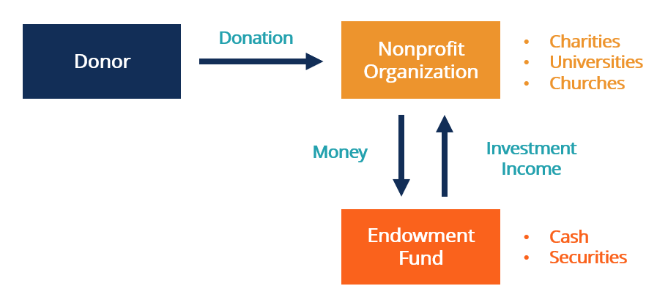
Source: CFI

There are 3 types of endowments:

Type | Principal Restrictions | Who Sets Terms? | Typical Use Case
Permanent (True) | Cannot be spent; held in perpetuity | Donor | Long-term institutional support via annual income only
Quasi-Endowment | Usually retained, but can be spent | Organization's board | Flexible reserves; spendable principal under special conditions
Term Endowment | Principal spent after set period/event | Donor or gift instrument | Funding for a defined time or trigger, then principal usable

Source: Perplexity

It’s important to add that an endowment is appropriate when a non-profit has successfully moved beyond immediate needs (ex. sufficient reserves exist and are consistently growing so the operating expenses are securely covered and when the organization seeks to reduce vulnerability to economic cycles and showcase their intention to operate indefinitely) and can focus on long-term stability.

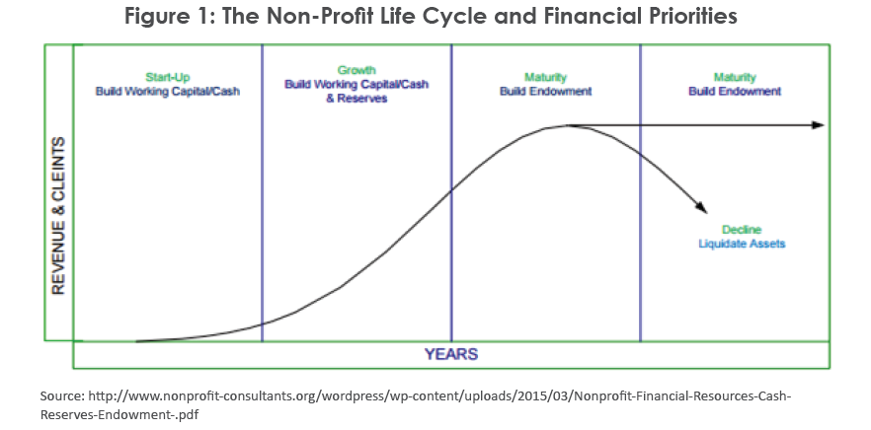

Source: LinkedIn

Mechanisms

Asset allocation
Traditionally, endowment portfolios were balanced 60% stocks, 40% bonds. But Yale, under the governance (1985–2021) of CIO David Swensen, demonstrated that further diversification, in particular into alternative assets, is key to improving returns.

In contrast to the 60/40 Portfolio, the Yale Model places significant emphasis on alternative investments. Alternative investments do not fall into one of the traditional asset class categories like equities or bonds; instead, they encompass private equity, real assets (including real estate), hedge funds, and commodities. Alternative investments are generally less correlated to traditional asset classes, meaning that the price movements of alternatives do not closely follow the same trend or direction as traditional assets. The low correlation between alternative and traditional investments reduces the overall volatility of portfolios. As a result, diversified portfolios with exposure to alternatives can better withstand market corrections and minimize the risk of portfolio drawdowns, thus preserving invested capital over the long term (Source: Two Ocean).

EE. UU. | LATAM | BRAZIL
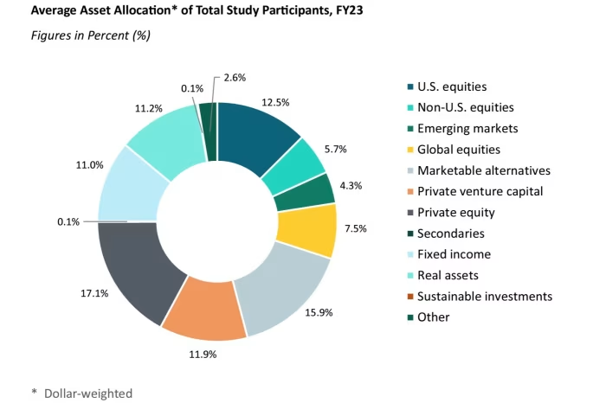 |  | 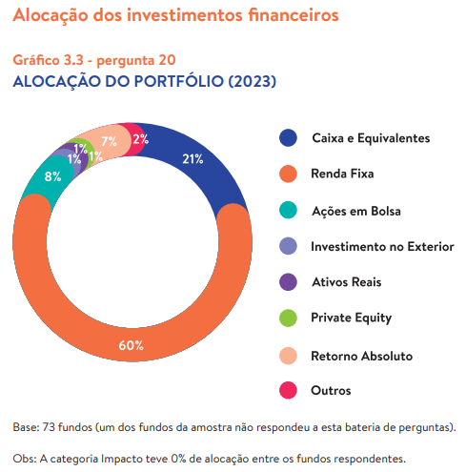  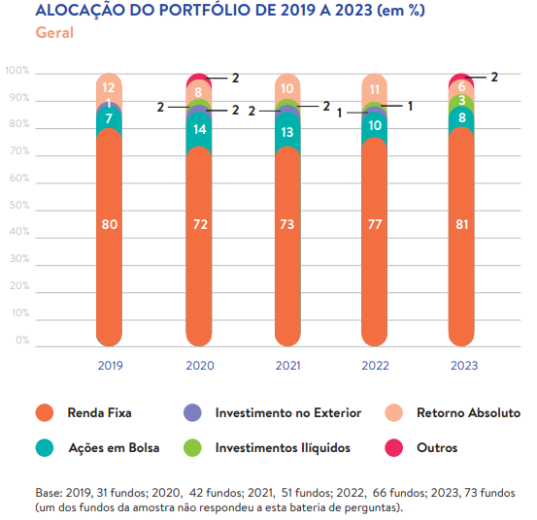
Source: Financial Times | Source: | Source: Idis (2023)

Portfolio rebalance

EE. UU. | LATAM | BRAZIL
Source: | Source: | Source:

Risk management

EE. UU. | LATAM | BRAZIL
Source: | Source: | Source:

Capital raising

Gifts and donations come from current and future students, alumni, current and future university faculty and administrators, and the larger university community.

It is common that donors specify the handling and use of their endowed gifts. Other gifts may be unrestricted and can be spent for general purposes.

Besides endowed gifts, donors can give expendable gift, which is money given by a donor that is to be spent, in its entirety, right away. It is not usually invested for the long term but will be used to meet a pressing priority.

Donor experience

Source: Columbia University

Ways to give

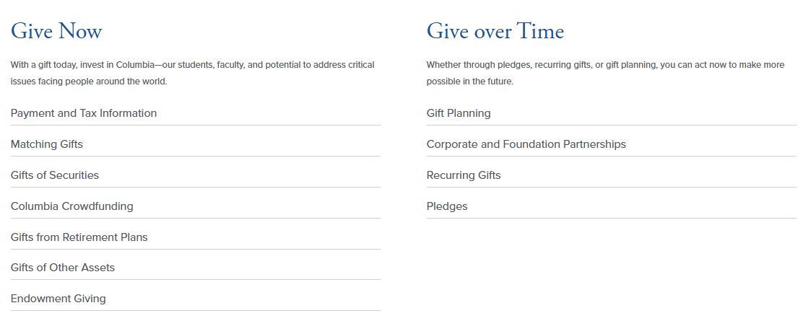

Donor stories



Make a gift

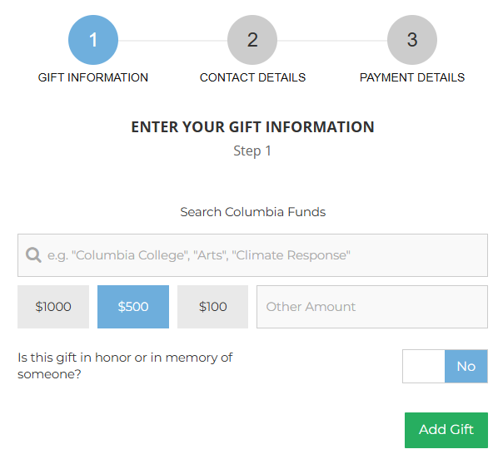

Performance & benchmarking

EE. UU. | LATAM | BRAZIL
 |  | 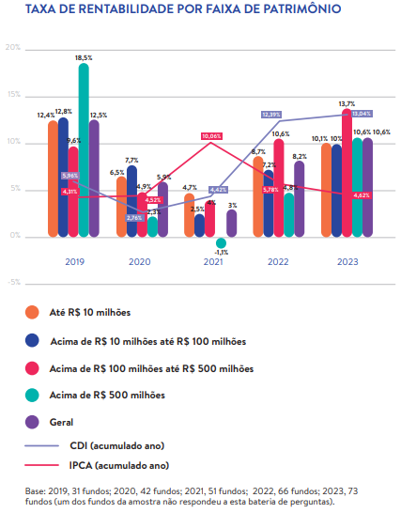
Source: | Source: | Source: Idis (2023)

Liquidity & spending rules

Spending rule

Main spending

EE. UU. | LATAM | BRAZIL
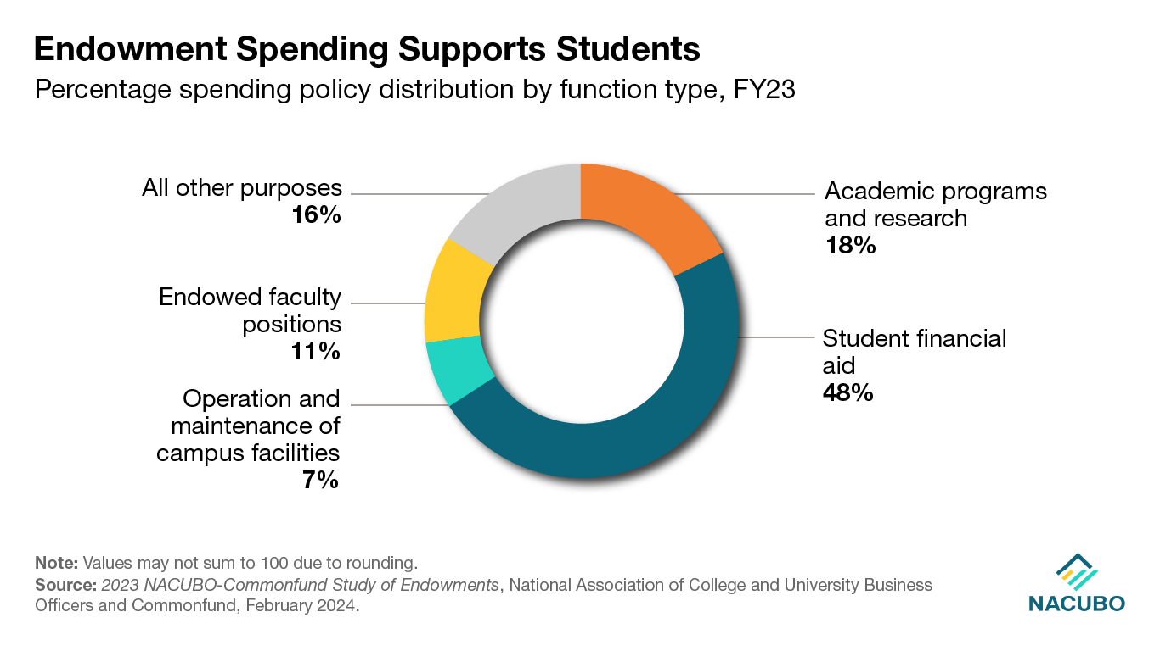 |  | 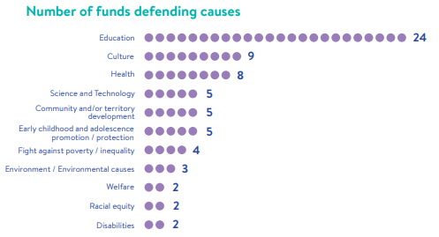
Source: NACUBO | Source: | Source: Idis

Governance

Main Challenges

U.S.
- Mainly allocated in alternative assets: In times of market turmoil, distributions from private equity are slower than expected or even zero (Source: Farther).
- University donors are not immune to the economy and markets; their donations cannot be taken for granted and can slow down (Source: Farther).

LATAM (MX):

Context:
- According to estimates by academics, more than 10,000 students were left without support in 2023. In some cases, even scholarship recipients conducting research abroad faced arbitrary suspension of funds. The transformation of Conacyt included the gradual elimination of trusts since 2020 without clear justification (Source: Perplexity).
- Scholarships for postdoctoral stays abroad were reduced from 103 in 2018 to just 50 in 2019. The professorship program lost significant support: in 2018, there were 1,500 professors assigned to 982 research projects, but in 2020, this was reduced to 1,076 professors within 664 projects (Source: Perplexity).
- The OECD notes that Mexico shares first place with Turkey in university dropout rates among member countries, with only 25% of young people attending university graduating. Nationally, the dropout rate is between 7.5% and 8.5%, with 1 in 10 young people dropping out along the way (Source: Perplexity).
- Tuition fees at private universities range from $14,500 to $111,000 per semester, which is a serious problem considering that the minimum wage is just over $120 per day. In addition to monthly tuition fees, some students face graduation costs of 40,000 to 50,000 pesos, plus other administrative fees (Source: Perplexity).

Brazil
- Fundraising and Profitability, specially after the bad economic performance saw in 2021 (Source: Idis).
  - Virtually all those who did not have significant initial endowments cite fundraising as their main difficulty, while those who already have significant assets find it difficult to ensure profitability during a prolonged period of financial crisis (Source: Idis Full Report).
- Geographic concentration: There’s an intense concentration in the state of São Paulo (38), the richest in the country, and scarce in the North-Northeast direction, the two poorest regions in Brazil (Source: Idis).
- Power concentration: Historically, in Brazil, the favored cause of philanthropists and corporate social investors is Education. This trend is clearly repeated when it comes to endowments, as 40 of the 52 endowments analyzed declared to defend specific causes and there is a strong presence of Education (Source: Idis).
  - The amount is disproportionate, considering that the next cause is less than half the amount of the first one.
- In Brazil endowments are regulated by “MODELO DA LEI 13.800/19” (Source: Idis Full Report).
  - The approval of Law 13.800/19, known as the Endowment Funds Law, contributed greatly to raising awareness of the issue and undoubtedly influenced the emergence of new endowment funds: 12 active funds and six more in the planning or structuring phase. However, few of them operate in accordance with the model proposed by the Act, and some of them have been adapted but do not meet all the requirements.
- Brazil's culture of giving, which focuses on short-term projects. This reality reinforces the need for a cultural shift, in which donors, partners, and society itself value long-term investments that ensure the sustainability of organizations and expand their social impact, such as endowment funds (Source: Idis Full Report).

Context:
- The National Council for Scientific and Technological Development (CNPq) faces mainly problems of insufficient funding and systematic budget cuts that affect its functioning and its ability to support scientific research in Brazil. Between 2013 and 2021, CNPq funding declined dramatically, reaching only about 29.6% of the 2013 budget in 2021. This has led to historic underfunding that has compromised the payment of scholarships to researchers, project financing, and the fulfillment of institutional goals (Source: Perplexity).
- The primary need highlighted by university students in Brazil in 2025 is greater financial support and access to scholarship and student loan programs, as more than 64% of them would not be able to pursue higher education without this assistance. They also demand better technological infrastructure and virtual laboratories that promote the use of digital tools and innovation in teaching. In addition, they call for education with greater curricular flexibility that is aligned with the needs of the labor market in order to improve their employability after graduation (Source: Perplexity).

