Scrap:

This gives them a greater chance of being on the best teams and having access to the best coaches.

This translates to player born early in the year being drafted more often than player born late in the year

Recently the WHL held their Bantam Draft for player born in 2000 (2 players were born in 1999).

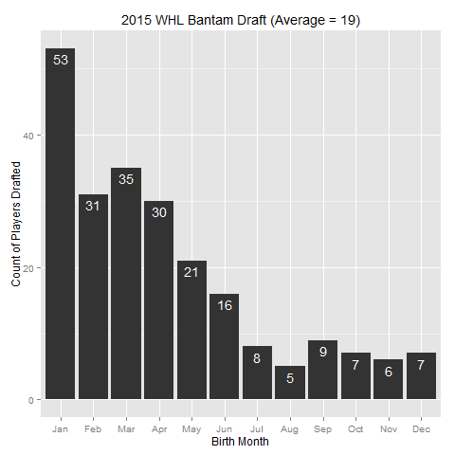

If there was no relative age effect than each month would have about 19 players drafted. However, we can see that 53 of the 228 players were born in January. February, March, and April are all well above the average of 19 players for a given month. The months in the second half of the year, July through December, all have 9 or less players drafted.

The Relative Age Effect is now commonly known in NHL circles. Players in the NHL are more likely to be born in January, February, or March than October, November, or December. The thinking

In 2013 Rob Deaner published a paper which highlighted the Relative Age Effects in the NHL. Players who are relatively older are more likely to succeed. This is