**Data Structure Practicals**

1. **Bubble Sort:-**

**Code:-**

#include<iostream>

#define max 25

using namespace std;

class bubble

{

int n, A[max],temp,count;

public:

bubble()

{

n = 0;

count = 0;

temp = 0;

}

void getdata()

{

cout<<"Enter the size of the Array"<<endl;

cin>>n;

A[n];

cout<<"Enter the values of the Array"<<endl;

for(int i=0; i<n; i++)

{

cin>>A[i];

}

}

void display()

{

cout<<endl;

for(int i=0; i<n; i++)

{

cout<<A[i]<<"\t";

}

cout<<endl;

}

void sort()

{

for(int i=0; i<n-1; i++)

{

count = 0;

for(int j=0; j<n-i-1; j++)

{

if(A[j]>A[j+1])

{

temp = A[j];

A[j] = A[j+1];

A[j+1] = temp;

count++;

}

}

cout<<"Pass = ";

display();

if(count == 0)

{

break;

}

}

}

};

int main()

{

bubble obj;

obj.getdata();

obj.display();

obj.sort();

cout<<"After sort :- ";obj.display();

return 0;

}

**Screenshots:-**

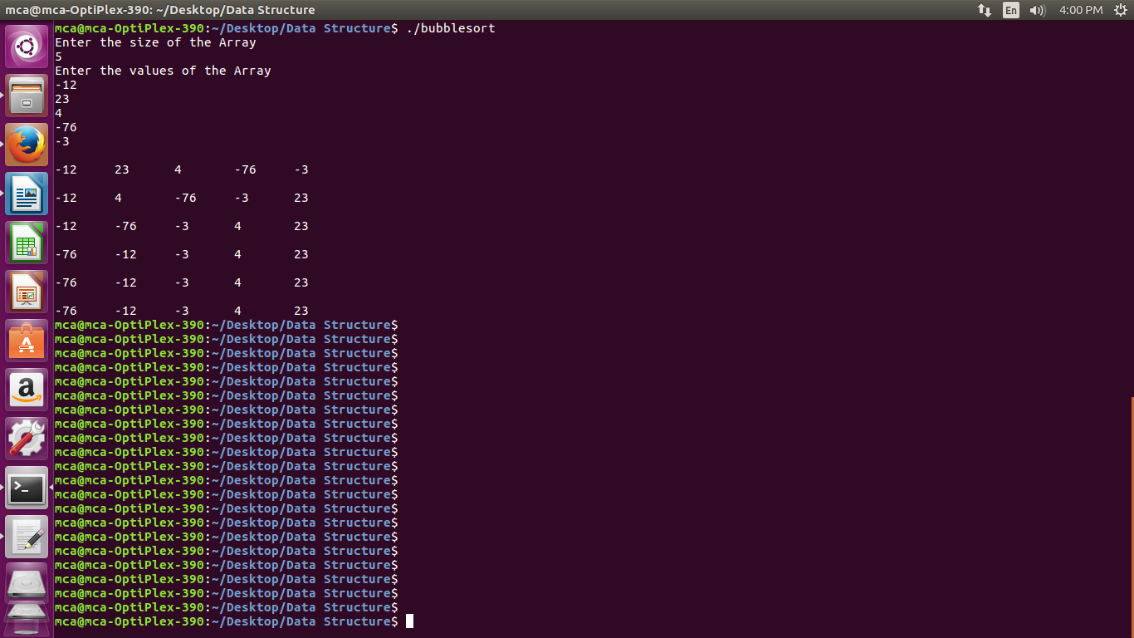

1. **Quick Sort:-**

**Code:-**

#include<iostream>

#define max 25

using namespace std;

class QuickSort

{

int n, A[max], lower, upper, temp, l, u, i;

public:

QuickSort()

{

n = 0;

temp = 0;

l = 0;

u = 0;

i = 0;

}

int getdata()

{

cout<<"Enter the size of the Array"<<endl;

cin>>n;

A[n];

cout<<"Enter the values of the Array"<<endl;

for(int i=0; i<n; i++)

{

cin>>A[i];

}

return n;

}

void display()

{

cout<<endl;

for(int i=0; i<n; i++)

{

cout<<A[i]<<"\t";

}

cout<<endl;

}

void sort(int lower, int upper)

{

if ( lower < upper )

{

int i = part ( A, lower, upper ) ;

sort ( lower, i - 1 ) ;

sort ( i + 1, upper ) ;

}

}

int part ( int *a, int lower, int upper )

{

l = lower + 1 ;

u = upper ;

i = a[lower] ;

while ( u >= l )

{

while ( a[l] < i )

{

l++ ;

}

while ( a[u] > i )

{

u-- ;

}

if ( u > l )

{

temp = a[l] ;

a[l] = a[u] ;

a[u] = temp ;

}

}

temp = a[lower] ;

a[lower] = a[u] ;

a[u] = temp ;

return u ;

}

};

int main()

{

QuickSort qs;

int x = qs.getdata();

qs.display();

qs.sort(0, x-1);

cout<<"Sorted :";

qs.display();

return 0;

}

**Screenshots:-**

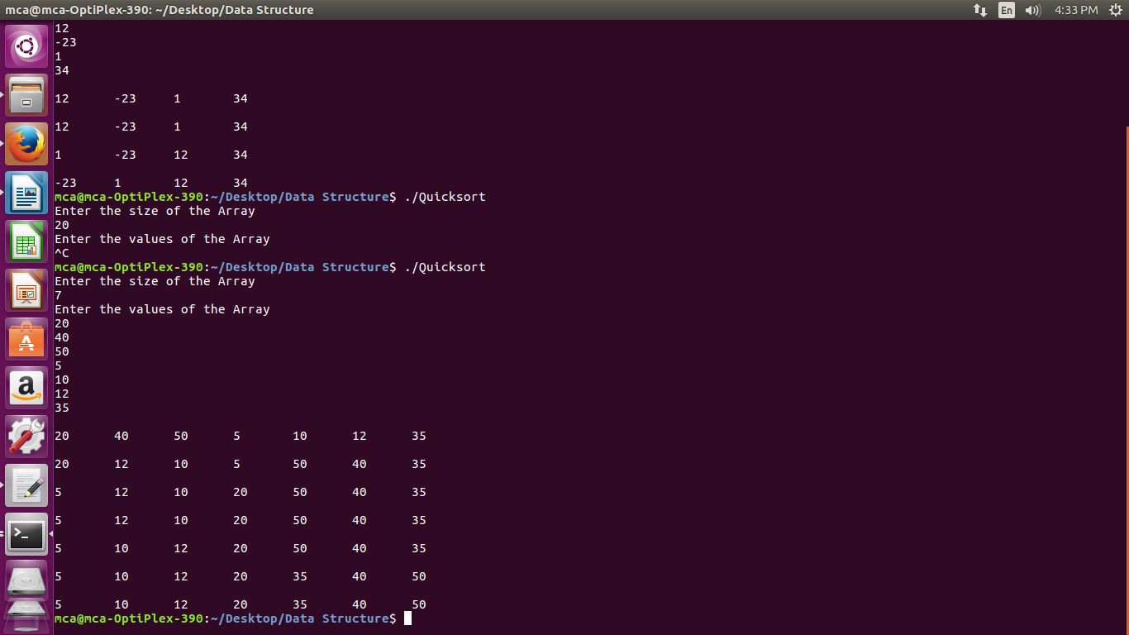

1. **Selection Sort**

**Code:-**

#include<iostream>

#define max 25

using namespace std;

class SelectionSort

{

int n, A[max], temp, i, j, t, m;

public:

SelectionSort()

{

n = 0;

m = 0;

t = 0;

i = 0;

j = 0;

temp = 0;

}

void getdata()

{

cout<<"Enter the size of the Array"<<endl;

cin>>n;

A[n];

cout<<"Enter the values of the Array"<<endl;

for(int i=0; i<n; i++)

{

cin>>A[i];

}

}

void display()

{

cout<<endl;

for(int i=0; i<n; i++)

{

cout<<A[i]<<"\t";

}

cout<<endl;

}

void sort()

{

for(i=0; i<n-1; i++)

{

m = A[i];

t = i;

for(j=i+1; j<n; j++)

{

if(m>A[j])

{

m = A[j];

t = j;

}

}

display();

cout<<endl;

temp = A[i];

A[i] = A[t];

A[t] = temp;

}

}

};

int main()

{

SelectionSort ss;

ss.getdata();

ss.display();

ss.sort();

ss.display();

return 0;

}

**Screenshots:-**

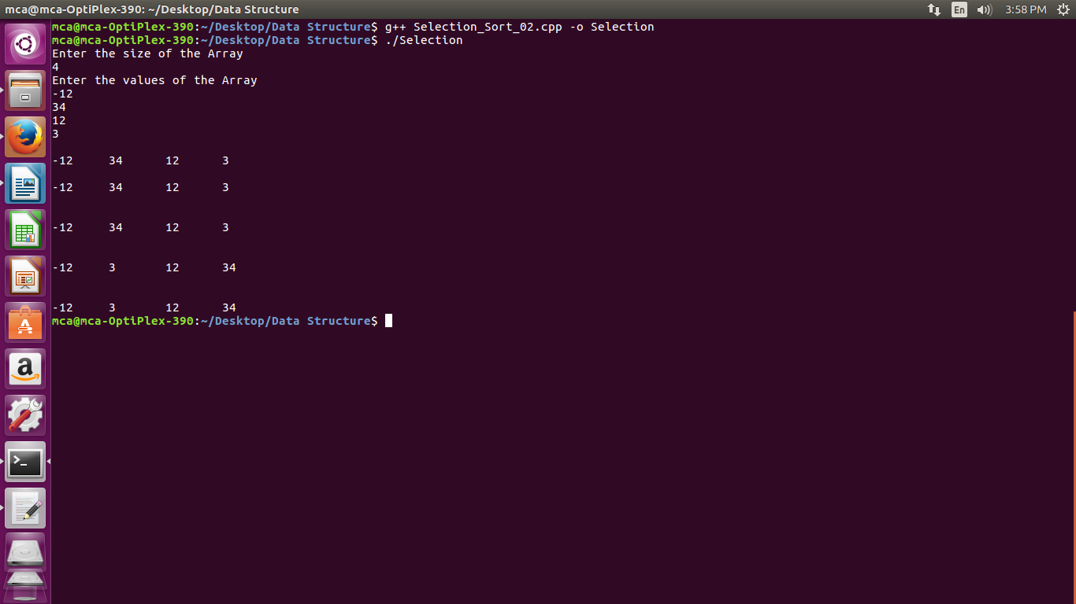

1. **Radix Sort**

**Code:-**

#include<iostream>

#define m 25

using namespace std;

class Radix

{

public:

int n, A[m], max, x;

Radix()

{

n=0; max=0; x=0;

}

void getdata()

{

cout<<"Enter the size of the Array"<<endl;

cin>>n;

A[n];

cout<<"Enter the values of the Array"<<endl;

for(int i=0; i<n; i++)

{

cin>>A[i];

}

}

int getMax(int A[], int n)

{

int temp=A[0];

for(int i=0; i<n; i++)

{

if(A[i]>temp)

{

temp = A[i];

}

}

return temp;

}

void countsort(int A[], int n,int x)

{

int count[10]={0}, i, output[n];

// Counter Initialized

// Exponential Game

for(i=0; i<n; i++)

{

count[(A[i]/x)%10]++;

}

//Total Count

for(i=1; i<10; i++)

{

count[i]=count[i]+count[i-1];

}

//Building Output Array

for(i=n-1; i>=0; i--)

{

output[count[(A[i]/x)%10]-1] = A[i];

count[(A[i]/x)%10]--;

}

// Copying the elements

for(i=0; i<n; i++)

{

A[i] = output[i];

}

}

void sort()

{

max=getMax(A, n);

for(x=1; max/x>0; x=x*10)

{

cout<<"Pass = ";

display();

countsort(A, n, x);

}

}

void display()

{

cout<<endl;

for(int i=0; i<n; i++)

{

cout<<A[i]<<"\t";

}

cout<<endl;

}

};

int main()

{

Radix r;

r.getdata();

r.display();

r.sort();

cout<<"Sorted Elements: \n";

r.display();

return 0;

}

**Screenshots:-**

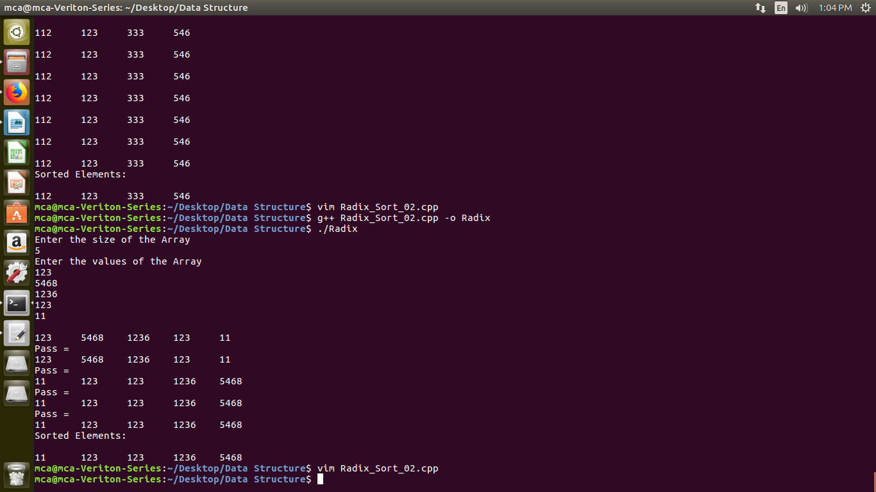

1. **Insertion Sort**

**Code:-**

#include<iostream>

#define max 50

using namespace std;

class InsertionSort

{

int n, i, j, t, A[max];

public:

InsertionSort()

{

n = 0;

i = 0;

j = 0;

t = 0;

}

int getdata()

{

cout<<"Enter the size of the Array"<<endl;

cin>>n;

A[n];

cout<<"Enter the values of the Array"<<endl;

for(int i=0; i<n; i++)

{

cin>>A[i];

}

}

void display()

{

cout<<endl;

for(int i=0; i<n; i++)

{

cout<<A[i]<<"\t";

}

cout<<endl;

}

void sort()

{

for(i=0; i<n; i++)

{

t = A[i];

j = i-1;

while((t<A[j]) && (j>=0))

{

A[j+1] = A[j];

j = j-1;

}

A[j+1]=t;

display();

}

}

};

int main()

{

InsertionSort is;

is.getdata();

is.display();

is.sort();

is.display();

return 0;

}

**Screenshots:-**

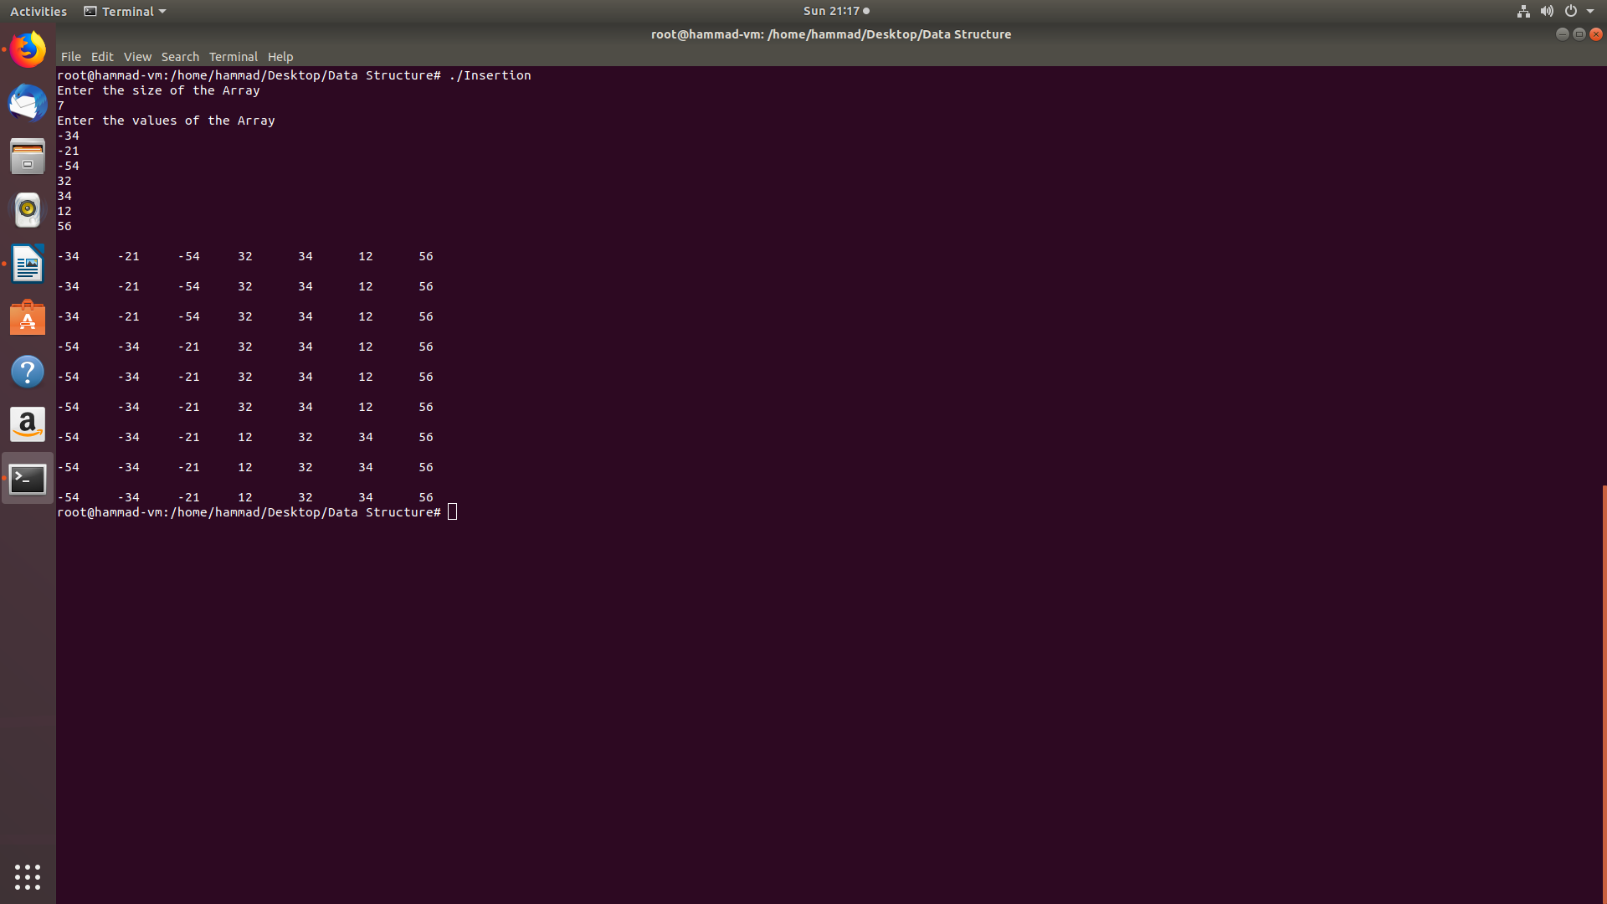

1. **Shell Sort**

**Code:-**

#include<iostream>

#define max 25

using namespace std;

class ShellSort

{

int n, A[max], temp, i, j;

public:

ShellSort()

{

n = 0;

i = 0;

j = 0;

temp = 0;

}

void getdata()

{

cout<<"Enter the size of the Array"<<endl;

cin>>n;

A[n];

cout<<"Enter the values of the Array"<<endl;

for(int i=0; i<n; i++)

{

cin>>A[i];

}

}

void display()

{

cout<<endl;

for(int i=0; i<n; i++)

{

cout<<A[i]<<"\t";

}

cout<<endl;

}

void sort()

{

for(i=n/2; i>0; i/=2)

{

display();

for(j=i; j<n; j++)

{

for(int k=j-i; k >= 0; k = k-i)

{

if(A[k+i] <= A[k] )

{

temp = A[k];

A[k] = A[k+i];

A[k+i] = temp;

}

else

{ break; }

}

}

}

}

};

int main()

{

ShellSort ss;

ss.getdata();

ss.display();

ss.sort();

ss.display();

return 0;

}

**Screenshots:-**

