**Practical No. 6**

1. Binary Search Tree

Code :

#include <stdio.h>

#include <stdlib.h>

struct node //Creating a node structure

{

int value;

struct node *l;

struct node *r;

}*root = NULL, *temp = NULL, *t2, *t1; //initializing pointers

void insert(); //declaration of functions

void inorder(struct node *t);

void create();

void search(struct node *t);

void preorder(struct node *t);

void postorder(struct node *t);

int flag = 1;

void main()

{

int ch;

/*menu driven programs*/

printf("\nOPERATIONS ---");

printf("\n1 - Insert an element into tree\n");

printf("2 - Inorder Traversal\n");

printf("3 - Preorder Traversal\n");

printf("4 - Postorder Traversal\n");

printf("5 - Exit\n");

while(1)

{

printf("\nEnter your choice : ");

scanf("%d", &ch);

switch (ch)

{

case 1:

insert();

break;

case 2:

inorder(root);

break;

case 3:

preorder(root);

break;

case 4:

postorder(root);

break;

case 5:

exit(0);

default :

printf("Wrong choice, Please enter correct choice ");

break;

}

}

}

/* To insert a node in the tree */

void insert()

{

create();

if (root == NULL) /*checking the first element in null*/

root = temp;

else

search(root); /*otherwise seach and insert*/

}

/* To create a node */

void create()

{ /*creating very first node of the element*/

int data;

printf("Enter data of node to be inserted : ");

scanf("%d", &data);

temp = (struct node *)malloc(1*sizeof(struct node));

temp->value = data;

temp->l = temp->r = NULL;

}

/* Function to search the appropriate position to insert the new node */

void search(struct node *t)

{

if ((temp->value > t->value) && (t->r != NULL)) /* value more than root node value insert at right */

search(t->r);

else if ((temp->value > t->value) && (t->r == NULL))

t->r = temp;

else if ((temp->value < t->value) && (t->l != NULL)) /* value less than root node value insert at left */

search(t->l);

else if ((temp->value < t->value) && (t->l == NULL))

t->l = temp;

}

/* recursive function to perform inorder traversal of tree */

void inorder(struct node *t)

{

if (root == NULL)

{

printf("No elements in a tree to display");

return;

}

if (t->l != NULL)

inorder(t->l);

printf("%d -> ", t->value);

if (t->r != NULL)

inorder(t->r);

}

/* To find the preorder traversal */

void preorder(struct node *t)

{

if (root == NULL)

{

printf("No elements in a tree to display");

return;

}

printf("%d -> ", t->value);

if (t->l != NULL)

preorder(t->l);

if (t->r != NULL)

preorder(t->r);

}

/* To find the postorder traversal */

void postorder(struct node *t)

{

if (root == NULL)

{

printf("No elements in a tree to display ");

return;

}

if (t->l != NULL)

postorder(t->l);

if (t->r != NULL)

postorder(t->r);

printf("%d -> ", t->value);

}

Screenshot :

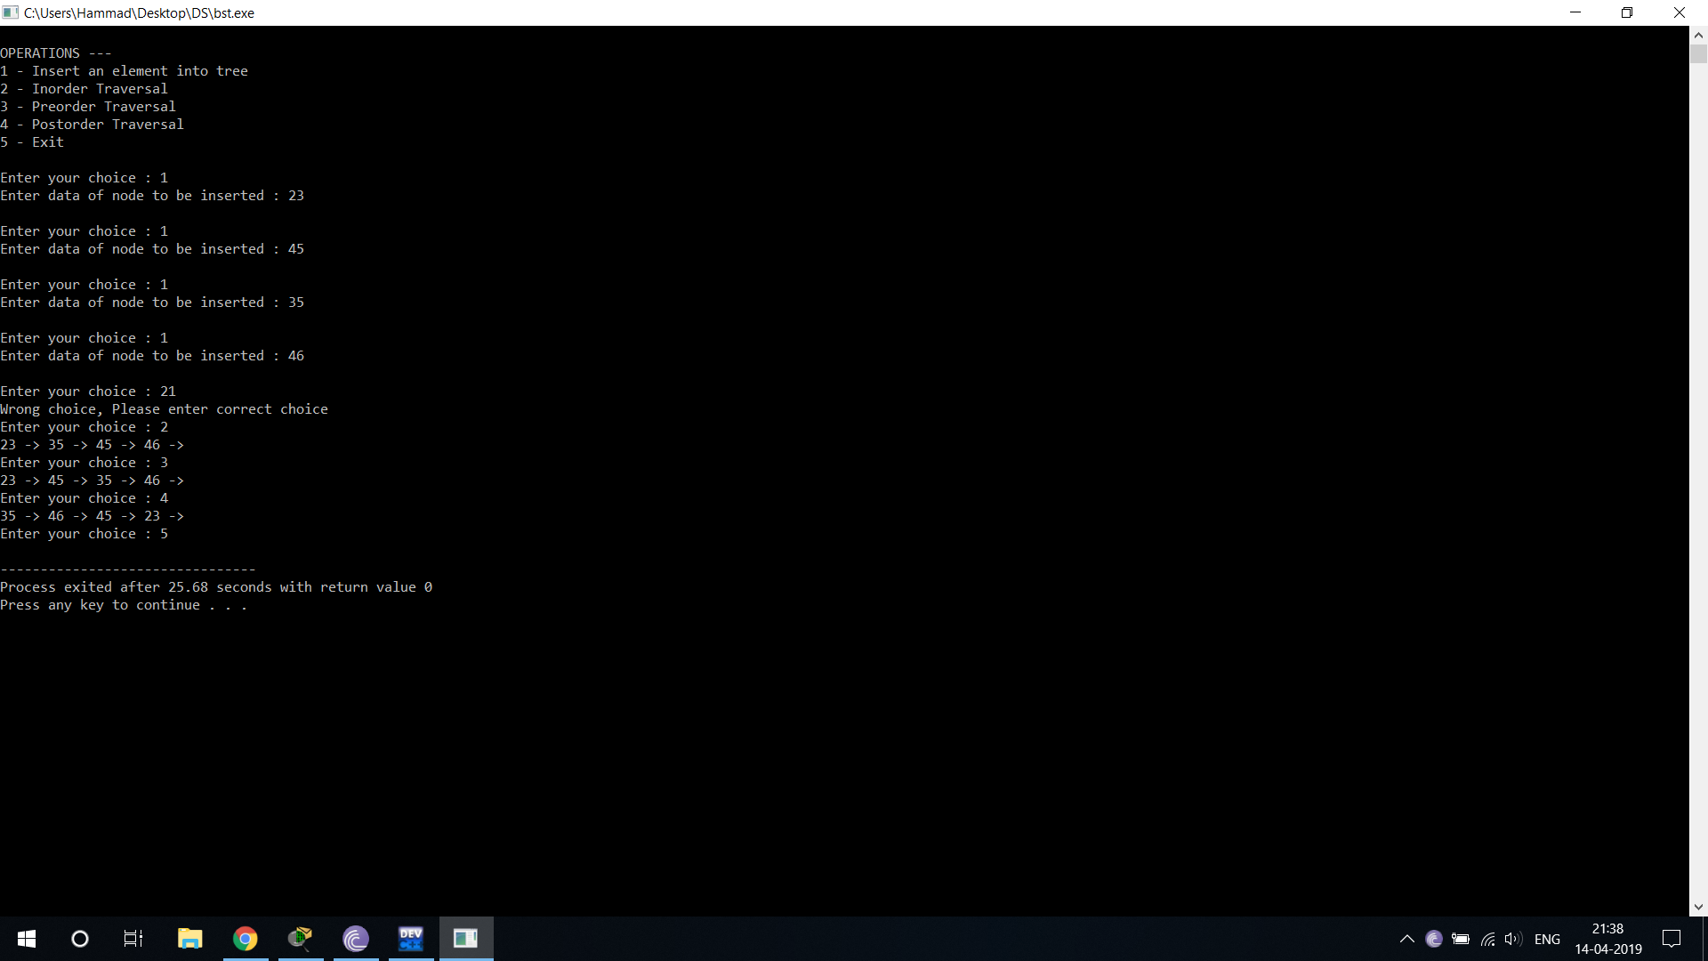

1. AVL Tree (Adelson-Velskii and Landis) Self Balancing Binary Search Tree

Code :

#include<iostream>

#include<cstdio>

#include<sstream>

#include<algorithm>

#define pow2(n) (1 << (n))

using namespace std;

struct node //creating a node structure

{

int data;

struct node *left;

struct node *right;

}*root;

/*

* Class Declaration

*/

class AVL

{

public: //defining all the functions

int height(node *);

int diff(node *);

node *rr_rotation(node *);

node *ll_rotation(node *);

node *lr_rotation(node *);

node *rl_rotation(node *);

node* balance(node *);

node* insert(node *, int );

void display(node *, int);

void inorder(node *);

void preorder(node *);

void postorder(node *);

AVL()

{

root = NULL;

}

};

/*

* Main Contains Menu

*/

int main()

{

int choice, item;

AVL avl;

while (1) ///menu driven program

{ cout<<"\n";

cout<<"1.Insert Element into the tree"<<endl;

cout<<"2.Display Balanced AVL Tree"<<endl;

cout<<"3.InOrder traversal"<<endl;

cout<<"4.PreOrder traversal"<<endl;

cout<<"5.PostOrder traversal"<<endl;

cout<<"6.Exit"<<endl;

cout<<"Enter your Choice: ";

cin>>choice;

switch(choice)

{

case 1:

cout<<"Enter value to be inserted: ";

cin>>item;

root = avl.insert(root, item);

break;

case 2:

if (root == NULL)

{

cout<<"Tree is Empty"<<endl;

continue;

}

cout<<"Balanced AVL Tree:"<<endl;

avl.display(root, 1);

break;

case 3:

cout<<"Inorder Traversal:"<<endl;

avl.inorder(root);

cout<<endl;

break;

case 4:

cout<<"Preorder Traversal:"<<endl;

avl.preorder(root);

cout<<endl;

break;

case 5:

cout<<"Postorder Traversal:"<<endl;

avl.postorder(root);

cout<<endl;

break;

case 6:

exit(1);

break;

default:

cout<<"Wrong Choice"<<endl;

}

}

return 0;

}

/*

* Height of AVL Tree

*/

int AVL::height(node *temp) //To calculate the height of the tree

{

int h = 0;

if (temp != NULL)

{

int l_height = height (temp->left);

int r_height = height (temp->right);

int max_height = max (l_height, r_height);

h = max_height + 1;

}

return h;

}

/*

* Height Difference

*/

int AVL::diff(node *temp) //to calculate the difference between the node

{

int l_height = height (temp->left);

int r_height = height (temp->right);

int b_factor= l_height - r_height; // The difference between heights of left and right subtrees cannot be more tham ome for all nodes

return b_factor;

}

/*

* Right- Right Rotation

*/

node *AVL::rr_rotation(node *parent)

{

node *temp;

temp = parent->right;

parent->right = temp->left;

temp->left = parent;

return temp;

}

/*

* Left- Left Rotation

*/

node *AVL::ll_rotation(node *parent)

{

node *temp;

temp = parent->left;

parent->left = temp->right;

temp->right = parent;

return temp;

}

/*

* Left - Right Rotation

*/

node *AVL::lr_rotation(node *parent)

{

node *temp;

temp = parent->left;

parent->left = rr_rotation (temp);

return ll_rotation (parent);

}

/*

* Right- Left Rotation

*/

node *AVL::rl_rotation(node *parent)

{

node *temp;

temp = parent->right;

parent->right = ll_rotation (temp);

return rr_rotation (parent);

}

/*

* Balancing AVL Tree

*/

node *AVL::balance(node *temp)

{

int bal_factor = diff (temp);

if (bal_factor > 1)

{

if (diff (temp->left) > 0)

temp = ll_rotation (temp);

else

temp = lr_rotation (temp);

}

else if (bal_factor < -1)

{

if (diff (temp->right) > 0)

temp = rl_rotation (temp);

else

temp = rr_rotation (temp);

}

return temp;

}

/*

* Insert Element into the tree

*/

node *AVL::insert(node *root, int value)

{

if (root == NULL)

{

root = new node;

root->data = value;

root->left = NULL;

root->right = NULL;

return root;

}

else if (value < root->data)

{

root->left = insert(root->left, value);

root = balance (root);

}

else if (value >= root->data)

{

root->right = insert(root->right, value);

root = balance (root);

}

return root;

}

/*

* Display AVL Tree

*/

void AVL::display(node *ptr, int level)

{

int i;

if (ptr!=NULL)

{

display(ptr->right, level + 1);

printf("\n");

if (ptr == root)

cout<<"Root -> ";

for (i = 0; i < level && ptr != root; i++)

cout<<" ";

cout<<ptr->data;

display(ptr->left, level + 1);

}

}

/*

* Inorder Traversal of AVL Tree

*/

void AVL::inorder(node *tree)

{

if (tree == NULL)

return;

inorder (tree->left);

cout<<tree->data<<" ";

inorder (tree->right);

}

/*

* Preorder Traversal of AVL Tree

*/

void AVL::preorder(node *tree)

{

if (tree == NULL)

return;

cout<<tree->data<<" ";

preorder (tree->left);

preorder (tree->right);

}

/*

* Postorder Traversal of AVL Tree

*/

void AVL::postorder(node *tree)

{

if (tree == NULL)

return;

postorder ( tree ->left );

postorder ( tree ->right );

cout<<tree->data<<" ";

}

Screenshot :

