Data Structure Practicals

- Bubble Sort:-

Code:-

#include<iostream>
#define max 25
using namespace std;

class bubble
{

int n, A[max],temp,count;

public:
bubble()
{
n = 0;
count = 0;
temp = 0;
}

void getdata()
{
cout<<"Enter the size of the Array"<<endl;
cin>>n;
A[n];
cout<<"Enter the values of the Array"<<endl;
for(int i=0; i<n; i++)
{
cin>>A[i];
}
}

void display()
{
cout<<endl;
for(int i=0; i<n; i++)
{
cout<<A[i]<<"\t";
}
cout<<endl;
}

void sort()
{
for(int i=0; i<n-1; i++)
{
count = 0;
for(int j=0; j<n-i-1; j++)
{
if(A[j]>A[j+1])
{
temp = A[j];
A[j] = A[j+1];
A[j+1] = temp;
count++;
}
}

cout<<"Pass = ";
display();
if(count == 0)
{
break;
}
}
}
};

int main()
{

bubble obj;

obj.getdata();
obj.display();
obj.sort();
cout<<"After sort :- ";obj.display();

return 0;
}

Screenshots:-

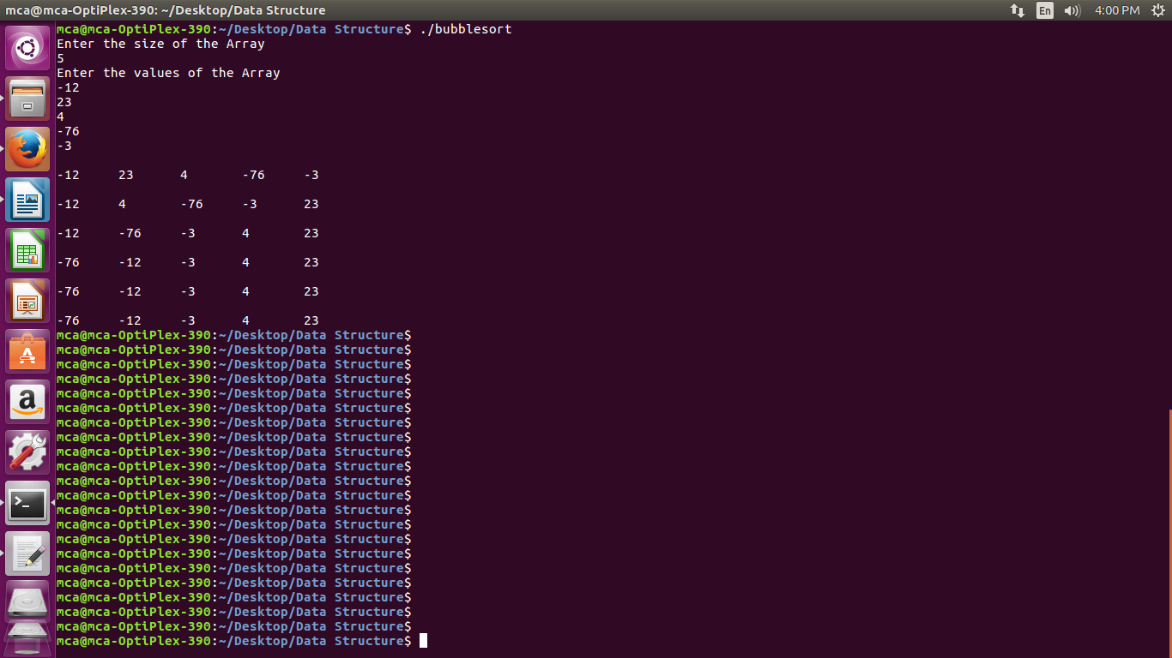
- Quick Sort:-

Code:-

#include<iostream>
#define max 25
using namespace std;

class QuickSort
{

int n, A[max], lower, upper, temp, l, u, i;

public:
QuickSort()
{
n = 0;
temp = 0;
l = 0;
u = 0;
i = 0;
}

int getdata()
{
cout<<"Enter the size of the Array"<<endl;
cin>>n;
A[n];
cout<<"Enter the values of the Array"<<endl;
for(int i=0; i<n; i++)
{
cin>>A[i];
}
return n;
}

void display()
{
cout<<endl;
for(int i=0; i<n; i++)
{
cout<<A[i]<<"\t";
}
cout<<endl;
}

void sort(int lower, int upper)
{
if ( lower < upper )
{
int i = part ( A, lower, upper ) ;
sort ( lower, i - 1 ) ;
sort ( i + 1, upper ) ;
}
}

int part ( int *a, int lower, int upper )
{
l = lower + 1 ;
u = upper ;
i = a[lower] ;
while ( u >= l )
{
while ( a[l] < i )
{
l++ ;
}
while ( a[u] > i )
{
u-- ;
}
if ( u > l )
{
temp = a[l] ;
a[l] = a[u] ;
a[u] = temp ;
}
}
temp = a[lower] ;
a[lower] = a[u] ;
a[u] = temp ;
return u ;
}
};

int main()
{

QuickSort qs;
int x = qs.getdata();
qs.display();
qs.sort(0, x-1);
cout<<"Sorted :";
qs.display();

return 0;
}

Screenshots:-

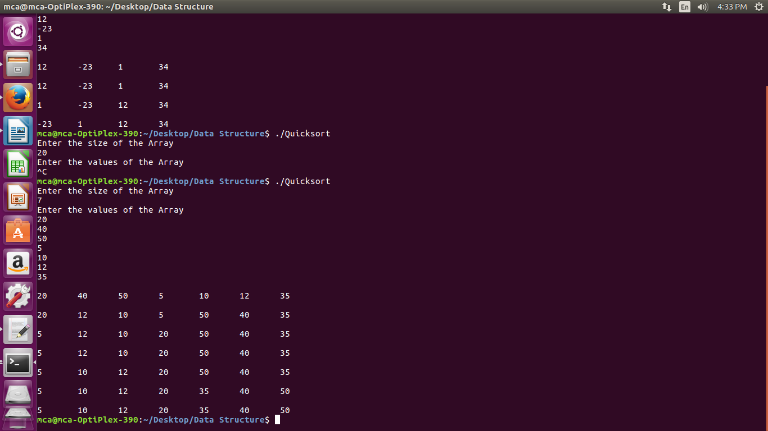
- Selection Sort

Code:-

#include<iostream>
#define max 25
using namespace std;

class SelectionSort
{

int n, A[max], temp, i, j, t, m;

public:
SelectionSort()
{
n = 0;
m = 0;
t = 0;
i = 0;
j = 0;
temp = 0;
}

void getdata()
{
cout<<"Enter the size of the Array"<<endl;
cin>>n;
A[n];
cout<<"Enter the values of the Array"<<endl;
for(int i=0; i<n; i++)
{
cin>>A[i];
}
}

void display()
{
cout<<endl;
for(int i=0; i<n; i++)
{
cout<<A[i]<<"\t";
}
cout<<endl;
}

void sort()
{
for(i=0; i<n-1; i++)
{
m = A[i];
t = i;
for(j=i+1; j<n; j++)
{
if(m>A[j])
{
m = A[j];
t = j;
}
}
display();
cout<<endl;
temp = A[i];
A[i] = A[t];
A[t] = temp;
}

}
};

int main()
{

SelectionSort ss;
ss.getdata();
ss.display();
ss.sort();
ss.display();

return 0;
}

Screenshots:-
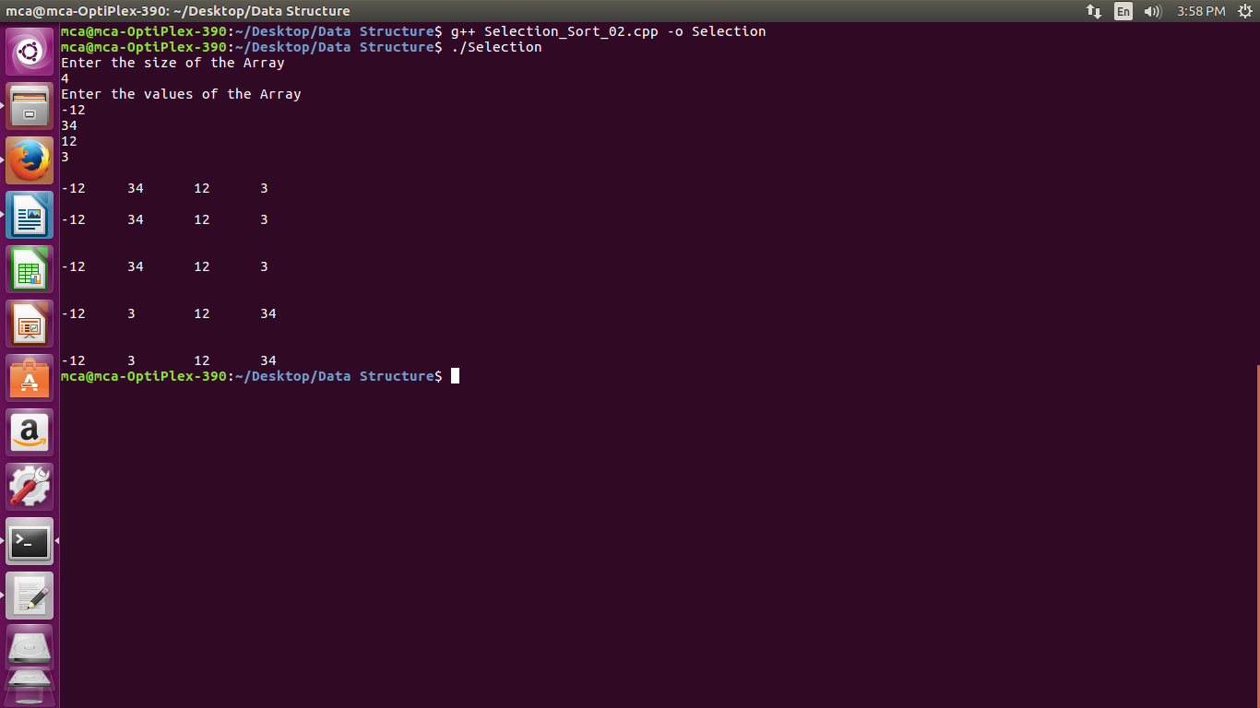

- Radix Sort

Code:-

#include<iostream>
#include<cmath>
#define m 25
using namespace std;

class Radix
{
public:
int n, A[m], max, x;

Radix()
{
n=0; max=0; x=0;
}

void getdata()
{
cout<<"Enter the size of the Array"<<endl;
cin>>n;
A[n];
cout<<"Enter the values of the Array"<<endl;
for(int i=0; i<n; i++)
{
cin>>A[i];
}
}

int getMax(int A[], int n)
{
int temp=A[0];
for(int i=0; i<n; i++)
{
if(A[i]>temp)
{
temp = A[i];
}
}
return temp;
}

void countsort(int A[], int n,int x)
{
int count[10]={0}, i, output[n];

// Counter Initialized
// Exponential Game
for(i=0; i<n; i++)
{
count[(A[i]/x)%10]++;
}

//Total Count
for(i=1; i<10; i++)
{
count[i]=count[i]+count[i-1];
}

//Building Output Array
for(i=n-1; i>=0; i--)
{
output[count[(A[i]/x)%10]-1] = A[i];
count[(A[i]/x)%10]--;
}
// Copying the elements
for(i=0; i<n; i++)
{
A[i] = output[i];
}

}

void sort()
{
max=getMax(A, n);
for(x=1; max/x>0; x=x*10)
{
cout<<"Pass = ";
display();
countsort(A, n, x);
}
}

void display()
{
cout<<endl;
for(int i=0; i<n; i++)
{
cout<<A[i]<<"\t";
}
cout<<endl;
}
};

int main()
{
Radix r;
r.getdata();
r.display();
r.sort();
cout<<"Sorted Elements: \n";
r.display();
return 0;
}

Screenshots:-

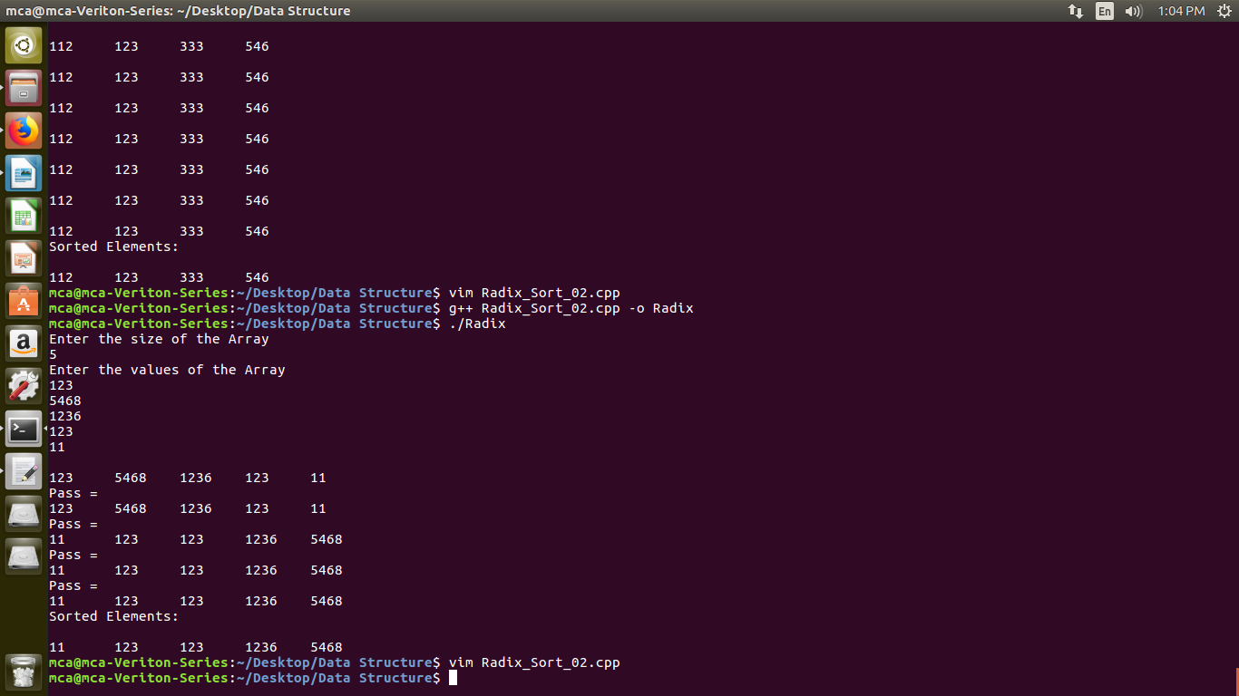

- Insertion Sort

Code:-

#include<iostream>
#define max 50

using namespace std;
class InsertionSort
{
int n, i, j, t, A[max];

public:
InsertionSort()
{
n = 0;
i = 0;
j = 0;
t = 0;
}

int getdata()
{
cout<<"Enter the size of the Array"<<endl;
cin>>n;
A[n];
cout<<"Enter the values of the Array"<<endl;
for(int i=0; i<n; i++)
{
cin>>A[i];
}
}

void display()
{
cout<<endl;
for(int i=0; i<n; i++)
{
cout<<A[i]<<"\t";
}
cout<<endl;
}

void sort()
{
for(i=0; i<n; i++)
{
t = A[i];
j = i-1;
while((t<A[j]) && (j>=0))
{
A[j+1] = A[j];
j = j-1;
}
A[j+1]=t;
display();
}
}

};

int main()
{

InsertionSort is;

is.getdata();
is.display();
is.sort();
is.display();

return 0;
}

Screenshots:-

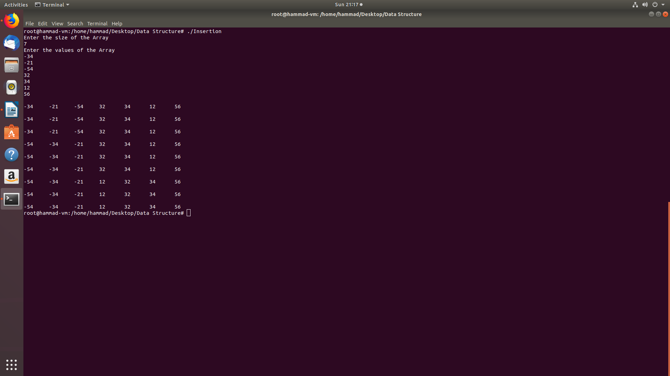

- Shell Sort

Code:-

#include<iostream>
#define max 25
using namespace std;

class ShellSort
{

int n, A[max], temp, i, j;

public:
ShellSort()
{
n = 0;
i = 0;
j = 0;
temp = 0;
}

void getdata()
{
cout<<"Enter the size of the Array"<<endl;
cin>>n;
A[n];
cout<<"Enter the values of the Array"<<endl;
for(int i=0; i<n; i++)
{
cin>>A[i];
}
}

void display()
{
cout<<endl;
for(int i=0; i<n; i++)
{
cout<<A[i]<<"\t";
}
cout<<endl;
}

void sort()
{
for(i=n/2; i>0; i/=2)
{
display();
for(j=i; j<n; j++)
{
for(int k=j-i; k >= 0; k = k-i)
{
if(A[k+i] <= A[k] )
{
temp = A[k];
A[k] = A[k+i];
A[k+i] = temp;
}
else
{ break; }
}
}
}

}
};

int main()
{

ShellSort ss;
ss.getdata();
ss.display();
ss.sort();
ss.display();

return 0;
}
Screenshots:-
