LAB2

List of Program:

1. To check if the given number is even or odd.

Code:

number = float(input("\nEnter number to check whether it is odd or even :-\n"))

if number == 0:

print("\nNumber is Zero!!!")

elif number % 2 == 0:

print("\nNumber is Even!!!")

elif number % 2 == 1:

print("\nNumber is Odd!!!")

else:

print("\nInvalid Number!!!")

Screenshot:

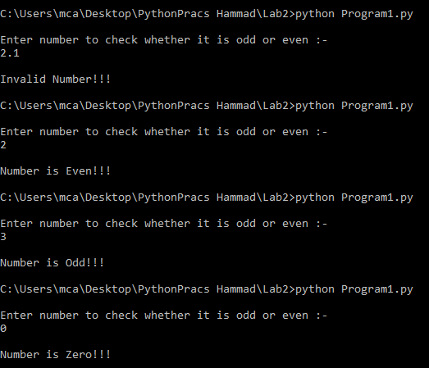

1. Write a program to take in the marks of 5 subjects and display the grade.

Code :

print("Out of 100")

maths = float(input("Marks in Maths?\n"))

science = float(input("Marks in Science?\n"))

english = float(input("Marks in English?\n"))

computer = float(input("Marks in Computer?\n"))

history = float(input("Marks in History?\n"))

if maths<=100 and science<=100 and english<=100 and computer<=100 and history<=100:

s = "pass"

sum = maths+science+english+computer+history

total = 500.00

p = (sum/total) \* 100

if maths<30 or science<30 or english<30 or computer<30 or history<30:

s = "fail"

print("Student is failed in at least one subject")

elif s != "fail":

if p>=80:

print("Grade 'O'")

elif p>=70:

print("Grade 'A'")

elif p>=60:

print("Grade 'B'")

elif p>=50:

print("Grade 'C'")

elif p>=30:

print("Grade 'D'")

elif p<30:

print("'Fail'")

print("Percentage = ",p)

else:

print("Subject Marks are greater than 100, Program Closed!")

Screenshot:

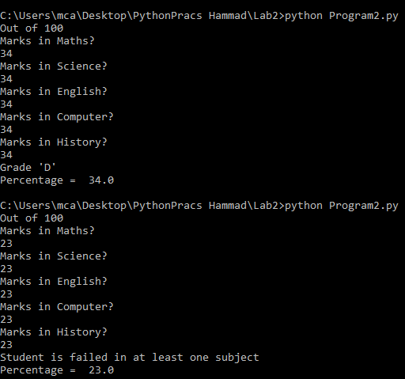

1. To find all the prime numbers in the interval 0 to 100.

Code:

flag = 0

high = 100

low = 0

print("All Prime Numbers Between {0} to {1}".format(low,high))

for n in range(low, high+1):

if n > 1:

flag = 0

for i in range(2,(n//2+1)):

if(n%i) == 0:

flag = flag + 1

break

if flag == 0:

print("%d"%n)

Screenshot :

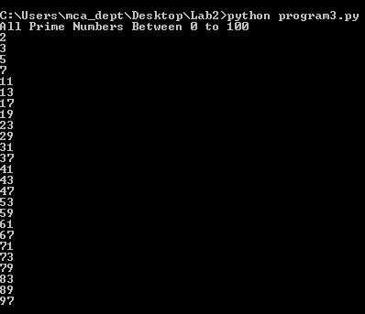

1. To check if the given number is Armstrong or not.

Code :

n = int(input(" Enter any number to check "))

sum = 0

temp = n

count = 0

while(temp>0):

temp //= 10

count = count + 1

temp = n

while(temp>0):

t = temp%10

sum += t\*\*count

temp //= 10

if n==sum :

print("%d Armstrong Number"%n)

else:

print(n,"is not an Armstrong number")

Screenshot:

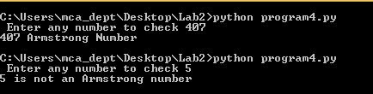

1. To check if the given char is vowel or consonant.

Code :

ch = input("Enter a character: ")

if(ch=='A' or ch=='a' or ch=='E' or ch =='e' or ch=='I' or ch=='i' or ch=='O' or ch=='o' or ch=='U' or ch=='u'):

print(ch, "is a Vowel")

else:

print(ch, "is a Consonant")

Screenshot:

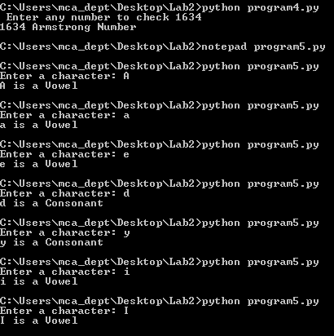

1. To add two matrices.

Code :

import numpy as np

x = int(input("Enter number of rows\n"))

y = int(input("Enter number of columns\n"))

A = np.zeros( (x, y) )

B = np.zeros( (x, y) )

print("Enter elements for matrix A")

for i in range (len(A)):

for j in range (len(A[0])):

A[i][j] = input('Enter Element {} x {} = '.format(i+1, j+1))

print("Enter elements for matrix B")

for i in range (len(B)):

for j in range (len(B[0])):

B[i][j] = input('Enter Element {} x {} = '.format(i+1, j+1))

C = A + B

print(A)

print("+")

print(B)

print("=")

print(C)

Screenshot:

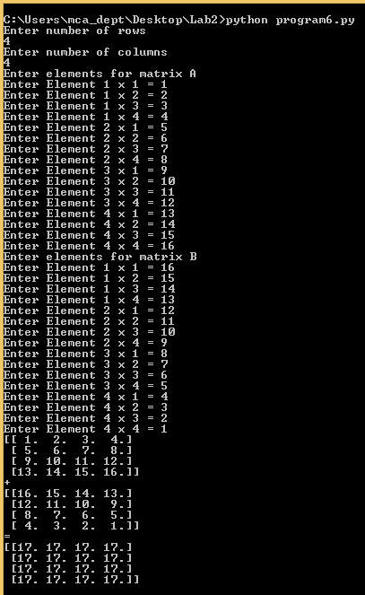

1. To convert month name to a number of days.

Code :

print("Months : \n1)January\n2)February\n3)March\n4)April\n5)May\n6)June\n7)July\n8)August\n9)September\n10)October\n11)November\n12)December")

s = input("Enter any month to know number of days \n")

if s == "February":

print("Number of days = 28/29")

elif s == "January" or s == "January" or s == "March" or s == "May" or s == "July" or s == "August" or s == "October" or s == "December":

print("Number of days = 31")

elif s == "April" or s == "June" or s == "September" or s == "November":

print("Number of days = 30")

else :

print("Invalid Month")

Screenshot:

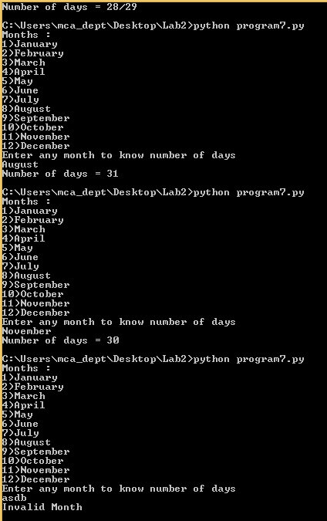

1. To check the validity of password input by users :
   1. At least 1 letter between [a-z] and 1 letter between [A-Z].
   2. At least 1 number between [0-9].
   3. At least 1 character from [$#@].
   4. Minimum length 6 characters.
   5. Maximum length 16 characters.

Code :

import re

count = 3

while count>0:

print("Number of attemps : ",count)

pw = input("Enter password \n")

flag = 0

while True:

if(len(pw)<6):

flag = 1

break

if(len(pw)>16):

flag = 1

break

elif not re.search("[a-z]", pw):

flag = 1

break

elif not re.search("[A-Z]", pw):

flag = 1

break

elif not re.search("[0-9]", pw):

flag = 1

break

elif not re.search("[#$@]", pw):

flag = 1

break

else :

flag = 0

count = 0

print("Valid password")

break

if( flag == 1):

print("Invalid password")

print(flag)

count-=1

Screenshot:

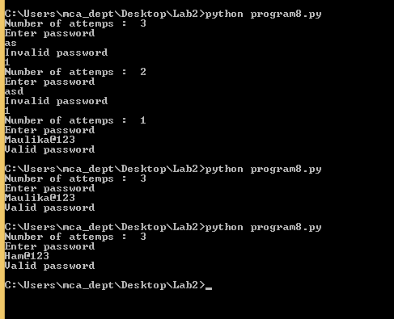

1. To check if a number is palindrome or not.

Code :

n = int(input("Enter any number to check if it is palindrome or not :-\n"))

rev = 0

temp = n

while(temp>0):

rev = rev \* 10

rev = rev + (temp % 10)

temp = temp // 10

print("Reverse of given input is : - ",rev)

if(rev == n):

print("Number is palindrome")

else:

print("Number is not palindrome")

Screenshot:

