**Practical No: 3**

1. **To merge two list and find second largest element in the list using bubble sort**

**Code:**

a = []  
c = []  
n=int(input("Enter number of elements:"))  
for i in range(1,n+1):  
 b=int(input("Enter element:"))  
 a.append(b)  
n=int(input("Enter number of elements:"))  
for i in range(1,n+1):  
 b=int(input("Enter element:"))  
 c.append(b)  
s = a+c  
  
n = len(s)  
for i in range(n):  
 for j in range(0, n-i-1):  
 if s[j] > s[j+1] :  
 temp = s[j]  
 s[j] = s[j+1]  
 s[j+1] = temp  
for i in range(0,n):  
 print("\n \t Element : ",s[i])  
  
print("Sorted :",n)  
print("2nd Last element of the list is :",s[n-2])

**Output:**

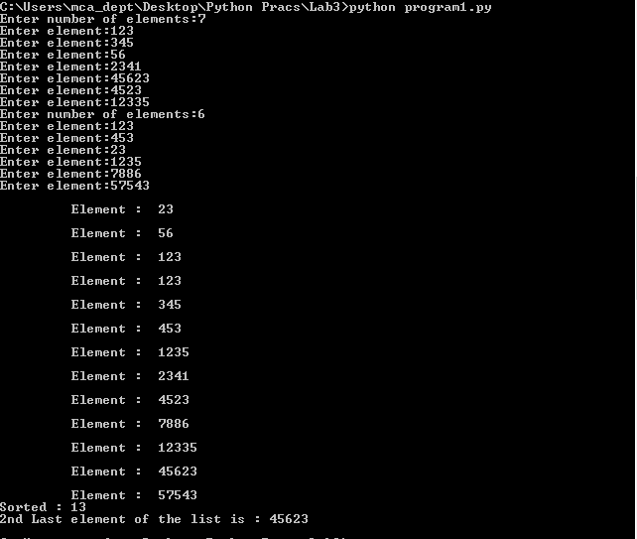

1. **To calculate the no of uppercase, lowercase letters, digits and spaces in a string**

**Code:**

mystring=input("Enter string:")  
n1=0  
n2=0  
n3=0  
n4=0  
for i in mystring:  
 if(i.islower()):  
 n1=n1+1  
 elif(i.isupper()):  
 n2=n2+1  
 elif(i.isspace()):  
 n3=n3+1  
 elif(i.isdigit()):  
 n4=n4+1  
  
print("The number of lowercase characters is:")  
print(n1)  
print("The number of uppercase characters is:")  
print(n2)  
print("The number of spaces is:")  
print(n3)  
print("The number of digits is:")  
print(n4)

**Output:**

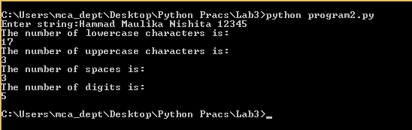

1. **To count the occurrences of each word in a given string sentence**

**Code:**

class StringFreq(object):  
 def freq(self, str):  
 str_list = str.split()   
 unique_words = set(str_list)  
 for words in unique_words :  
 print('Frequency of ', words , ' : ', str_list.count(words))  
  
obj = StringFreq()  
str = input("Enter a string to check word frequency :- \n")  
str = str.lower()   
obj.freq(str)

**Output:**

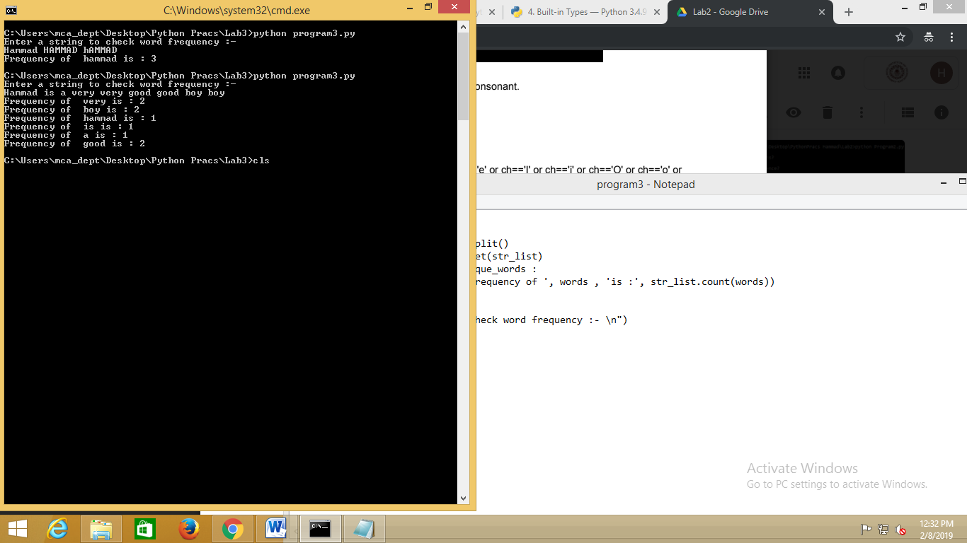

1. **To add key value pair to the dictionary and search and then delete the given key from the dictionary**

**Code:**

class OxfordDictionary(object):  
 oxfordDict = {'person': 'a human being','marathon': 'a running race that is about 4 miles','resist': 'to remain strong against the force','run': 'to move with haste; act quickly'}   
   
 def __init__(self):  
 print(self.oxfordDict)  
  
 def random(self):  
 self.oxfordDict['shoe'] = 'an external covering for the human foot'  
 print (" Shoe : ",self.oxfordDict['shoe'])  
   
 def added(self):  
 k = input("Enter the key\n")  
 p = input("Enter the pair\n")  
 self.oxfordDict[k] = p  
 print(" Added ",k," : ",self.oxfordDict[k])  
  
 def display(self):  
 print (self.oxfordDict)  
   
 def search(self):  
 key = input("Enter Key Value to Search\n")  
 if key in self.oxfordDict:  
 print("Searched Element is ",key," : ",self.oxfordDict[key])  
 else :  
 print("Key Not Found");  
   
 def delete(self):  
 key = input("Enter Key Value to delete\n")  
 if key in self.oxfordDict:  
 print("Deleting Element ",key," : ",self.oxfordDict[key])  
 del self.oxfordDict[key]  
 else :  
 print("Key Not Found");  
  
obj = OxfordDictionary()  
  
while True:  
 print("\n1.To Add \n2.To add static value \n3.To Delete\n4.To Search\n5.To Display\n6.To Quit")  
 choice = int(input("Enter choice\n"))  
 if choice==1:  
 obj.added()  
 elif choice==2:  
 obj.random()  
 elif choice==3:  
 obj.delete()  
 elif choice==4:  
 obj.search()  
 elif choice==5:  
 obj.display()  
 elif choice==6:  
 break  
 else:  
 print("Invalid choice, please choose again\n")  
print("Thank you!!!")

Output :

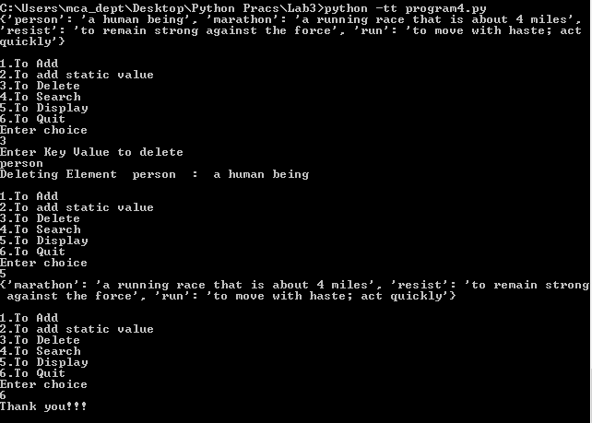

1. **Create one dictionary of 5 students with their name, address, age, class and marks of 5 subjects. Perform all the operations on the created dictionary**

**Code:**

global all_students

global n

class StudentDictionary(object):

all_students = {}

n = 0

def __init__(self, x):

for i in range(0,x):

self.all_students[i] = {}

self.n=x

for i in range(0,x):

self.all_students[i]['Name']=input('Enter the name of student: ')

print (self.all_students[i]['Name'])

self.all_students[i]['RollNo']=input('Enter the roll number of student: ')

print (self.all_students[i]['RollNo'])

self.all_students[i]['Address']=input('Enter the address of student: ')

print (self.all_students[i]['Address'])

self.all_students[i]['Age']=input('Enter the age of student: ')

print (self.all_students[i]['Age'])

self.all_students[i]['Class']=input('Enter the class of student: ')

print (self.all_students[i]['Class'])

self.all_students[i]['Mark1']=int(input('Enter the marks in subject 1: '))

print (self.all_students[i]['Mark1'])

self.all_students[i]['Mark2']=int(input('Enter the marks in subject 2: '))

print (self.all_students[i]['Mark2'])

self.all_students[i]['Mark3']=int(input('Enter the marks in subject 3: '))

print (self.all_students[i]['Mark3'])

self.all_students[i]['Mark4']=int(input('Enter the marks in subject 4: '))

print (self.all_students[i]['Mark4'])

self.all_students[i]['Mark5']=int(input('Enter the marks in subject 5: '))

print (self.all_students[i]['Mark5'])

self.all_students[i]['Total'] = self.all_students[i]['Mark1'] + self.all_students[i]['Mark2'] + self.all_students[i]['Mark3'] + self.all_students[i]['Mark4'] + self.all_students[i]['Mark5']

print("Total is: ", self.all_students[i]['Total'])

self.all_students[i]['Average'] = self.all_students[i]['Total']//5

print ("Average is :", self.all_students[i]['Average'])

print(self.all_students)

def added(self):

self.n = self.n+1

i = self.n-1

self.all_students[i] = {}

self.all_students[i]['Name']=input('Enter the name of student: ')

print (self.all_students[i]['Name'])

self.all_students[i]['RollNo']=input('Enter the roll number of student: ')

print (self.all_students[i]['RollNo'])

self.all_students[i]['Address']=input('Enter the address of student: ')

print (self.all_students[i]['Address'])

self.all_students[i]['Age']=input('Enter the age of student: ')

print (self.all_students[i]['Age'])

self.all_students[i]['Class']=input('Enter the class of student: ')

print (self.all_students[i]['Class'])

self.all_students[i]['Mark1']=int(input('Enter the marks in subject 1: '))

print (self.all_students[i]['Mark1'])

self.all_students[i]['Mark2']=int(input('Enter the marks in subject 2: '))

print (self.all_students[i]['Mark2'])

self.all_students[i]['Mark3']=int(input('Enter the marks in subject 3: '))

print (self.all_students[i]['Mark3'])

self.all_students[i]['Mark4']=int(input('Enter the marks in subject 4: '))

print (self.all_students[i]['Mark4'])

self.all_students[i]['Mark5']=int(input('Enter the marks in subject 5: '))

print (self.all_students[i]['Mark5'])

self.all_students[i]['Total'] = self.all_students[i]['Mark1'] + self.all_students[i]['Mark2'] + self.all_students[i]['Mark3'] + self.all_students[i]['Mark4'] + self.all_students[i]['Mark5']

print("Total is: ", self.all_students[i]['Total'])

self.all_students[i]['Average'] = self.all_students[i]['Total']//5

print ("Average is :", self.all_students[i]['Average'])

def display(self):

print (self.all_students)

def search(self):

key = input("Enter Key Value to Search\n")

for key in self.all_students:

if key in self.all_students:

print("Searched Element is ",key," : ",self.all_students[key])

else :

print("Key Not Found");

def delete(self):

key = input("Enter Key Value to Delete\n")

for key in self.all_students:

if key in self.all_students:

print("Deleting Element ",key," : ",self.all_students[key])

del self.all_students[key]

break

else :

print("Key Not Found")

def update(self):

key = input("Enter Key Value to Update\n")

i = key

for i in self.all_students:

if i in self.all_students:

self.all_students[i]['Name']=input('Enter the name of student: ')

print (self.all_students[i]['Name'])

self.all_students[i]['RollNo']=input('Enter the roll number of student: ')

print (self.all_students[i]['RollNo'])

self.all_students[i]['Address']=input('Enter the address of student: ')

print (self.all_students[i]['Address'])

self.all_students[i]['Age']=input('Enter the age of student: ')

print (self.all_students[i]['Age'])

self.all_students[i]['Class']=input('Enter the class of student: ')

print (self.all_students[i]['Class'])

self.all_students[i]['Mark1']=int(input('Enter the marks in subject 1: '))

print (self.all_students[i]['Mark1'])

self.all_students[i]['Mark2']=int(input('Enter the marks in subject 2: '))

print (self.all_students[i]['Mark2'])

self.all_students[i]['Mark3']=int(input('Enter the marks in subject 3: '))

print (self.all_students[i]['Mark3'])

self.all_students[i]['Mark4']=int(input('Enter the marks in subject 4: '))

print (self.all_students[i]['Mark4'])

self.all_students[i]['Mark5']=int(input('Enter the marks in subject 5: '))

print (self.all_students[i]['Mark5'])

self.all_students[i]['Total'] = self.all_students[i]['Mark1'] + self.all_students[i]['Mark2'] + self.all_students[i]['Mark3'] + self.all_students[i]['Mark4'] + self.all_students[i]['Mark5']

print("Total is: ", self.all_students[i]['Total'])

self.all_students[i]['Average'] = self.all_students[i]['Total']//5

print ("Average is :", self.all_students[i]['Average'])

break

else :

print("Key Not Found");

n = int(input("Please enter number of students:"))

obj = StudentDictionary(n)

while True:

print("\n1.To Add. \n2.To Update. \n3.To Delete. \n4.To Search. \n5.To Display. \n6.To Quit.")

choice = int(input("Enter choice :-\n"))

if choice==1:

obj.added()

elif choice==2:

obj.update()

elif choice==3:

obj.delete()

elif choice==4:

obj.search()

elif choice==5:

obj.display()

elif choice==6:

break

else:

print("Invalid choice, please choose again.\n")

print("Thank you!!!")

Output:

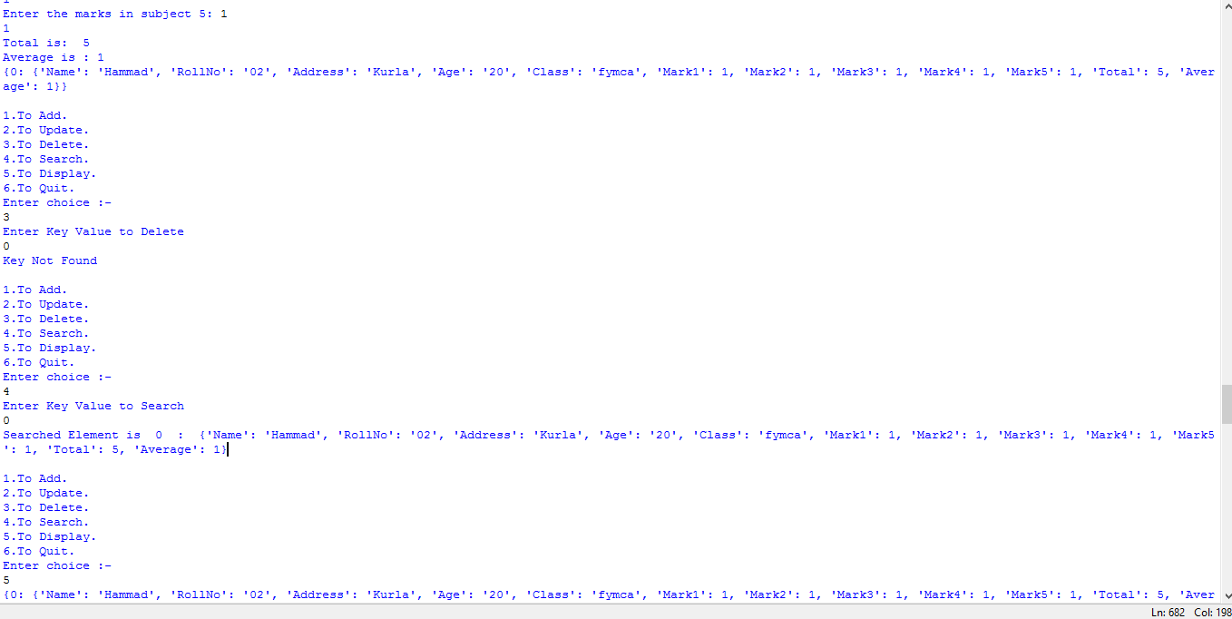

1. **To concatenate two dictionaries and find sum of all values in dictionary**

**Code:**

print("Items of my books:")

MyBooks = {'Absalom, Absalom!': 1, 'Ah, Wilderness!': 2, 'An Acceptable Time': 3}

print(MyBooks)

print("sum of all values of my books:")

print(sum(MyBooks.values()))

print("Items of your books:")

YourBooks = {'Antic Hay': 2, 'Death Be Not Proud': 4, 'A Fanatic Heart': 5}

print(YourBooks)

print("sum of all values of your books:")

print(sum(YourBooks.values()))

print("merging of My Books and Your Books:")

MyBooks.update(YourBooks)

print (MyBooks)

**Output:**

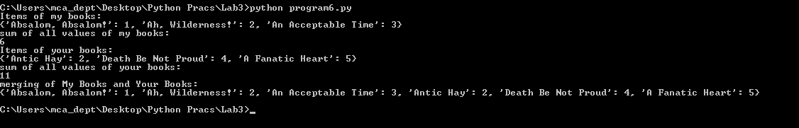

1. **To add and remove elements from set and perform all the set operations like Union, Intersection, Difference and Symmetric Difference**

**Code:**

A = {0, 2, 4, 6, 8};

B = {1, 2, 3, 4, 5};

print(A)

print(B)

A.add(11)

print ("Updated set:",A)

B.remove(5)

print ("Updated set:",B)

print("Union :", A | B)

print("Intersection :", A & B)

print("Difference :", B - A)

print("Symmetric difference :", A ^ B)

**Output:**

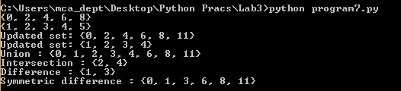

1. **Perform different operations on Tuple.**

**Code:**

t=(1,2,3,4,5,6)

print (max(t)) #max element

print (min(t)) #min element

print (t*2) #multiply the elements of tuple

print (2 in t) #if that element is present in the tuple

print (8 in t)

print (t[-5]) #backward indexing

print (t[3]) #forward indexing

print (t[2:4]) #slicing

**Output:**

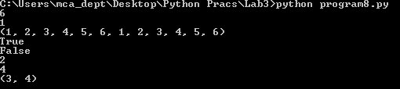

1. **Write a Python program to count the elements in a list until an element is a tuple.**

**Code:**

def Count(f):

count = 0

for i in f:

if isinstance(i, tuple):

break

count = count + 1

return count

MyList = [4, 5, 6, 10, 11, 2, 4, (7, 8, 9)]

print(Count(MyList))

**Output:**

