**Practical No: 3**

1. **To merge two list and find second largest element in the list using bubble sort**

**Code:**

a = []  
c = []  
n=int(input("Enter number of elements:"))  
for i in range(1,n+1):  
 b=int(input("Enter element:"))  
 a.append(b)  
n=int(input("Enter number of elements:"))  
for i in range(1,n+1):  
 b=int(input("Enter element:"))  
 c.append(b)  
s = a+c  
  
n = len(s)  
for i in range(n):  
 for j in range(0, n-i-1):  
 if s[j] > s[j+1] :  
 temp = s[j]  
 s[j] = s[j+1]  
 s[j+1] = temp  
for i in range(0,n):  
 print("\n \t Element : ",s[i])  
  
print("Sorted :",n)  
print("2nd Last element of the list is :",s[n-2])

**Output:**

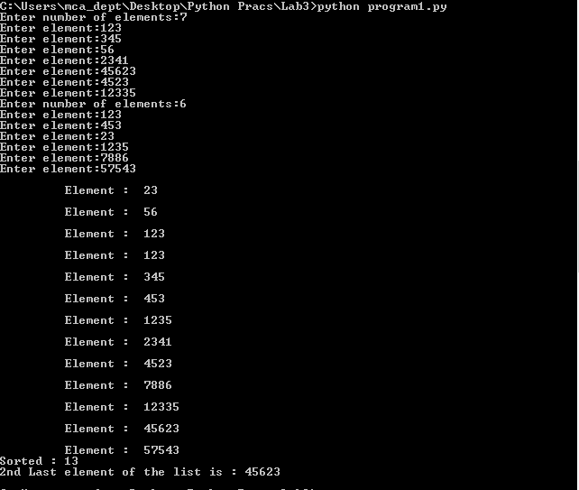

1. **To calculate the no of uppercase, lowercase letters, digits and spaces in a string**

**Code:**

mystring=input("Enter string:")  
n1=0  
n2=0  
n3=0  
n4=0  
for i in mystring:  
 if(i.islower()):  
 n1=n1+1  
 elif(i.isupper()):  
 n2=n2+1  
 elif(i.isspace()):  
 n3=n3+1  
 elif(i.isdigit()):  
 n4=n4+1  
  
print("The number of lowercase characters is:")  
print(n1)  
print("The number of uppercase characters is:")  
print(n2)  
print("The number of spaces is:")  
print(n3)  
print("The number of digits is:")  
print(n4)

**Output:**

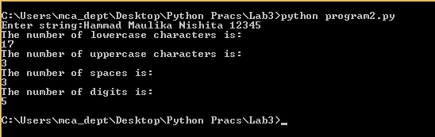

**8. Perform different operations on Tuple.**

**Code:**

t=(1,2,3,4,5,6)

print (max(t)) #max element

print (min(t)) #min element

print (t*2) #multiply the elements of tuple

print (2 in t) #if that element is present in the tuple

print (8 in t)

print (t[-5]) #backward indexing

print (t[3]) #forward indexing

print (t[2:4]) #slicing

**Output:**

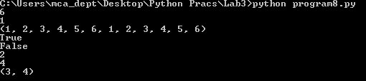

**9. Write a Python program to count the elements in a list until an element is a tuple.**

**Code:**

def Count(f):

count = 0

for i in f:

if isinstance(i, tuple):

break

count = count + 1

return count

MyList = [4, 5, 6, 10, 11, 2, 4, (7, 8, 9)]

print(Count(MyList))

**Output:**

