**Practical No. 07**

1. **Google Login Form:-**

**Code :-**

from tkinter import *

#from tkinter.ttk import Style,Notebook

from PIL import Image, ImageTk

window=Tk()

window.title(" Create your Google Account ")

window.geometry("700x500")

window.configure(background="white")

#Contents of Signup tab

## Google logo

img1=ImageTk.PhotoImage(Image.open("google.png"))

imgGoogle=Label(window,image=img1)

imgGoogle.place(x=30,y=0)

## Google Sheild logo

img2=ImageTk.PhotoImage(Image.open("signupshield.png"))

imgGoogleSheild=Label(window,image=img2)

imgGoogleSheild.place(x=350,y=100)

## First Name Area

lblFirstName=Label(window,text="First Name",background="white")

lblFirstName.place(x=50,y=100)

edtFirstName=Entry(window)

edtFirstName.place(x=50,y=125)

## Last Name Area

lblLastname=Label(window,text="Last Name",background="white")

lblLastname.place(x=200,y=100)

edtULastname=Entry(window)

edtULastname.place(x=200,y=125)

## Username Area

lblUsername=Label(window,text="Username",background="white")

lblUsername.place(x=50,y=200)

edtUsername=Entry(window)

edtUsername.place(x=50,y=225)

lblExtensionUsername=Label(window,text="@gmail.com",background="white")

lblExtensionUsername.place(x=180,y=225)

## Password Area

lblPassword=Label(window,text="Password",background="white")

lblPassword.place(x=50,y=300)

edtPassword=Entry(window,show="*")

edtPassword.place(x=50,y=325)

## Confirm Password Area

lblConfirmPassword=Label(window,text="Confirm Password",background="white")

lblConfirmPassword.place(x=200,y=300)

edtConfirmPassword=Entry(window,show="*")

edtConfirmPassword.place(x=200,y=325)

## Goto Login Page

btnGoto=Button(window,text="Sign in instead!",background="white",fg="blue",relief=RAISED,borderwidth=0)

btnGoto.place(x=50,y=425)

## Submit Values Area

btnSignUp=Button(window,text="Next!",background="blue",fg="white")

btnSignUp.place(x=200,y=425)

window.mainloop()

**Screenshot:-**

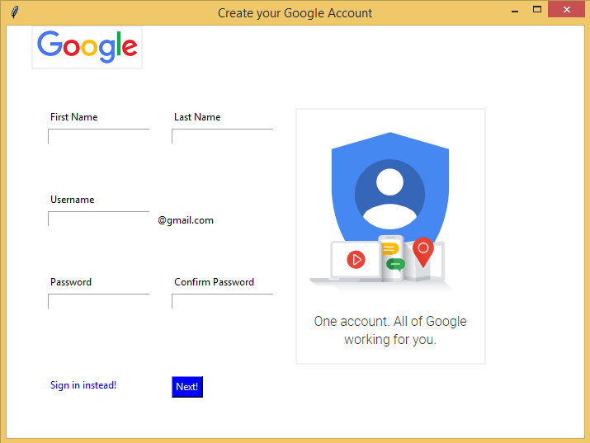

1. **Login and Registration with database connectivity.**

**Code :-**

#imports

from tkinter import *

from tkinter import messagebox as ms

import sqlite3

# make database and users (if not exists already) table at programme start up

with sqlite3.connect('mydb.db') as db:

c = db.cursor()

c.execute('CREATE TABLE IF NOT EXISTS user (username TEXT NOT NULL ,password TEX NOT NULL);')

db.commit()

db.close()

#main Class

class main:

def __init__(self,master):

# Window

self.master = master

# Some Usefull variables

self.username = StringVar()

self.password = StringVar()

self.n_username = StringVar()

self.n_password = StringVar()

#Create Widgets

self.widgets()

#Login Function

def login(self):

#Establish Connection

with sqlite3.connect('mydb.db') as db:

c = db.cursor()

#Find user If there is any take proper action

find_user = ('SELECT * FROM user WHERE username = ? and password = ?')

c.execute(find_user,[(self.username.get()),(self.password.get())])

result = c.fetchall()

if result:

self.logf.pack_forget()

self.head['text'] = self.username.get() + '\n Loged In'

self.head['pady'] = 150

else:

ms.showerror('Oops!','Username Not Found.')

def new_user(self):

#Establish Connection

with sqlite3.connect('mydb.db') as db:

c = db.cursor()

#Find Existing username if any take proper action

find_user = ('SELECT * FROM user WHERE username = ?')

c.execute(find_user,[(self.username.get())])

if c.fetchall():

ms.showerror('Error!','Username Taken Try a Diffrent One.')

else:

ms.showinfo('Success!','Account Created!')

self.log()

#Create New Account

insert = 'INSERT INTO user(username,password) VALUES(?,?)'

c.execute(insert,[(self.n_username.get()),(self.n_password.get())])

db.commit()

#Frame Packing Methords

def log(self):

self.username.set('')

self.password.set('')

self.crf.pack_forget()

self.head['text'] = 'LOGIN'

self.logf.pack()

def cr(self):

self.n_username.set('')

self.n_password.set('')

self.logf.pack_forget()

self.head['text'] = 'Create Account'

self.crf.pack()

#Draw Widgets

def widgets(self):

self.head = Label(self.master,text = 'LOGIN',font = ('',35),pady = 10)

self.head.pack()

self.logf = Frame(self.master,padx =10,pady = 10)

Label(self.logf,text = 'Username: ',font = ('',20),pady=5,padx=5).grid(sticky = W)

Entry(self.logf,textvariable = self.username,bd = 5,font = ('',15)).grid(row=0,column=1)

Label(self.logf,text = 'Password: ',font = ('',20),pady=5,padx=5).grid(sticky = W)

Entry(self.logf,textvariable = self.password,bd = 5,font = ('',15),show = '*').grid(row=1,column=1)

Button(self.logf,text = ' Login ',bd = 3 ,font = ('',15),padx=5,pady=5,command=self.login).grid()

Button(self.logf,text = ' Create Account ',bd = 3 ,font = ('',15),padx=5,pady=5,command=self.cr).grid(row=2,column=1)

self.logf.pack()

self.crf = Frame(self.master,padx =10,pady = 10)

Label(self.crf,text = 'Username: ',font = ('',20),pady=5,padx=5).grid(sticky = W)

Entry(self.crf,textvariable = self.n_username,bd = 5,font = ('',15)).grid(row=0,column=1)

Label(self.crf,text = 'Password: ',font = ('',20),pady=5,padx=5).grid(sticky = W)

Entry(self.crf,textvariable = self.n_password,bd = 5,font = ('',15),show = '*').grid(row=1,column=1)

Button(self.crf,text = 'Create Account',bd = 3 ,font = ('',15),padx=5,pady=5,command=self.new_user).grid()

Button(self.crf,text = 'Go to Login',bd = 3 ,font = ('',15),padx=5,pady=5,command=self.log).grid(row=2,column=1)

#create window and application object

root = Tk()

root.title("Login Form")

main(root)

root.mainloop()

**Screenshot:-**

