**Practical No.08**

1. Client Server Connection

Code :

Client.py

import socket

s = socket.socket()

port = 12345

s.connect(('127.0.0.1', port))

print(s.recv(1024))

s.close()

Server.py

import socket

s = socket.socket()

print("Socket Successfully Created!!!")

port = 12345

s.bind(('', port))

print("Socket binded to %s"%(port))

s.listen(50)

print("Socket is listening")

con = 1

while con==1:

c, addr = s.accept()

print("Got connection from ", addr)

c.send(b"Thank you for connecting ")

c.close()

con = con + 1

s.close()

Screenshot :

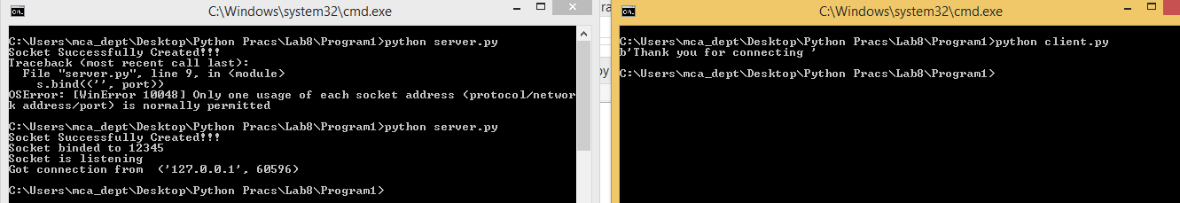

1. Sending a file from server to client

Code :

Client.py

import socket

s = socket.socket()

host = '127.0.0.1'

port = 12345

s.connect((host, port))

s.send(b"Hello server!!!")

with open('recieved_file.txt','wb') as f:

print("File opened")

while True:

print("Receiving data...")

data = s.recv(1024)

print("data = %s", (data))

if not data:

break

f.close()

print("File closed")

s.close()

print("Connection closed")

Server.py

import socket

s = socket.socket()

print("Socket Successfully Created!!!")

port = 12345

s.bind(('', port))

print("Socket binded to %s"%(port))

s.listen(50)

print("Socket is listening")

con = 1

while con==1:

c, addr = s.accept()

print("Got connection from ", addr)

c.send(b"Thank you for connecting ")

#sending file

filename = 'myfile.txt'

f = open(filename, 'rb')

l = f.read(1024)

c.send(l)

c.close()

con = con + 1

s.close()

Screenshot :

