In this challenge, I am analyzing climate data for Hawaii. There were two major components, the *Climate Analysis and Exploration* and the *Climate App*

**Climate Analysis and Exploration**

The code for the Climate and Analysis and Exploration can be seen in the file climate.ipynb Here, I did multiple analyses.

First the results of the precipitation analysis. This was looking at the precipitation of all stations in the last year of data - 08/23/16 to 08/23/17. Here is a plot of the results

[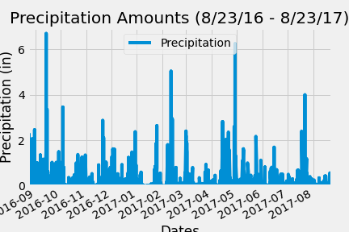](https://github.com/derrikdennis/sqlalchemy-challenge/blob/master/results/precipitation.png)

Second are the results of the station analysis.

If we are looking at the station with the most observations **in the dataset**, the results are for Waihee

[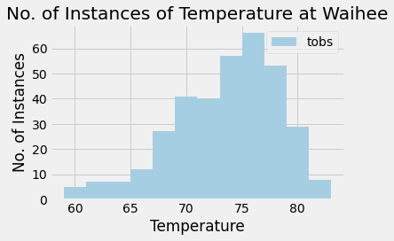](https://github.com/derrikdennis/sqlalchemy-challenge/blob/master/results/waihee-histogram.png)

If we are looking at the station with the most observations **in the dataset *in the last year***, the results are for Waikiki,

[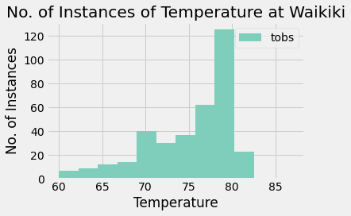](https://github.com/derrikdennis/sqlalchemy-challenge/blob/master/results/wakiki-histogram.png)

**Climate App**

Code for the climate app can be found under app.py. Enter "python app.py" into a terminal. You then will go to [http://127.0.0.5000/](http://127.0.19.136/) to start the results.

**Bonus: Other Recommended Analysis**

There were optional challenge queries. I shall now attempt these.

**Temperature Analysis I**

Hawaii is reputed to enjoy mild weather all year. is there a meaningful difference between the temperature in June and December?

* I will bring in Hawaii measurements.csv using pandas’ reads() to perform this portion.
* I will identify the average temperature in June at all stations across all available years. And I will do the same thing for December.
* I will use the t-test to determine where the difference in the means, if any, is statistically significant.