Quarto Computations
Yamada Ichiro SAMPLE
Sato Tadashi SAMPLE
2024-06-29
Abstract
This is a demo of quarto manuscript

NumPy
array([[ 0, 1, 2, 3, 4],
[ 5, 6, 7, 8, 9],
[10, 11, 12, 13, 14]])
_{Source: Article Notebook}
Reference test Wickham and Grolemund (2016)

Matplotlib
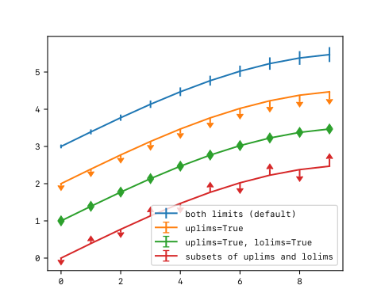
Figure 1
_{Source: Article Notebook}

Plotly
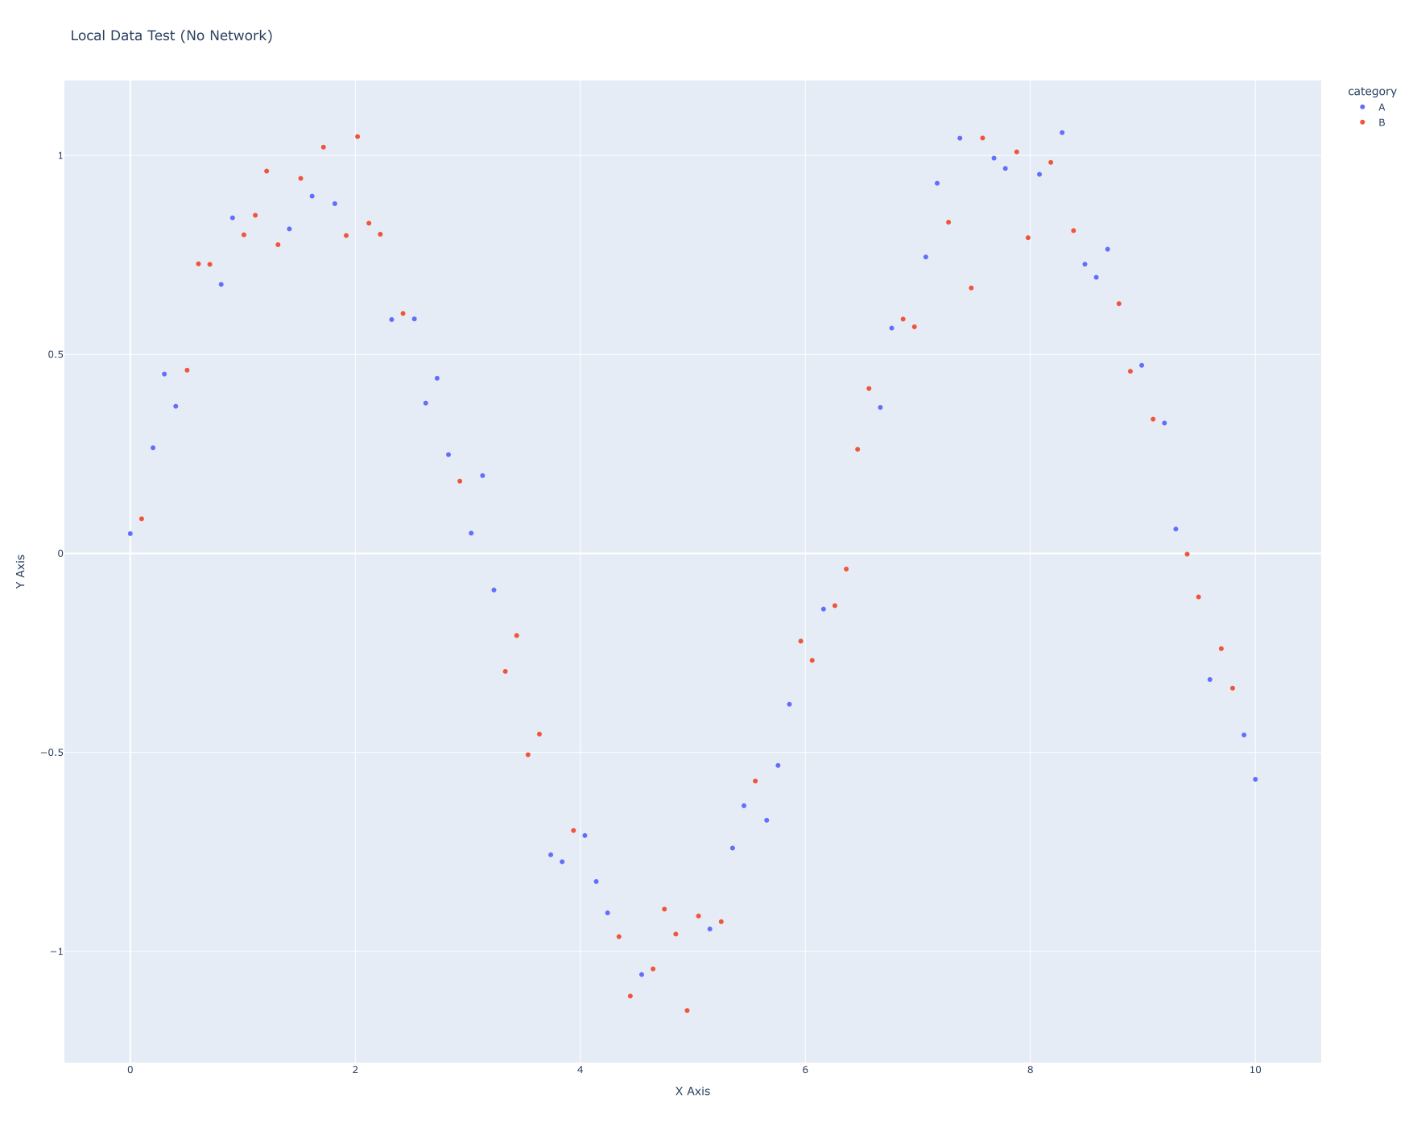
Figure 2
_{Source: Article Notebook}

R
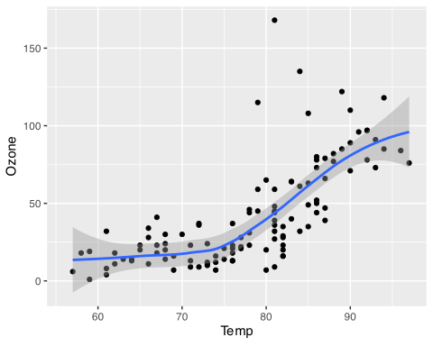
Figure 3: Temperature and ozone level.
_{Source: Article Notebook}

References
Wickham, Hadley, and Garrett Grolemund. 2016. R for Data Science: Import, Tidy, Transform, Visualize, and Model Data. “O’Reilly Media, Inc.”

