DEMO: Quarto Computations

Yamada Ichiro SAMPLE

Sato Tadashi SAMPLE

2024-06-29

Abstract

This is a demo of quarto manuscript

# NumPy

array([[ 0, 1, 2, 3, 4],  
 [ 5, 6, 7, 8, 9],  
 [10, 11, 12, 13, 14]])

Source: [Article Notebook](https://fryagbye.github.io/tinderboxwithquarto/main.qmd.html)

Reference test Wickham and Grolemund (2016)

# Matplotlib

Source: [Article Notebook](https://fryagbye.github.io/tinderboxwithquarto/main.qmd.html)

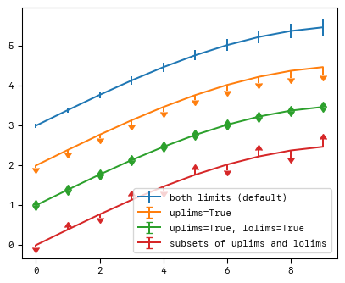

Source: [Article Notebook](https://fryagbye.github.io/tinderboxwithquarto/main.qmd.html)

# Plotly

Source: [Article Notebook](https://fryagbye.github.io/tinderboxwithquarto/main.qmd.html)

Source: [Article Notebook](https://fryagbye.github.io/tinderboxwithquarto/main.qmd.html)

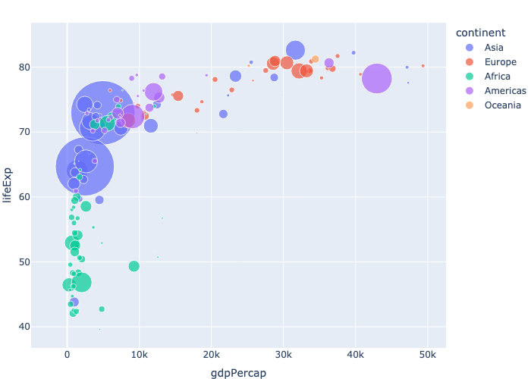

Source: [Article Notebook](https://fryagbye.github.io/tinderboxwithquarto/main.qmd.html)

# References

Source: [Article Notebook](https://fryagbye.github.io/tinderboxwithquarto/main.qmd.html)

Wickham, Hadley, and Garrett Grolemund. 2016. *R for Data Science: Import, Tidy, Transform, Visualize, and Model Data*. “O’Reilly Media, Inc.”