The workbook Exped.xlsx contains a sample of 1000 sales transactions of the Expeditioner Inc. For each sale, there is a row recording when it was sold, where it was sold, what was sold, how it was sold, the quantity sold, and the sales revenue.

Create a PivotTable to produce the following report:
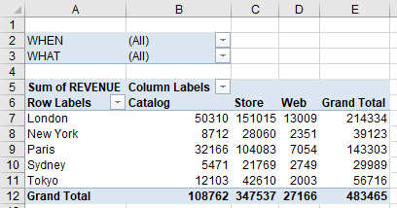
Continue to use the Pivot Table to answer the following questions:
1. What was the value of catalog sales for London in the first quarter?
Zunächst Where mit When als Zeilendimension tauschen. Dann auf das erste Datum gehen und im Ribbonband Group Selection wählen. Im Fenster nun Quarters markieren und Months entmarkieren. Nun den Rest einschränken:
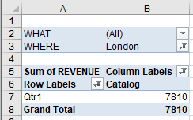
2. What percent of the total annual sales were Tokyo's Web sales in the fourth quarter?
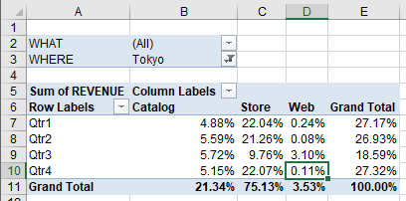
Ribbon Pivot Table Tools wählen
-> Options wählen
-> Show Values as
-> % of Grand Total
3. What percent of Sydney's annual sales was its Catalog sales?
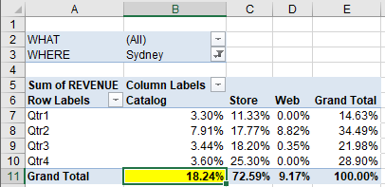
4. What was the value of Camel saddle sales for Paris in 2002 by quarter?
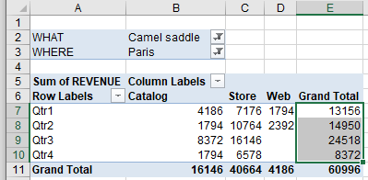
5. What was the value of catalog sales for London in January and give details of the transactions?
Zunächst mit “Group Selection” von Quarters auf Month wechseln!
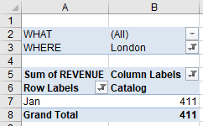

Nun rechte Maustaste auf die 411 und Show Details wählen. Es öffnet sich ein neues Spreadsheet mit:
6. How many Elephant polo sticks were sold in New York in each month of 2002?
Revenue als Werte rausnehmen und Quantity reinziehen:
