ICIS 2025 Nashville Paper Title
Gerit Wagner
Abstract
Text…

Introduction
We ask that authors follow these basic guidelines when submitting to ICIS. In essence, you should format your paper exactly like this document. The easiest way to use this template is to replace the placeholder content with your own material. The template file contains specially formatted styles (e.g., Normal, Heading, Bullet, References, Title, Author, Affiliation) that are designed to reduce the work in formatting your final submission.
Webster and Watson (2002)
As shown in Figure 1, …
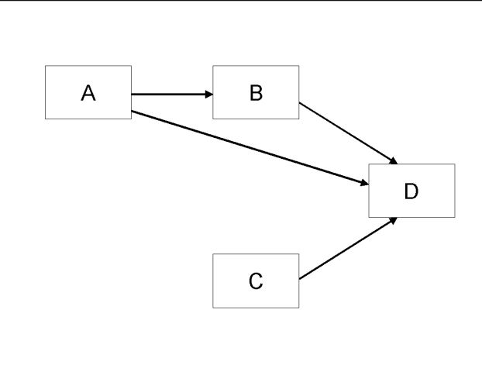
Figure 1: Modified Research Model

More Information
You can learn more about controlling the appearance of Word output here: https://quarto.org/docs/output-formats/ms-word.html

References
Webster, J., and Watson, R. T. 2002. “Analyzing the Past to Prepare for the Future - Writing a Literature Review,” MIS Quarterly (26:2), Xiii–xxiii.

