

Thesis title

Name: | Student Name
Student ID: | 12345678
Date of submission: | 2026-09-01
Thesis advisor: | Prof. Dr. Gerit Wagner

A thesis submitted for the degree of
Bachelor of Science
at Frankfurt School of Finance & Management
Management Department
Table of contents
Abstract 3
Declaration 4
Acknowledgments 5
Introduction 6
References 7

Acknowledgments
I would like to thank my pet goldfish for . . .

Abstract
The abstract should outline the main approach and findings of the thesis and must not be more than 500 words.

Introduction
Lorem ipsum dolor sit amet, consetetur sadipscing elitr, sed diam nonumy eirmod tempor invidunt ut labore et dolore magna aliquyam erat, sed diam voluptua. At vero eos et accusam et justo duo dolores et ea rebum. Stet clita kasd gubergren, no sea takimata sanctus est Lorem ipsum dolor sit amet. Lorem ipsum dolor sit amet, consetetur sadipscing elitr, sed diam nonumy eirmod tempor invidunt ut labore et dolore magna aliquyam erat, sed diam voluptua. At vero eos et accusam et justo duo dolores et ea rebum. Stet clita kasd gubergren, no sea takimata sanctus est Lorem ipsum dolor sit amet (Webster & Watson, 2002).
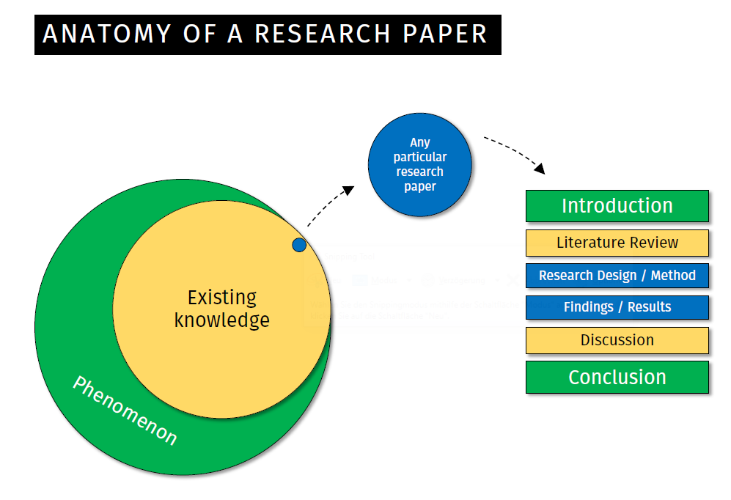
Figure 1: Anatomy of a research paper (Blair Wang, Figshare)

Column 1 | Column 2
… | …
Table 1: Example

References
Webster, J., & Watson, R. T. (2002). Analyzing the Past to Prepare for the Future—Writing a Literature Review. MIS Quarterly, 26(2), xiii–xxiii.

